ATV and Universal Controller Project

By:

|  |  |  |
| --- | --- | --- |
| Joshua Makuch  Baden Brenner  Zachary Christensen | 6th semester  6th semester  5th semester | Team Lead  Team Lead  Team Member |

Idaho State University

College of Technology

Robotics and Communication Systems Engineering Technology

Spring Semester 2024

Prepared for:

Shane Slack

# Table of Contents

# 

1 Abstract 11

2 Background 12

3 Proposed Problem 14

4 Environmental and Ethical Considerations 15

4.1 Environmental and Ethical Considerations 15

5 Block Diagram and System Overview 16

5.1 Overall Block Diagram For The Universal Control System (UCS) 16

6 System Overview and Circuit Analysis for the URC and Peripherals 18

6.1 System Overview for the URC 18

6.2 Circuit Analysis for the URC 21

6.3 System Overview for the Peripheral Turret Controller (Address 8) 25

6.4 Circuit Analysis for the Peripheral Turret Controller (Address 8) 27

6.5 System Overview for the Peripheral LCD Screen (Address 50) 29

7 Breadboard/PCB Design for the URC and Peripherals 30

7.1 Breadboard Overview for Peripheral Turret Controller (Address 8) 30

7.2 Peripheral Controller Individual Stage Design 31

7.3 PCB Design for URC 33

8 Shell Design for the URC PCB 36

8.1 URC Shell Design 36

9 Code Overview and Calibration For the URC and Peripherals 44

9.1 URC Setup Code 44

9.2 URC Main Code 44

9.3 URC UART Code 45

9.4 URC General Peripheral Code 51

9.5 URC Peripheral Controller Code (Address 8) 54

9.6 URC Peripheral Display Code (Address 50) 55

9.7 URC Peripheral Controller Code (Address 50) 59

10 Overview for the on-bot Master 61

10.1 Master Board Summary 61

10.2 Master Board Design 61

10.2 Master Board Code 65

11 Overview for the on-bot Slaves 66

11.1 Slave Board Summary 66

11.2 Slave Board Design 66

11.3 Slave Board Code 67

11.4 Breakout Boards 69

12 Mechanical Design 73

12.1 Overview 73

12.2 Turret Design 73

13 Troubleshooting and Calibration Procedure 80

13.1 Troubleshooting Procedure For The URC 80

13.2 Troubleshooting Procedure for the Master, Slave, and Breakout Boards 80

13.3 UCS Calibration Procedure 81

14 Cost Analysis 82

14.1 URC and Peripheral Cost Analysis 82

14.2 ATV Project Cost Analysis 83

14.3 Overall Cost Analysis 85

15 Conclusion and Recommendations 86

15.1 Conclusion 86

15.2 Recommendations 86

16 Appendix A: Engineering Logs 87

17 Appendix B: Schematics 90

18 Appendix C: Bitmaps 98

19 Appendix D: Flowcharts 108

20 Appendix E: Code Printouts 122

21 Appendix F: Mechanical Drawings 187

22 Appendix G: Works Cited 196

# Table Of Figures

# 

| Figure | Title | Page |
| --- | --- | --- |
| 2.1.1 | Mini ATV Picture from 2023 | 12 |
| 2.1.2 | Universal Remote Controller from 2023 | 13 |
| 5.1.1 | Overall Block Diagram for the UCS | 16 |
| T-5.1.1 | RCET UART Data Structure Standard | 16 |
| T-5.1.2 | RCET UART Action List | 17 |
| T-5.1.3 | RCET Peripheral Device Address List | 17 |
| 6.1.1 | Proposed Controller Scheme/Layout | 18 |
| T-6.1.1 | URC Controls | 19 |
| 6.1.2 | Overall Block Diagram of the URC and 2 Peripherals | 20 |
| 6.2.1 | PIC16LF1789 QFN Package Layout | 21 |
| 6.2.2 | Power Regulator Circuitry | 22 |
| 6.2.3 | Buttons, Triggers, and Switches | 22 |
| 6.2.4 | Joysticks and Drive Mode Switch | 23 |
| 6.2.5 | Communication Circuitry | 24 |
| 6.3.1 | Proposed Peripheral Controller Scheme/Layout (Address 8) | 25 |
| T-6.3.1 | Peripheral Address 8 Controls | 26 |
| 6.4.1 | PIC16F1788 SPDIP Package Layout | 27 |
| 6.4.2 | Peripheral Controller Regulator Circuitry & I^2C | 28 |
| 6.4.3 | Peripheral Controller Controls | 28 |
| 6.4.4 | LK204-25 LCD Screen | 29 |
| 7.1.1 | Breadboard Peripheral Controller (Address 8) | 30 |
| 7.2.1 | Breadboard Peripheral Controller PIC Stage | 31 |
| 7.2.2 | Breadboard Peripheral Controller Buttons and Switches Stage | 31 |
| 7.2.3 | Breadboard Peripheral Controller LED Indicator Stage | 32 |
| 7.2.4 | Breadboard Peripheral Controller Encoder Stage | 32 |
| 7.3.1 | Kicad Design For Rev B URC | 33 |
| 7.3.2 | Physical PCB Front Component Breakdown | 34 |
| 7.3.3 | Physical PCB Back Component Breakdown | 35 |
| 8.1.1. | Shell Overview | 36 |
| 8.1.2 | URC Bottom Shell | 37 |
| 8.1.3 | URC Top Shell | 38 |
| 8.1.4 | URC Buttons | 39 |
| 8.1.5 | Keyed Button Placement | 39 |
| 8.1.6 | URC Shoulder Buttons | 40 |
| 8.1.7 | Battery Strap Mount | 41 |
| 8.1.8 | Battery Strap Mounted on Case | 42 |
| 8.1.9 | Peripheral Mounts | 42 |
| 8.1.10 | LCD Screen Case/Mount | 42 |
| 8.1.11 | Full Case Assembly Front View | 43 |
| 8.1.12 | Full Case Assembly Side View | 43 |
| 9.2.1 | URC Main Flowchart | 45 |
| 9.2.2 | URC Main Mode 2 Flowchart | 45 |
| 9.2.3 | URC Main Mode 1 Flowchart (1/2) | 46 |
| 9.2.4 | URC Peripheral Status Register Allocation | 46 |
| 9.2.5 | URC Main Mode 1 Flowchart (2/2) | 47 |
| 9.3.1 | “SEND_DATA_PACKET” Protocol | 48 |
| 9.3.2 | Typical UART Transmission (Cannon Mechanism) | 48 |
| 9.3.3 | “TX_SEND” Protocol | 49 |
| 9.3.4 | “REC_BYTE” Protocol | 49 |
| 9.3.5 | “HANDLE_RX_DATA” Protocol | 50 |
| 9.3.6 | “HANDLE_RX_DATA_Protocol Subsection | 50 |
| 9.4.1 | General “I^2C Idle” Protocol | 51 |
| 9.4.2 | General “Identify Peripheral Protocol” | 52 |
| 9.4.3 | One Identified and One Non-Identified Peripheral | 52 |
| 9.4.4 | General “Never Acknowledge” Protocol | 53 |
| 9.4.5 | No Peripherals Identified | 53 |
| 9.5.1 | “Read From Peripheral 8” Subroutine | 54 |
| 9.5.2 | Continuous Receive Code Snippet | 54 |
| 9.6.1 | “Transmit Command” Subroutine | 55 |
| 9.6.2 | “Transmit Character” Subroutine | 55 |
| T-9.6.1 | LK204-25 Command List | 56 |
| T-9.6.2 | LK204-25 Character Set | 56 |
| 9.6.3 | “Identify Peripheral Address 50” Subroutine | 57 |
| 9.6.4 | LCD Screen Post Setup | 57 |
| 9.6.5 | “Write to Peripheral 50” Subroutine | 58 |
| 9.6.6 | Typical I^2C Communication | 58 |
| 9.7.1 | Peripheral Controller Main Flowchart | 59 |
| 9.7.2 | Peripheral Controller Main Mode 1 Flowchart | 59 |
| 9.7.3 | Peripheral Controller Main Mode 2 Flowchart | 59 |
| 9.7.4 | Peripheral Controller Interrupt Service Routine | 60 |
| 10.2.1 | Microcontroller on the Master | 61 |
| 10.2.2 | Xbee on the Master | 62 |
| 10.2.3 | Master Board Power Supply | 63 |
| 10.2.4 | I^2C communications on the master board | 63 |
| 10.2.5 | Master Board Layout | 64 |
| 10.3.1 | Master Board Main Loop and Interrupt Flowchart | 65 |
| 11.2.1 | Slave Board Microcontroller | 66 |
| 11.2.2 | Slave Board Layout | 67 |
| 11.3.1 | Driveboard Main | 68 |
| 11.3.2 | Driveboard Interrupt Service Routine | 69 |
| 11.4.1 | Debug Board Schematic | 70 |
| 11.4.2 | Debug Board Layout | 70 |
| 11.4.3 | Breakout Board Schematic | 71 |
| 11.4.4 | Optical Isolated Breakout Board Schematic | 71 |
| 11.4.5 | Breakout Board Layout | 72 |
| 11.4.6 | Optical Isolated Breakout Board Layout | 72 |
| 12.2.1 | Cannon Turret | 74 |
| 12.2.2 | Cannon Holder | 74 |
| 12.2.3 | Turret Pivot Arm | 75 |
| 12.2.4 | Turret 90 | 75 |
| 12.2.5 | Turret 90 Mirrored | 76 |
| 12.2.6 | Turret End Cap | 76 |
| 12.2.7 | Turret Pivot Block | 77 |
| 12.2.8 | Steering Bearing Mount | 78 |
| 12.2.9 | Steering Bearing Race | 79 |
| 12.2.10 | Sheet Metal Parts | 79 |
| 14.1.1 | URC Bill Of Materials | 82 |
| 14.1.2 | Peripheral Bill of Materials | 82 |
| 14.2.1 | Master Board Bill Of Materials | 83 |
| 14.2.2 | Slave Board Bill of Materials | 84 |
| 14.3.1 | Cost Analysis | 85 |

# 

# 

# Abstract

# 

1.1 Abstract Description

This report is a comprehensive summary of the work done on the ATVs and Universal Remote Controller (URC) projects during the Spring 2024 semester. The project itself is a continuation of the work done by the students of the Fall 2023 semester and whose progress since then has been combined into this one document.

The primary objectives for this semester were to redesign the electronics and firing systems for the ATVs as well as create a shell and additional peripherals for the URC. This was initially started with the redesign and development of PCBs for both sides of the project. A master, slave, and additional breakout boards were designed and ordered for the ATV, while a main board was designed and ordered for the URC. Both of these project boards were intended to be used with one another seamlessly to form a universal control system.

From there, mechanical work was done to the mini ATV as well as the larger ATV project in order to shift firing systems between the two. Additionally, some work was done to the ATV project to attempt to get it functioning in terms of control, drive, and firing systems.

For the URC, a shell was designed in conjunction with a PCB in order to create a more professional platform. Additionally, there was a development of multiple types of peripherals that could interface with the URC for future projects. This eventually led to a major overhaul of the URC code and to a partial overhaul of the RCET command structure.

The accompanying documentation has been included in this project and recommendations as well as troubleshooting procedures for the various systems has been specifically noted for any future development.

# 

# Background

# 

2.1 Background

The ATV project began in 2015 by Brain Bischoff, Bill Lewis, Rhett Martin, and Steve Jargensen. The gasoline engine was removed and replaced with an electric motor, and the steering was connected to a linear actuator. A turret was constructed to sit on top of the ATV with a paintball gun that could be controlled by the user. Bill Lewis then designed a remote to drive the ATV. The remote control was controlled with a PIC16LF1789 and transmitted UART serial data with a zigbee. There were 4 joysticks, 8 buttons, and 8 LED indicators. In 2018, more work was done to replace the paintball turret with a Nerf turret that was better suited to demonstrations in public areas. Additionally, some modifications were made to the code aspect to alter the control systems, namely to use a LabVIEW graphical user interface(GUI) for control. The controller was unchanged.

In 2023, the ATV project was reconstructed from the ground up by Baden Brenner and Xavier Hoskins. In the same year a new Universal Remote Controller began development by Joshua Makuch and Jessica McArthur. The ATV itself saw a redesign of the chassis, drive, steering, turret, and electronics. The accompanying URC was designed with the intent of operating off of a pre-made RCET command structure that all future robots would be designed with. Additionally, there was an attempt at the development of peripheral devices to be able to use an array of new control, display, and/or adapter devices if need be in future projects. This is where the project was left off for the Spring 2024 semester.

Figure 2.1.1: Mini ATV Picture from 2023

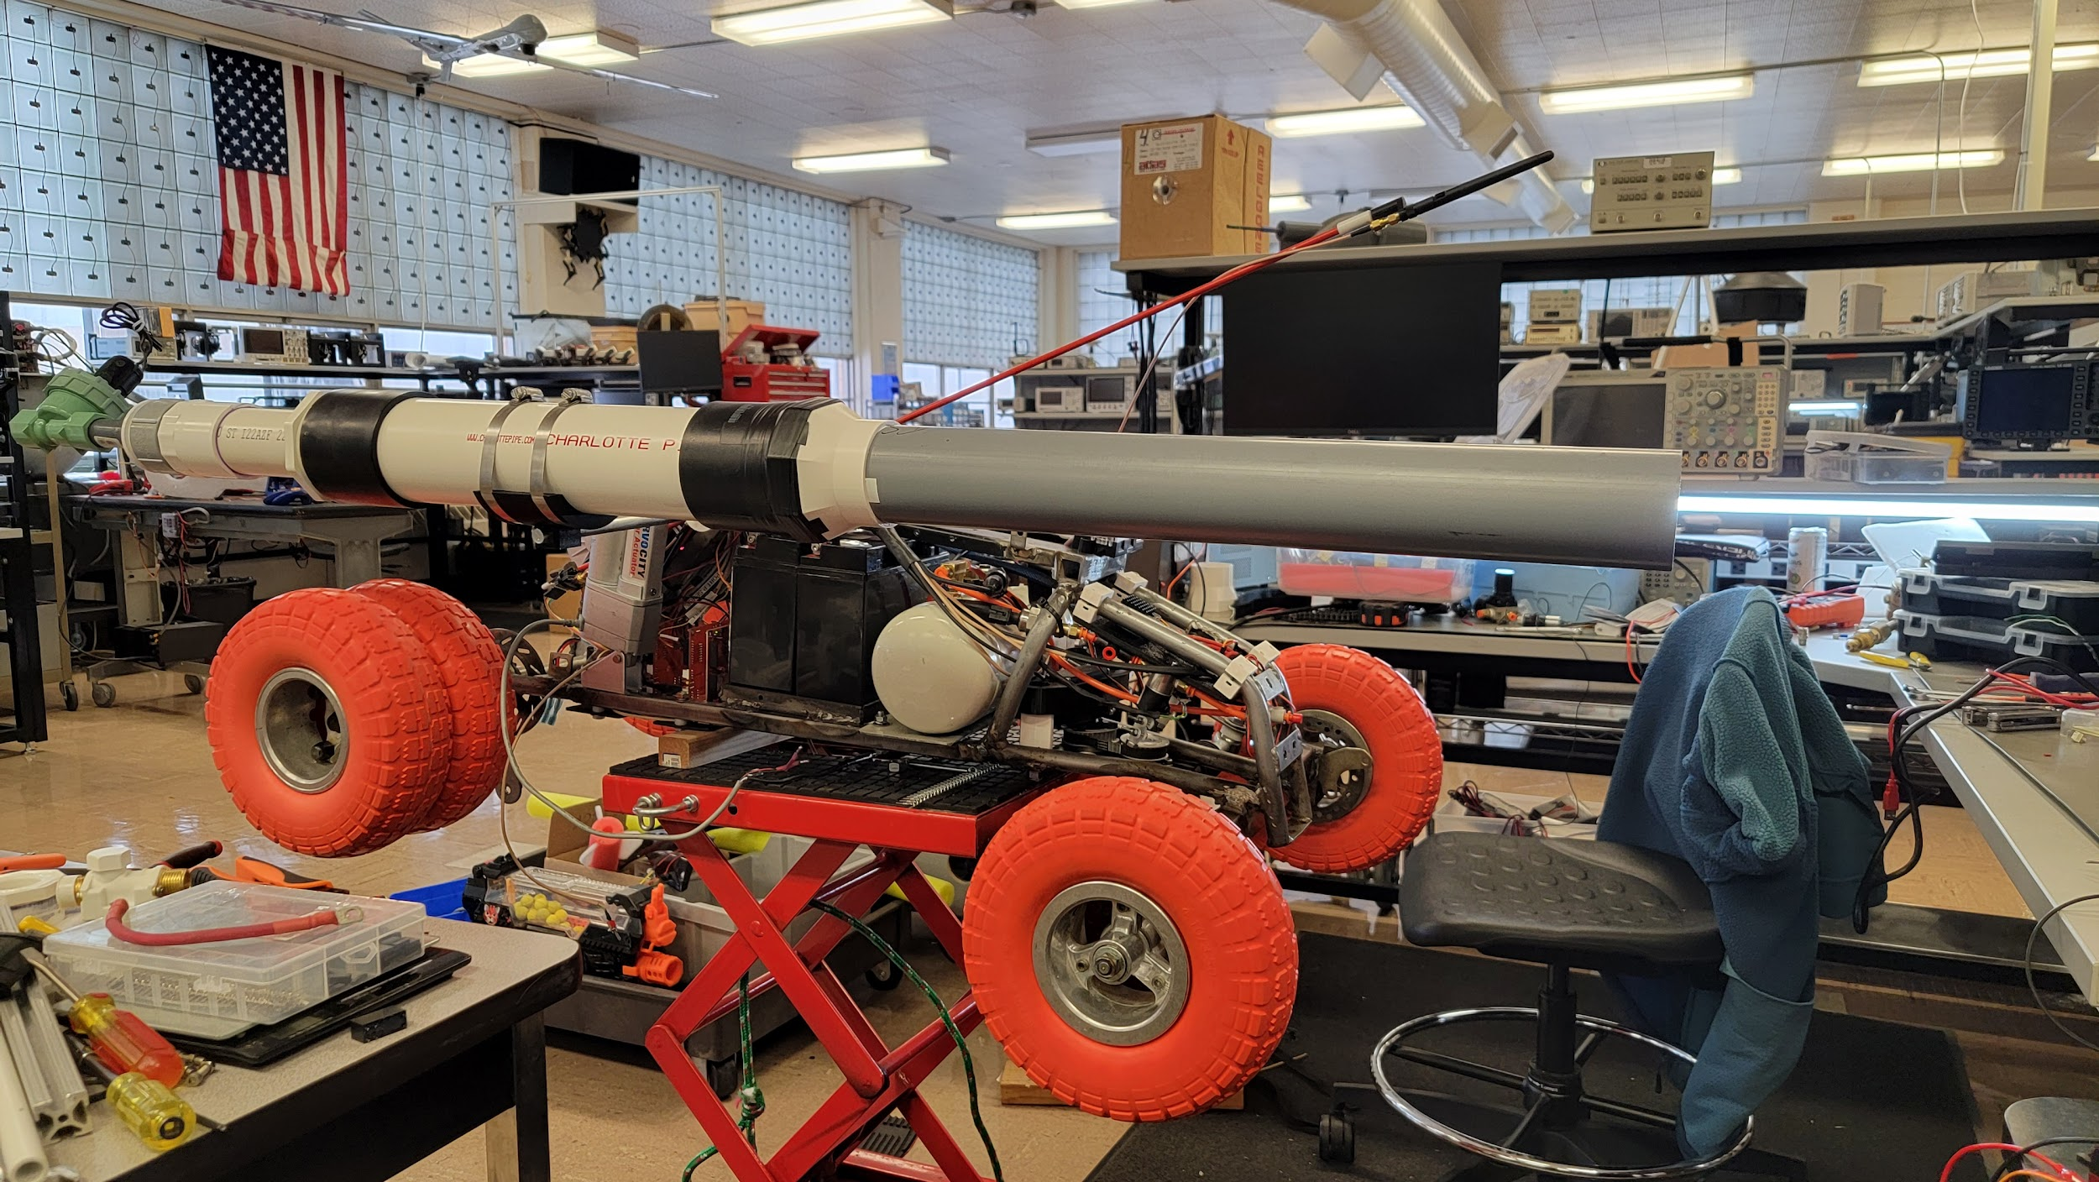

Figure 2.1.2: Universal Remote Controller from 2023

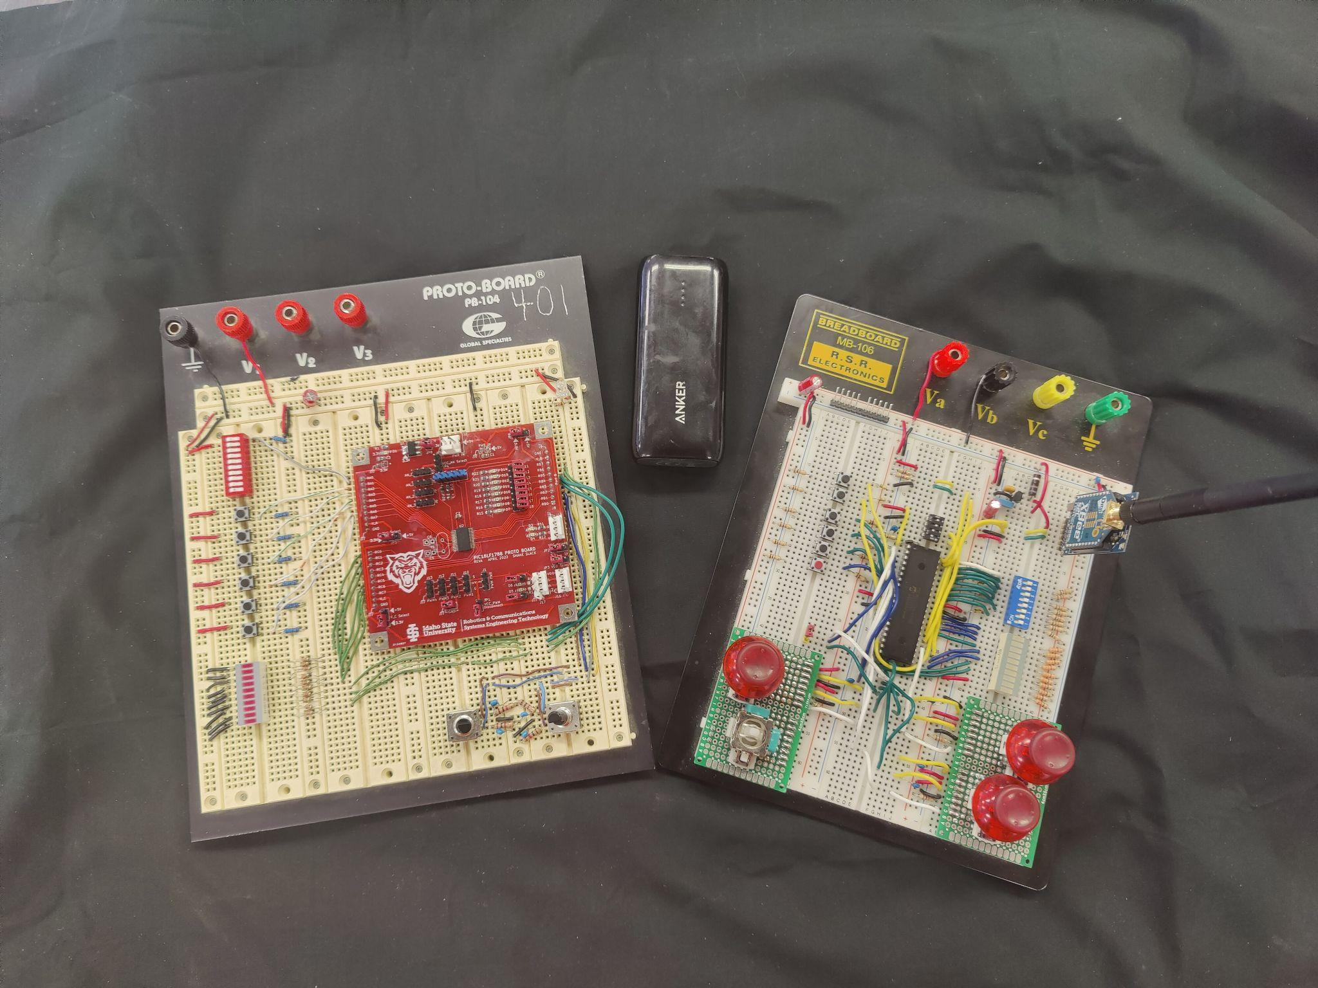

# 

# Proposed Problem

# 

3.1 Proposed Problem

Due to the operating requirements and size of the primary cannon mounted to the mini ATV, a swapping of turrets was required. Additionally, the current electronics used to control the mini ATV was entirely made up of custom protoboards and three PIC development boards. This meant that the primary problem for the ATVs was that a new turret system and new boards needed to be made. Additionally, the layout, design, and protocols should be designed to also function with the exact same protocols as the URC. For example, all I^2C communications were to be done, ideally, through an RJ11 connector. This meant that the underlying proposal was to create a system that would be able to be used to interface with one another under a nearly infinite array of possibilities.

Similarly, the URC was to operate using the exact same protocols and design considerations. But the overall proposed problem was that a custom PCB and shell were to be designed and peripheral devices were to be integrated into the functionality for the URC. The underlying proposal was to ensure multiple points of functionality to cover an array of possibilities. This essentially attempted to turn the URC into a smart remote that could detect what data was needed for proper communication for both peripherals and robots. Among many other proposed ideas, the URC was to become a perfect all-in-one controller, capable of utilizing all commands established in the “RCET REMOTE DEVICE DATA STRUCTURE” and “I^2C Peripheral Worksheet” either via physically connecting new devices or via code through ideally modular code snippets and files.

Finally, should the ability arise, the large ATV was to be built and function tested using the exact same boards as seen on the mini ATV to prove universalizability.

# 

# Environmental and Ethical Considerations

# 

4.1 Environmental and Ethical Considerations

When working on any project it is important to consider every aspect, one area that is easy to overlook is the impact that it may have on the world around us. Given a project involving modern technology like electronics it is important to consider not only the impact on the environment but also how it can impact the future. Looking back throughout history there are many technological advancements that have changed the world we live in today. It is important to consider both the good and the bad when it comes to the impact of a project like this.

When looking at the environmental impact on projects like this one of the largest concerns is that of the electronic waste or E-waste. With the increasing use of electronics, it has become much more critical to properly dispose of these materials when they reach the end of their service life. Many electronic components contain harmful chemicals and heavy metals. These materials are what make disposing of them properly so important. Proper disposal of hazardous material is not something unique to electronics and it is something that is also considered in other aspects of a project like this for items as innocuous as adhesive.

When considering the topic of ethics for this project, it doesn't seem that far-fetched for a nerf cannon to be replaced by something a little more lethal. As seen recently in global conflicts like that taking place currently in Ukraine, technology which is not necessarily intended for war can be adapted to meet its demands. Soldiers have adapted these drones originally intended for photography and videography to help them on the front lines. With that said it is realistic to see how an autonomous vehicle with less than lethal weapons could be adapted to serve a more lethal purpose.

# 

# Block Diagram and Overall System Overview

# 

5.1 Overall Block Diagram For The Universal Control System (UCS)

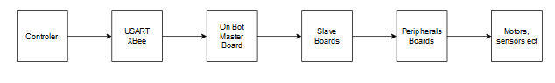

***Figure 5.1.1*** ***Overall Block Diagram for the UCS***

The Universal Control System or UCS is a system designed to operate within itself seamlessly and under a specific set of standards and protocols designed by the ISU RCET program. This mainly includes a standard for UART communication, I^2C communication, and various circuitry that can be used to interface between the UCS and the rest of the world. In terms of UART communication, the standard noted in the 2023 report of this project is still the same. This refers to the 6 bytes of data (as seen in table 5.1.1) being transmitted and/or received by either a robot or URC and the list of possible robot commands (as seen in table 5.1.2). What has also been added, however, is the list of peripheral devices and their corresponding standards for communication (as seen in table 5.1.3). Additional considerations in regards to the modularity and customizability of the various circuits used to interface the PIC with a robot have been interwoven into the design on the boards talked about in sections

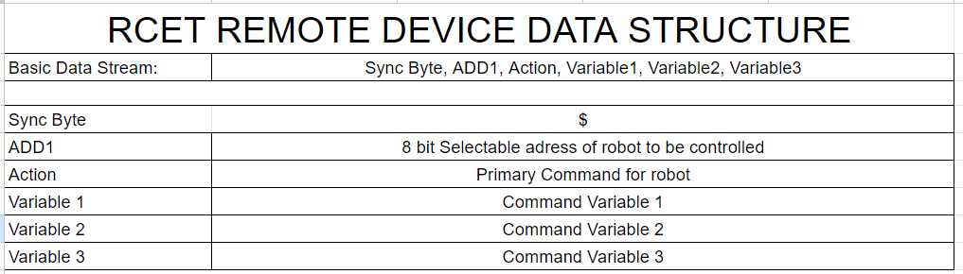***Table 5.1.1 RCET UART Data Structure Standard***

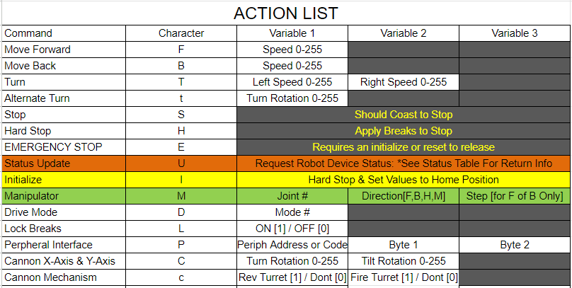

***Table 5.1.2 RCET UART Updated Action List***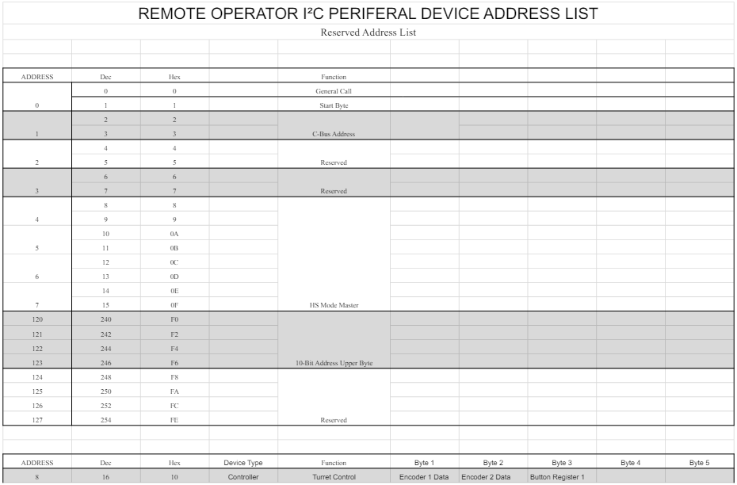

***Table 5.1.3 RCET Peripheral Device Address List***

# System Overview and Circuit Analysis for the URC and Peripherals

# 

6.1 System Overview for the URC

***Figure 6.1.1 Proposed Controller Scheme/Layout***

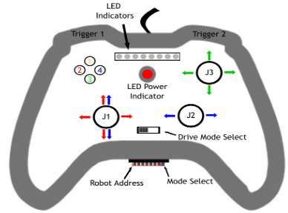

Image Retrieved From: (1) Makuch, J. & McArthur, J. (2023) *Universal Main and Peripheral Controller.* Pg. 14.

Since its inception in 2023, The Universal Remote Controller (URC) was designed to act as a device capable of communicating with and controlling any robot operating under the RCET command structure. Additionally, the use of I^2C allowed the URC to expand its capabilities via peripheral devices. While the code that allowed all of this to happen is what primarily changed during the project, the overarching design and layout was unchanged since then. This was also what was proposed when designing the PCB and shell design for the URC.

The available controls consist of: 2 triggers, 4 buttons, 3 joysticks, 3 joystick buttons, a 7-bit robot address switch, a mode select switch, a drive mode select switch, and 8 LED indicators.

***Table 6.1.1 URC Controls***

| ***Control*** | ***Function (Main Mode 1/2) (Drive Mode 1/2)*** |
| --- | --- |
| Trigger 1 | - Turret Rev Control (Main Mode 1)  - *Unused (*Main Mode 2) |
| Trigger 2 | - Turret Fire Control (Main Mode 1)  - *Unused (*Main Mode 2) |
| Button 1 | - Hard Stop (Main Mode 1) |
| Button 2 | - Lock/Unlock Brakes (Main Mode 1)  - *Unused (*Main Mode 2) |
| Button 3 | *- Unused* (Main Mode 1 & Main Mode 2) |
| Button 4 | - Emergency Stop (Main Mode 1 & Main Mode 2) |
| Joystick 1 | - Robot Drive Y-Axis & X-Axis (Main Mode 1)  - Toggle speed between slow & fast using its built-in button (Main Mode 1)  - *Unused (*Main Mode 2) |
| Joystick 2 | - Robot Drive X-Axis (Main Mode 1)  - *Unused (*Main Mode 2) |
| Joystick 3 | - Robot Turret Y-Axis & X-Axis (Main Mode 1)  - *Unused (*Main Mode 2) |
| Robot Address | - 7-bit (127) selectable robot address (Main Mode 1 & Main Mode 2) |
| Mode Select Switch | - This is what sets the URC to Main Mode 1 or Main Mode 2 |
| Drive Mode Select Switch | - This ties Joystick 1 L/R input to either Joystick 1 L/R or Joystick 2 (L/R) (Main Mode 1 & Main Mode 2) |
| LED Indicators | - Used to identify what peripheral devices are connected and if the device is stuck in a I^2C idle loop. Also shows Joystick 1 thresholds. (Main Mode 1)  - Used to indicated button press indicators (Main Mode 2) |

The controls for the URC change based on what mode (Main Mode 1 or Main Mode 2) the device is in. Additionally, the drive mode select switch changes the function of Joystick 1 and Joystick 2 based on what drive mode it is in (Arcade or Tank)

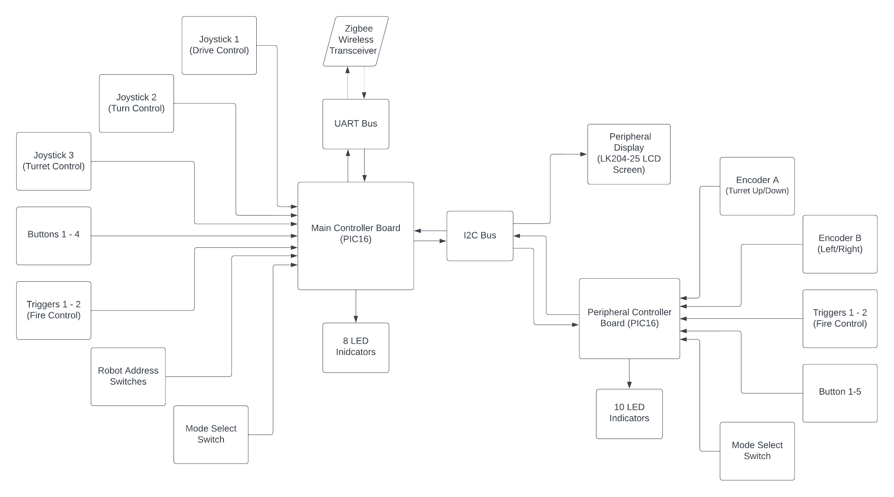

***Figure 6.1.2 Overall Block Diagram of The URC and Two Peripherals***

The overall project consists of a URC and two peripherals. The main board’s controls feed into the URC’s PIC16LF1789. Similarly, the peripheral board’s controls feed into the PIC16F1788 where it is processed and held in variable registers. From there, any I^2C data is pushed/pulled from the various connected peripheral devices to the URC’s PIC. Within the URC PIC code, this information is handled accordingly and all necessary data is sent to the UART bus for the robot and to the display peripheral for the user. Alongside the various LED indicators, a Human Machine Interface (HMI) is created that allows the user to understand much more than meets the eye, while still being able to control nearly any robot with relative ease.

6.2 Circuit Analysis for the URC

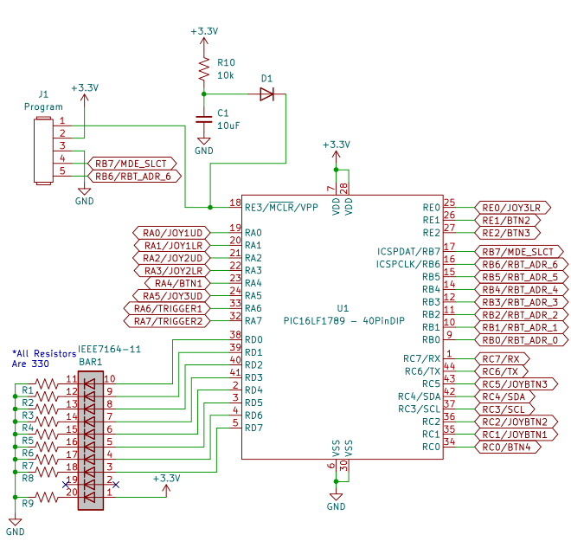

***Figure 6.2.1 PIC16LF1789 QFN Package Layout***

The PIC16LF1789 is reused in this version of the URC. The primary difference in terms of the PIC layout is that a larger capacitor (C1) was used for the power-on-reset (POR) circuit and the PIC pinout uses the QFN package instead of the PDIP package.

The reason a larger cap was used in the POR was because the peripheral devices (specifically the peripheral controller) wouldn’t get past setup before the URC would attempt to communicate with it, causing various issues. This fix essentially made it so the URC would turn on ~100mS after initial power up; 10 times the time required for the peripheral device to turn on.

In terms of the pinout, it was originally set up for the PDIP package, which means that when the PCBs arrived from the board house, they were unusable. As of April 4, 2024, the newest version of the schematic and PCB utilize the QFN pinout and the issue is resolved for future endeavors.

There are no other major changes done specifically to the PIC layout portion of the URC circuit. ***\*It is important to note that the program header (J1) should be disconnected during operation to ensure full functionality.***

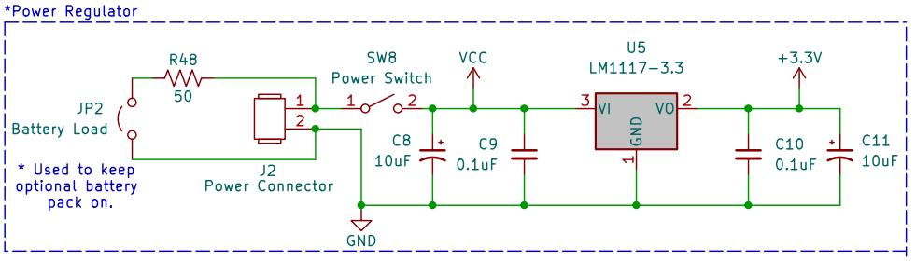

***Figure 6.2.2 Power Regulator Circuitry***

This portion of the URC did receive an update with the use of a load resistor (R48) and a header (JP2) to connect/disconnect it from the power input. The point of this circuit is to provide a high power load for the input supply. A common issue that other controls have is that they don’t draw enough current to keep their respective power banks on which will cause them to shut down. This was added to draw at least 100mA from a 5v supply, this results in ~0.5 W being consumed at the resistor, so a 1 W resistor is recommended. ***\*It is important to note the voltage applied to the Vin should be limited to ~5v to prevent damage to the I^2C lines and R48.***

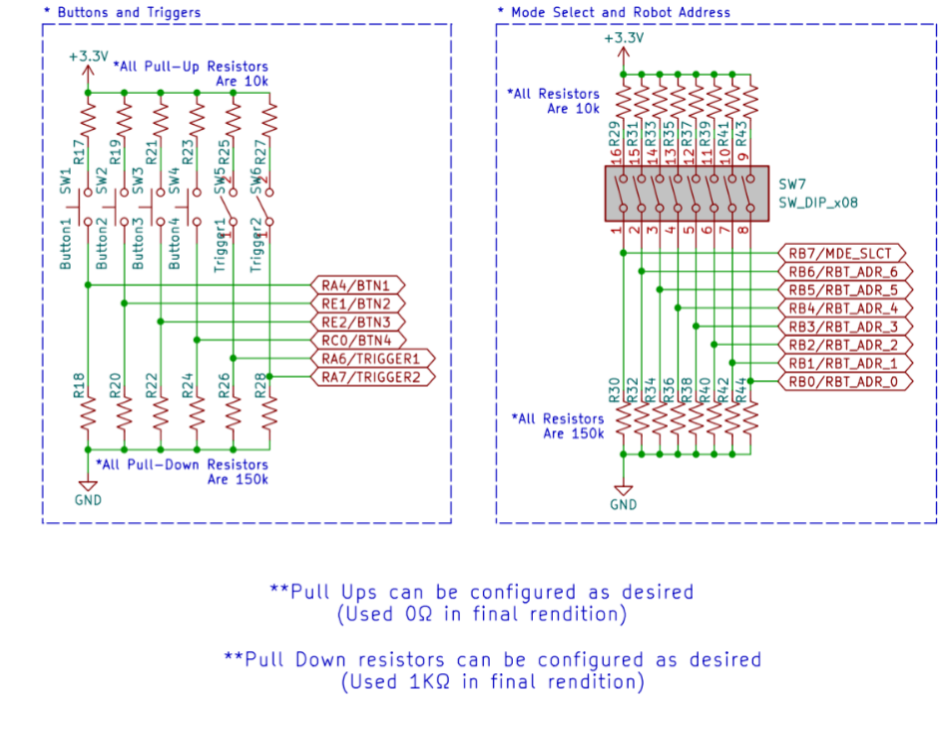

***Figure 6.2.3 Buttons, Triggers, and Switches***

This is also relatively unchanged from the original URC. However, it should be noted that although pull-ups and pull-downs were used that had high values, smaller values or even shorts can be used and is recommended. The reason for this is due to issues regarding some inputs floating on power due to the discharge path for the pins being through a 150k resistor, this would cause inputs to read as high before it settled. This can be fixed by using a lower resistance pull-down and shorted pull-up, however, this may result in damage to the PIC if the inputs were accidentally set to outputs. During the final build of the PCB, a 1k pull-down and shorted pull-up was used, this fixed the previously noted issue.

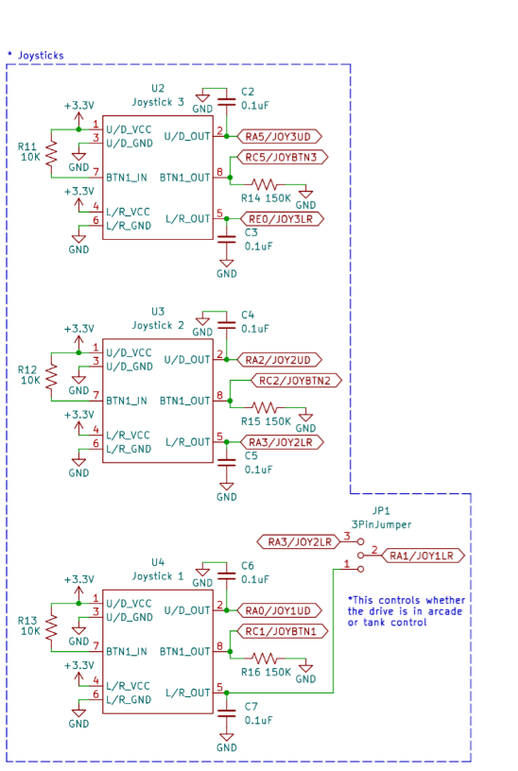

***Figure 6.2.4 Joysticks and Drive Mode Switch***

Similar to the buttons, triggers, and switches, the pull-up and pull-down recommendations also apply here. The other important note is that the jumpers nets have been updated as they were previously connected to the joystick buttons and not the joystick potentiometers. The newest version of the schematic reflects this update. The final important note about this section is that the joysticks used are an older version of the joysticks from the same company; Alpine. The newer versions will likely require updates to both the schematic and PCB.

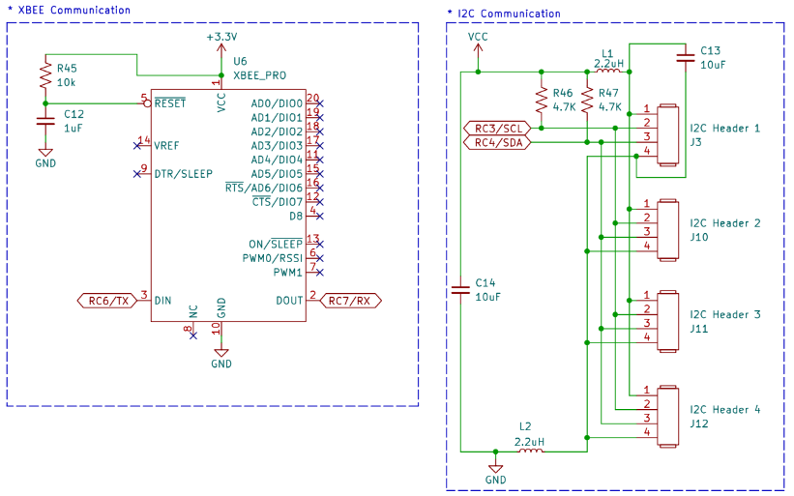

***Figure 6.2.5 Communication Circuitry***

The UART portion of this circuit is unchanged but the I^2C portion of the circuit has been heavily updated. The largest difference has to do with the addition of L1, L2, C13, and C14. L1 and L2 have been added to help match the source voltage of the URC and of any peripheral device connected. The same is done with the ground to help match the potential between the two while preventing any large in-rushes of current. C13 and C14 are filters for either side of the VCC and grounds for I^2C. The other major change is the inclusion of 3 additional I^2C headers in the form of RJ11 connectors. These will serve to allow the URC to connect up to 4 different peripherals without any further expansion. R46 and R47 are designed to keep the maximum current provided to the SCL and SDA lines under 3mA. In this case it should be ~1.1 mA with a 5v supply.

6.3 System Overview for the Peripheral Turret Controller (Address 8)

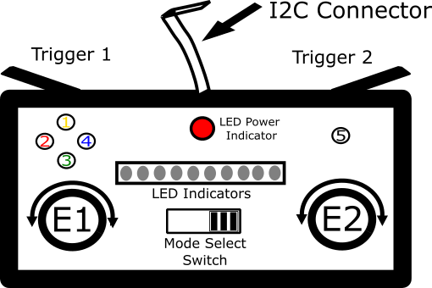

***Figure 6.3.1 Proposed Peripheral Controller Scheme/Layout (Address 8)***

The peripheral controller is one of many different peripheral devices that could be used with the URC. The one proposed for this project, however, is one that would be able to control a robot turret. Listed as peripheral 8 or I^2C address 8, this controller utilizes: 2 rotary encoders, 5 buttons, 2 triggers, a mode select switch, and 10 LED indicators. This version of the remote was only able to make it into the breadboarding stage of development. This primarily served as a starting point or proof of concept for the use of 2-way I^2C communication.

During an I^2C communication, the device will first initialize connection to the master URC when it is written to. If it responds with an acknowledgement then the master will begin retrieving data from the peripheral via a series of reads. The peripheral controller responds with currently stored values for encoder 1, 2, and button register 1. This is the current extent of the peripheral controller’s impact on the URC.

***Table 6.3.1 Peripheral Address 8 Controls***

| ***Control*** | ***Function (Main Mode 1/2)*** |
| --- | --- |
| Trigger 1 | - Turret Rev Control (Main Mode 1)  - *Unused (*Main Mode 2) |
| Trigger 2 | - Turret Fire Control (Main Mode 1)  - *Unused (*Main Mode 2) |
| Button 1 | - *Unused (*Main Mode 1 & Main Mode 2) |
| Button 2 | - *Unused (*Main Mode 1 & Main Mode 2) |
| Button 3 | - *Unused (*Main Mode 1 & Main Mode 2) |
| Button 4 | - *Unused (*Main Mode 1 & Main Mode 2) |
| Button 5 | - *Unused (*Main Mode 1 & Main Mode 2) |
| Encoder 1 | - Controls the turret X-Axis via a count (Main Mode 1)  *- Unused (*Main Mode 2)  - Buttons are also *unused* *(*Main Mode 1 & Main Mode 2) |
| Encoder 2 | - Controls the turret Y-Axis via a count (Main Mode 1)  *- Unused (*Main Mode 2)  - Buttons are also *unused* *(*Main Mode 1 & Main Mode 2) |
| Mode Select Switch | - This is what sets the URC to Main Mode 1 or Main Mode 2 |
| LED Indicators | - Shows the combined count of encoder 1 & 2 (Main Mode 1)  - Used to indicated button press indicators (Main Mode 2) |

The controls for the peripheral controller change based on what mode (Main Mode 1 or Main Mode 2) the device is in.

6.4 Circuit Analysis for the Peripheral Turret Controller (Address 8)

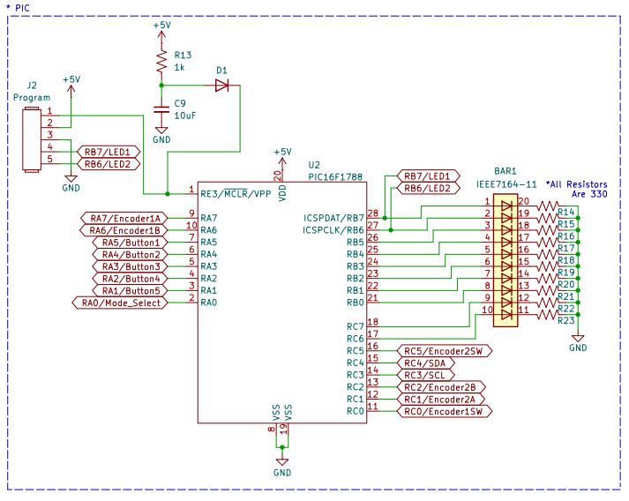

***Figure 6.4.1 PIC16F1788 SPDIP Package Layout***

The peripheral controller utilizes a PIC16F1788 as it doesn’t require very much in terms of I/O. Additionally, it is still able to keep up with the PIC16LF1789’s 115.2k baud rate and 400kHz clock frequency of I^2C. However, it does use the “F” variant which means it operates off of a 5v supply. This is to be expected though as the I^2C line is supplied with a 5v rail for any peripherals to use. While it is currently unnecessary, the current setup does utilize a POR circuit meant to allow the different controls time to get to a normal level, however, this does also mean that its turn on time is delayed just like the URC. In order to fix this the URC utilizes a longer time in its POR circuit than this one to allow for the peripheral controller to turn on and settle before the URC does.

In terms of port utilization, PORT A is used to read data from encoder 1, buttons 1-5, and the mode select switch. PORT B is used for the programming header and first 8 LED indicators in the array. Finally, PORT C is used for the last 2 LED indicators, econder 1 & 2 switches, encoder 2, and the data and clock lines for I^2C. Similar to the URC, this layout utilizes a program header labeled as J2. While this doesn’t impede the functionality of the controls for this controller, it is best to disconnect it during operation in order to utilize LEDs 1 & 2.

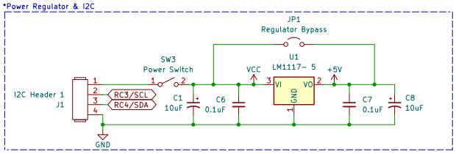

***Figure 6.4.2 Peripheral Controller Power Regulator Circuitry and I^2C Header***

The peripheral controller utilizes the expected 5v VCC of the I^2C line provided by the URC. While it is able to receive higher voltages and regulate it down to 5v as needed, the option to bypass this is included with header JP1. In terms of I^2C this is where the data and clock lines are received for the PIC to use.

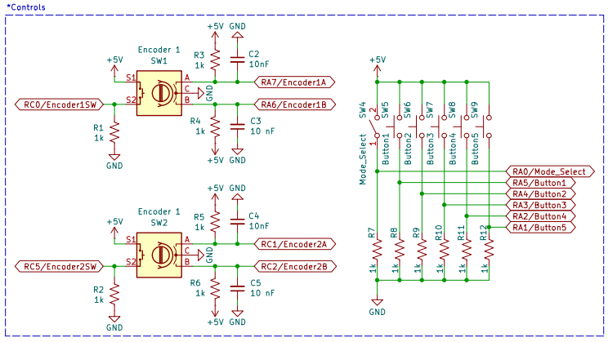

***Figure 6.4.3 Peripheral Controller Controls***

Unlike the URC, all button and switch inputs use a basic 1k pull-down resistor in order to cut down on complexity and unit cost. The encoders themselves however, are EC11 encoders that use a pulse in order to indicate a step. This is done on pin A & B which are normally open but short the pin to pin C (ground) on a step. If pin A pulls low before pin B, a clockwise step has occurred and vice versa. The purpose of the resistor and capacitor attached to each pin is to prevent ringing during steps by slowing down the transitions, this helped prevent miscounts.

6.5 System Overview for the Peripheral LCD Screen (Address 50)

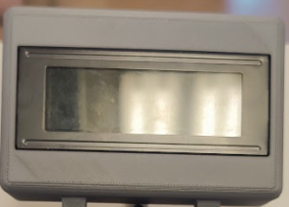

***Figure 6.4.4 LK204-25 LCD Screen***

This is another potential peripheral that could be used with the URC over I^2C. In this case the LK204-205 LCD screen was used in its default state as a means of displaying various information contained in the URC. In order for it to function, it was set to its default state which set its I^2C address to 50. By writing to it and receiving an acknowledgement, the URC knows its functioning and would write characters to it to fill the screen. Once an initialization has occurred, the URC would update only certain characters on the screen to cut down on the length of communication.

While the original purpose of the display was to show data received from the robot, during this project it would simply display cannon X/Y-Axis info, brake and speed toggle states, and the currently chosen robot address.

This device requires a 4 pin locking header to operate. In order to connect the URC to the LCD screen, an RJ11 to 4-pin locking header adapter will be required.

# 

# Breadboard/PCB Design for the URC and Peripherals

# 

7.1 Breadboard Overview for Peripheral Turret Controller (Address 8) 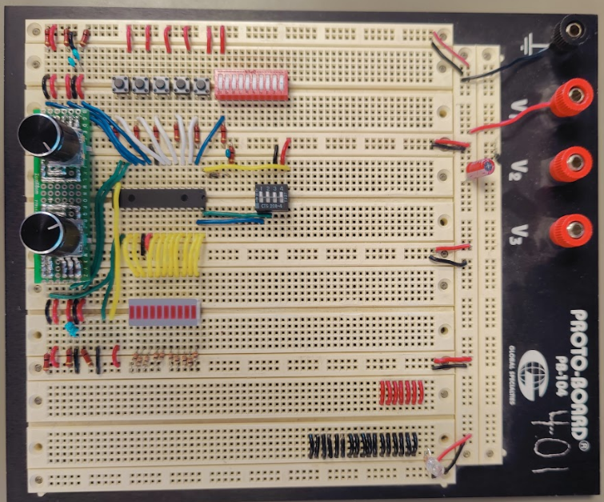

***Figure 7.1.1 Breadboard Peripheral Controller (Address 8)***

While the peripheral controller’s schematic was unchanged, the breadboard layout was redesigned during this semester. This is because the original that utilized a PIC development board in order to operate, was disassembled earlier in the semester. Additionally, due to various constraints regarding time and functionality, the peripheral controller never left the breadboard stage. As of the end of this project, the peripheral controller is able to be turned into a PCB and a shell can begin development.

7.2 Peripheral Controller Individual Stage Design

***Figure 7.2.1 Breadboard Peripheral Controller PIC Stage***

Figure 7.2.1 shows the peripheral controller’s PIC layout located in the center of the breadboard. The green box shows the SPDIP version of the PIC16F1788 used in this controller that was readily available in the core lab. The red box shows the POR circuit discussed in section 6.4. Finally, the blue box shows where the program header of a PICKit would be inserted. There is a 4-pin dip-switch to disconnect the header from RB7/6 on the PIC, this aided development as it wasn’t required to disconnect the header every time full functionality needed to be tested***.***

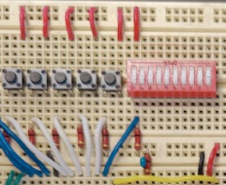

***Figure 7.2.2 Breadboard Peripheral Controller Buttons and Switches Stage***

Figure 7.2.2 shows the 5 buttons and 1 mode select switch utilized by the peripheral controller located on the middle right of the breadboard. A 10 dip-switch package was chosen for its breadboarding convenience, but only switch 10 is used in this design. Additionally, all of these controls result in a normally low state at the PIC and when actuated create a high at the PIC. This is achieved using a pull-down resistor of 1kΩ. At 5v this would cause every control to draw 1mA when actuated.

***Figure 7.2.3 Breadboard Peripheral Controller LED Indicator Stage***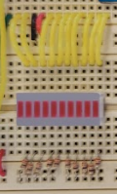

This stage shows the 10 LED indicators used in the peripheral controller. These are located in the middle-right portion of the breadboard. The entirety of PORTB is used for the first 8 LEDs (top down) while PORT C’s pin 7 & 6 are used to drive the last bottom two LEDs. With a forward voltage of ~2v and 330Ω in-line resistor, each LED would draw ~15.2mA during operation, totaling to 152 mA when all 10 are lit.

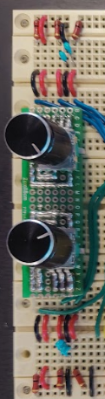

***Figure 7.2.4 Breadboard Peripheral Controller Encoder Stage***

The final stage is the EC11 encoder stage. A custom soldered proto-board was used to break out both encoders for ease of breadboarding. The encoders themselves were placed at the bottom of the breadboard. These operate using a 1kΩ pull-up resistor with a filter cap to ground on each of the A/B pins. Pin C goes to ground as the action of turning the encoders causes both pins A & B to short to Pin C, this is how the encoder signifies a step has occurred. Due to the nature of the encoders, they can be turned infinitely and the PIC would keep track of the amount of turns using an 8-bit register. After 255 steps, the count is reset.

7.3 PCB Design for URC

PCB Design Overview

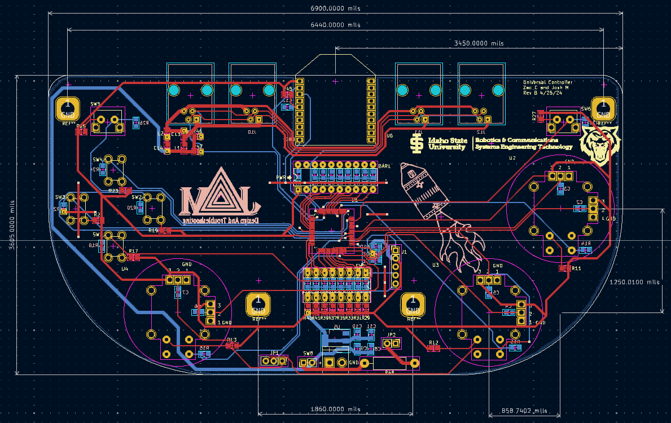

# ***Figure 7.3.1: Kicad Design For Rev B URC***

# The Universal Controller PCB was developed and designed using KiCad V 8.0.1. The initial Design for the Universal Remote Control was centered around the Joystick and button placement. The design was based on the original concept shown in Figure 6.1.1 (Pg 18). A few adjustments were made as we prototyped the design to accommodate closer placement of the joysticks and buttons for a more ergonomic design. The second main Consideration during PCB design was the placement of the I^2C Peripheral Ports and XBee antenna communication. These ports were placed at the top of the board to not interfere with the usability of the controller while maintaining antenna connection and the ability to add peripherals. The traces on the PCB were designed with 3 sizes in mind. First the 3.3V supply lines are 30 mil traces supporting up to 1.96A. The I^2C Supply lines are 40 mil traces supporting up to 2.42 A. Lastly, the signal lines are 15 mil traces supporting up to 1.18A.

# Two versions were developed as Rev A and B. Figure 7.3.1 depicts revision B whereas all the physical images that follow are of Rev A. The necessity of a second revision was due to an error in the design. Revision A used the pinout for the PDIP PIC16LF1789 which needed to be updated for the QFN PIC16LF1789 pinout.

# PCB Design Component Layout

# 

# ***Figure 7.3.2: Physical PCB Front Component Breakdown***

# 

The Breakdown of component placement in figure 7.3.2 is as follows. The Green Boxes indicate the user interface controls. With Three joysticks, a set of 4 buttons, and two shoulder buttons/bumpers. The Blue box shows the power input and power load resistor section. Additionally, JP1 is the Drive mode select jumper for Arcade or Tank Drive selection. The Orange box shows the address select Dip switch allowing the user to address the Robot they wish to control. The Cyan Box indicates the location of the Xbee antenna connection. This is designed so that the Antenna overhangs the board edge. Additionally, The Ground Flood plane avoids the Xbee area to prevent interference with communication. Finally, the Purple area shows the I^2C peripheral ports. The peripheral ports were designed to use an RJ11 cable to allow easy connection and a modulus design.

# 

# ***Figure 7.3.3: Physical PCB Back Component Breakdown***

# 

# The components on the back of the PCB were limited as much as possible. Any pull down resistors were placed on the back to easily connect to the ground plane. The Blue box indicates the power input regulation circuitry. The Purple box indicates the RJ11 I^2C Ports. The Cyan portion is the current limiting resistors for the LED indicator Package. Lastly, the Orange Section shows the pulldown resistors for the Address select switches and the Power on Circuitry for the PIC.

# 

# Shell Design for the URC PCB

# 

8.1 URC Shell Design

Shell Design Overview



***Figure 8.1.1 Shell Overview***

The controller case and physical components were designed using AutoDesk Fusion 360. The URC Case was designed to help with ergonomics and give the user physical buttons that interface with the tactile controls on the PCB. The added benefit of this design is that it will help protect the circuitry of the PCB and make the controller more visually appealing. The design began with exporting the Step file for the PCB and then importing the Step file into the CAD software. All dimensions were referenced from the imported step file for the correct placement to actuate the controls. The model was then 3D printed using a variety of methods and materials. Below we will break down each section and the considerations used when designing the shell.

# Bottom Shell Break Down

# 

# ***Figure 8.1.2 URC Bottom Shell***

# The design began with the bottom case. The walls of the shell were drawn to be an eighth inch thick with an eighth inch clearance from the edge of the PCB to the wall. The intent was that the PCB would be sandwiched in between the top and bottom shell with the top of the PCB sitting flush to the top of the bottom case. As such, The stand offs (Shown in Green) were designed to be shorter than the walls by the thickness of the PCB. The I^2C peripheral port slots (Shown in Blue) were designed to bump out from the back of the case to minimize the overall thickness of the controller. The Power input (Shown in Orange) was placed according to the input from the PCB design with the added option of either a 90° connector to exit the bottom of the controller (down in the above image) or with a straight connection out the back of the PCB(into the image shown above). Furthermore, the power switch was designed into the case to fit directly underneath the Xbee antenna and in between the I^2C connections (Shown in Red)

# 

# Top Shell Break Down

# 

# ***Figure 8.1.3 URC Top Shell***

# The Top Shell’s thickness was determined by the height of the joysticks as they stood the furthest off the PCB. In Addition to this, we added a raised edge around the joysticks to help keep the overall thickness of the controller down (Shown in Green). The Rectangular holes were added to allow the The LED indicator(Shown in Blue) and Address select(Shown in Orange) to be accessible. The smallest hole(Shown in Red) was designed to allow the user to access the Tank / Arcade select Control Jumper from the outside of the case. Additionally, the drive mode select hole can fit a small switch if desired. The four front facing buttons will be discussed in the next section.

# 

# Both Outer Shells, top and bottom, were FDM 3D printed with carbon fiber infused filament. This provides a strong exterior design to help protect the electronics. The material choice also provides secure mounting for the PCB.

# Buttons and Bumpers



# 

# The buttons designed for the universal remote control were intended to create easy access to the momentary buttons on the face of the PCB from the exterior of the case. The head of each button was rounded and denoted with letters of the greek alphabet commonly used in electronics. The Omega(Ω) that is used as the symbol of ohm, the unit of resistance. The Beta(β) used as the symbol for current transfer ratio in transistors. The Phi (ϕ) used to denote a phase shift in a signal. Lambda(λ) used to signify the wavelength of a signal.

# 

# 

# ***Figure 8.1.4 URC Buttons***



# The buttons were keyed to Keep the symbols upright. The addition of the smaller keying was to arrange each button to be placed in the correct location, that is to say, left, right, up, and down. The added benefit of keying the buttons ensures the movement is inhibited to only up and down motion. The bottom of the button tapers down to the size of the momentary button head. Moreover, the base of the taper has an indented ring to accompany a spring to return the button when depressed.

***Figure 8.1.5 Keyed Button Placement***

The buttons for the controller were 3D printed with an SLA resin printer. This was done to achieve the detail desired for the symbols on the heads of the buttons. The buttons were printed in a translucent orange, coupled with filling the symbol indentations with black enamel paint made the symbols stand out.



***Figure 8.1.6 URC Shoulder Buttons***

The Shoulder buttons were designed with the insight of the rigid yet elastic nature of the carbon fiber filament. When printed thin enough this filament will remain pliable and will elastically deform, returning to its original shape. With this in mind we designed the shoulder buttons to rely on this elastic deformation as the spring force to return the shoulder buttons after being depressed. The thin portion of the bumper was planned to fit into the slot at the top of the front shell and pivot from that point for the elastic deformation. This deformation was physically limited by the interior wall of the front shell with enough range of motion to actuate the vertical momentary buttons on the PCB. Though the body of the bumper is printed in carbon fiber, the point that interacts with the button on the PCB was printed in TPU. This filament is flexible and helps protect the electronics from the shoulder buttons being pushed too forcefully. The added benefit of the TPU material is that it will also deform elastically, increasing the returning force for the bumper.

# 

# Battery Strap

# 

# ***Figure 8.1.7 Battery Strap Mount***



***Figure 8.1.8 Battery Strap Mounted on Case***

# 

# The mounting for the controller’s battery is designed to fit many different portable battery packs through the use of a strap design. The top of the strap mount slots into the back of the case and is secured with two mounting screws on the bottom of the case(Shown in figure 8.8). The mount has cut outs to allow access to the case screws in the event the case needs to be disassembled without the need to remove the battery strap. A channel through the strap mount can accommodate a 0.75 inch velcro strap to be inserted and used to secure the battery. This design is intended to be modular while still being able to utilize the mounting design for future renditions. One possible future design would be to create a battery box that contains two 18650 batteries with the necessary circuitry to regulate the charge and output voltage.

# Peripheral Mount

# 

***Figure 8.1.9 Peripheral Mounts***

The peripheral mounts(Highlighted in Green) are designed as hinges that can support a variety of peripherals. The hinges are placed near the RJ11 connectors for easy access for communication with the controller. The design for hinges is based on the main peripheral developed this semester of an LCD screen. However, the peripheral mounts are attached to the case with mounting screws to remain optional. Additionally, each hinge is mounted with only one screw so that future mounts dependent on use case can be designed.



***Figure 8.1.10 LCD Screen Case/Mount***

The peripheral developed this semester was an LCD Screen used to display the status of the controller and connected robot. The LCD case was designed around the LCD PCB and mounting holes. This case was a simple design intended to protect the screen and mount to the controller. The only needed outlets into this case were that of the screen and the I^2C input.

# Full Case Assembly

# 

# ***Figure 8.1.11 Full Case Assembly Front View***

# 

# ***Figure 8.1.12 Full Case Assembly Side View***

# 

# All mechanical drawings for the physical components discussed in this section are included in Appendix F.

# Code Overview and Calibration for the URC and Peripherals

# 

The largest and most fleshed out portion of the URC is the code. This section will explain all relevant aspects of the code included with the URC and its 2 peripherals. This includes flowcharts and snippet descriptions of the setup code, main code, and any additional files that have protocols in them. Should there be any changes to the way the code operates, calibration procedures (labeled as ***this***) will be laid out for each section to describe how to easily introduce changes without potentially causing the URC to fail.

9.1 URC Setup Code

The setup code for the URC establishes the very basics for the URC to function. This includes: allocating names for all 51 variable registers, setting up UART communications, setting up various interrupts, setting up the master communication for I^2C, setting up PORT and ADC configurations, a pre-main setup, etc. Once it has done so, the URC moves on to main where it loops forever.

The portion of the setup code that would require any real changes is the pre-main setup. The pre-main setup is meant to act as a one time start-up condition, however, later iterations may use this area to re-initialize the URC if needed. Currently, the pre-main setup turns on all relevant interrupts, clears all relevant interrupt flags, initializes the ADC for the joysticks by starting a conversion with RA0, begins the timer 2 count, clears all relevant variable registers, and attempts to identify any peripheral devices.

***Peripheral Handling:*** If there is a peripheral being used with the URC, it will likely have a peripheral file that must be included in the main code to function properly. Any and all peripheral files are capable of being used in nearly any way, but it is recommended that all functions and addresses used in them label themselves by putting a “_ADR(X)” after the function name to prevent accidentally using a function from not within that file. Additionally, all peripherals should follow the nomenclature laid out in the currently utilized files. The reason for this is to ensure a degree of standardization among the URC main code and any future coding endeavors.

9.2 URC Main Code

The URC main code first begins by including any and all files associated with the URC. This would mainly include the setup code, UART code, and any peripheral files. After that, the PIC begins configuring itself and establishes that it operates using an internal 16 MHz clock. Once that is all said and done, it begins main, where it loops forever. Also, most of the code for the URC and its associated files have comments that closely resemble code from Visual Basic. This is meant to help understand the function of large chunks of assembly code.

***Figure 9.2.1 URC Main Flowchart***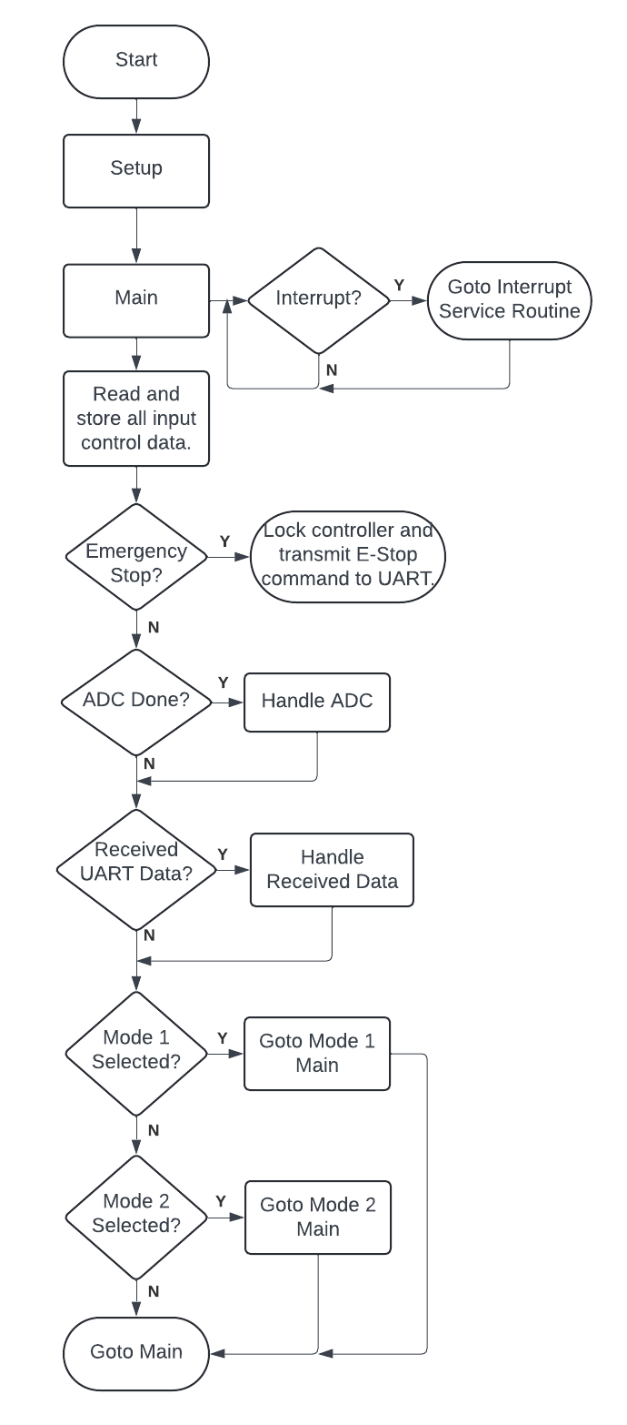

The URC main is meant to act as a point of return once everything has been done. As such anything that wouldn’t be mode dependent such as input reading and storing would occur here. For example, in the event the URC recognizes an emergency stop state, it will lock itself into a state where it will be unable to do anything except transmitting an emergency stop to the robot. This is meant to occur no matter what mode the URC is in.

Another universal function is UART reception and handling. In the event the robot transmits an emergency stop or other information, the URC will, at the very least, recognize and record that data no matter what mode it is in and handle it.

*Also, the ADC handling, Received UART Data handling, and Timer 2 interrupt protocols are mostly unchanged from the previous URC code from 2023. ADC handling did receive an update to prevent RA7 from starting a conversion.*

***Changes to Main:*** For additions to certain aspects to main, it should be noted that anything that will cause the code to loop until a condition occurs will ultimately freeze or delay the URC as it operates almost purely sequentially. This is the case because only two interrupts are used to help prevent any other interrupts from colliding with one another. At this point, the time it takes for main to iterate is extremely fast which helps prevent input lag from the controls.

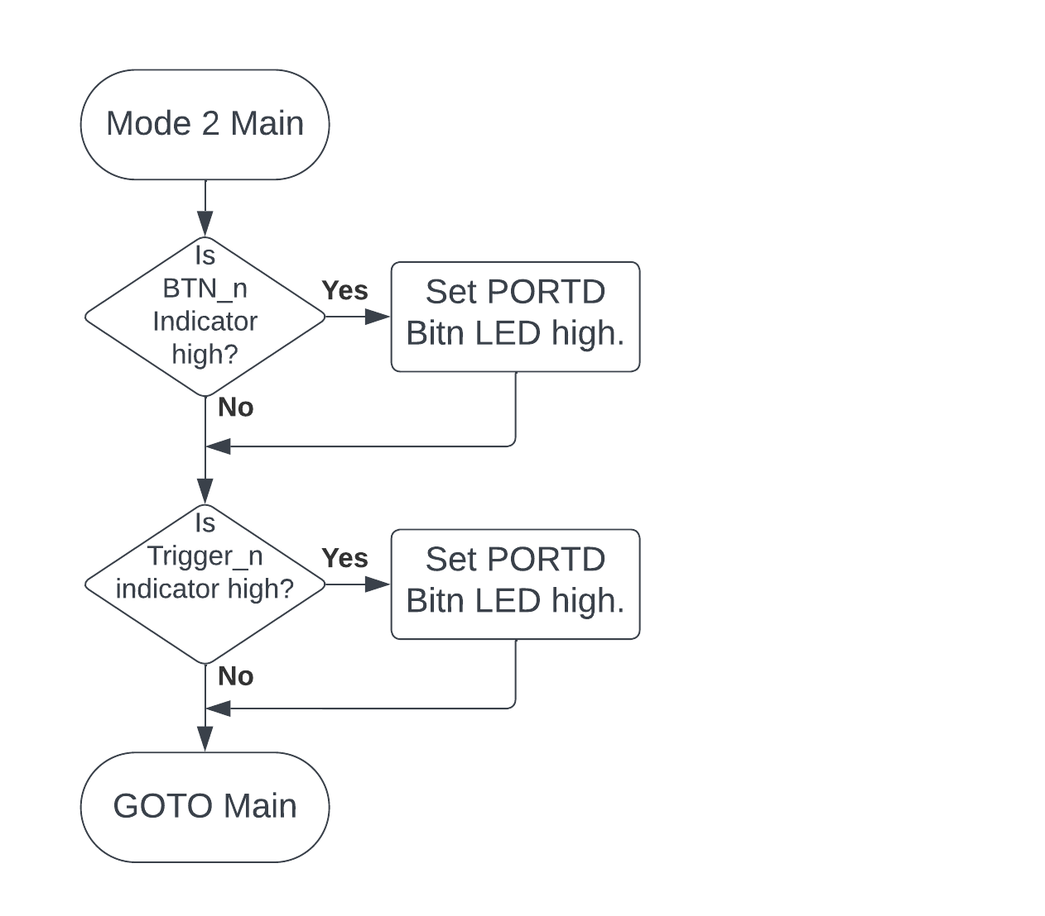

***Figure 9.2.2 URC Main Mode 2 Flowchart***

Mode 2 currently operates as a method of showing whether the buttons are working. It is otherwise unused in this version of the URC. However, the future function of mode 2 will primarily be to switch the URC from “smart-mode” to “simple-mode”.

Smart-mode is meant to actively communicate with the robot to determine what and when it needs to send appropriate data packets for the robot to use. This would help with main run-time and allow it to operate in a much more efficient mode.

Simple-mode is how the URC currently operates and is meant to transmit all data-packets all the time. This is meant to ignore initialization from the robot and just run.

***Figure 9.2.3 URC Main Mode 1 Flowchart (1/2)***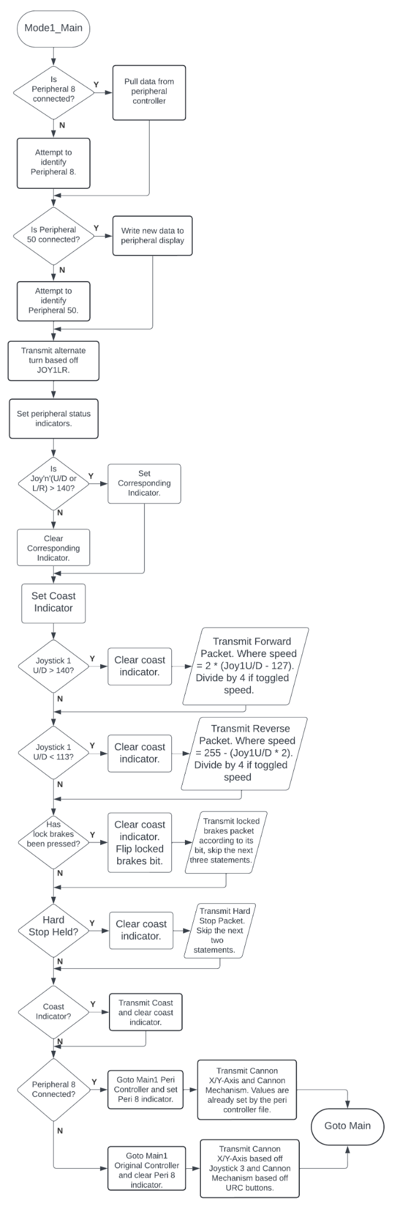

Main mode 1 is where the majority of the URC functionality is located. Here, the original controller code and peripherals are handled and incorporated into the data for UART transmission via the various “TX_Data_” registers. Part 1/2 of this flowchart shows how peripherals are identified and ultimately read/written. This occurs every instance of main as to be able to (re)connect, initialize, and communicate with any peripheral even if they have temporarily disconnected. Upon reconnection the peripheral status register is set and allows the URC to replace or handle certain bytes of data.

***Peripheral Handling:*** For any new peripheral devices, the same protocols should be used to help maintain functionality and prevent lock-ups.

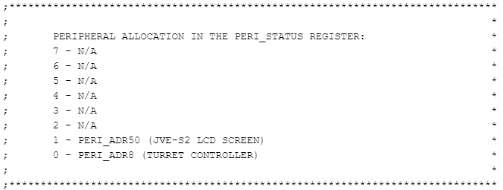

***Figure 9.2.4 URC Peripheral Status Register Allocation***

Figure 9.2.4 shows the current peripheral allocation of the PERI_STATUS register for use in main mode 1. These are set based on what the peripheral files choose to set.

***Peripheral Allocation:*** If a new peripheral file is included in the URC, ensure that they aren’t overwriting any of the PERI_STATUS bits.

***Figure 9.2.5 URC Main Mode 1 Flowchart (2/2)***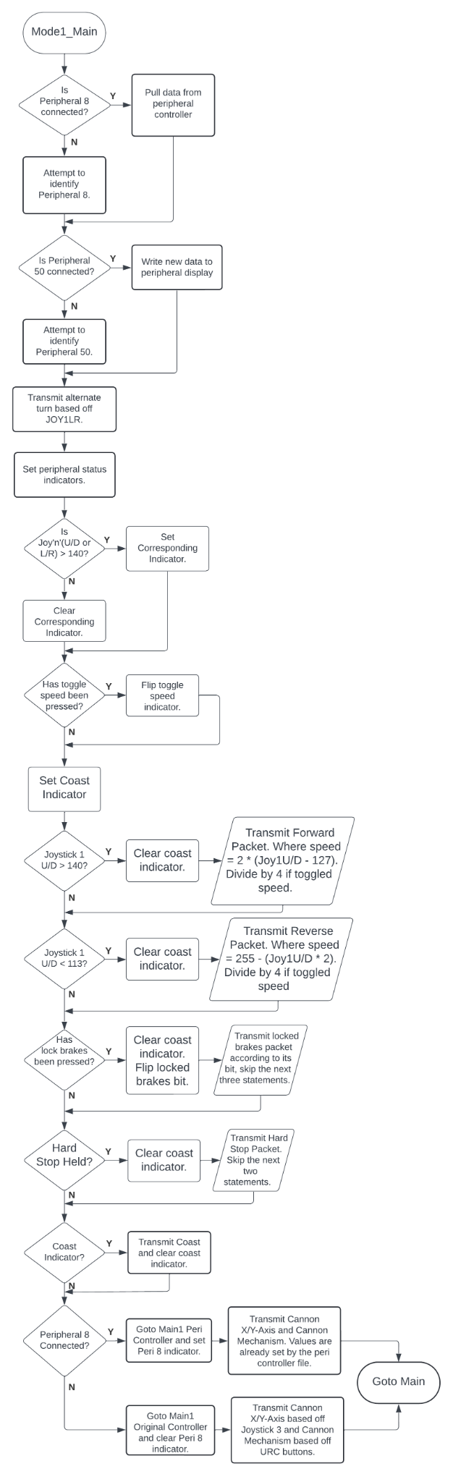

The second portion of mode 1 covers the URC’s control’s functions. Initially the toggle speed indicator is updated. After that the coast indicator is set, if any command occurs that would overwrite the coast command, they will clear the coast indicator and transmit their respective command. For example, if the URC joysticks indicated a forward or backward, they would clear the coast indicator, set their respective “TX_Data” register based on their value and toggle speed state, then transmit the “TX_Data” register as needed. After that, lock brakes is updated and hard stop is checked. All aspects of these utilize the “TX_Send” functions outlined in the UART file in order to actually transmit data packets. Once mode 1 is done, the code returns to main.

***Peripheral Impact on UART:*** If there is a peripheral that would alter certain parts of the URC’s transmission to the robot (i.e a peripheral controller), there are “TX_Data” registers that can be changed from within the peripheral files. If that is the case it is recommended that a read from the peripheral would occur after this portion of the main code. Otherwise, it may be required to check the peripheral status register before setting the “TX_Data” registers to see if they even need to be changed such as with the last blocks in the flowchart.

9.3 URC UART Code

All of the UART code was moved to a separate file to reduce the overall size of code located in the main code source file. Additionally, it was updated to suit a much more accessible and alterable transmission routine. As of Spring 2024, the baud rate for UART communication is set to ***115.2k baud rate*** to help increase the speed of main as transmission of UART data is inline with the sequential code of the URC.

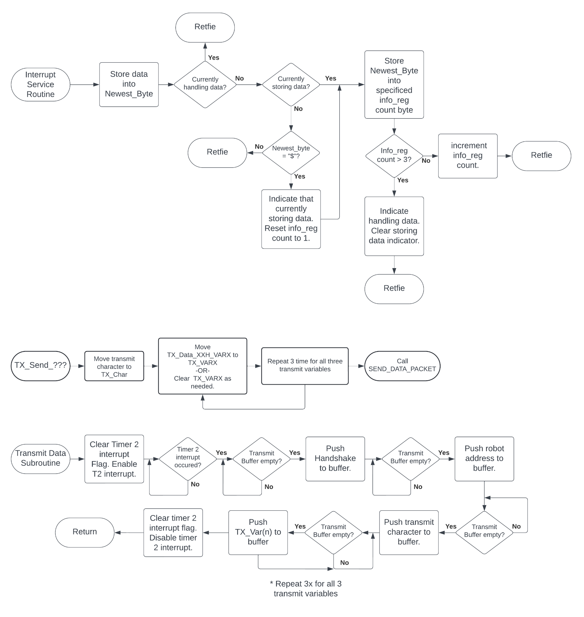

***Figure 9.3.1 “SEND_DATA_PACKET” Protocol***

This portion of the UART code is what is used the most in the UART code file. This handles the transmission of UART data whenever “SEND_DATA_PACKET” is called and it utilizes timer 2 in order to generate a delay between transmissions. The delay was introduced to aid in UART reception for any robot, but as such, causes an in-line delay with main. Currently, with a 115.2k baud rate, the typical time it takes for both timer 2 to finish (560 uS @ 16 MHz) and a full 6-byte command to transmit (~560 uS) totals to about 1.1 mS. Every command sent adds another ~1.1 mS to the main code.

***New Commands***: Ensure that if any new commands are added, that they don’t cause too much delay in the main code as it will reduce the response time of the various controls.

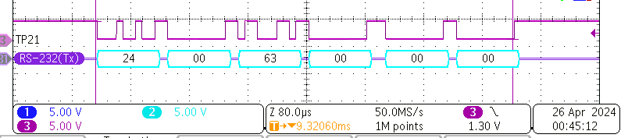

***Figure 9.3.2 Typical UART Transmission (Cannon Mechanism)***



***Figure 9.3.3 “TX_SEND” Protocol***

This portion of the UART code is what is used the most in the main code source file. This is meant to represent every possible command that can be transmitted over UART as of Spring 2024. During a TX_SEND, the appropriate variables are pushed to TX_Var and any that aren’t used are cleared.

***New Commands***: For new commands: simply copy and paste another TX_Send, alter it as needed, and add new TX_Data variables as needed. This ensures that uniformity is maintained.



***Figure 9.3.4 “REC_BYTE” Protocol***

The “REC_Byte” protocol is unchanged from the previous semester. This is the only protocol that is actively interrupting the main code to ensure reception can be handled at any point in main. However, there is no buffer currently implemented for received commands.

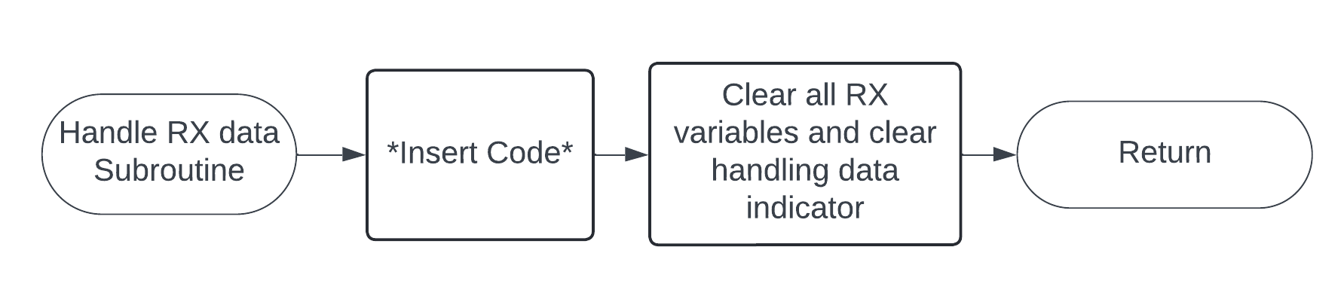

***Figure 9.3.5 “HANDLE_RX_DATA” Protocol***

When this gets called by the main code, this will handle data that has just been received indicated by the handling data flag in RX_INFO_REG. As of right now, it doesn’t do anything other than respond to a lock brakes command for troubleshooting purposes. Once it has handled the data however, it clears all RX variables, and clears the handling data indicator in RX_INFO_REG.

***Handling Data***: The handling data protocol currently doesn’t do much beyond resetting for another reception. In future developments, the red box shows where handling of received data UART data could happen.



***Figure 9.3.6 “HANDLE_RX_DATA” Protocol Subsection***

9.4 URC General Peripheral Code

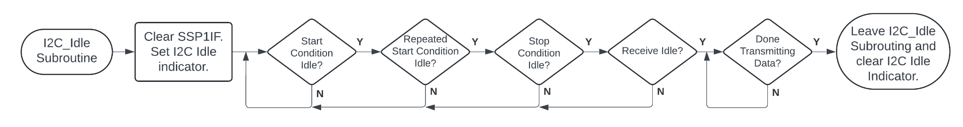

***Figure 9.4.1 General “I^2C Idle” Protocol***

This is currently implemented in every single peripheral file as it is vital to ensuring the I^2C lines operate as intended. However, this only functions when I^2C devices are actively communicating. If a device disconnects in the middle of a communication, it may result in the URC bricking as it is stuck in the I^2C loop. Future endeavors may be able to fix this using a timer, however, the slave may still be locked up and a power reset may be required to fix.

***Bricking The URC:*** This is most likely the spot where the URC will get stuck as the I^2C line doesn’t go idle. This can be due to various things such as a peripheral device locking up, or a disconnect halfway through a communication. The only way to fix the I^2C line is to reset the serial port as noted in the 2023 report. This could be accomplished in later versions via a timer or count of some sort that increments throughout the loop.

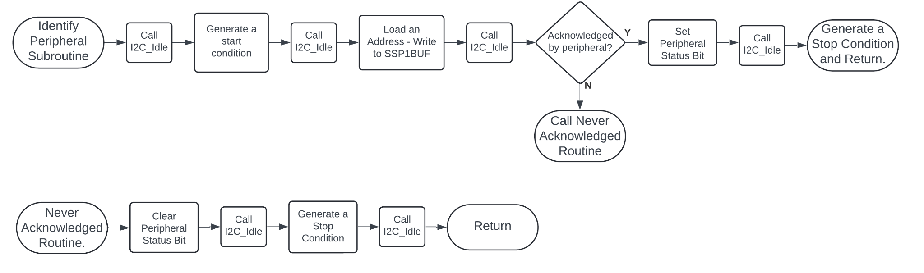

***Figure 9.4.2 General “Identify Peripheral” Protocol***

This is used in both peripheral files to identify a peripheral device. If it doesn’t respond the code will clear the indicator and begin a “Never Acknowledged” routine. There is a slight variation, however, for identifying the display peripheral. This is mentioned in section 9.6.

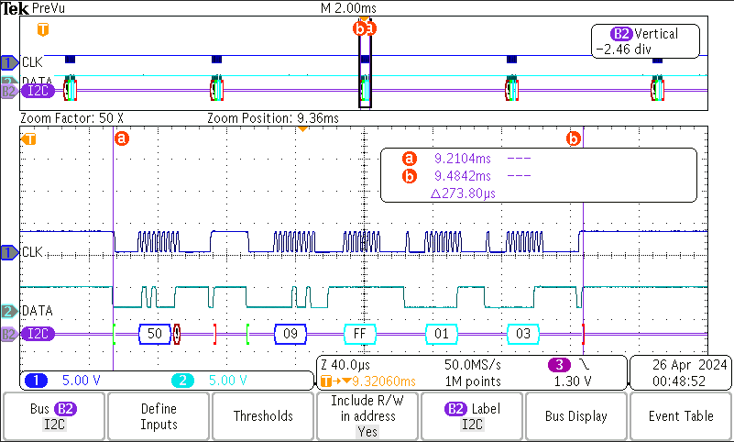

***Figure 9.4.3 One Identified and One Non-Identified Peripheral***

Figure 9.4.2 shows an oscilloscope capture of two peripherals being addressed. Channel 1 (blue) represents the SCL line, Channel 2 (cyan) represents the SDA line, and Bus 2 (purple) represents the decoded data. In this capture address 50 (peripheral display) is attempting to be identified via a write, however, no acknowledgement is received and as such moves on. Address 8 (peripheral controller) on the other hand, has been identified and is transmitting data to the master. This occurs over and over again during every iteration of the main, an indication of the simple-mode the URC is currently operating in.



***Figure 9.4.4 General “Never Acknowledge” Protocol***

This is a general protocol used when a peripheral device doesn’t respond with an acknowledgement. It is used in identify, read, and write protocols for I^2C. This allows the I^2C line to go back to a normal, non-peripheral, state as seen with the peripheral controller.

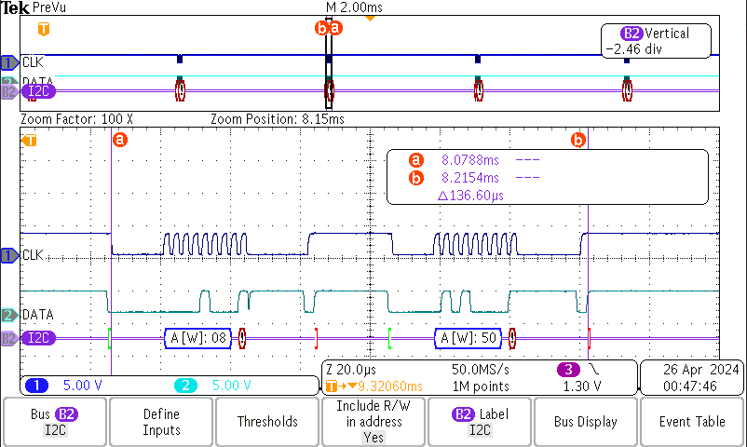

***Figure 9.4.5 No Peripherals Identified***

Figure 9.4.2 shows an oscilloscope capture of two peripherals attempting to be addressed. Channel 1 (blue) represents the SCL line, Channel 2 (cyan) represents the SDA line, and Bus 2 (purple) represents the decoded data. In this capture neither of the peripherals acknowledged the master and as such no communication occurs between them. This is a result of the “Never Acknowledged” protocol taking effect. This allows the main to continue operating despite the lack of expected peripheral communication.

9.5 URC Peripheral Controller Code (Address 8)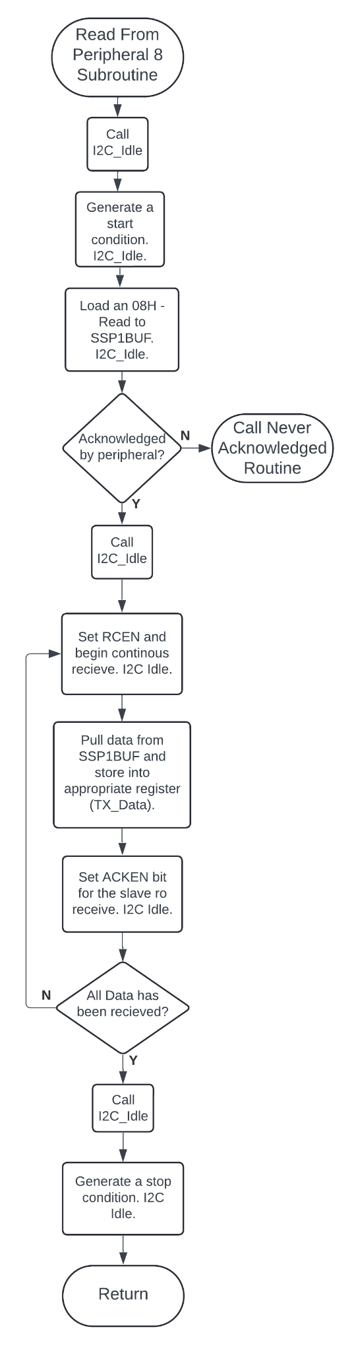

***Figure 9.5.1 “Read From Peripheral 8” Subroutine***

This will iterate through 3 times to gather all the necessary data and push it to the appropriate registers. The first byte (encoder 1) is transferred to TX_DATA_43H_VAR1 which represents the cannon X-Axis. The second byte (encoder 2) is transfered to TX_DATA_43H_VAR2 which represents the cannon Y-Axis. And finally, the third byte is first brought in and tested to see if the TX_DATA_63H_VAR1/2 needs to be set. Those bytes represent the rev and fire control of the robot cannon. Once this has been iterated through for all 3 bytes, it generates a stop condition and returns back to main.

***Code Expansion:*** When altering portions of the code, it is recommended to repeat the code in the same way it does for all 3 bytes as variations in the steps, idling, and so on have resulted in either the master or the slave locking up the I^2C lines. It took many weeks to identify the correct steps in code to be able to write and read multiple bytes between PICs.

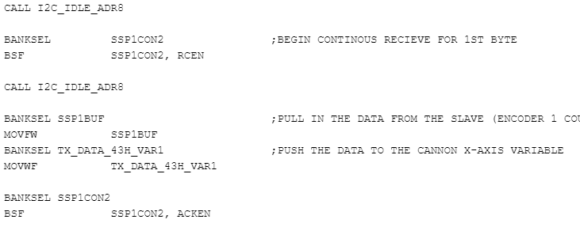

***Figure 9.5.2 Continuous Receive Code Snippet***

The code used to continuously receive utilizes a specific yet basic sequence. This allows the line to operate as intended for multiple bytes. As of Spring 2024, this is the only method known for doing so.

9.6 URC Peripheral Display Code (Address 50)

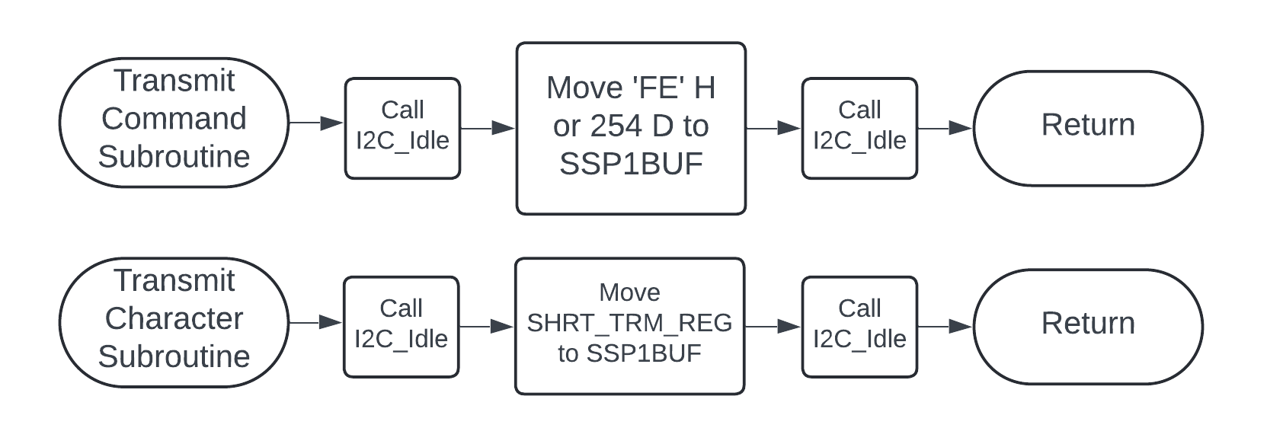

***Figure 9.6.1 “Transmit Command” Subroutine***

Since transmitting a command character is a frequent occurrence it has been turned into its own subroutine. This essentially handles the necessary code to transmit a 0xFE to the LK204-25 LCD screen that is used as a peripheral display in this project. Any characters that follow this character are intended to act as a follow up command byte. Refer to table 9.6.1 for a list of possible follow up commands.



***Figure 9.6.2 “Transmit Character” Subroutine***

This subroutine handles any characters that want to be sent by initially moving a value to SHRT_TRM_REG then immediately calling the subroutine. This will take that character and transmit it to the LCD screen. If it is not following-up a command character, then whatever character that is sent will be displayed on the LCD screen. Refer to table 9.6.2 for the character set that is used by the LK204-25 LCD screen.

***Table 9.6.1 LK202-25 Command List Table 9.6.2 LK204-25 Character Set***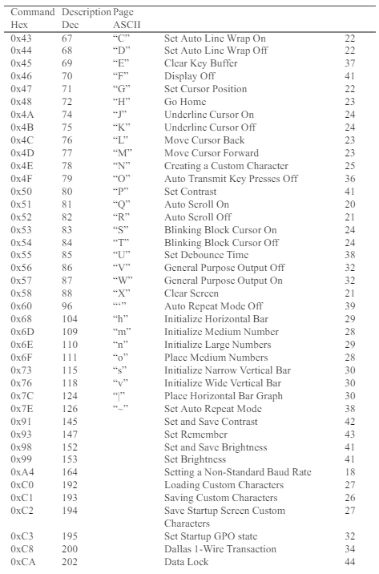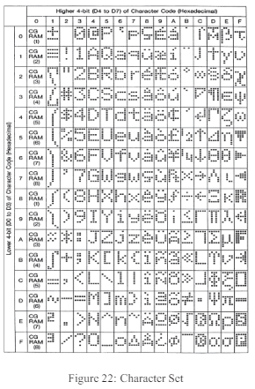

Both Images Retrieved From: (3) Matrix Orbital (2018). *LK204-25 Technical Manual Revision 2.1*.Pg. 53 & 20.

***Figure 9.6.3 “Identify Peripheral Address 50” Subroutine (Updated from General)***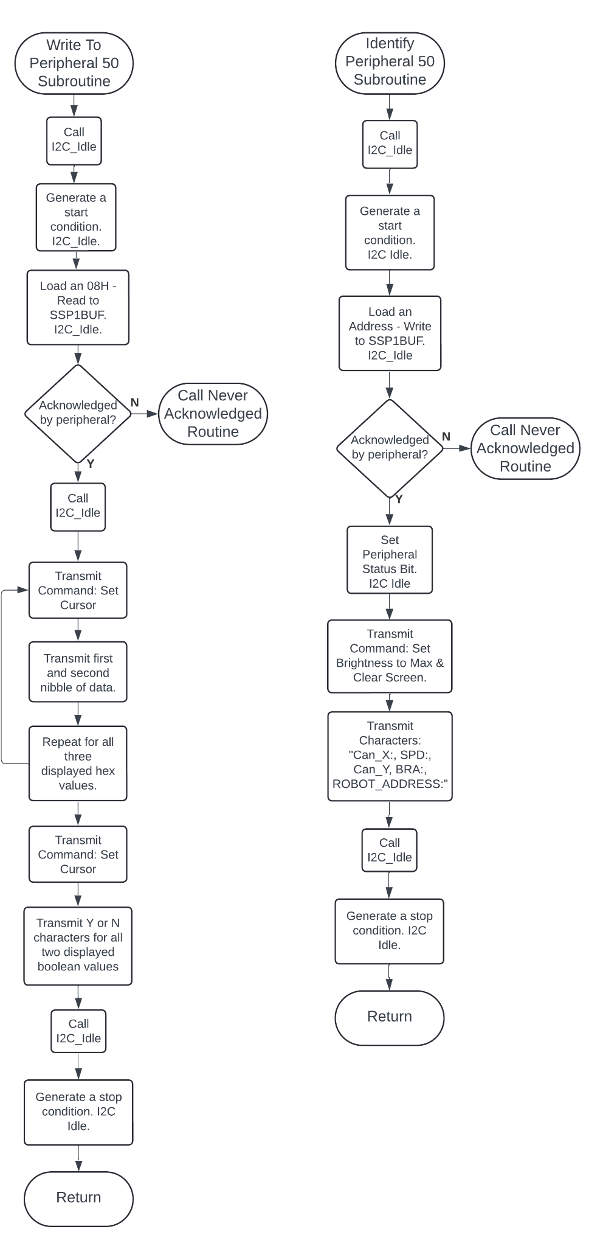

This subroutine is a slightly modified version of the “Identify Peripheral Address” subroutine mentioned in section 9.4. The reason for this is because it was desired to clear the screen, set maximum brightness, and establish the template for the display ONLY on initialization. During the write subroutine this allowed the overall communication to be shortened down to a few cursor commands followed by 1-2 characters. Previously, the entire screen was re-written every time the write command was transmitted which caused the write transmission to be unnecessarily long.

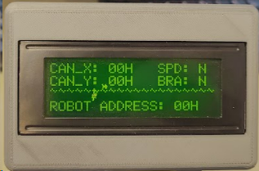

***Figure 9.6.4 LCD Screen Post Setup***

Figure 9.6.4 shows the LCD screen post-initialization. The current values range from “0 - ?” technically but still represent each nibble value plus 30H due to how they are handled in code.

***Figure 9.6.5 “Write To Peripheral 50” Subroutine***

The “Write To Peripheral 50” subroutine updates the display by moving the cursor where characters are added to specific spots. Once it has done so, any characters transmitted after that will overwrite the one currently there. This allowed the communication to be cut down to a fraction of the length as seen in figure 9.6.6.

***Figure 9.6.6 Typical I^2C Communication***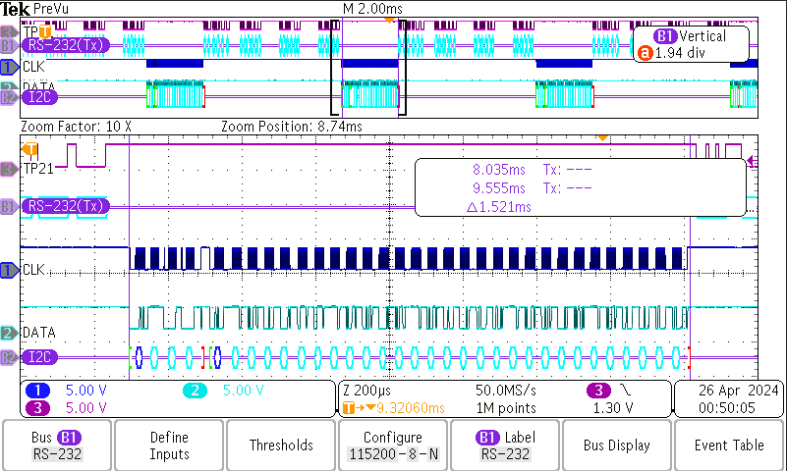

Figure 9.6.5 shows an oscilloscope capture of the newest version of the communication between the URC and the peripheral display (starting at the second green bracket). Channel 1 (blue) represents the SCL line, Channel 2 (cyan) represents the SDA line, and Bus 2 (purple) represents the decoded data. The overall time it takes has been reduced to nearly a fifth of the original length, totaling up to ~1.2mS.

***Changing Display Info:*** Should the user decide to change the information on the display, a table may be a good suggestion. This allows the user to completely write a new screen off of a much smaller section of code compared to the amount of lines and space required to write every single character as it is currently implemented in this version of the URC.

9.7 Peripheral Controller Code (Address 50)

***Figure 9.7.1 Peripheral Controller Main Flowchart***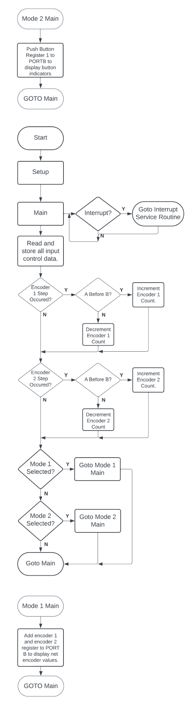

The main for the peripheral controller is relatively simple. Here the input control data is read and stored into their respective registers. For the encoders, they are initially checked for a step occurrence which is indicated when either of the pins (A or B) have gone low, after that, it checks for which has gone low first which determines the step direction.



***Figure 9.7.2 Peripheral Controller Main Mode 1 Flowchart***

Main mode 1 of this controller will display the net encoder values on PORT B by adding the two values together. Otherwise it is unused.



***Figure 9.7.3 Peripheral Controller Main Mode 2 Flowchart***

Main mode 2 of this controller will display the button register values on PORT B. Otherwise it is unused.

***Figure 9.7.4 Peripheral Controller Interrupt Service Routine***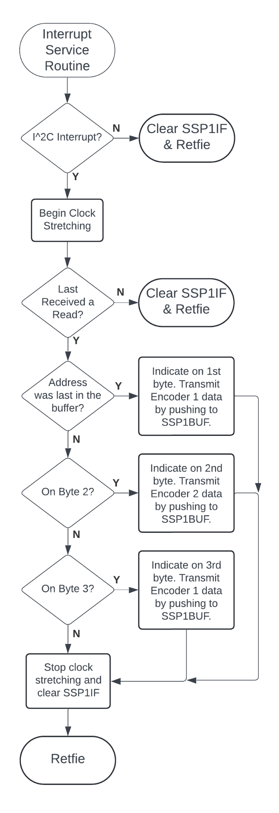

The most important part of the peripheral controller code is the ISR. This is where an I^2C communication occurs between the controller and the URC. The entire ISR can be boiled down to four main parts: the start of clock stretching, the movement of data to SSP1BUF, the end of clock stretching, and the clearing of the SSP1IF. If the peripheral doesn’t follow that order, it will result in either the SCL or SDA lines locking up and freezing both the peripheral controller and URC. However, the logic to recognize when to do this is also vital to ensuring all data is properly transmitted and a stop condition can be fully realized by both devices. If the amount of data that is transmitted doesn’t match what the master expects, this will also lock the lines. This is why the current code requires the use of a register to keep track of what data byte the device is on. Additionally, this will continue only if a read occurs. Once a read occurs, this will be stored until another address has been sent to the peripheral. After the peripheral recognizes a read, it will then check if the most recent data in the SSP1BUF was an address (this is set automatically and only once by the PIC), if it was, then it will reset the data count and transmit the first data byte. After that, it will stop clock stretching in order to allow the master to clock in the data. Finally, the SSP1IF is reset and will wait for the master’s follow-up acknowledgement. The ACK from the master then causes the SSP1IF to flip and the process starts all over again but with a different data byte.

***Code Expansion:*** Much like the URC I^2C code, any code expansion should follow the exact same template laid out by this section of code.

# Overview for the on-bot Master

# 

10.1 Master Board Summary

The Hardware on the bot is designed where the master board decrypts the control commands and relays them over I^2C to the slave boards. By separating the main communications over UART it allows for the microcontroller to clock at a higher frequency than the slave which has to clock at a lower frequency to achieve the 50Hz required to control servos and other devices. The system is designed where RJ9 connectors are used for all the I^2C and RJ45 connectors are used to send the port pin data to the peripherals.

10.2 Master Board Design

The master board is made to be very simple with the serial data connections for I^2C and for the XBee. since the master is designed to primarily handle the data communication there are minimal other interfaces on this board other than the bot address selection switch (SW1) and one RJ45 allowing for some interfacing with hardware on PortA if necessary.

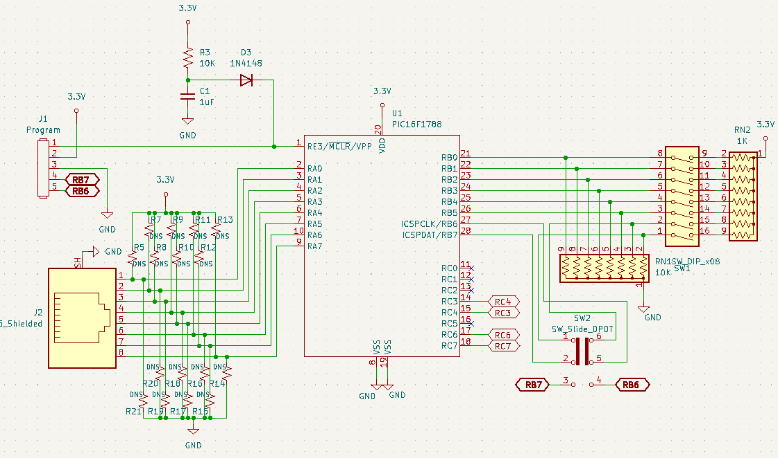

***Figure 10.2.1 Microcontroller on the Master***

U1

For the master the PIC16LF1788 was chosen due to its simplicity with the internal oscillator; it allows for the device's clock frequency to be easily changed to meet the demands of the project. The LF(+3.3v) version was selected for the master board because the XBee used for the wireless USRT communications is a +3.3v device.

SW1

SW1 is a dip switch package used to select the bots address (this address must match the address selected on the controller to control the bot)

Changing the address

When changing the address the bot must be restarted to set the new address.

SW2

SW2 is a double pull double throw switch which disconnects RB6-7 from the address switch and connects them to the program header this prevents interference when programming.

DNS resistors

The resistors labeled DNS are there to be implemented by the user if needed as pull up/down resistors to protect the microcontroller.

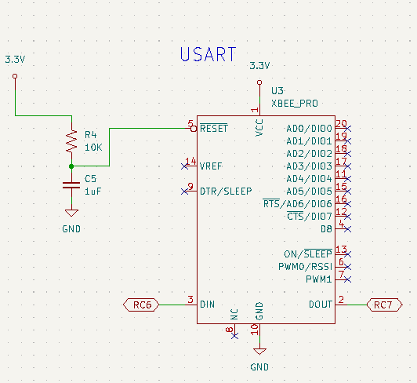

***Figure 10.2.2 XBee on the Master***

The XBee is a FM radio used to transmit and receive the USRT control data

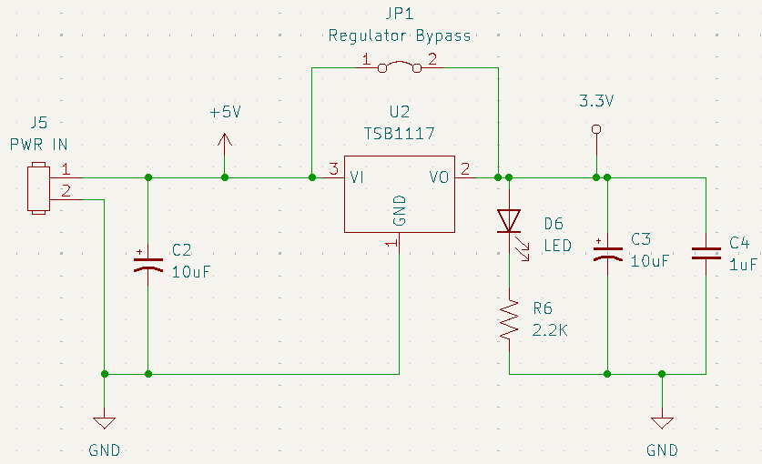

***Figure 10.2.3 master board power supply***

Since the XBee(U3) and the microcontroller(U1) are +3.3v devices a voltage regulator is required to reduce the +5v supply voltage for the rest of the control electronics.

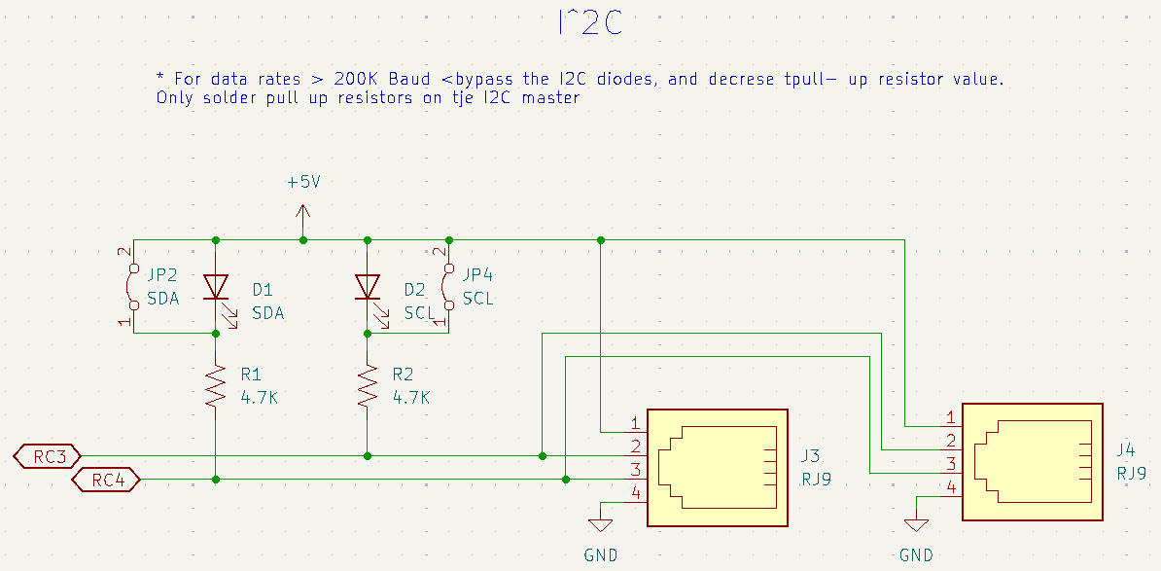

***Figure 10.2.4 I^2C communications on the master board***

Since for I^2C operation pullup resistors are required to limit the current in the SCL and SDA lines additional LEDs are included to help to indicate the state of the port. If there is distortion on rise/fall time, decrease the resistor value to allow for more current to flow on the bus; this change is usually required for higher baud rates or longer runs.

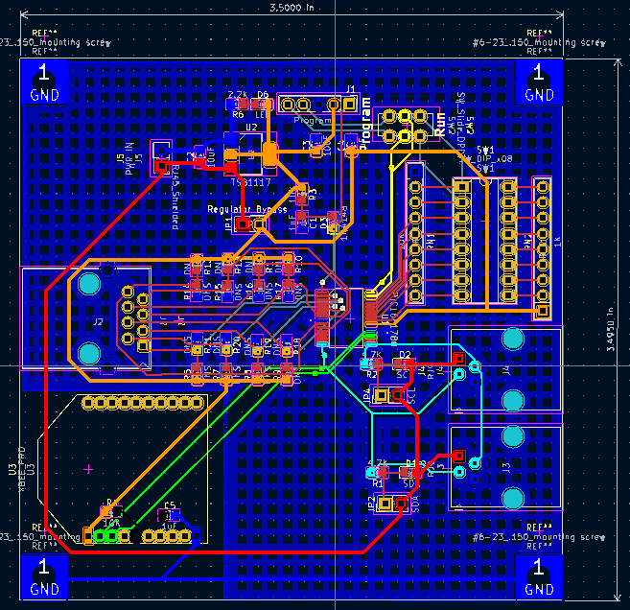

***Figure 10.2.5 Master Board Layout***

10.3 Master Board Code

# 

# ***Figure 10.3.1 Master Board Main Loop and Interrupt Flowchart***

# The code for the on-bot master configures the PIC16LF1788 to receive the UART data from the XBee with 9600 KHz Baud. The received control data from the controller is then stored in variable registers before sending the data out over the I^2C at 100 KHz Baud.

See Appendix D For all the Flow charts

# Overview for the on-bot Slaves

# 

11.1 Slave Board Summary

The slave boards are designed to receive the I^2C command data sent from the master and use that information to control various devices on the bot. The slave board itself does not have any direct connections to peripherals as it is designed to be connected through a breakout board this allows for the slave board to be located close to the master. The breakout boards are designed to be connected to a slave by a shielded RJ45 allowing all portX pins as well as ground. The main benefit of running multiple slaves to control various functions is the ability to separate different systems for example operating at different clock frequencies.

11.2 Slave Board Design

The slave board itself is very simple as the main interfacing occurs on the breakout boards. This means that the slave board is simplified to the PIC16F1788, RJ9s for I^2C and UART and RJ45s to connect to the breakout boards. Since the slave board is designed to communicate with I2C the UART pins can be jumpered to go out the RJ45 to the breakout board using JP5-6.

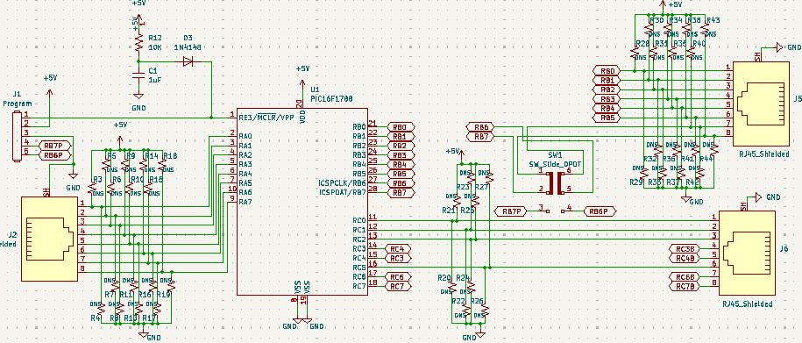

***Figure 11.2.1 Slave Board Microcontroller***

For the slave boards the microcontroller selected was the PIC16F1788; the +5v version was selected because most of the devices that it will control require a 5v control signal.

DNS resistors

The resistors labeled DNS are there to be implemented by the user if needed as pull up/down resistors to protect the microcontroller.

SW2

SW2 is a double pull double throw switch which disconnects RB6-7 from the address switch and connects them to the program header this prevents interference when programming.

For the serial communications on the slave they match that seen on the master however for I^2C the pull ups are only required on the master.

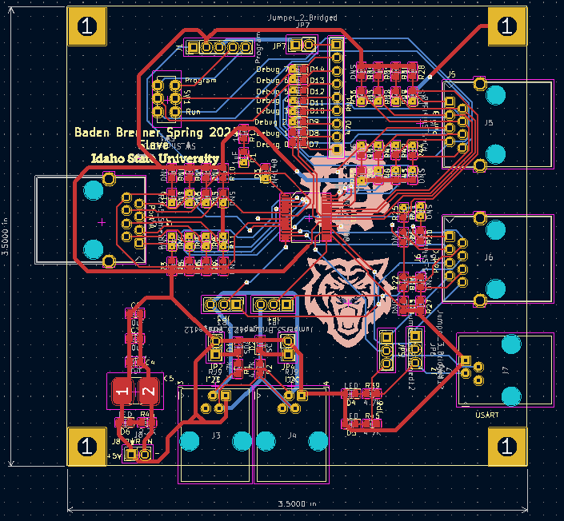

***Figure 11.2.2 Slave Board Layout***

11.3 Slave Board Code

The slave boards are set up to control different parts of the bot independently of each other; this helps with troubleshooting and adaptability by allowing for different systems to operate independently of each other. The slaves were implemented in the manner last semester with the Drive board and the Turret board. By separating the controls in this manner it allows for the use of the CCPx

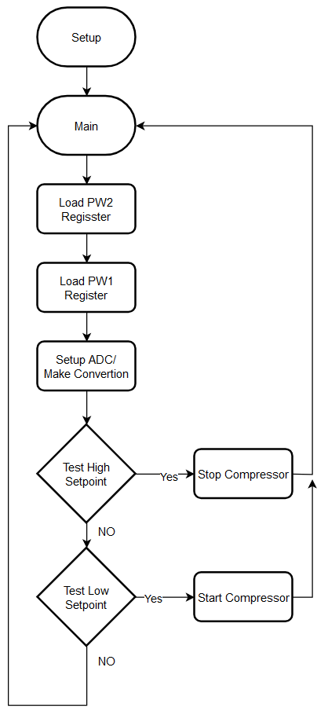

***Figure 11.3.1 Driveboard Main***

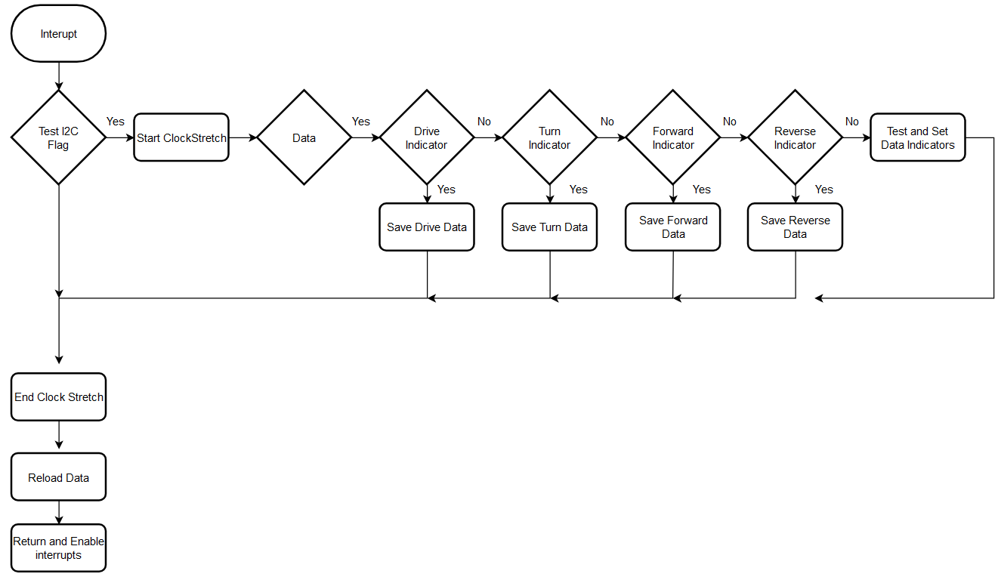

***Figure 11.3.2 Driveboard Interrupt Service Routine***

11.4 Breakout Boards

The breakout board system is designed to be modular and daisy chainable aiming to simplify and clean up the bots wiring harness. This ability allows for the universal control system to be adapted to any project by making custom breakout boards which meet the specific demands of the project.

Debug Breakout Board

The debug breakout board is a simple tool allowing for the user to connect it to any RJ45 in the system and visualize the states of the pins on the port (assuming the frequency is low enough).

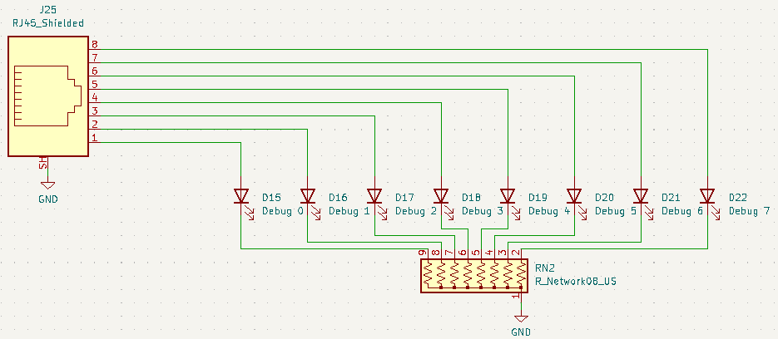

***Figure 11.4.1 Debug Board Schematic***

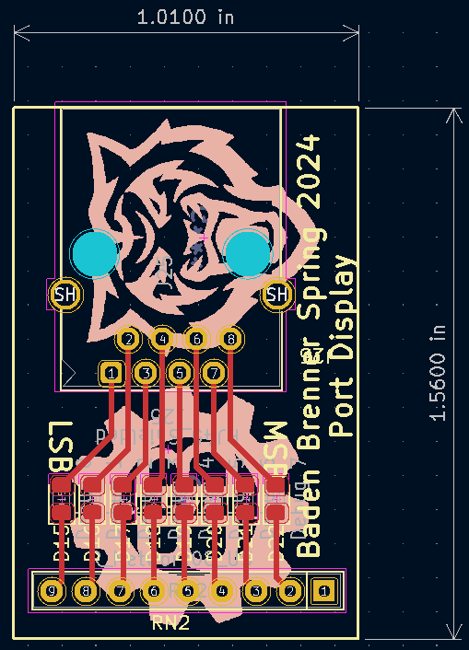

***Figure 11.4.2 Debug Board Layout***

Main Breakout Board

The main breakout is designed to allow for any one of the port pins to be selected as either an input or an output with each pin being terminated to a 3 pin header with ground on pin1 fused selectable power on pin 2 and signal on pin 3 this is designed to match the pinout for a standard servo. If you are not using one of the pins signal on this board you can select the passthrough position on the jumpers JP8-15. For the 2 supply voltages they are connected to the board through the XT60 connector and isolated using inductors and capacitors isolating the load.

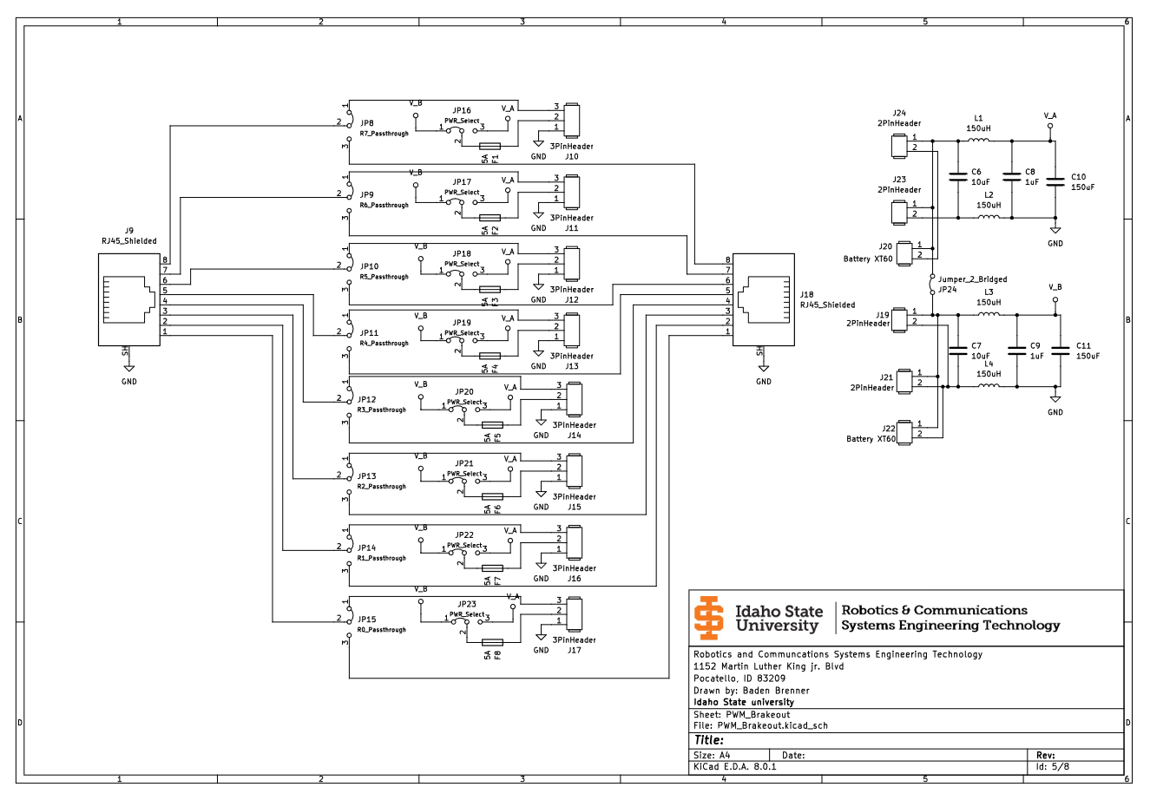

***Figure 11.4.3 Breakout Board Schematic***

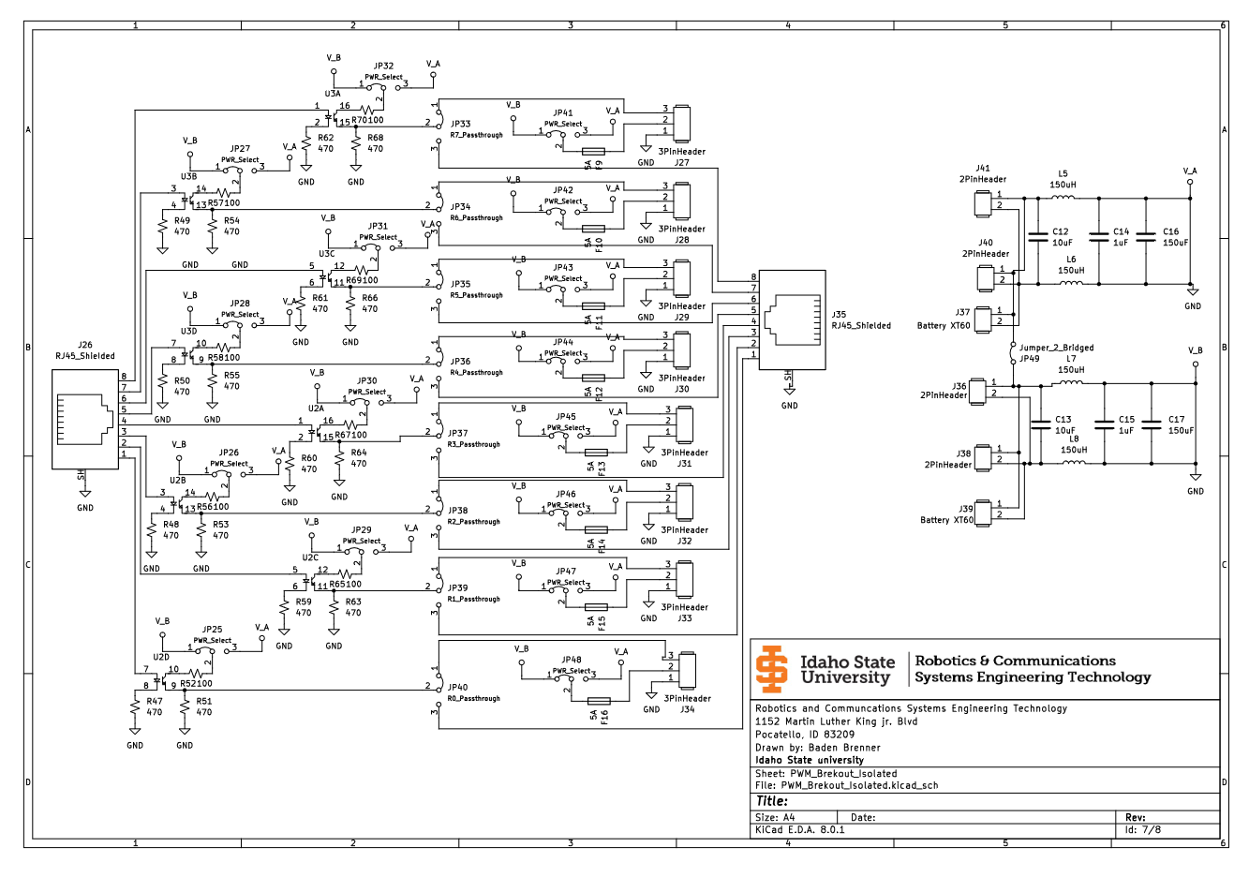

***Figure 11.4.4 Optical Isolated Breakout Board Schematic***

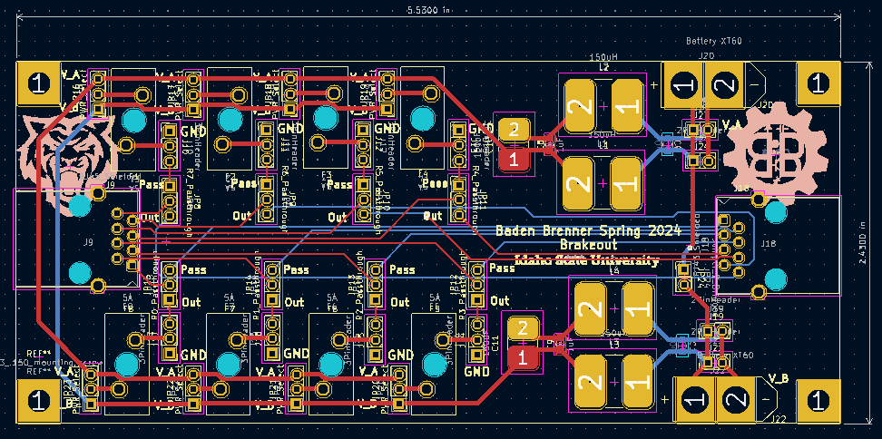

***Figure 11.4.5 Breakout Board Layout***

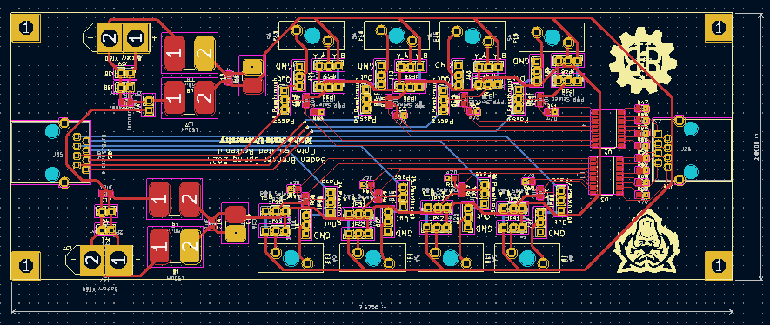

***Figure 11.4.6 Optical Isolated Breakout Board Layout***

# 

# Mechanical Design

# 

12.1 Overview

This iteration of the ATV project saw a few changes with the testing performed; the mini ATV was too small to support an air system that can handle the demandes of the cannons. This resulted in the decision being made to move the AIR cannons to the full size ATV chassis and put a nerf turret on the mini ATV.

12.2 Turret Design

To mount the 2 air cannons to the full size ATV we needed a turret system. We settled on an A Frame design which holds a rotating assembly holding the cannons. The whole assembly rotates on a large lazy susan bearing which is mounted to the chassis using laser cut metal tabs. The body of the turret is built from carbon fiber tubes joined by 3D printed carbon fiber reinforced nylon joints.

The rotating assembly holding the cannons is designed to be rotated by a 12v car window motor with limit switches setting the range of motion. (not yet implemented)

To spin the whole turret it is designed to be turned by a stepper connected to a ring gear moted to the base of the turret. (not yet implemented).

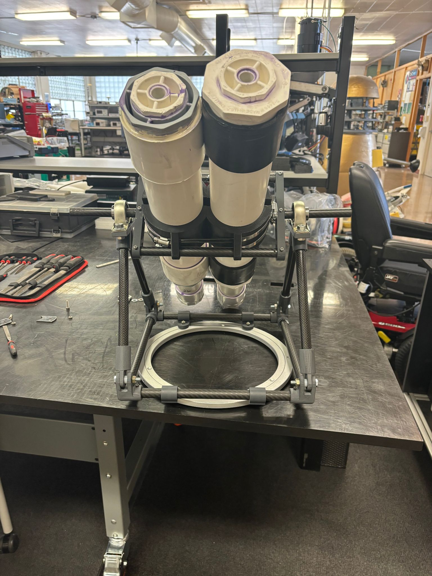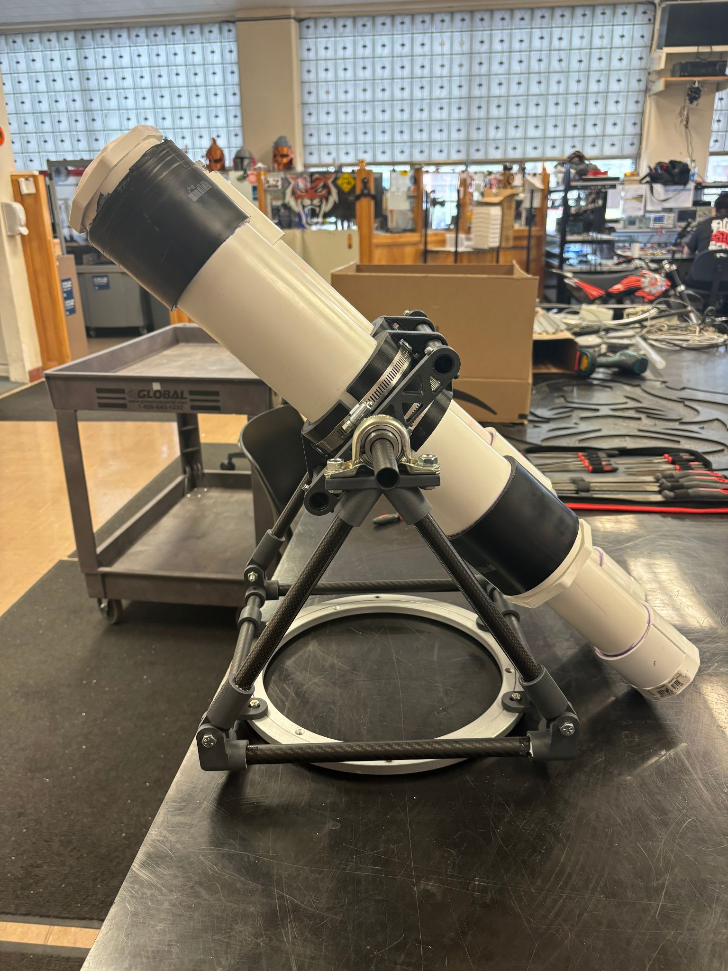

***Figure 12.2.1 Cannon turret***

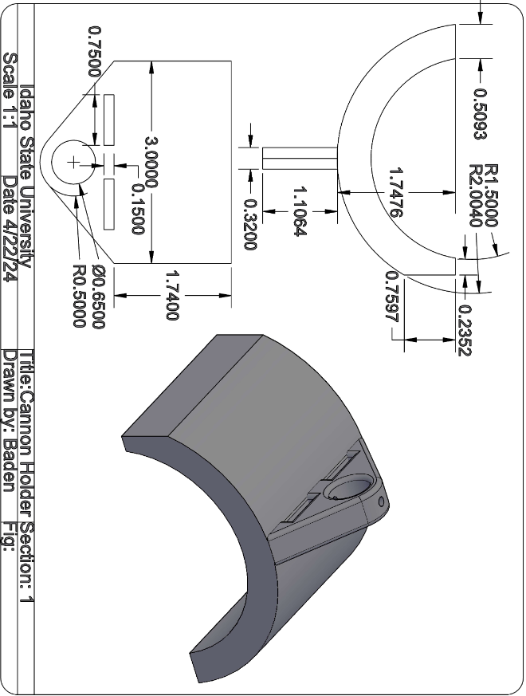

***Figure 12.2.2 Cannon Holder***

The cannon holder is designed to be hose clamped to the body of the cannon and slid over the carbon tubes on the top and the bottom of the rotating assembly.

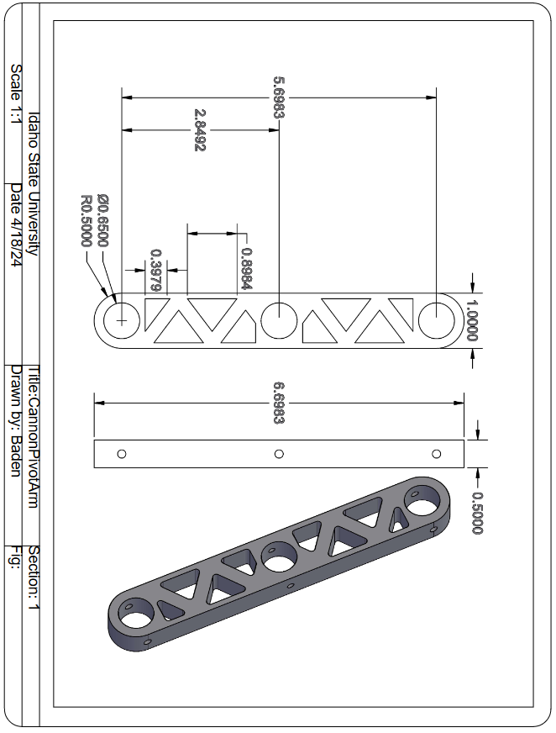

***FIgure 12.2.3 Turret Pivot Arm***

The pivot arm is the main structure of the rotating assembly with the holes on either end designed to hold the carbon tubes which hold the cannon. And the center hole is designed for the carbon tubes which slide into the bearings on either side.

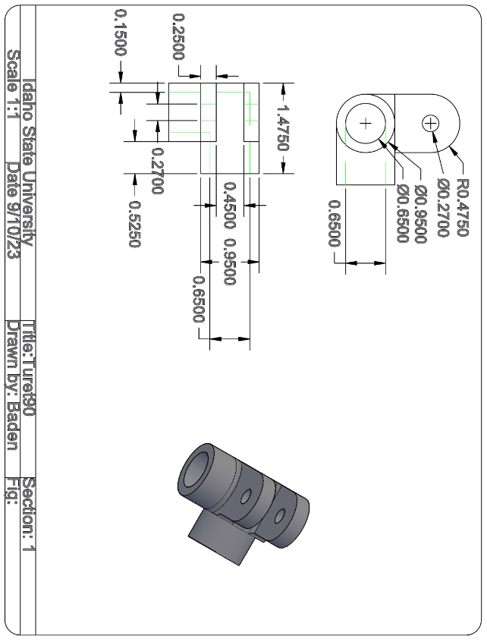

***Figure 12.2.4 Turret 90***

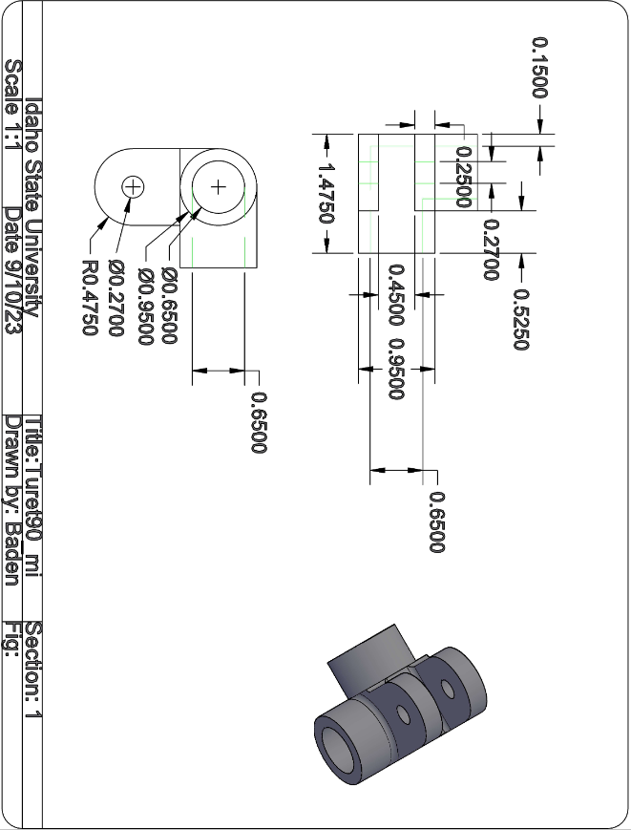

***Figure 12.2.5 Turret 90 mirrored***

The turret 90’s are the coroners which hold the main tubes which make up the uprights and the base of the turret. The ears on the top of them are designed to be bolted to the end cap of the uprights using a ¼-20 fastener.

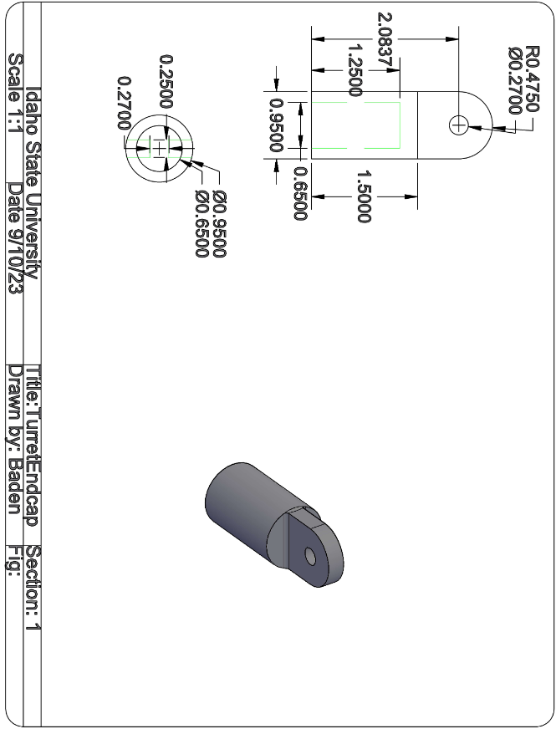

***Figure 12.2.6 Turret Endcap***

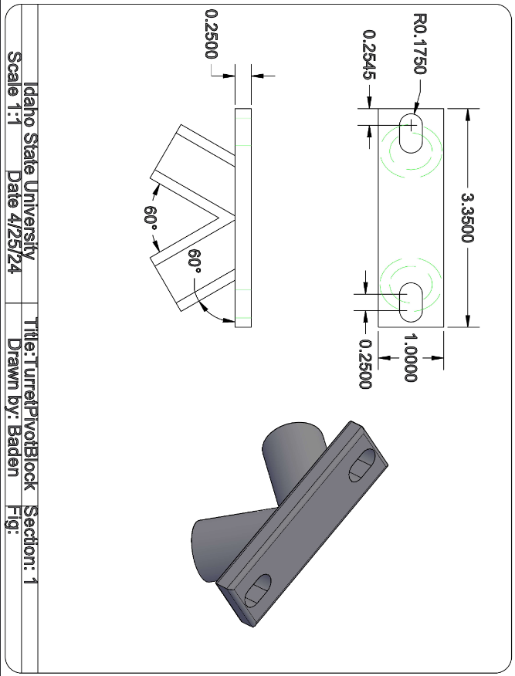

***Figure 12.2.7 Turret Pivot Block***

The turret pivot block is designed to hold the 2 uprights together creating the top of the triangle. On the top of the turret pivot block there are mounting holes for the bearings which serve as the pivot point for the tilt of the turret.

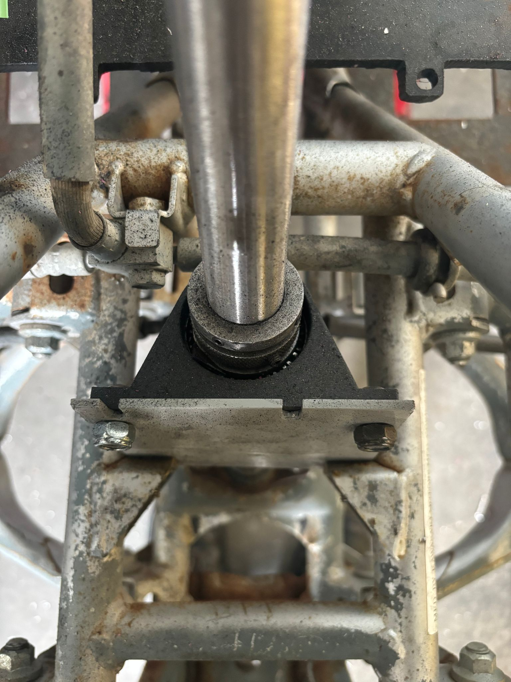

***Figure 12.2.8 Steering Bearing Mount***

For the large ATV to make room for the turret and air system the handlebars were removed and the sterling post was cut down. The shortened length of the sterling tube no longer allowed for the stock sterling bushing, using a roller barong and a 3D printed bearing race (figure 12.2.9) allowed for the steering post to be held securely much closer to the base providing more room for the stepper motor and gearbox which drives the sterling.

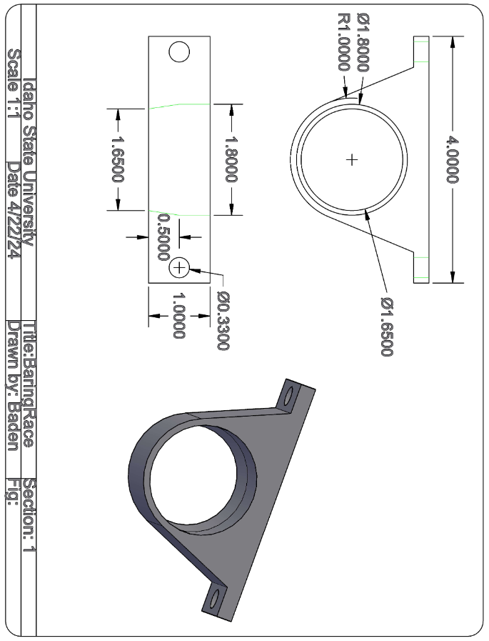

***Figure 12.2.9 Steering Bearing Race***

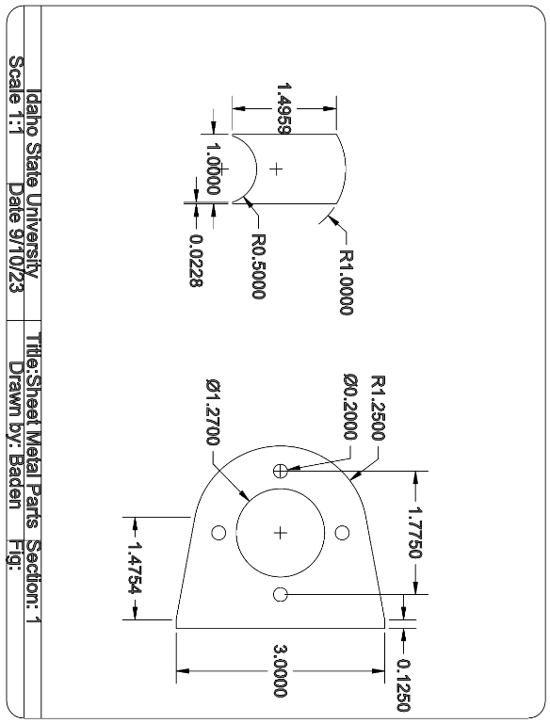

***Figure 12.2.10 Sheet Metal Parts***

# Troubleshooting and Calibration Procedure

# 

13.1 Troubleshooting Procedure For The URC

- The device turns on, but is frozen: Start by making sure that any peripheral devices haven’t locked-up as this may cause the various I^2C protocols to be stuck in an endless loop.

- The device froze when connecting or disconnecting a peripheral device: Try to restart the device and URC and have it already connected to the URC, communication interrupts occurring during an attempt of communication may lock up either device.

- I’ve connected the device to a robot but it's not running: Ensure the correct mode and robot address are selected. Otherwise, the Xbee radio may be malfunctioning. Ensure that the UART is established at the URC baud rate (115.2k). If that doesn’t fix it, make sure the Xbee is seated well in the PCB as it may disconnect in the shell.

- Power/Data isn’t being delivered to my peripheral: Ensure the cable used to connect either is the correct pinout. Flipping the VCC and GND may result in damage to either device.

- My connected battery/power bank is constantly turning off: Make sure the battery load jumper is set and ensure the load draws enough power to maintain the required current load for the power source to stay on.

13.2 Troubleshooting procedure for the Master, Slave, and Breakout Boards.

- Power/Data isn’t being delivered to my slave/breakout boards: Ensure the cable used to connect either is the correct pinout. Flipping the VCC and GND may result in damage to either device.

- My voltage on my breakout board headers are wrong: Ensure that the correct voltage source is jumpered into the line.

- The data coming into my optocoupled board isn't making it to the port: The Optocoupled ports are one way, and that way is as an output from the port.

- The boards are not communicating with each other despite proper connections: Ensure that the PICs have been programmed correctly before use.

13.3 UCS Calibration Procedure

- The URC calibration procedures for code tweaking have been included throughout the code overview section of the project (section 9). Any Notes highlighted like ***This*** indicates a calibration procedure.

- The Master’s, Slave’s, and Breakout Boards' calibration procedures are mainly limited to the various jumpers and code outlined throughout the report. Refer to sections 10-12 for further details.

# 

# Cost Analysis

# 

14.1 URC and Peripheral Cost Analysis

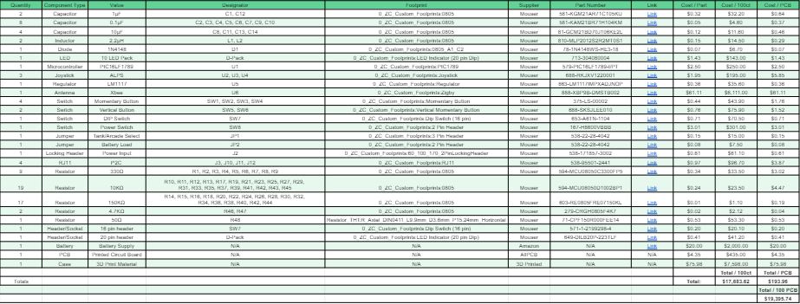

***Figure 14.1.1 URC Bill Of Materials***

<https://docs.google.com/spreadsheets/d/10A9ygm6o8m-e0a_6TTz3_dJLuG95VhqOR5hyRQT7U8k/edit?usp=sharing>

[Universal Controller BOM](https://docs.google.com/spreadsheets/d/10A9ygm6o8m-e0a_6TTz3_dJLuG95VhqOR5hyRQT7U8k/edit?usp=sharing)

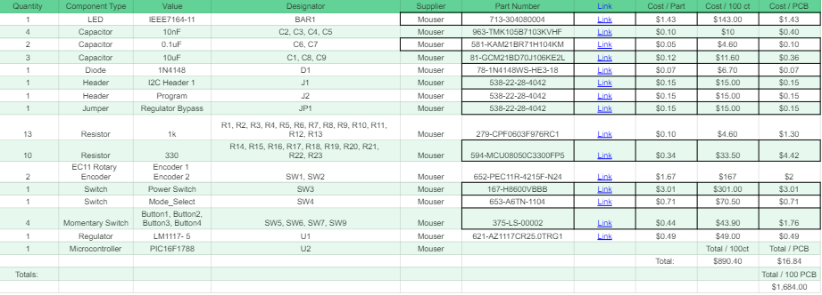

***Figure 14.1.2 Peripheral Bill Of Materials***

<https://docs.google.com/spreadsheets/d/1t4c-n3MuuA3V5Kv8g-wBUTj5Ao5KgUR_FU1jE0WB6QA/edit?usp=sharing>

[Peirpheral Controller BOM](https://docs.google.com/spreadsheets/d/1t4c-n3MuuA3V5Kv8g-wBUTj5Ao5KgUR_FU1jE0WB6QA/edit?usp=sharing)

14.2 ATV Project Cost Analysis

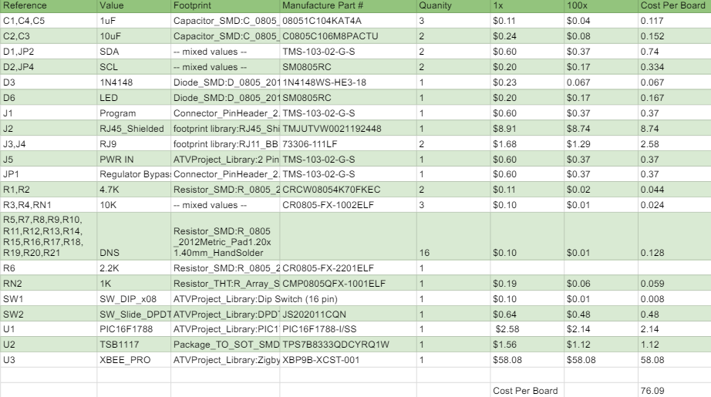

***Figure 14.2.1 Master Board Bill of Materials***

<https://docs.google.com/spreadsheets/d/12E0ZV0dstUS_LF84y4GSmWtW9e7tHLmi7XvJAtdt3wg/edit?usp=sharing>

[ATV_Project_Master_Board](https://docs.google.com/spreadsheets/d/12E0ZV0dstUS_LF84y4GSmWtW9e7tHLmi7XvJAtdt3wg/edit?usp=sharing)

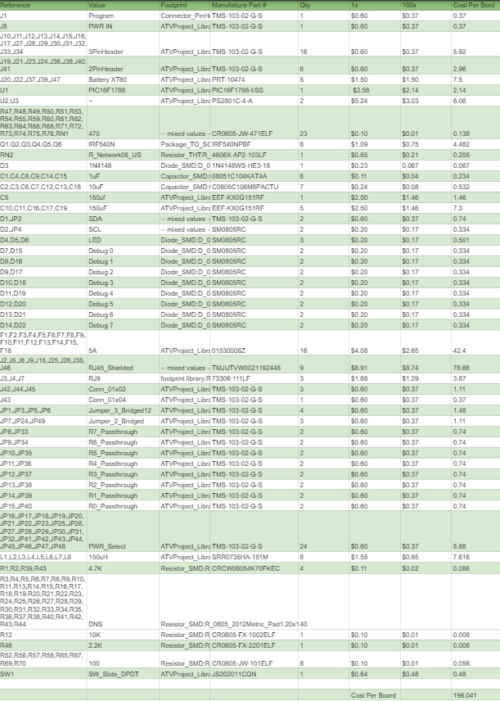

***Figure 14.2.2 Slave Board Bill of Materials***

<https://docs.google.com/spreadsheets/d/1W5Jkfi1fVixjjD_BP8D9IqvqJffaY_IQ4NMq_xMpoVY/edit?usp=sharing>

[ATV_Project_Slave_Board](https://docs.google.com/spreadsheets/d/1W5Jkfi1fVixjjD_BP8D9IqvqJffaY_IQ4NMq_xMpoVY/edit?usp=sharing)

14.3 Overall Cost Analysis

| Category | Cost |
| --- | --- |
| Electronics | $557.93 |
| Mechanical Components | $353.00 |
| 3D Printing | $292.17 |
| Labor Baden Brenner (116 hours @ $50/hr) | $5,800.00 |
| Labor Joshua Makuch (103 hours @ $50/hr) | $5,150.00 |
| Labor Zachary Christensen (101.5 hours @ $50/hr) | $5,075.00 |
| Total | $17,228.10 |

***Table 14.3.1 Cost Analysis***

- Electronics: This cost came mostly from the Xbee radios, Shielded RJ45 Connectors, and the LCD Screen

- Mechanical Components: This was mostly due Carbon tubes and geared stepper motors.

- 3D Printing: Most of the cost was due to using carbon fiber filament where the turret and cannon mount ate the highest costs, followed by the URC shell.

# 

# Conclusion and Recommendations

# 

15.1 Conclusion

Overall the project was relatively successful. The URC almost solved all of its proposed problems. Two peripheral devices were created that function to a very usable degree. Initialization and loss of connection was established and could handle a number of likely scenarios. Additionally, modularity with the code was successfully implemented, meaning that any individual (assuming they’re using the outlines in the calibration procedure) could swap out peripheral devices and maintain overall URC usability while seamlessly integrating peripheral devices. Finally, a shell was made that, although could use a few tweaks, acts as the first functional version of the URC shell.

In terms of major issues, however, the PCB was unfortunately non-functional. Due to a faulty schematic, the pinout for the PIC used in the PCB didn’t match the actual QFN package pinout, but instead the PDIP package as that was what was used in the previous semester. A new revision has been created that fixes this issue, but it is untested.

The (mini)ATV project also saw a lot of work done. The proposed UCS was implemented and partially function tested. This will allow any user to be able to build a system or robot with a large array of adaptability and control options as the system is able to be seamlessly controlled via the URC. Should the desire to breakout or even optocoupler some of the output, there is an option for that. In terms of the ATVs themselves, the miniATV was stripped and began having the proposed nerf turret attached to its chassis, however, time ran out. The larger ATV did manage to begin development on the air cannon turret with a baseline established. Additionally, the steering column was fixed with a high-torque stepper motor good for handling high load steering (150 in-lbs max).

In terms of major issues, however, the UCS boards were unable to be fully function tested. This was due to the slave board being fried because of a crossover RJ11 cable which shorted VCC to ground. Because of this none of the other boards were able to be function tested as the slave board is a vital part of the UCS circuitry. However, future developments will be able to solve this issue as a diode across the rails to provide reverse polarity protection.

15.2 Recommendations

- Finalize the steering system for a full size ATV.

- Finalize the turret system for full size ATV.

- Connect the on-bot hardware for a mini ATV.

- Finalize and test the dead man switch system.

- Test updated URC PCB designs.

- Add reverse polarity protection on the I^2C connectors.

-Create a battery pack with charge and output regulation.

# Appendix A: Engineering Logs

# 

***Figure A.1 Baden Brenner Engineering Logs***

***Figure A.2 Zachary Christensen Engineering Logs***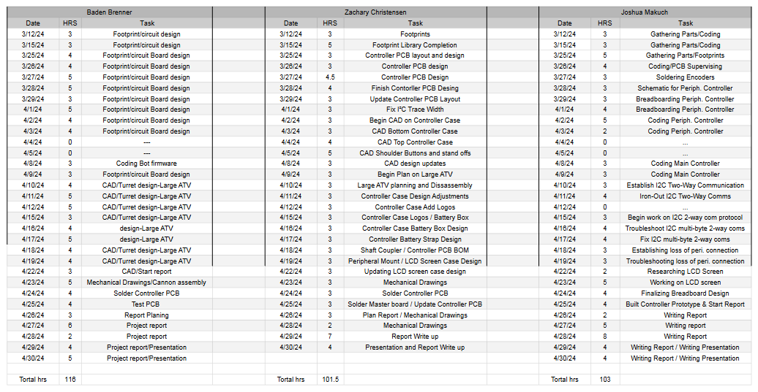

# 

# ***Figure A.3 Joshua Makuch Engineering Logs***

# Appendix B: Schematics

# 

B.1 URC and Peripheral Schematics

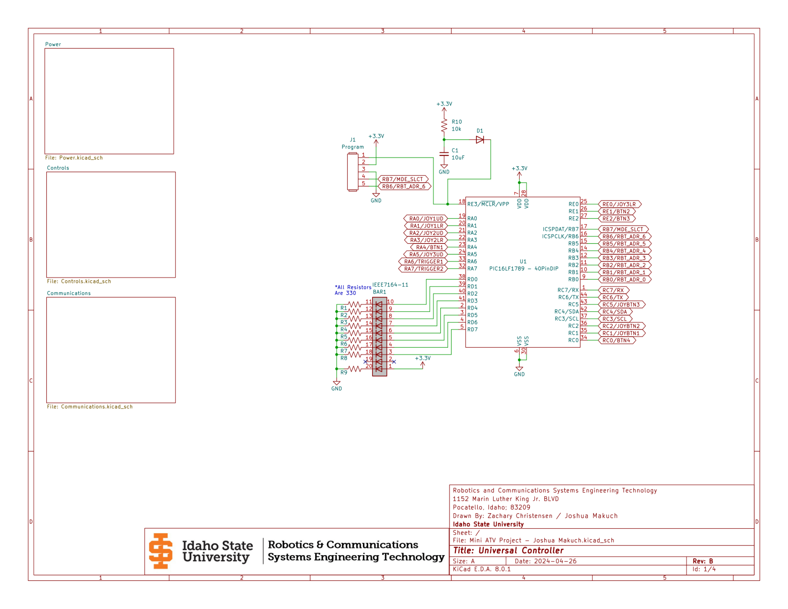

***Figure B.1.1 URC PIC Layout***

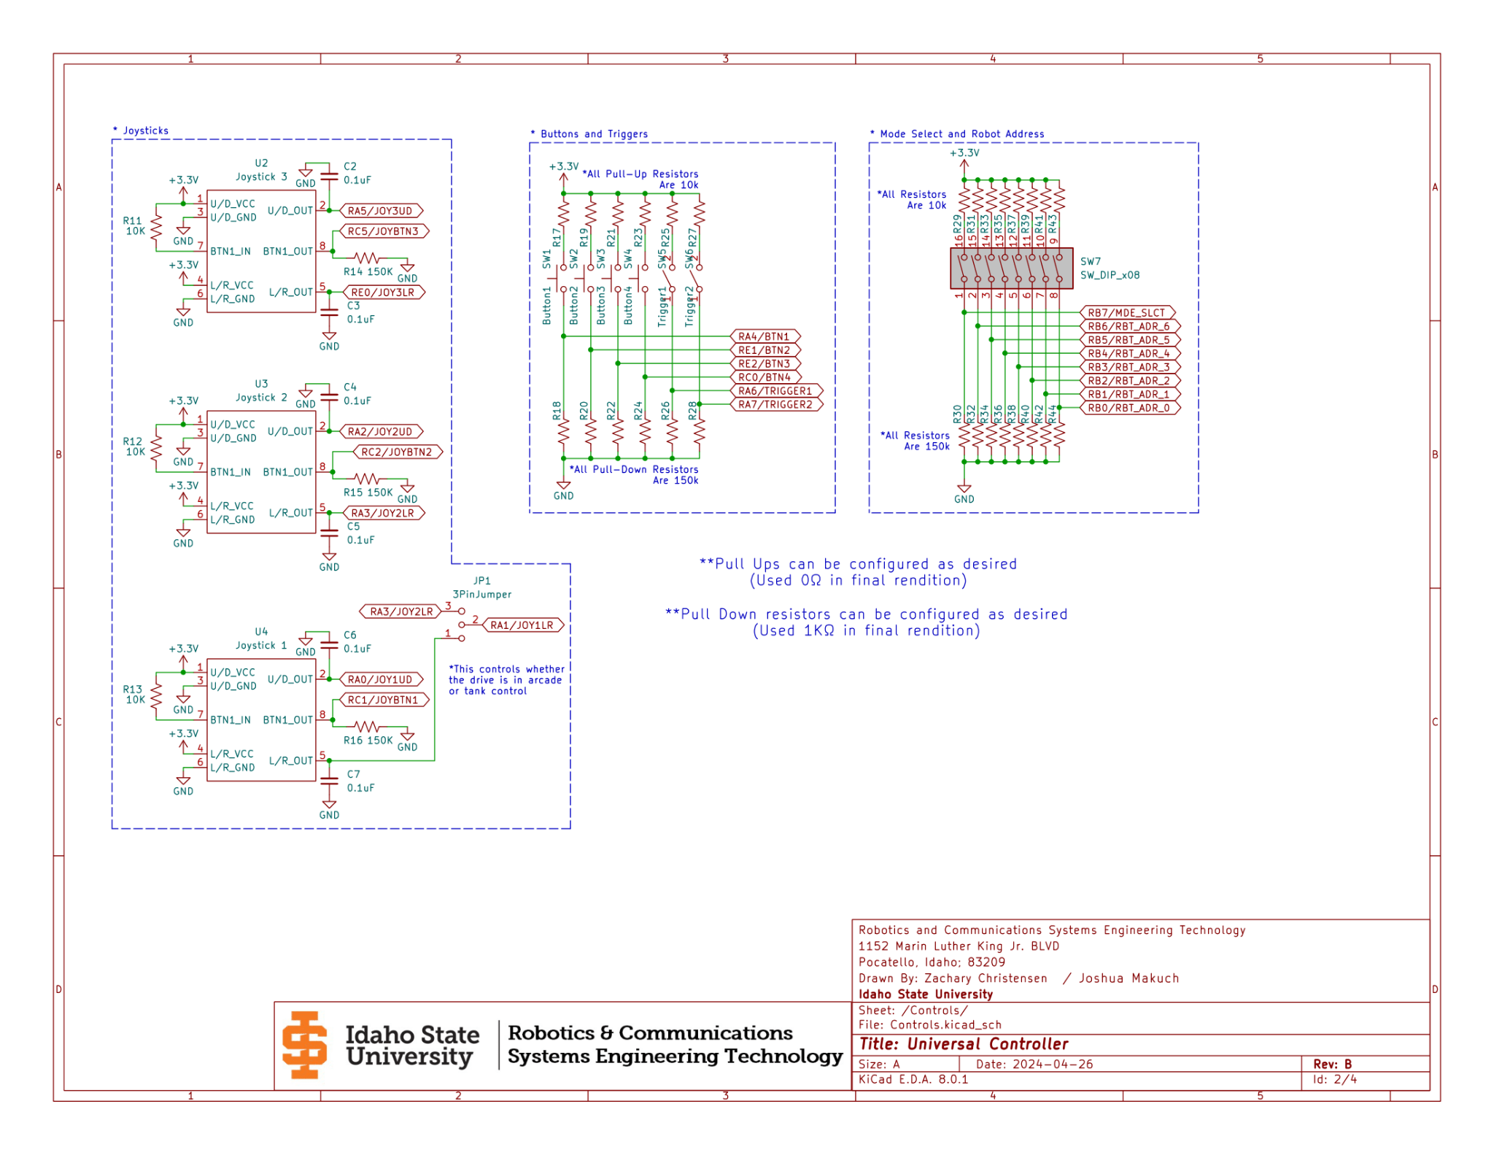

***Figure B.1.2 URC Controls***

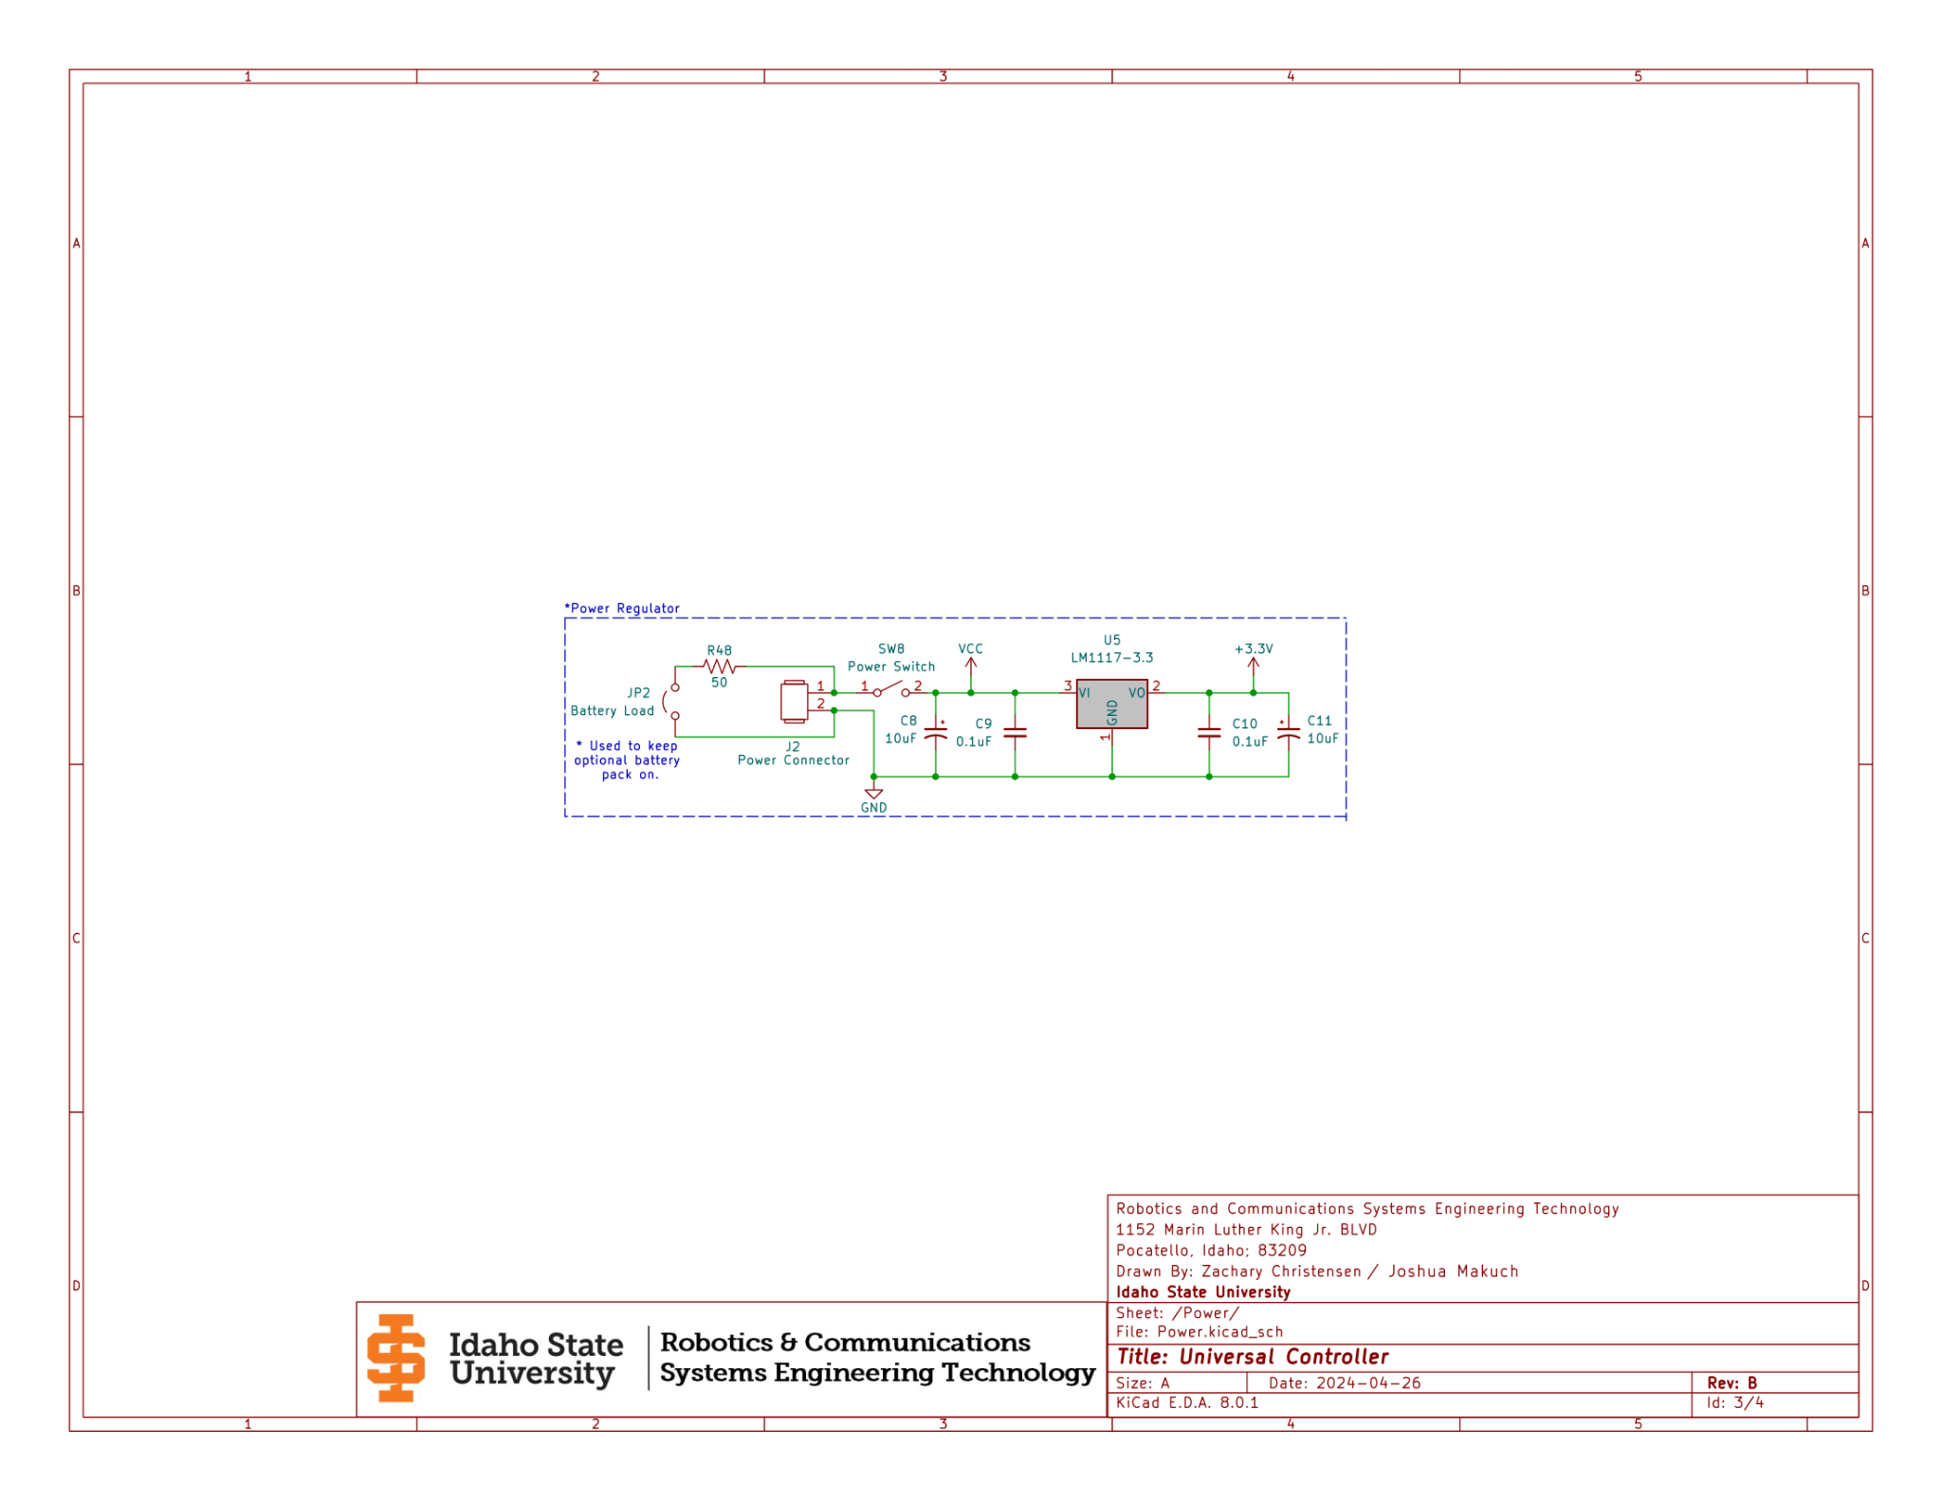

***Figure B.1.3 URC Power Regulation***

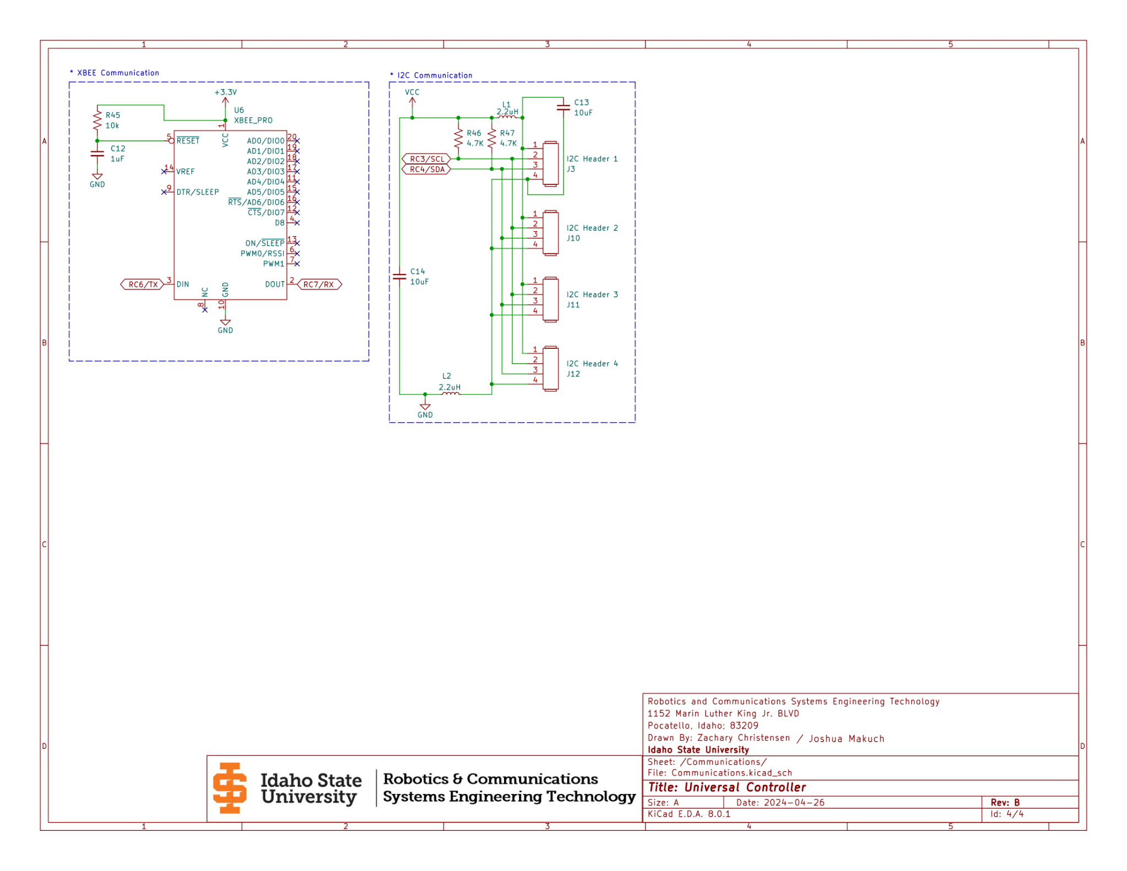

***Figure B.1.4 URC Communications***

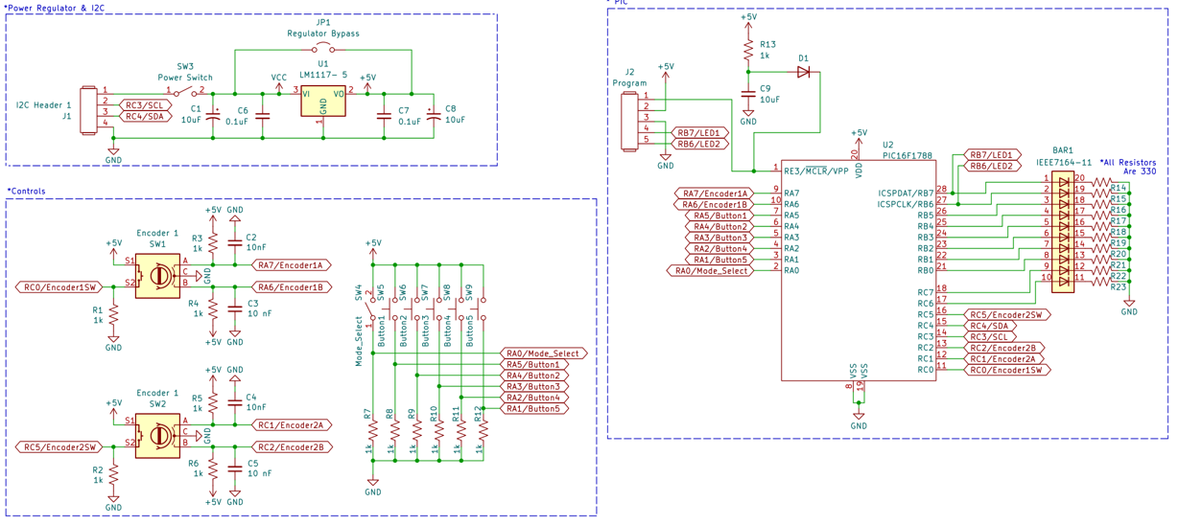

***Figure B.1.5 Peripheral Controller 8 Schematic***

B.2 Master, Slave, and Breakout Board Schematics

# 

# ***Figure B.2.1 Slave Board Schematic***

# 

# 

***Figure B.2.2 Slave Board Power Schematic***

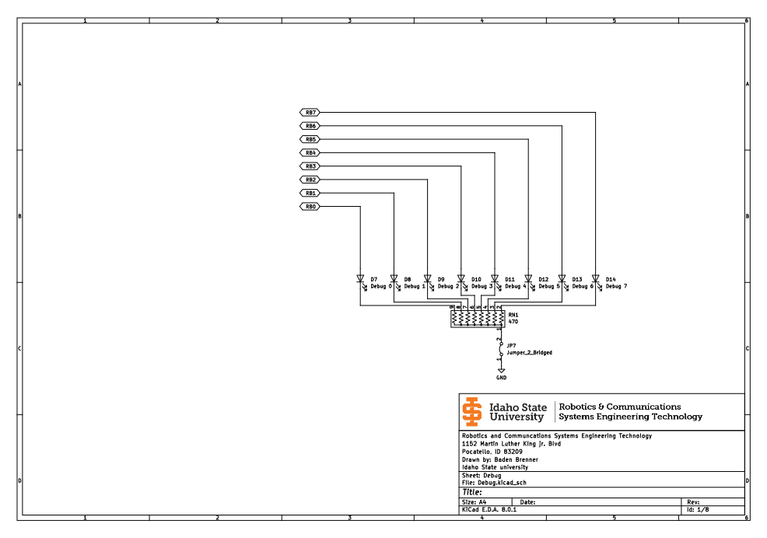

***Figure B.2.3 Debug LED on Slave Board***

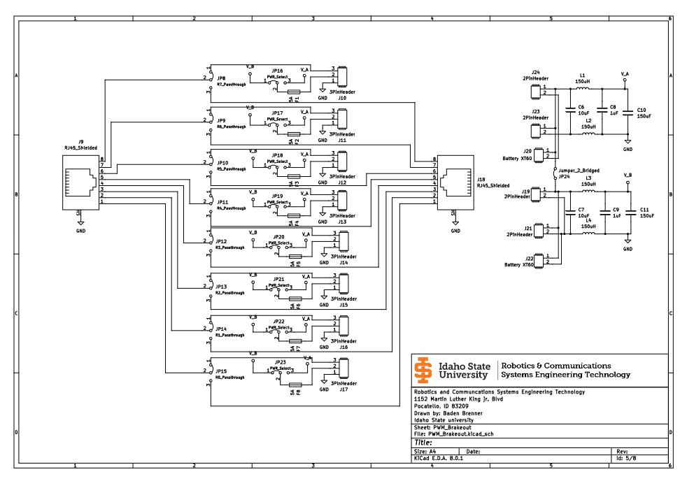

***Figure B.2.4 Breakout Board Schematic***

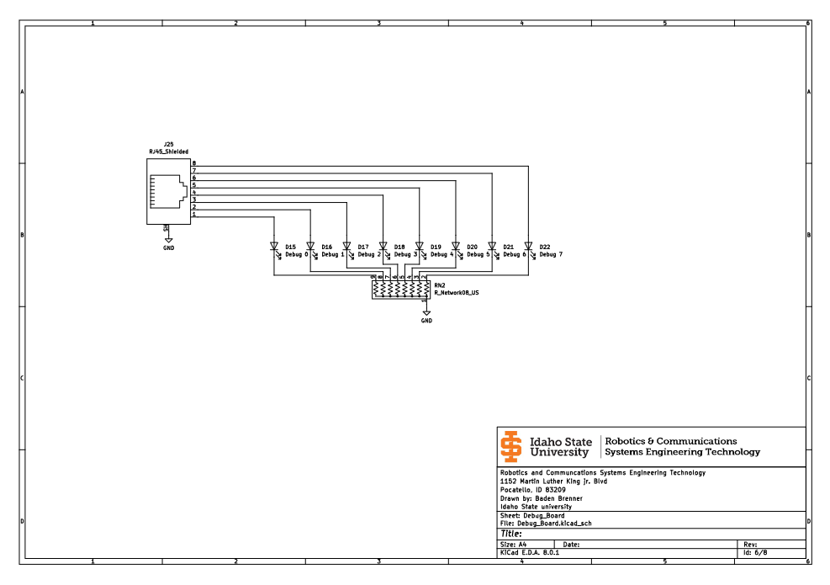

***Figure B.2.5 Debug Board Schematic***

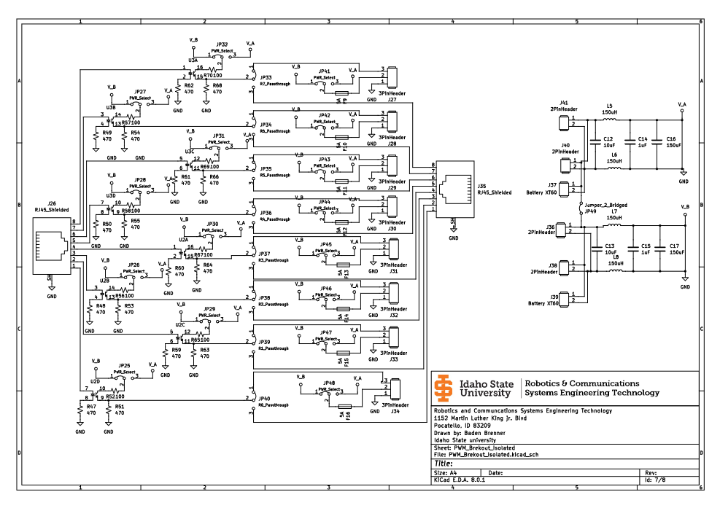

***Figure B.2.6 Optical Isolated Breakout Board Schematic***

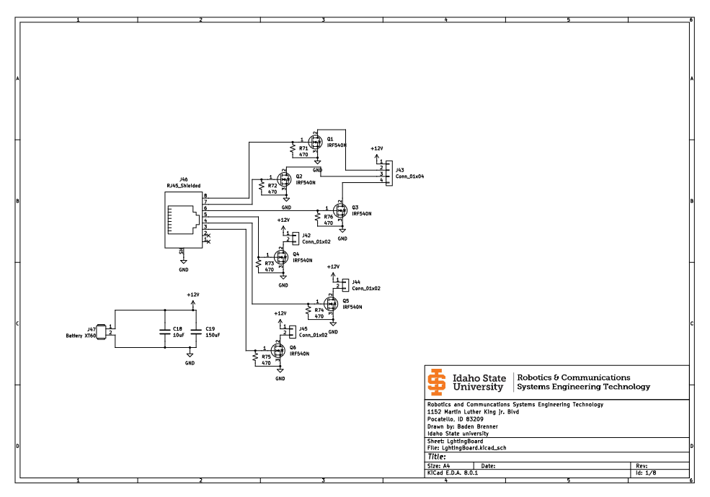

***Figure B.2.7 Lighting Board***

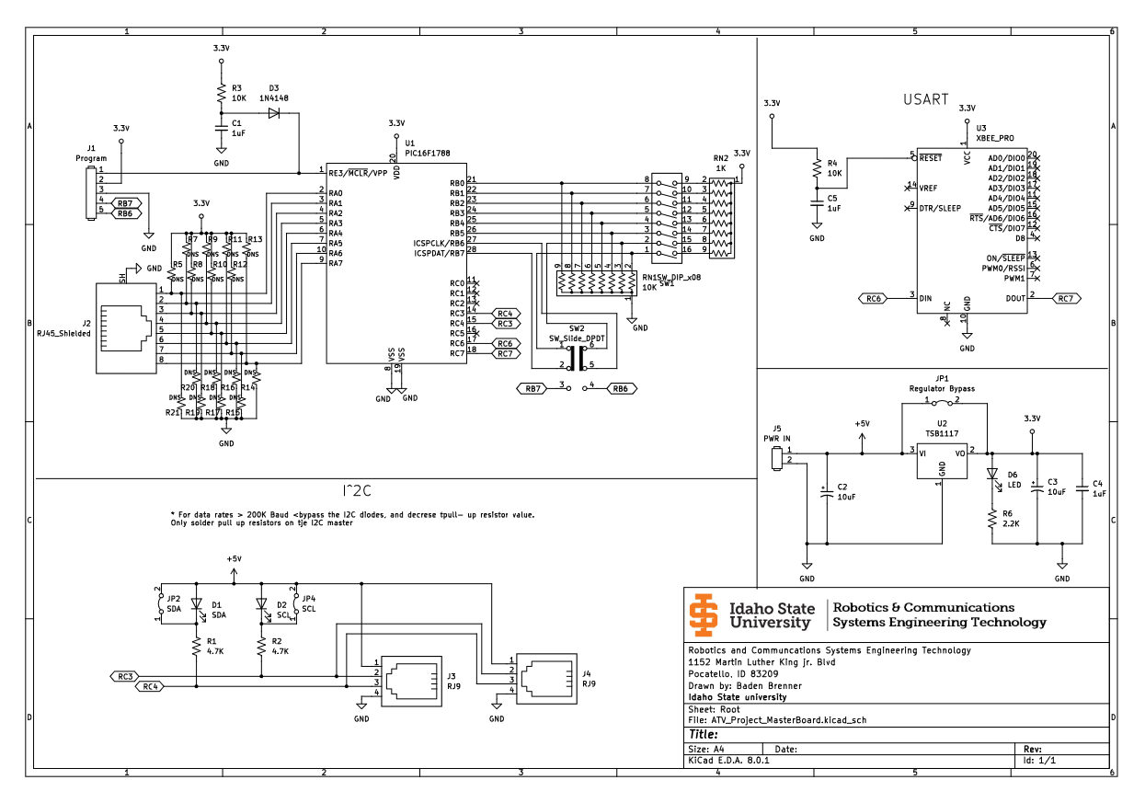

***Figure B.2.8 Master Board Schematic***

# 

# Appendix C: Bitmaps

# 

C.1 URC Bitmaps

| **W_SAVE** | | | | | | | |
| --- | --- | --- | --- | --- | --- | --- | --- |
| 7 (MSB) | 6 | 5 | 4 | 3 | 2 | 1 | 0 (LSB) |
| Stores the working register during an interrupt. | | | | | | | |
| **STATUS_SAVE** | | | | | | | |
| 7 (MSB) | 6 | 5 | 4 | 3 | 2 | 1 | 0 (LSB) |
| Saves the status register during an interrupt. | | | | | | | |
| **BTN_REG_1** | | | | | | | |
| 7 (MSB) | 6 | 5 | 4 | 3 | 2 | 1 | 0 (LSB) |
| JoyBtn1 | JoyBtn2 | Button 4 | Button 3 | Button 2 | Button 1 | Trigger 1 | Trigger 2 |
| **ADC_RESULT** | | | | | | | |
| 7 (MSB) | 6 | 5 | 4 | 3 | 2 | 1 | 0 (LSB) |
| Stores the result of the ADC (upper 8 bits) | | | | | | | |
| **TMR_CNT** | | | | | | | |
| 7 (MSB) | 6 | 5 | 4 | 3 | 2 | 1 | 0 (LSB) |
| Stores the timer 2 external count | | | | | | | |
| **RBT_ADDR** | | | | | | | |
| 7 (MSB) | 6 | 5 | 4 | 3 | 2 | 1 | 0 (LSB) |
| Stores the robot address | | | | | | | |
| **JOY1UD/LR & JOY2UD/LR & JOY3UD/LR** | | | | | | | |
| 7 (MSB) | 6 | 5 | 4 | 3 | 2 | 1 | 0 (LSB) |
| Stores the joystick up/down or left/right value for its respective joystick. (This is an 8-bit ADC result) | | | | | | | |
| **SHRT_TRM_REG** | | | | | | | |
| 7 (MSB) | 6 | 5 | 4 | 3 | 2 | 1 | 0 (LSB) |
| Used as a temporary register that can be written and read at any point in the code (except in an interrupt) | | | | | | | |
| **BTN_REG_2** | | | | | | | |
| 7 (MSB) | 6 | 5 | 4 | 3 | 2 | 1 | 0 (LSB) |
| Not Used | | | | | | Mode State | JoyBtn3 |
| **TX_CHAR** | | | | | | | |
| 7 (MSB) | 6 | 5 | 4 | 3 | 2 | 1 | 0 (LSB) |
| Stores the UART transmit character before transmitting | | | | | | | |
| **TX_VAR1/VAR2/VAR3** | | | | | | | |
| 7 (MSB) | 6 | 5 | 4 | 3 | 2 | 1 | 0 (LSB) |
| Stores the UART transmit variable 1/2/3 before transmitting | | | | | | | |
| **INFO_REG** | | | | | | | |
| 7 (MSB) | 6 | 5 | 4 | 3 | 2 | 1 | 0 (LSB) |
| Coast Indicator | Hard Stop Indicator | Lock Brakes Indicator | Toggle Speed State | T2 Int Indicator | Move FWD Indicator | Move BWD Indicator | Unused |
| **Newest_Byte** | | | | | | | |
| 7 (MSB) | 6 | 5 | 4 | 3 | 2 | 1 | 0 (LSB) |
| Stores the newest received byte from UART reception. | | | | | | | |
| **RX_HS** | | | | | | | |
| 7 (MSB) | 6 | 5 | 4 | 3 | 2 | 1 | 0 (LSB) |
| Stores the “ideally” received handshake from UART reception. | | | | | | | |
| **RX_ADDR** | | | | | | | |
| 7 (MSB) | 6 | 5 | 4 | 3 | 2 | 1 | 0 (LSB) |
| Stores the received address from UART reception. | | | | | | | |
| **RX_CHAR** | | | | | | | |
| 7 (MSB) | 6 | 5 | 4 | 3 | 2 | 1 | 0 (LSB) |
| Stores the received character from UART reception. | | | | | | | |
| **RX_VAR1/VAR2/VAR3** | | | | | | | |
| 7 (MSB) | 6 | 5 | 4 | 3 | 2 | 1 | 0 (LSB) |
| Stores the received variable 1/2/3 from UART reception. | | | | | | | |
| **RX_INFO_REG** | | | | | | | |
|  | | | | | | | |
| 7 (MSB) | 6 | 5 | 4 | 3 | 2 | 1 | 0 (LSB) |
| Storing data indicator | Handling data indicator | Unused | Unused | Unused | Received byte count (indicates what byte the reception is on in the 6 byte packet) | | |
| **SHRT_TRM_REG_INT** | | | | | | | |
|  | | | | | | | |
| 7 (MSB) | 6 | 5 | 4 | 3 | 2 | 1 | 0 (LSB) |
| A short term register used to temporarily store data (only meant for interrupts) | | | | | | | |
| **PERI_STATUS** | | | | | | | |
| 7 (MSB) | 6 | 5 | 4 | 3 | 2 | 1 | 0 (LSB) |
| Unused | Unused | Unused | Unused | Unused | Unused | Peripheral 50 Indicator | Peripheral 8 Indicator |
| **TX_DATA_XXH_VAR1/2/3** | | | | | | | |
| 7 (MSB) | 6 | 5 | 4 | 3 | 2 | 1 | 0 (LSB) |
| These registers store UART transmission data for the various actions on the RCET action list (XXH = hex character). These are transmitted when a “TX_SEND” is called. Refer to table 5.1.2 for the currently implemented action list | | | | | | | |
| **I2C_RX_REG1/2/3/4/5** | | | | | | | |
| 7 (MSB) | 6 | 5 | 4 | 3 | 2 | 1 | 0 (LSB) |
| This is used to store data from a received I^2C communication. Currently, these are unused. | | | | | | | |

C.2 Peripheral Controller (Address 8) Bitmap

| **W_SAVE** | | | | | | | |
| --- | --- | --- | --- | --- | --- | --- | --- |
| 7 (MSB) | 6 | 5 | 4 | 3 | 2 | 1 | 0 (LSB) |
| Stores the working register during an interrupt. | | | | | | | |
| **STATUS_SAVE** | | | | | | | |
| 7 (MSB) | 6 | 5 | 4 | 3 | 2 | 1 | 0 (LSB) |
| Saves the status register during an interrupt. | | | | | | | |
| **BTN_REG_1** | | | | | | | |
| 7 (MSB) | 6 | 5 | 4 | 3 | 2 | 1 | 0 (LSB) |
| Encoder 2 Switch | Encoder 1 Switch | Mode Select Switch | Button 5 | Button 4 | Button 3 | Button 2 | Button 1 |
| **INFO_REG_1** | | | | | | | |
| 7 (MSB) | 6 | 5 | 4 | 3 | 2 | 1 | 0 (LSB) |
| Encoder 1 CW step indicator | Encoder 1 CCW step indicator | Encoder 22 CW step indicator | Encoder 2 CCW step indicator | Unused | | | |
| **ENCODER_1_CNT** | | | | | | | |
| 7 (MSB) | 6 | 5 | 4 | 3 | 2 | 1 | 0 (LSB) |
| This register holds onto the encoder 1 step count | | | | | | | |
| **ENCODER_2_CNT** | | | | | | | |
| 7 (MSB) | 6 | 5 | 4 | 3 | 2 | 1 | 0 (LSB) |
| This register holds onto the encoder 2 step count | | | | | | | |
| **SHRT_TRM_REG** | | | | | | | |
| 7 (MSB) | 6 | 5 | 4 | 3 | 2 | 1 | 0 (LSB) |
| Used as a temporary register that can be written and read at any point in the code (except in an interrupt) | | | | | | | |
| **RX_I2C_VAR1** | | | | | | | |
| 7 (MSB) | 6 | 5 | 4 | 3 | 2 | 1 | 0 (LSB) |
| Unused | | | | | | | |
| **TESTING_REG** | | | | | | | |
| 7 (MSB) | 6 | 5 | 4 | 3 | 2 | 1 | 0 (LSB) |
| Unused | | | | | TX Byte 3 Indicator | TX Byte 2 Indicator | TX Byte 1 Indicator |

C.3 Master PIC Bitmaps

| PORTC - Master Board | | | | | | | |
| --- | --- | --- | --- | --- | --- | --- | --- |
| Bit 0 | Bit 1 | Bit 2 | Bit 3 | Bit 4 | Bit 5 | Bit 6 | Bit7 |
| N/A | N/A | N/A | SCL(I2C) | SDA(I2C) | N/A | TX(UART) | RX(UART) |

| TRISC - Master Board | | | | | | | |
| --- | --- | --- | --- | --- | --- | --- | --- |
| Bit 0 | Bit 1 | Bit 2 | Bit 3 | Bit 4 | Bit 5 | Bit 6 | Bit7 |
| X | X | X | 1 | 1 | X | 0 | 1 |
| Bits 3 & 4 are set as inputs for I2C communication, bit 6 is set as output for UART TX, and bit 7 is set as input for UART RX. | | | | | | | |

| COUNT - Master Board | | | | | | | |
| --- | --- | --- | --- | --- | --- | --- | --- |
| Bit 0 | Bit 1 | Bit 2 | Bit 3 | Bit 4 | Bit 5 | Bit 6 | Bit7 |
| Used to keep a count of UART bytes received and save received bytes in the correct registers | | | | | | | |

| COUNT_CHECK - Master Board | | | | | | | |
| --- | --- | --- | --- | --- | --- | --- | --- |
| Bit 0 | Bit 1 | Bit 2 | Bit 3 | Bit 4 | Bit 5 | Bit 6 | Bit7 |
| Used to compare the COUNT register to set values for properly saving received UART data. | | | | | | | |

| RECEIVE - Master Board | | | | | | | |
| --- | --- | --- | --- | --- | --- | --- | --- |
| Bit 0 | Bit 1 | Bit 2 | Bit 3 | Bit 4 | Bit 5 | Bit 6 | Bit7 |
| Flag used to indicate when all 6 data bytes have been received through UART | N/A | N/A | N/A | N/A | N/A | N/A | N/A |

| W_Save - Master Board | | | | | | | |
| --- | --- | --- | --- | --- | --- | --- | --- |
| Bit 0 | Bit 1 | Bit 2 | Bit 3 | Bit 4 | Bit 5 | Bit 6 | Bit7 |
| Used to Save the Working Register during an interrupt event. | | | | | | | |

| Status_Save - Master Board | | | | | | | |
| --- | --- | --- | --- | --- | --- | --- | --- |
| Bit 0 | Bit 1 | Bit 2 | Bit 3 | Bit 4 | Bit 5 | Bit 6 | Bit7 |
| Used to Save the Status Register during an interrupt event. | | | | | | | |

| BYTE_1 - Master Board | | | | | | | |
| --- | --- | --- | --- | --- | --- | --- | --- |
| Bit 0 | Bit 1 | Bit 2 | Bit 3 | Bit 4 | Bit 5 | Bit 6 | Bit7 |
| Used to save the first byte of data that is received over UART; also used to validate the sync byte sent from the controller. | | | | | | | |

| BYTE_2 - Master Board | | | | | | | |
| --- | --- | --- | --- | --- | --- | --- | --- |
| Bit 0 | Bit 1 | Bit 2 | Bit 3 | Bit 4 | Bit 5 | Bit 6 | Bit7 |
| Used to save the second byte of data that is received over UART, which is the address byte. | | | | | | | |

| BYTE_3 - Master Board | | | | | | | |
| --- | --- | --- | --- | --- | --- | --- | --- |
| Bit 0 | Bit 1 | Bit 2 | Bit 3 | Bit 4 | Bit 5 | Bit 6 | Bit7 |
| Used to save the third byte of data that is received over UART, which is the command byte. | | | | | | | |

| BYTE_4 - Master Board | | | | | | | |
| --- | --- | --- | --- | --- | --- | --- | --- |
| Bit 0 | Bit 1 | Bit 2 | Bit 3 | Bit 4 | Bit 5 | Bit 6 | Bit7 |
| Used to save the fourth byte of data that is received over UART, which is the first variable byte. | | | | | | | |

| BYTE_5 - Master Board | | | | | | | |
| --- | --- | --- | --- | --- | --- | --- | --- |
| Bit 0 | Bit 1 | Bit 2 | Bit 3 | Bit 4 | Bit 5 | Bit 6 | Bit7 |
| Used to save the fifth byte of data that is received over UART, which is the second variable byte. | | | | | | | |

| BYTE_6 - Master Board | | | | | | | |
| --- | --- | --- | --- | --- | --- | --- | --- |
| Bit 0 | Bit 1 | Bit 2 | Bit 3 | Bit 4 | Bit 5 | Bit 6 | Bit7 |
| Used to save the sixth byte of data that is received over UART, which is the third variable byte. | | | | | | | |

| TEMP_ADD - Master Board | | | | | | | |
| --- | --- | --- | --- | --- | --- | --- | --- |
| Bit 0 | Bit 1 | Bit 2 | Bit 3 | Bit 4 | Bit 5 | Bit 6 | Bit7 |
| Used to store and send the I2C address of the peripheral device of intended communication. | | | | | | | |

| DRIVE_COMMAND - Master Board | | | | | | | |
| --- | --- | --- | --- | --- | --- | --- | --- |
| Bit 0 | Bit 1 | Bit 2 | Bit 3 | Bit 4 | Bit 5 | Bit 6 | Bit7 |
| Used to send the appropriate command byte to the peripheral boards over I2C depending on the received UART data. | | | | | | | |

| DRIVE_DATA - Master Board | | | | | | | |
| --- | --- | --- | --- | --- | --- | --- | --- |
| Bit 0 | Bit 1 | Bit 2 | Bit 3 | Bit 4 | Bit 5 | Bit 6 | Bit7 |
| Used to send the appropriate data byte to the peripheral boards over I2C depending on the received UART data. | | | | | | | |

C.4 Drive PIC Bitmaps

| Port B-Drive Board | | | | | | | |
| --- | --- | --- | --- | --- | --- | --- | --- |
| Bit 0 | Bit 1 | Bit 2 | Bit 3 | Bit 4 | Bit 5 | Bit 6 | Bit7 |
| N/A | N/A | N/A | N/A | N/A | N/A | N/A | Row 4 |

| Port A-Drive Board | | | | | | | |
| --- | --- | --- | --- | --- | --- | --- | --- |
| Bit 0 | Bit 1 | Bit 2 | Bit 3 | Bit 4 | Bit 5 | Bit 6 | Bit7 |
| Tank Pressure | N/A | N/A | N/A | N/A | N/A | N/A | N/A |

| Port C-Drive Board | | | | | | | |
| --- | --- | --- | --- | --- | --- | --- | --- |
| Bit 0 | Bit 1 | Bit 2 | Bit 3 | Bit 4 | Bit 5 | Bit 6 | Bit7 |
| N/A | CCP1(Stering) | CCP2(Drive) | SCL(I2C) | SDA(I2C) | N/A | N/A | N/A |

| ADCSave-Drive Board | | | | | | | |
| --- | --- | --- | --- | --- | --- | --- | --- |
| Bit 0 | Bit 1 | Bit 2 | Bit 3 | Bit 4 | Bit 5 | Bit 6 | Bit7 |
| Used to save the ADC value | | | | | | | |

| ADCCount-Drive Board | | | | | | | |
| --- | --- | --- | --- | --- | --- | --- | --- |
| Bit 0 | Bit 1 | Bit 2 | Bit 3 | Bit 4 | Bit 5 | Bit 6 | Bit7 |
| Used to manipulate the ADC value | | | | | | | |

| W_Save-Drive Board | | | | | | | |
| --- | --- | --- | --- | --- | --- | --- | --- |
| Bit 0 | Bit 1 | Bit 2 | Bit 3 | Bit 4 | Bit 5 | Bit 6 | Bit7 |
| Used to Save the Working Register | | | | | | | |

| Status_Save-Drive Board | | | | | | | |
| --- | --- | --- | --- | --- | --- | --- | --- |
| Bit 0 | Bit 1 | Bit 2 | Bit 3 | Bit 4 | Bit 5 | Bit 6 | Bit7 |
| Used to Save the Status Register | | | | | | | |

| Turn_Data-Drive Board | | | | | | | |
| --- | --- | --- | --- | --- | --- | --- | --- |
| Bit 0 | Bit 1 | Bit 2 | Bit 3 | Bit 4 | Bit 5 | Bit 6 | Bit7 |
| Used to Save the Turn data | | | | | | | |

| SaveData3-Drive Board | | | | | | | |
| --- | --- | --- | --- | --- | --- | --- | --- |
| Bit 0 | Bit 1 | Bit 2 | Bit 3 | Bit 4 | Bit 5 | Bit 6 | Bit7 |
| Used to Save the I2C data upon receive | | | | | | | |

| Byteint-Drive Board | | | | | | | |
| --- | --- | --- | --- | --- | --- | --- | --- |
| Bit 0 | Bit 1 | Bit 2 | Bit 3 | Bit 4 | Bit 5 | Bit 6 | Bit7 |
| N/A | N/A | N/A | N/A | REVERCEIND | FORWARDING | TURNIND | DRIVEIND |

| Forward_Data-Drive Board | | | | | | | |
| --- | --- | --- | --- | --- | --- | --- | --- |
| Bit 0 | Bit 1 | Bit 2 | Bit 3 | Bit 4 | Bit 5 | Bit 6 | Bit7 |
| Used to Save the forward Data | | | | | | | |

| Reveive_Data-Drive Board | | | | | | | |
| --- | --- | --- | --- | --- | --- | --- | --- |
| Bit 0 | Bit 1 | Bit 2 | Bit 3 | Bit 4 | Bit 5 | Bit 6 | Bit7 |
| Used to Save the Receive Data | | | | | | | |

| Drive_Data-Drive Board | | | | | | | |
| --- | --- | --- | --- | --- | --- | --- | --- |
| Bit 0 | Bit 1 | Bit 2 | Bit 3 | Bit 4 | Bit 5 | Bit 6 | Bit7 |
| Used to Save the Drive Data | | | | | | | |

| Stering_Data-Drive Board | | | | | | | |
| --- | --- | --- | --- | --- | --- | --- | --- |
| Bit 0 | Bit 1 | Bit 2 | Bit 3 | Bit 4 | Bit 5 | Bit 6 | Bit7 |
| Used to Save the Steering Data | | | | | | | |

# 

C.5 Turret PIC Bitmaps

| Port B-Turret Board | | | | | | | |
| --- | --- | --- | --- | --- | --- | --- | --- |
| Bit 0 | Bit 1 | Bit 2 | Bit 3 | Bit 4 | Bit 5 | Bit 6 | Bit7 |
| N/A | N/A | N/A | N/A | N/A | N/A | N/A | Row 4 |

| Port A-Turret Board | | | | | | | |
| --- | --- | --- | --- | --- | --- | --- | --- |
| Bit 0 | Bit 1 | Bit 2 | Bit 3 | Bit 4 | Bit 5 | Bit 6 | Bit7 |
| N/A | N/A | N/A | N/A | N/A | N/A | N/A | N/A |

| Port C-Turret Board | | | | | | | |
| --- | --- | --- | --- | --- | --- | --- | --- |
| Bit 0 | Bit 1 | Bit 2 | Bit 3 | Bit 4 | Bit 5 | Bit 6 | Bit7 |
| N/A | CCP1(Yaxis) | CCP2(Xaxis) | SCL(I2C) | SDA(I2C) | N/A | N/A | N/A |

| ADCSave-Turret Board | | | | | | | |
| --- | --- | --- | --- | --- | --- | --- | --- |
| Bit 0 | Bit 1 | Bit 2 | Bit 3 | Bit 4 | Bit 5 | Bit 6 | Bit7 |
| Used to save the ADC value | | | | | | | |

| ADCCount-Turret Board | | | | | | | |
| --- | --- | --- | --- | --- | --- | --- | --- |
| Bit 0 | Bit 1 | Bit 2 | Bit 3 | Bit 4 | Bit 5 | Bit 6 | Bit7 |
| Used to manipulate the ADC value | | | | | | | |

| W_Save-Turret Board | | | | | | | |
| --- | --- | --- | --- | --- | --- | --- | --- |
| Bit 0 | Bit 1 | Bit 2 | Bit 3 | Bit 4 | Bit 5 | Bit 6 | Bit7 |
| Used to Save the Working Register | | | | | | | |

| Status_Save-Turret Board | | | | | | | |
| --- | --- | --- | --- | --- | --- | --- | --- |
| Bit 0 | Bit 1 | Bit 2 | Bit 3 | Bit 4 | Bit 5 | Bit 6 | Bit7 |
| Used to Save the Status Register | | | | | | | |

| Tilt_Data-Turret Board | | | | | | | |
| --- | --- | --- | --- | --- | --- | --- | --- |
| Bit 0 | Bit 1 | Bit 2 | Bit 3 | Bit 4 | Bit 5 | Bit 6 | Bit7 |
| Used to Save the Tilt data | | | | | | | |

| SaveData3-Turret Board | | | | | | | |
| --- | --- | --- | --- | --- | --- | --- | --- |
| Bit 0 | Bit 1 | Bit 2 | Bit 3 | Bit 4 | Bit 5 | Bit 6 | Bit7 |
| Used to Save the I2C data upon receive | | | | | | | |

| Byteind-Turret Board | | | | | | | |
| --- | --- | --- | --- | --- | --- | --- | --- |
| Bit 0 | Bit 1 | Bit 2 | Bit 3 | Bit 4 | Bit 5 | Bit 6 | Bit7 |
| N/A | N/A | N/A | N/A | N/A | N/A | TILTING | PANIND |

| Pan_Data-Turret Board | | | | | | | |
| --- | --- | --- | --- | --- | --- | --- | --- |
| Bit 0 | Bit 1 | Bit 2 | Bit 3 | Bit 4 | Bit 5 | Bit 6 | Bit7 |
| Used to Save the Pan Data | | | | | | | |

| Xaxis-Turret Board | | | | | | | |
| --- | --- | --- | --- | --- | --- | --- | --- |
| Bit 0 | Bit 1 | Bit 2 | Bit 3 | Bit 4 | Bit 5 | Bit 6 | Bit7 |
| Used to Save the Xaxis Data | | | | | | | |

| YAxis-Turret Board | | | | | | | |
| --- | --- | --- | --- | --- | --- | --- | --- |
| Bit 0 | Bit 1 | Bit 2 | Bit 3 | Bit 4 | Bit 5 | Bit 6 | Bit7 |
| Used to Save the Drive Data | | | | | | | |

| Preshure_set-Turret Board | | | | | | | |
| --- | --- | --- | --- | --- | --- | --- | --- |
| Bit 0 | Bit 1 | Bit 2 | Bit 3 | Bit 4 | Bit 5 | Bit 6 | Bit7 |
| Used to Save the Pressure Setpoint | | | | | | | |

# 

# Appendix D: Flowcharts

# 

D.1 URC and Peripheral Flow Charts

***Figure D.1.1 URC Main Flowchart (Left)***

***Figure D.1.2 URC Main Mode 2 Flowchart (Right)***

***- Figure D.1.3 URC Main Mode 1 Flowchart (1/2) (Left)***

***- Figure D.1.4 URC Main Mode 1 Flowchart (2/2) (Right)***



***Figure D.1.5 “SEND_DATA_PACKET” Protocol***

***Figure D.1.6 “TX_SEND” Protocol******Figure D.1.7 “REC_BYTE” Protocol***

***Figure D.1.8 “HANDLE_RX_DATA” Protocol******Figure D.1.9 General “I^2C Idle” Protocol***

***Figure D.1.10 General “Identify Peripheral” Protocol***

***Figure D.1.11 General “Never Acknowledge” Protocol***

***Figure D.1.12 “Read From Peripheral 8” Subroutine (Left)***



***Figure D.1.15 “Transmit Command” Subroutine***



***Figure D.1.14 “Transmit Character” Subroutine***

***Figure D.1.15 “Identify Peripheral Address 50” Subroutine (Updated from General) (Left)***

***Figure D.1.16 “Write To Peripheral 50” Subroutine (Right)***

***Figure D.1.17 Peripheral Controller Main Flowchart (Left)***

***Figure D.1.18 Peripheral Controller Main Mode 1 Flowchart (Right Top)***

***Figure D.1.19 Peripheral Controller Main Mode 3 Flowchart (Right Bottom)***

***Figure D.1.20 Peripheral Controller Interrupt Service Routine***

D.2 On-Bot Master Flow Charts

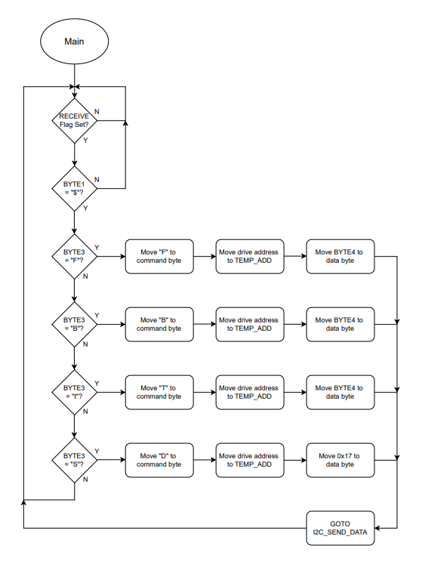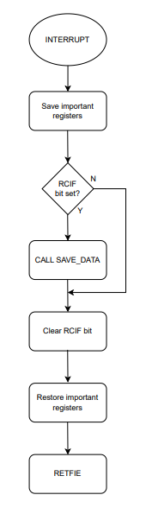

***Figure D.2.1 Master Board Main Loop and Interrupt Flowchart***

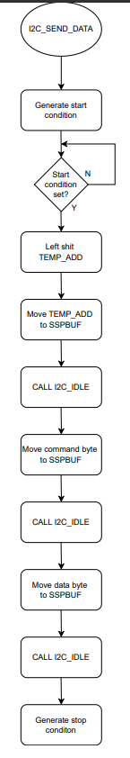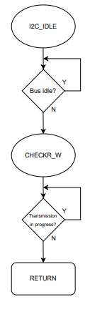

***Figure D.2.2 I2C Send and Idle Flowcharts***

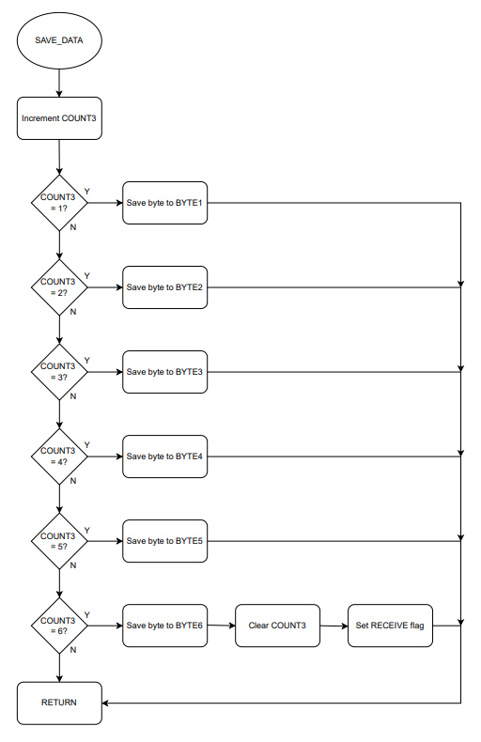

***Figure D.2.23 UART Save Flowchart***

# D.3 On-Bot Slave Flow Charts



# ***Figure D.2.4 Driveboard Main***



***Figure D.2.5 Driveboard Interrupt Service Routine***

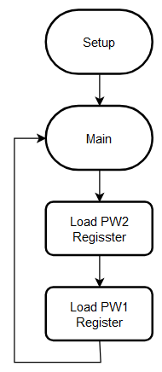

***Figure D.2.6 Turret Board Main***

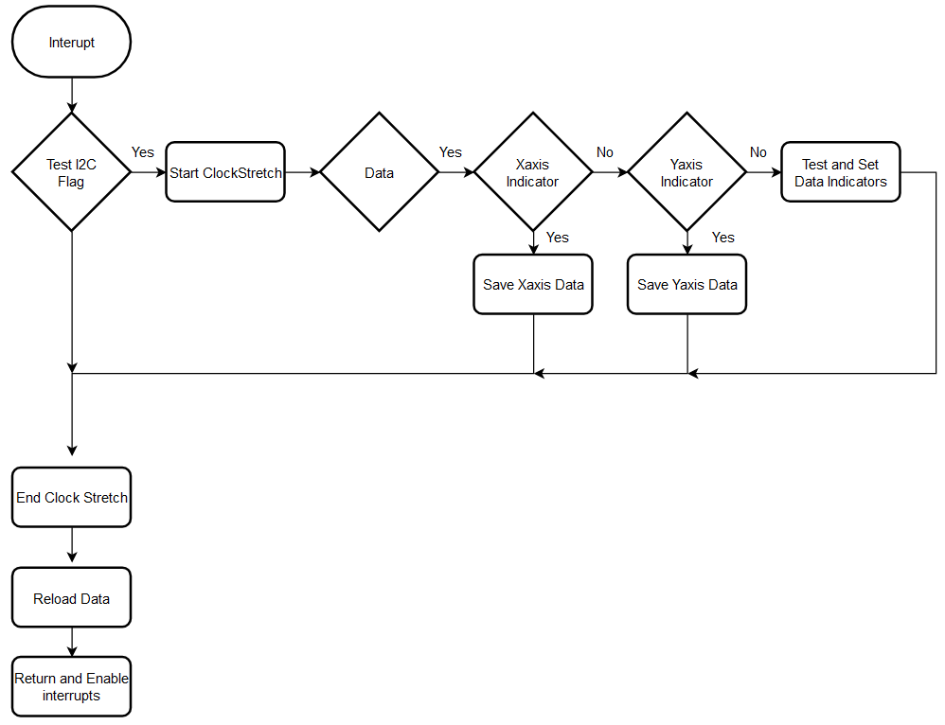

***Figure D.2.7 Turret Board Interrupt Service Routine***

# 

# 

# Appendix E: Code Printouts

# 

E.1 URC Main ASM (MiniATV_Controller_Master_Code.asm)

;******************************************************************************

; *

; Filename: MiniATV_Controller_Master_Code.asm *

; Date: November 9, 2023 *

; File Version: 8 *

; Author: Joshua Makuch *

; Company: Idaho State University *

; Description: Firmware for runing the Master PIC for the MiniATV *

; Controller *

; *

;******************************************************************************

;******************************************************************************

; *

; Revision History: *

; 1: Basic setup for the PIC16LF1789. Test program for the dev board *

; increments portb to indicate that the 1789 was soldered correctly *

; 2: This version will now have 3 joysticks, 7 buttons, 2 triggers, *

; a mode select switch, robot address dip switch package, and *

; several LED indicators. *

; 3: UART transmission and reception function. Mode 1 utilizes nearly *

; all controls to function. Mode 2 is a button test display. Only *

; drive works ATM however. *

; 5: UART still works, however, UART is now 115.2k Baud Rate as well as *

; a PCB has been made for this design. I2C is about to begin *

; development. *

; 6: ADC has been fixed. The issue was that AN6 was being toggled and *

; causing PORTE pin1 (button 2) to accidentally toggle and tie to *

; another analog input, creating a spike and toggling the input. *

; Additionally, basic I2C has been integrated. *

; 7: This version utilizes the lock brakes button for use in I2C comms *

; testing. This overwrites a lot of stuff, don't use this version *

; 8: This is the final version of the 2024 spring semester. This *

; version contains procedures for handling two peripherals as well *

; as a semi-functioning disconnect/connect indicator. Additionally *

; work has been done for UART TX and RX. Refer to the report. This *

; is meant to be the template version for future designs. Any *

; offshoots from here will require the user to alter the include *

; files and main code. Good luck from here future coders :D 4/25/24 *

; *

; STARTED NOV 17 2023 - CURRENT VERSION IMPLEMENTED *

; *

;******************************************************************************

;******************************************************************************

; *

; PERIPHERAL ALLOCATION IN THE PERI_STATUS REGISTER: *

; 7 - N/A *

; 6 - N/A *

; 5 - N/A *

; 4 - N/A *

; 3 - N/A *

; 2 - N/A *

; 1 - PERI_ADR50 (JVE-S2 LCD SCREEN) *

; 0 - PERI_ADR8 (TURRET CONTROLLER) *

; *

;******************************************************************************

LIST p=16LF1789

INCLUDE P16LF1789.INC

INCLUDE 1789_SETUP.INC

INCLUDE 1789_UART.INC

INCLUDE 1789_PERIPHERAL_ADR8.INC

INCLUDE 1789_PERIPHERAL_ADR50.INC

; CONFIG1

; __config 0xEFE4

__CONFIG _CONFIG1, _FOSC_INTOSC & _WDTE_OFF & _PWRTE_OFF & _MCLRE_ON & _CP_OFF & _CPD_OFF & _BOREN_OFF & _CLKOUTEN_OFF & _IESO_OFF & _FCMEN_OFF

; CONFIG2

; __config 0xFFFF

__CONFIG _CONFIG2, _WRT_OFF & _PLLEN_OFF & _STVREN_ON & _BORV_LO & _LPBOR_OFF & _LVP_ON

;suppress "not in bank 0" message, Found label after column 1,

errorlevel -302,-207,-305,-206,-203

;******************************************

;ORIGIN VECTORS & SETUP

;******************************************

ORG H'000'

GOTO SETUP ;RESET CONDITION GOTO SETUP

ORG H'004'

GOTO INTERUPT

SETUP

CALL INITIALIZE ;CALLS THE SETUP FILE 1788_SETUP.INC

GOTO MAIN

;******************************************

;INTERUPT SERVICE ROUTINE

;******************************************

INTERUPT

BANKSEL W_SAVE

MOVWF W_SAVE ;SAVE WORKING REGISTER CONTENTS

BANKSEL STATUS

MOVFW STATUS

MOVWF STATUS_SAVE ;SAVES STATUS REGISTER CONTENTS

BANKSEL PIR1

BTFSC PIR1, RCIF ;TESTS THE RECEIVE INTERRUPT FLAG, IF SET CALL RECEIVED_BYTE

CALL REC_BYTE

BANKSEL PIR1

BTFSC PIR1, TMR2IF ;IF TIMER2 INTERRUPT FLAG, THEN HANDLE TIMER COUNT

CALL HANDLE_T2_INT

BANKSEL PIR1

BCF PIR1, SSP1IF

BANKSEL STATUS_SAVE ;RECALL STATUS REGISTER CONTENTS

MOVFW STATUS_SAVE

MOVWF STATUS ;RESTORE STATUS REGISTER CONTENTS

BANKSEL W_SAVE

MOVFW W_SAVE ;RESTORE WORKING REGISTER CONTENTS

RETFIE ;RETURN AND RESET INTERRUPT ENABLE BITS

;******************************************

; SUBROUTINES

;******************************************

;*** HANDLE T2_INT *************************************

HANDLE_T2_INT

BANKSEL PIR1 ;PG.36

BCF PIR1, TMR2IF ;TMR2 INTERRUPT FLAG RESET

BANKSEL TMR_CNT

DECFSZ TMR_CNT ;IF ? COUNTS OF TMR_CNT HAS OCCURED, RESET THE COUNT

RETURN

BANKSEL TMR_CNT

MOVLW D'024'

MOVWF TMR_CNT

BANKSEL INFO_REG

BSF INFO_REG, 3

RETURN

;*** CONVERSION_DONE ***********************************

CONVERSION_DONE

BANKSEL ADCON0 ;TEMPORARILY STORES ADCON0 FOR USE IN ANALOG READING

MOVFW ADCON0

BANKSEL SHRT_TRM_REG

MOVWF SHRT_TRM_REG

MOVLW B'00000100' ;INCREMENT "ADCON0" ANALOG CHANNEL SELECT IN SHRT_TRM_REG

BANKSEL SHRT_TRM_REG

ADDWF SHRT_TRM_REG, 1

MOVLW B'10011001' ;IF ("ANALOG SELECT CHANNEL" = AN6) THEN:

BANKSEL SHRT_TRM_REG ;RESET ADCON0 ANALOG SELECT CHANNEL TO AN0

XORWF SHRT_TRM_REG, 0 ;ELSE:

BANKSEL STATUS ;INCREMENT ADCON0 ANALOG CHANNEL SELECT

BTFSS STATUS, Z

GOTO SEC_CON_ADC_1

BANKSEL ADCON0

BCF ADCON0, CHS4

BCF ADCON0, CHS3

BCF ADCON0, CHS2

BCF ADCON0, CHS1

BCF ADCON0, CHS0

GOTO END_ADC_1

SEC_CON_ADC_1

MOVLW B'00000100'

BANKSEL ADCON0

ADDWF ADCON0, 1

END_ADC_1

MOVLW B'00000100'

BANKSEL SHRT_TRM_REG

SUBWF SHRT_TRM_REG, 1

BANKSEL ADRESH ;STORES THE UPPER 8-BIT ADC CONVERSTION RESULT INTO ADC_RESULT

MOVFW ADRESH

BANKSEL ADC_RESULT

MOVWF ADC_RESULT

;SELECT CASE (ANALOG SELECT CHANNEL (ANX)):

MOVLW B'10000001' ;CASE 0

BANKSEL SHRT_TRM_REG ;STORE ADC_RESULT INTO JOY1UD

XORWF SHRT_TRM_REG, 0

BANKSEL STATUS

BTFSS STATUS, Z

GOTO $ + 4

BANKSEL ADC_RESULT

MOVFW ADC_RESULT

MOVWF JOY1UD

MOVLW B'10000101' ;CASE 1

BANKSEL SHRT_TRM_REG ;STORE ADC_RESULT INTO JOY1LR

XORWF SHRT_TRM_REG, 0

BANKSEL STATUS

BTFSS STATUS, Z

GOTO $ + 4

BANKSEL ADC_RESULT

MOVFW ADC_RESULT

MOVWF JOY1LR

MOVLW B'10001001' ;CASE 2

BANKSEL SHRT_TRM_REG ;STORE ADC_RESULT INTO JOY2UD

XORWF SHRT_TRM_REG, 0

BANKSEL STATUS

BTFSS STATUS, Z

GOTO $ + 4

BANKSEL ADC_RESULT

MOVFW ADC_RESULT

MOVWF JOY2UD

MOVLW B'10001101' ;CASE 3

BANKSEL SHRT_TRM_REG ;STORE ADC_RESULT INTO JOY2LR

XORWF SHRT_TRM_REG, 0

BANKSEL STATUS

BTFSS STATUS, Z

GOTO $ + 4

BANKSEL ADC_RESULT

MOVFW ADC_RESULT

MOVWF JOY2LR

MOVLW B'10010001' ;CASE 4

BANKSEL SHRT_TRM_REG ;STORE ADC_RESULT INTO JOY3UD

XORWF SHRT_TRM_REG, 0

BANKSEL STATUS

BTFSS STATUS, Z

GOTO $ + 4

BANKSEL ADC_RESULT

MOVFW ADC_RESULT

MOVWF JOY3UD

MOVLW B'10010101' ;CASE 5

BANKSEL SHRT_TRM_REG ;STORE ADC_RESULT INTO JOY3LR

XORWF SHRT_TRM_REG, 0

BANKSEL STATUS

BTFSS STATUS, Z

GOTO $ + 4

BANKSEL ADC_RESULT

MOVFW ADC_RESULT

MOVWF JOY3LR

;END CASE

BANKSEL ADCON0

BSF ADCON0, 1 ;BEGIN A NEW CONVERSION

RETURN

;*** SET_HARD_STOP ************************

SET_HARD_STOP

BANKSEL INFO_REG

BSF INFO_REG, 6

BCF INFO_REG, 7

CALL TX_SEND_HARD_STOP

RETURN

;*** TOGGLE_LOCK_BRAKES *******************

TOGGLE_LOCK_BRAKES

BANKSEL INFO_REG ;FLIP THE LOCK BRAKES STATE

MOVLW B'00100000'

XORWF INFO_REG, 1

MOVLW 0X00 ;IF (LOCK BRAKES STATE) THEN:

BTFSC INFO_REG, 5 ;SET TX_DATA_44H_VAR11 TO LOCK BRAKES

MOVLW 0X01 ;ELSE

MOVWF TX_DATA_44H_VAR1 ;SET TX_DATA_44H_VAR1 TO RELEASE BRAKES

CALL TX_SEND_LOCK_BRAKES

BANKSEL BTN_REG_1 ;CLEAR BUTTON 2 INDICATOR

BCF BTN_REG_1, 3 ;CLEAR COAST AND HARD STOP INDICATORS

BANKSEL INFO_REG

BCF INFO_REG, 7

BCF INFO_REG, 6

RETURN

;*** TOGGLE_SPEED *************************

TOGGLE_SPEED

BANKSEL BTN_REG_1 ;CLEAR JOYBTN1 INDICATOR

BCF BTN_REG_1, 6

BANKSEL INFO_REG ;FLIP THE TOGGLE SPEED STATE

MOVLW B'00010000'

XORWF INFO_REG, 1

RETURN

;*** SET_FWD_VAR **************************

SET_FWD_VAR

BANKSEL JOY1UD ;SET TX_DATA_42H_VAR1 TO 2 * (JOY1UD - 128)

MOVFW JOY1UD

BANKSEL TX_DATA_46H_VAR1

MOVWF TX_DATA_46H_VAR1

MOVLW D'128'

SUBWF TX_DATA_46H_VAR1, 1

LSLF TX_DATA_46H_VAR1, 1

BANKSEL INFO_REG

BTFSC INFO_REG, 4 ;IF (TOGGLED SPEED) THEN:

LSRF TX_DATA_46H_VAR1, 1 ;TX_DATA_42H_VAR1 = TX_DATA_42H_VAR1 / 4

BTFSC INFO_REG, 4

LSRF TX_DATA_46H_VAR1, 1

CALL TX_SEND_MOVE_FORWARD

BANKSEL INFO_REG

BCF INFO_REG, 7 ;CLEAR COAST INDICATOR (INFO_REG, 7)

BANKSEL INFO_REG

BSF INFO_REG, 2 ;SET MOVE FWD INDICATOR

RETURN

;*** SET_BWD_VAR **************************

SET_BWD_VAR

BANKSEL JOY1UD ;SET TX_DATA_42H_VAR1 TO 255 - (JOY1UD * 2)

MOVFW JOY1UD

BANKSEL TX_DATA_42H_VAR1

MOVWF TX_DATA_42H_VAR1

LSLF TX_DATA_42H_VAR1, 1

MOVFW TX_DATA_42H_VAR1

SUBLW D'255'

MOVWF TX_DATA_42H_VAR1

BANKSEL INFO_REG

BTFSC INFO_REG, 4 ;IF (TOGGLED SPEED) THEN:

LSRF TX_DATA_42H_VAR1, 1 ;TX_DATA_42H_VAR1 = TX_DATA_42H_VAR1 / 4

BANKSEL INFO_REG

BTFSC INFO_REG, 4

LSRF TX_DATA_42H_VAR1, 1

CALL TX_SEND_MOVE_BACK

BANKSEL INFO_REG

BCF INFO_REG, 7 ;CLEAR COAST INDICATOR (INFO_REG, 7)

BANKSEL INFO_REG

BSF INFO_REG, 1 ;SET MOVE BWD INDICATOR

RETURN

;******************************************

MODE_1_MAIN

;******************************************

BANKSEL PERI_STATUS ;IF (PERI_ADR8 ISN'T CONNECTED) THEN:

BTFSS PERI_STATUS, 0 ;CALL IDENTIFY_PERIPHERAL_ADR8

CALL IDENTIFY_PERIPHERAL_ADR8

BANKSEL PERI_STATUS ;IF (PERI_ADR50 ISN'T CONNECTED) THEN:

BTFSS PERI_STATUS, 1 ;CALL IDENTIFY_PERIPHERAL_ADR5

CALL IDENTIFY_PERIPHERAL_ADR50

BANKSEL PERI_STATUS ;IF (PERI_ADR8 IS CONNECTED) THEN:

BTFSC PERI_STATUS, 0 ;CALL READ_FROM_PERIPHERAL_ADR8

CALL READ_FROM_PERIPHERAL_ADR8

BANKSEL PERI_STATUS ;IF (PERI_ADR50 IS CONNECTED) THEN:

BTFSC PERI_STATUS, 1 ;CALL WRITE_TO_PERIPHERAL_ADR8

CALL WRITE_TO_PERIPHERAL_ADR50

BANKSEL JOY1LR ;SEND ALTERNATE TURN BASED OFF OF (JOY1LR)

MOVFW JOY1LR

MOVWF TX_DATA_74H_VAR1

CALL TX_SEND_ALTERNATE_TURN

BANKSEL PERI_STATUS ;IF (PERI_ADR50 CONNECTED) THEN:

BTFSC PERI_STATUS, 1 ;SET PERI_ADR50 CONNECTED INDICATOR

GOTO PERI_ADR50_INDICATOR_ON ;ELSE:

BTFSS PERI_STATUS, 1 ;CLEAR PERI_ADR50 CONNECTED INDICATOR

GOTO PERI_ADR50_INDICATOR_OFF

PERI_ADR50_INDICATOR_ON

BANKSEL PORTD

BSF PORTD, 6

GOTO PERI_ADR50_INIDICATOR_END

PERI_ADR50_INDICATOR_OFF

BANKSEL PORTD

BCF PORTD, 6

GOTO PERI_ADR50_INIDICATOR_END

PERI_ADR50_INIDICATOR_END

MOVLW D'150' ;IF (JOY1UD > 150) THEN:

BANKSEL JOY1UD ;SET PORTD BIT 0 (LED INDICATOR)

SUBWF JOY1UD, 0 ;ELSE

BANKSEL STATUS ;CLEAR PORTD BIT

BTFSC STATUS, C

BSF PORTD, 0

BTFSS STATUS, C

BCF PORTD, 0

MOVLW D'150'

BANKSEL JOY1LR

SUBWF JOY1LR, 0

BANKSEL STATUS

BTFSC STATUS, C

BSF PORTD, 1

BTFSS STATUS, C

BCF PORTD, 1

BANKSEL BTN_REG_1 ;IF (JOYBTN1 & !PORTC_1) THEN:

BTFSS BTN_REG_1, 6 ;CALL TOGGLE_SPEED

GOTO TOGGLE_SPEED_END1 ;SET TX_VAR1 = TX_VAR1 / 4

BTFSC PORTC, 1 ;CLEAR JOYBTN1 INDICATOR

GOTO TOGGLE_SPEED_END1

CALL TOGGLE_SPEED

TOGGLE_SPEED_END1

BANKSEL INFO_REG

BSF INFO_REG, 7 ;SET COAST INDICATOR (INFO_REG, 7)

BANKSEL INFO_REG

BCF INFO_REG, 2

MOVLW D'150' ;IF (JOY1UD > 150) THEN:

BANKSEL JOY1UD ;CALL SET_FWD_VAR

SUBWF JOY1UD, 0 ;SET MOVE FWD INDICATOR

BANKSEL STATUS ;CLEAR COAST INDICATOR (INFO_REG, 7)

BTFSC STATUS, C ;ELSE:

CALL SET_FWD_VAR ;CLEAR MOVE FWD INDICATOR

BANKSEL INFO_REG

BCF INFO_REG, 1

MOVLW D'113' ;IF (JOY1UD < 113) THEN:

BANKSEL JOY1UD ;CALL SET_BWD_VAR

SUBWF JOY1UD, 0 ;SET MOVE BWD INDICATOR

BANKSEL STATUS ;CLEAR COAST INDICATOR (INFO_REG, 7)

BTFSS STATUS, C ;ELSE:

CALL SET_BWD_VAR ;SET MOVE BWD INDICATOR

BANKSEL BTN_REG_1 ;IF (BUTTON 1 PRESSED) THEN:

BTFSS BTN_REG_1, 2 ;CLEAR COAST INDICATOR

BCF INFO_REG, 6 ;SET HARDSTOP INDICATOR

BTFSC BTN_REG_1, 2 ;ELSE:

CALL SET_HARD_STOP ;CLEAR HARDSTOP INDICATOR

BANKSEL BTN_REG_1 ;IF (BTN2_IND & !PORTE_1) THEN:

BTFSS BTN_REG_1, 3 ;CALL TOGGLE_LOCK_BRAKES

GOTO LOCK_BRAKES_END1 ;CLEAR COAST INDICATOR

BTFSS PORTE, 1 ;CLEAR HARD STOP INDICATOR

CALL TOGGLE_LOCK_BRAKES

LOCK_BRAKES_END1

BANKSEL INFO_REG ;IF (COAST INDICATOR) THEN:

BTFSC INFO_REG, 7 ;CALL SEND_COAST

CALL TX_SEND_STOP ;CLEAR COAST INDICATOR (INFO_REG, 7)

BANKSEL PERI_STATUS ;IF (PERIPHERAL 0 CONNECTED) THEN:

BTFSC PERI_STATUS, 0 ;GOTO MAIN1_PERI_CONTROLLER AND INDICATE CONNECTED

GOTO MAIN1_PERI_CONTROLLER ;ELSE:

GOTO MAIN1_ORIGINAL_CONTROLLER ;GOTO MAIN1_ORIGINAL_CONTROLLER AND INDICATE DISCONNECTED

MAIN1_PERI_CONTROLLER

BANKSEL PORTD ;INDICATE PERIPHERAL CONTROLLER CONNECTED

BSF PORTD, 7

CALL TX_SEND_CANNON_X_AXIS_AND_Y_AXIS ;THE PERIPHERAL_ADR8 FILE SHOULD HAVE HANDELED ALL APPROPRIATE DATA

CALL TX_SEND_CANNON_MECHANISM ;THE PERIPHERAL_ADR8 FILE SHOULD HAVE HANDELED ALL APPROPRIATE DATA

GOTO MAIN ;EXIT MODE 1

MAIN1_ORIGINAL_CONTROLLER

BANKSEL PORTD ;INDICATE PERIPHERAL CONTROLLER DISCONNECTED

BCF PORTD, 7

BANKSEL TX_DATA_43H_VAR1 ;SEND CANNON X/Y-AXIS BASED OFF OF (JOY3LR) AND (JOY3UD), RESPECTIVELY

MOVFW JOY3LR

MOVWF TX_DATA_43H_VAR1

MOVFW JOY3UD

MOVWF TX_DATA_43H_VAR2

CALL TX_SEND_CANNON_X_AXIS_AND_Y_AXIS

BANKSEL TX_DATA_63H_VAR1

MOVLW 0X00 ;IF (TRIGGER 1 INDICATOR) THEN:

BTFSC BTN_REG_1, 0 ;SET REV INDICATOR (1) TO TX_DATA_63H_VAR1

MOVLW 0X01 ;ELSE:

MOVWF TX_DATA_63H_VAR1 ;SET DON'T REV INDICATOR (0) TO TX_DATA_63H_VAR1

MOVLW 0X00 ;IF (TRIGGER 2 INDICATOR) THEN:

BTFSC BTN_REG_1, 1 ;SET REV INDICATOR (1) TO TX_DATA_63H_VAR2

MOVLW 0X01 ;ELSE:

MOVWF TX_DATA_63H_VAR2 ;SET DON'T REV INDICATOR (0) TO TX_DATA_63H_VAR1

CALL TX_SEND_CANNON_MECHANISM

GOTO MAIN ;EXIT MODE 1

;******************************************

MODE_2_MAIN

;******************************************

BANKSEL PORTE ;IF (NOT BUTTON 2) THEN:

BTFSC PORTE, 1 ;CLEAR BUTTON2_INDICATOR (BTN_REG_1 BIT3)

BSF BTN_REG_1, 3 ;ELSEIF (BUTTON 2) THEN:

BTFSS PORTE, 1 ;SET BUTTON2_INDICATOR (BTN_REG_1 BIT3)

BCF BTN_REG_1, 3

BANKSEL PORTC ;IF (NOT JOYBTN 1) THEN:

BTFSC PORTC, 1 ;CLEAR JOYBTN1_INDICATOR (BTN_REG_1 BIT6)

BSF BTN_REG_1, 6 ;ELSEIF (JOYBTN 1) THEN:

BTFSS PORTC, 1 ;SET JOYBTN1_INDICATOR (BTN_REG_1 BIT6)

BCF BTN_REG_1, 6

BANKSEL PORTD

BTFSC BTN_REG_1, 0

BSF PORTD, 7

BTFSS BTN_REG_1, 0

BCF PORTD, 7

BANKSEL PORTD

BTFSC BTN_REG_1, 1

BSF PORTD, 6

BTFSS BTN_REG_1, 1

BCF PORTD, 6

BANKSEL PORTD

BTFSC BTN_REG_1, 2

BSF PORTD, 5

BTFSS BTN_REG_1, 2

BCF PORTD, 5

BANKSEL PORTD

BTFSC BTN_REG_1, 3

BSF PORTD, 4

BTFSS BTN_REG_1, 3

BCF PORTD, 4

BANKSEL PORTD

BTFSC BTN_REG_1, 4

BSF PORTD, 3

BTFSS BTN_REG_1, 4

BCF PORTD, 3

BANKSEL PORTD

BTFSC BTN_REG_1, 5

BSF PORTD, 2

BTFSS BTN_REG_1, 5

BCF PORTD, 2

BANKSEL PORTD

BCF PORTD, 1

BTFSC BTN_REG_1, 6

BSF PORTD, 1

BTFSC BTN_REG_1, 7

BSF PORTD, 1

BTFSC BTN_REG_2, 0

BSF PORTD, 1

BCF PORTD, 0

GOTO MAIN

;!!!!!!!!!!!!!!!!!!!!!!!!!!!!!!!!!!!!!!!!!!

EMERGENCY_MODE

;!!!!!!!!!!!!!!!!!!!!!!!!!!!!!!!!!!!!!!!!!!

; BANKSEL INTCON

; CLRF INTCON ;DISABLE ALL INTERRUPTS

BANKSEL TX_CHAR

MOVLW 0X45 ;TRANSMIT EMERGENCY STOP CONSTANTLY

MOVWF TX_CHAR

CLRF TX_VAR1

CLRF TX_VAR2

CLRF TX_VAR3

CALL SEND_DATA_PACKET

BANKSEL PORTD ;SET ALL LED INDICATORS HIGH

MOVLW 0XFF

MOVWF PORTD

GOTO EMERGENCY_MODE

;******************************************

MAIN

;******************************************

BANKSEL PORTB ;STORE PORTB INTO ROBOT ADDRESS

MOVFW PORTB ;CLEAR BIT 7 AS THIS IS A 7-BIT ADDRESS

MOVWF RBT_ADDR

BCF RBT_ADDR, 7

BANKSEL PORTA ;IF (NOT TRIGGER1) THEN:

BTFSC PORTA, 6 ;CLEAR TRIGGER1_INDICATOR (BTN_REG_1 BIT0)

BSF BTN_REG_1, 0 ;ELSEIF (TRIGGER1) THEN:

BTFSS PORTA, 6 ;SET TRIGGER1_INDICATOR (BTN_REG_1 BIT0)

BCF BTN_REG_1, 0

BANKSEL PORTA ;IF (NOT TRIGGER2) THEN:

BTFSC PORTA, 7 ;CLEAR TRIGGER2_INDICATOR (BTN_REG_1 BIT1)

BSF BTN_REG_1, 1 ;ELSEIF (TRIGGER1) THEN:

BTFSS PORTA, 7 ;SET TRIGGER2_INDICATOR (BTN_REG_1 BIT1)

BCF BTN_REG_1, 1

BANKSEL PORTA ;IF (NOT BUTTON 1) THEN:

BTFSC PORTA, 4 ;CLEAR BUTTON1_INDICATOR (BTN_REG_1 BIT2)

BSF BTN_REG_1, 2 ;ELSEIF (BUTTON 1) THEN:

BTFSS PORTA, 4 ;SET BUTTON1_INDICATOR (BTN_REG_1 BIT2)

BCF BTN_REG_1, 2

BANKSEL PORTE ;IF (NOT BUTTON 2) THEN:

BTFSC PORTE, 1 ;CLEAR BUTTON2_INDICATOR (BTN_REG_1 BIT3)

BSF BTN_REG_1, 3 ;ELSEIF (BUTTON 2) THEN:

; BTFSS PORTE, 1 ;SET BUTTON2_INDICATOR (BTN_REG_1 BIT3)

; BCF BTN_REG_1, 3 :! This section is off for use in toggling function

BANKSEL PORTE ;IF (NOT BUTTON 3) THEN:

BTFSC PORTE, 2 ;CLEAR BUTTON3_INDICATOR (BTN_REG_1 BIT4)

BSF BTN_REG_1, 4 ;ELSEIF (BUTTON 3) THEN:

BTFSS PORTE, 2 ;SET BUTTON3_INDICATOR (BTN_REG_1 BIT4)

BCF BTN_REG_1, 4

BANKSEL PORTC ;IF (NOT BUTTON 4) THEN:

BTFSC PORTC, 0 ;CLEAR BUTTON4_INDICATOR (BTN_REG_1 BIT5)

BSF BTN_REG_1, 5 ;ELSEIF (BUTTON 4) THEN:

BTFSS PORTC, 0 ;SET BUTTON4_INDICATOR (BTN_REG_1 BIT5)

BCF BTN_REG_1, 5

BANKSEL PORTC ;IF (NOT JOYBTN 1) THEN:

BTFSC PORTC, 1 ;CLEAR JOYBTN1_INDICATOR (BTN_REG_1 BIT6)

BSF BTN_REG_1, 6 ;ELSEIF (JOYBTN 1) THEN:

; BTFSS PORTC, 1 ;SET JOYBTN1_INDICATOR (BTN_REG_1 BIT6)

; BCF BTN_REG_1, 6 :! This section is off for use in toggling function

BANKSEL PORTC ;IF (NOT JOYBTN 2) THEN:

BTFSC PORTC, 2 ;CLEAR JOYBTN2_INDICATOR (BTN_REG_1 BIT7)

BSF BTN_REG_1, 7 ;ELSEIF (JOYBTN 2) THEN:

BTFSS PORTC, 2 ;SET JOYBTN2_INDICATOR (BTN_REG_1 BIT7)

BCF BTN_REG_1, 7

BANKSEL PORTC ;IF (NOT JOYBTN 3) THEN:

BTFSC PORTC, 5 ;CLEAR JOYBTN3_INDICATOR (BTN_REG_2 BIT0)

BSF BTN_REG_2, 0 ;ELSEIF (JOYBTN 3) THEN:

BTFSS PORTC, 5 ;SET JOYBTN3_INDICATOR (BTN_REG_2 BIT0)

BCF BTN_REG_2, 0

BANKSEL PORTB ;IF (NOT MODE SELECT) THEN:

BTFSC PORTB, 7 ;CLEAR MODE_SELECT_INDICATOR (BTN_REG_2 BIT1)

BSF BTN_REG_2, 1 ;ELSEIF (MODE SELECT) THEN:

BTFSS PORTB, 7 ;SET MODE SELECT (BTN_REG_2 BIT1)

BCF BTN_REG_2, 1

BANKSEL BTN_REG_1

BTFSC BTN_REG_1, 5 ;IF (EMERGENCY BUTTON) THEN:

GOTO EMERGENCY_MODE ;GOTO EMERGENCY MODE

BANKSEL ADCON0 ;IF (ADC DONE) THEN:

BTFSS ADCON0, 1 ;CALL CONVERSION_DONE

CALL CONVERSION_DONE

BANKSEL RX_INFO_REG ;IF (HANDLE DATA INDICATOR) THEN:

BTFSC RX_INFO_REG, 6 ;CALL HANDLE DATA

CALL HANDLE_RX_DATA

BANKSEL PORTB ;IF (!MODE SELECT) THEN:

BTFSS PORTB, 7 ;GOTO MODE_1_MAIN

GOTO MODE_1_MAIN ;ELSEIF (MODE SELECT) THEN:

BANKSEL PORTB ;GOTO MODE_2_MAIN

BTFSC PORTB, 7

GOTO MODE_2_MAIN

GOTO MAIN ;LOOP BACK

END

;********************END PROGRAM DIRECTIVE ***********************************

;*****************************************************************************

E.2 URC Setup (1789_SETUP.INC)

;******************************************************************************

; *

; Filename: 1789_SETUP.INC *

; Date: NOVEMBER 9 2023 *

; File Version: 3 *

; Author: JOSHUA MAKUCH *

; Company: Idaho State University *

; Description: FIRMWARE FOR SETTING UP THE CONTROLLER FOR *

; DRIVING THE MINIATV *

; *

;******************************************************************************

;******************************************************************************

; *

; Revision History: *

; 1: INITIAL FILE TO SETUP A PIC16F1788 SPECIFICS ON SETUP SHOULD BE *

; LISTED HERE AS MODIFIED *

; *

; 2: Swapped PICs to the 1789 and added a few other controls. *

; *

; 3: Included UART communication for 6-byte data packets. Controls for *

; the drive have been implemented in MODE 1. If further controls are *

; desired, code can be copy-pasted with slight varaitions *

; *

; 5: UART is now 115200 baud rate and timer 2 has been changed to be a *

; few hundred microseconds. *

; *

; STARTED NOV 8 2023 - CURRENT VERSION IMPLEMENTED *

;******************************************************************************

;******************************************

;DEFINE PERSONAL SFR LOCATIONS

;******************************************

W_SAVE EQU 0X20 ;REGISTER FOR STORING WORKING REGISTER

STATUS_SAVE EQU 0X21 ;REGISTER FOR STORING STATUS REGISTER

BTN_REG_1 EQU 0X22 ;REGISTER FOR BUTTON FLAGS (TRIG 1-2, BTN 1-4, JOYBTN 1-2)

ADC_RESULT EQU 0X23 ;TEMPORARILY STORES THE ADRESH RESULT FOR ADC CONVERSION

TMR_CNT EQU 0X24 ;REGISTER FOR STORING THE TIMER2 COUNT

RBT_ADDR EQU 0X25 ;STORES THE ROBOT ADDRESS ACCORDING TO THE DIP SWITCHES

JOY1UD EQU 0X26 ;STORES THE VALUE FOR JOYSTICK 1'S UP/DOWN

JOY1LR EQU 0X27 ;STORES THE VALUE FOR JOYSTICK 1'S LEFT/RIGHT

JOY2UD EQU 0X28 ;STORES THE VALUE FOR JOYSTICK 2'S UP/DOWN

JOY2LR EQU 0X29 ;STORES THE VALUE FOR JOYSTICK 2'S LEFT/RIGHT

JOY3UD EQU 0X2A ;STORES THE VALUE FOR JOYSTICK 3'S UP/DOWN

JOY3LR EQU 0X2B ;STORES THE VALUE FOR JOYSTICK 3'S LEFT/RIGHT

SHRT_TRM_REG EQU 0X2C ;A REGISTER USED TO TEMPORARILY STORE DATA WHEN NEEDED

BTN_REG_2 EQU 0X2D ;REGISTER FOR BUTTON FLAGS (JOYBTN 3)

TX_CHAR EQU 0X2E ;TRANSMISSION CHARCTER/COMMAND

TX_VAR1 EQU 0X2F ;TRANSMISSION VARIABLE 1

TX_VAR2 EQU 0X30 ;TRANSMISSION VARIABLE 2

TX_VAR3 EQU 0X31 ;TRANSMISSION VARAIBLE 3

INFO_REG EQU 0X32 ;INFORMATION REGISTER USED TO STORE CUSTOM FLAGS

NEWEST_BYTE EQU 0x33 ;NEWEST RECEIVED BYTE REGISTER

RX_HS EQU 0X34 ;RECEIVED HANDSHAKE BYTE

RX_ADDR EQU 0x35 ;RECEIVED ADDRESS

RX_CHAR EQU 0x36 ;RECEIVED CHARACTER

RX_VAR1 EQU 0x37 ;RECEIVED VARIABLE 1

RX_VAR2 EQU 0x38 ;RECEIVED VARAIBLE 2

RX_VAR3 EQU 0x39 ;RECEIVED VARAIBLE 3

RX_INFO_REG EQU 0X3A ;INFORMATION REGISTER USED TO STORE RECEIVING UART FLAGS

SHRT_TRM_REG_INT EQU 0X3B ;A REGISTER USED TO TEMPORARILY STORE DATA WHEN IN AN INTERRUPT

PERI_STATUS EQU 0X3C ;A REGISTER USED TO STORE PERIPHERAL COMMUNICATION STATUSES

TX_DATA_46H_VAR1 EQU 0X3D ;A TX REGISTER USED TO STORE "MOVE FORWARD (F)" COMMAND VARAIBLE 1 DATA

TX_DATA_42H_VAR1 EQU 0X3E ;A TX REGISTER USED TO STORE "MOVE BACKWARD (B)" COMMAND VARIABLE 1 DATA

TX_DATA_54H_VAR1 EQU 0X3F ;A TX REGISTER USED TO STORE "TURN (T)" COMMAND VARIABLE 1 DATA

TX_DATA_54H_VAR2 EQU 0X40 ;A TX REGISTER USED TO STORE "TURN (T)" COMMAND VARIABLE 2 DATA

TX_DATA_74H_VAR1 EQU 0X41 ;A TX REGISTER USED TO STORE "ALTERNATE TURN (t)" COMMAND VARIABLE 1 DATA

TX_DATA_4DH_VAR1 EQU 0X42 ;A TX REGISTER USED TO STORE "MANIPULATOR (M)" COMMAND VARIABLE 1 DATA

TX_DATA_4DH_VAR2 EQU 0X43 ;A TX REGISTER USED TO STORE "MANIPULATOR (M)" COMMAND VARIABLE 2 DATA

TX_DATA_4DH_VAR3 EQU 0X44 ;A TX REGISTER USED TO STORE "MANIPULATOR (M)" COMMAND VARIABLE 3 DATA

TX_DATA_44H_VAR1 EQU 0X45 ;A TX REGISTER USED TO STORE "DRIVE MODE (D)" COMMAND VARIABLE 1 DATA

TX_DATA_4CH_VAR1 EQU 0X46 ;A TX REGISTER USED TO STORE "LOCK BREAKS(L)" COMMAND VARIABLE 1 DATA

TX_DATA_50H_VAR1 EQU 0X47 ;A TX REGISTER USED TO STORE "PERIPHERAL INTERFACE (P)" COMMAND VARIABLE 1 DATA

TX_DATA_50H_VAR2 EQU 0X48 ;A TX REGISTER USED TO STORE "PERIPHERAL INTERFACE (P)" COMMAND VARIABLE 2 DATA

TX_DATA_50H_VAR3 EQU 0X49 ;A TX REGISTER USED TO STORE "PERIPHERAL INTERFACE (P)" COMMAND VARIABLE 3 DATA

TX_DATA_43H_VAR1 EQU 0X4A ;A TX REGISTER USED TO STORE "CANNON X-AXIS & Y-AXIS (C)" COMMAND VARIABLE 1 DATA

TX_DATA_43H_VAR2 EQU 0X4B ;A TX REGISTER USED TO STORE "CANNON X-AXIS & Y-AXIS (C)" COMMAND VARIABLE 2 DATA

TX_DATA_63H_VAR1 EQU 0X4C ;A TX REGISTER USED TO STORE "CANNON MECHANISM (c)" COMMAND VARIABLE 1 DATA

TX_DATA_63H_VAR2 EQU 0X4D ;A TX REGISTER USED TO STORE "CANNON MECHANISM (c)" COMMAND VARIABLE 2 DATA

I2C_RX_REG_1 EQU 0X4E ;A REGISTER USED TO STORE TEMPORARY VALUES FROM AN I2C COMMUNICATION

I2C_RX_REG_2 EQU 0X4F ;A REGISTER USED TO STORE TEMPORARY VALUES FROM AN I2C COMMUNICATION

I2C_RX_REG_3 EQU 0X50 ;A REGISTER USED TO STORE TEMPORARY VALUES FROM AN I2C COMMUNICATION

I2C_RX_REG_4 EQU 0X51 ;A REGISTER USED TO STORE TEMPORARY VALUES FROM AN I2C COMMUNICATION

I2C_RX_REG_5 EQU 0X52 ;A REGISTER USED TO STORE TEMPORARY VALUES FROM AN I2C COMMUNICATION

;******************************************

;DEFINE PIN / BIT LABELS

;******************************************

SETUP_CODE CODE ;START OF THE FILE

INITIALIZE

;------OSC SETUP ----------------------------------------------

BANKSEL OSCCON ;PG.86

BCF OSCCON, SPLLEN ;SOFTWARE PLL ENABLE BIT

BSF OSCCON, IRCF3 ;INTERNAL OSCILLATOR FREQUENCY SELECT BITS

BSF OSCCON, IRCF2 ;(SET TO 16 MHz)

BSF OSCCON, IRCF1

BSF OSCCON, IRCF0

BSF OSCCON, SCS1 ;SYSTEM CLOCK SELECT BITS

BSF OSCCON, SCS0 ;(SET TO INTERNAL OSCILLATOR BLOCK)

;------ COMM PINS SETUP ----------------------------------------------

;*******I2C PORT ON RC 3&4, UART ON RC 6&7 FOR CALIBRATION ******************

BANKSEL APFCON1 ;PG.132

BCF APFCON1, SCKSEL ;0 [SCK = RC3] / 1 [SCK = RB7]

BCF APFCON1, SDISEL ;0 [SDA = RC4] / 1 [SDA = RB6]

BCF APFCON1, TXSEL ;0 [TX = RC6] / 1 [TX = RB6]

BCF APFCON1, RXSEL ;0 [RX = RC7] / 1 [RX = RB7]

BCF APFCON1, C2OUTSEL ;0 [C2OUT = RA5] / 1 [C2OUT = RA6]

BCF APFCON1, CCP1SEL ;0 [CCP1 = RC2] / 1 [CCP1 = RB0]

BCF APFCON1, SDOSEL ;0 [CCP1 = RC5] / 1 [CCP1 = RB5]

BCF APFCON1, CCP2SEL ;0 [CCP2 = RC1] / 1 [CCP2 = RB3]

;ADCON0 REGISTER

BANKSEL ADCON0 ;PG.177

BSF ADCON0, ADRMD ;SET DATA PRECISION TO 10 BIT

BCF ADCON0, ADON ;DISABLE A/D CONVERTER

BCF ADCON0, CHS4 ;00000 SET A/D CHANNEL TO AN0 (RA0)

BCF ADCON0, CHS3

BCF ADCON0, CHS2

BCF ADCON0, CHS1

BCF ADCON0, CHS0

;ADCON1 REGISTER

BANKSEL ADCON1 ;PG.178

BCF ADCON1, ADFM ;SIGN-MAGNITUDE FORMAT (LEFT JUSTIFIED)

BSF ADCON1, ADCS2 ;110 A/D CONVERSION CLOCK = FOSC/64 = 4uS

BSF ADCON1, ADCS1

BCF ADCON1, ADCS0

BCF ADCON1, ADNREF ;VREF- = VSS = GND

BCF ADCON1, 1 ;VREF+ = VDD = +3.3V

BCF ADCON1, 0

;ADCON2 REGISTER

BANKSEL ADCON2 ;PG.179

BCF ADCON2, TRIGSEL3 ;0000 A/D AUTO TRIG DISABLED

BCF ADCON2, TRIGSEL2

BCF ADCON2, TRIGSEL1

BCF ADCON2, TRIGSEL0

BSF ADCON2, CHSN3 ;1111 A/D NEG DIF CHANNEL BY ADNREF

BSF ADCON2, CHSN2

BSF ADCON2, CHSN1

BSF ADCON2, CHSN0

;A/D SETUP ******************************************************************

BANKSEL ANSELA ;PG.137

MOVLW B'00101111' ;SET ALL BUT BITS 0,1,2,3, AND 5 TO DIGITAL I/O

MOVWF ANSELA

BANKSEL ANSELB

CLRF ANSELB ;SET ALL PORTB TO DIGITAL I/O

BANKSEL ANSELC

CLRF ANSELC ;SET ALL PORTC TO DIGITAL I/O

BANKSEL ANSELD

CLRF ANSELD ;SET ALL PORTD TO DIGITAL I/O

BANKSEL ANSELE

MOVLW B'00000001' ;SET ALL BUT BIT 0 TO DIGITAL I/O

MOVWF ANSELE

;------ I/O PORT SETUP ------------------------------------------------------

;*** PORT A SETUP **************************************

BANKSEL LATA ;PG.136

CLRF LATA ;CLEARS ALL PORTA LATCHES

BANKSEL TRISA

MOVLW 0xFF ;SET PORTA AS INPUTS

MOVWF TRISA

BANKSEL WPUA ;DISABLE PORT A WEAK PULLUPS

MOVLW 0X00

MOVWF WPUA

BANKSEL SLRCONA ;SLEWRATE TO MAXIMUM

CLRF SLRCONA

BANKSEL INLVLA ;SET INPUT LEVEL TO TTL

CLRF INLVLA

BANKSEL ODCONA ;SET PORT A TO PUSH PULL

CLRF ODCONA

;*** PORT B SETUP **************************************

BANKSEL LATB ;PG.141

CLRF LATB ;CLEAR PORTB LATCHES

BANKSEL TRISB ;PORTB SET TO ALL INPUTS

MOVLW 0xFF

MOVWF TRISB

BANKSEL WPUB ;DIABLE ALL PORTB WEAK-PULLUPS

MOVLW 0X00

MOVWF WPUB

BANKSEL SLRCONB ;SLEWRATE TO MAXIMUM

CLRF SLRCONB

BANKSEL INLVLB ;SET INPUT LEVEL TO TTL

CLRF INLVLB

BANKSEL ODCONB ;SET PORT B TO PUSH PULL

CLRF ODCONB

;***PORT C SETUP ***************************************

BANKSEL LATC ;PG.145

CLRF LATC ;CLEAR ALL PORTC LATCHES

BANKSEL TRISC ;RC0-2 INPUTS

MOVLW B'10111111' ;RC3&4 INPUT FOR I2C

MOVWF TRISC ;RC6 TX & RC7 RX

BANKSEL WPUC ;DISABLE WEAK PULLUPS

MOVLW 0X00

MOVWF WPUC

BANKSEL SLRCONC ;SLEWRATE TO MAXIMUM

CLRF SLRCONC

BANKSEL INLVLC ;SET INPUT LEVEL TO TTL

CLRF INLVLC

BANKSEL ODCONC ;SET PORT C TO PUSH PULL

CLRF ODCONC

;***PORT D SETUP ***************************************

BANKSEL LATD ;PG.150

CLRF LATD ;CLEAR ALL PORTD LATCHES

BANKSEL TRISD ;SET ALL PORTD TO OUTPUTS

MOVLW 0x00

MOVWF TRISD

BANKSEL WPUD ;DISABLE WEAK PULLUPS

MOVLW 0X00

MOVWF WPUD

BANKSEL SLRCOND ;SLEWRATE TO MAXIMUM

CLRF SLRCOND

BANKSEL INLVLD ;SET INPUT LEVEL TO TTL

CLRF INLVLD

BANKSEL ODCOND ;SET PORT D TO PUSH PULL

CLRF ODCOND

;***PORT E SETUP ***************************************

BANKSEL LATE ;PG.150

CLRF LATE ;CLEAR ALL PORTE LATCHES

BANKSEL TRISE ;SET ALL PORTE TO INPUTS

MOVLW 0xFF

MOVWF TRISE

BANKSEL WPUE ;DISABLE WEAK PULLUPS

MOVLW 0X00

MOVWF WPUE

BANKSEL SLRCONE ;SLEWRATE TO MAXIMUM

CLRF SLRCONE

BANKSEL INLVLE ;SET INPUT LEVEL TO TTL

CLRF INLVLE

BANKSEL ODCONE ;SET PORT E TO PUSH PULL

CLRF ODCONE

;*** I2C SETUP *****************************************

;SSPADD REGISTER (MASTER MODE):

BANKSEL SSPADD ;PG.343

MOVLW D'09' ;BAUD RATE CLOCK DIVIDER BITS ((ADD<7:0> + 1)*4)/FOSC = 2.5 uS

MOVWF SSPADD

;SSPCON1 REGISTER:

BANKSEL SSPCON ;PG.340

BCF SSPCON, WCOL ;WRITE COLLISION DETECT BIT

BCF SSPCON, SSPOV ;RECEIVE OVERFLOW INDICATOR BIT

BSF SSPCON, SSPEN ;SYNCHRONUS SERIAL PORT ENABLE BIT. SETS SDA & SCL PINS AS SERIAL INPUTS

BSF SSPCON, CKP ;CLOCK POLARITY SELECT BIT (UNUSED IN MASTER I2C)

BSF SSPCON, SSPM3 ;SYNCHRONUS SERIAL PORT MODE SELECT BITS

BCF SSPCON, SSPM2 ;SET TO MASTER (CLK = FOSC / (4 * (SSPAD + 1)))

BCF SSPCON, SSPM1

BCF SSPCON, SSPM0

;SSPCON2 REGISTER:

BANKSEL SSPCON2 ;PG.341

BCF SSPCON2, GCEN ;GENERAL CALL INTERRUPT ENABLE BIT (SLAVE MODE ONLY)

BCF SSPCON2, ACKSTAT ;ACKNOWLEDGE STATUS BIT (ACKNOWLEDGE WAS RECEIEVED)

BCF SSPCON2, ACKDT ;(IN RECEIVE MODE) ACKNOWLEDGE SEQUENCE IDLE

BCF SSPCON2, ACKEN ;ACKNOWLEDGE SEQUENCE ENABLE BIT (MASTER MODE ONLY)

BCF SSPCON2, RCEN ;RECEIVE ENABLE BIT (MASTER MODE ONLY)

BCF SSPCON2, PEN ;STOP CONDITION ENABLE BIT (MASTER MODE ONLY)

BCF SSPCON2, RSEN ;REPEATED START CONDITION ENABLE BIT (MASTER MODE ONLY)

BCF SSPCON2, SEN ;START CONDITION ENABLE/STRECTH ENABLE BIT

;SSPCON3 REGISTER:

BANKSEL SSP1CON3 ;PG.342

BCF SSP1CON3, ACKTIM ;ACKNOWLEDGE TIME STATUS BIT

BCF SSP1CON3, PCIE ;STOP CONDITION INTERRUP ENABLE BIT

BCF SSP1CON3, SCIE ;START CONDITION INTERRUPT ENBLE BIT

BCF SSP1CON3, BOEN ;BUFFER OVERWRITE ENABLE BIT

BCF SSP1CON3, SDAHT ;SDA HOLD TIME SELECTION BIT

BCF SSP1CON3, SBCDE ;SLAVE MODE BUS COLLISION DETECT ENABLE BIT

BCF SSP1CON3, AHEN ;ADDRESS HOLD ENABLE BIT

BCF SSP1CON3, DHEN ;DATA HOLD ENABLE BIT

;SSPSTAT REGISTER:

BANKSEL SSPSTAT ;PG.338

BCF SSPSTAT, SMP ;SPI DATA INPUT SAMPLE BIT

BCF SSPSTAT, CKE ;SPI CLOCK EDGE SELECT BIT (SPI MODE ONLY)

BSF SSPSTAT, D_NOT_A ;DATA/!ADDRESS BIT (INDICATES THE FIRST BYTE IS ADDRESS BYTE)

BCF SSPSTAT, P ;STOP BIT INDICATOR

BCF SSPSTAT, S ;START BIT INDICATOR

BCF SSPSTAT, R_NOT_W ;READ/!WRITE BIT INFORMATION

BCF SSPSTAT, UA ;UPDATE ADDRESS BIT (10-BIT I2C MODE ONLY)

BCF SSPSTAT, BF ;BUFFER FULL STATUS BIT (RX - NOT COMPLETE, TX- TRANSMIT COMPLETE)

;*** USART SETUP ***************************************

;BAUDRATE REGISTERS:

BANKSEL BAUDCTL ;PG.356

BCF BAUDCTL, ABDOVF ;AUTO-BAUD DETECT OVERFLOW BIT (DID NOT OVERFLOW)

BSF BAUDCTL, RCIDL ;RECEIVED IDLE FLAG BIT (RECEIVER IS IDLE)

BCF BAUDCTL, SCKP ;SYNCHRONUS CLCK POLRAITY BIT (TRANSMIT NON-INVERTED DATA TO RC6/TX/CK)

BSF BAUDCTL, BRG16 ;8-BIT BAUD RATE GENERATOR USED

BCF BAUDCTL, WUE ;WAKEUP ENABLE BIT (OPERATING NORMALLY)

BCF BAUDCTL, ABDEN ;AUTO-BAUD DETECT ENABLE BIT (DISABLED)

;SPBRG REGISTER:

BANKSEL SPBRG ;PG.357

MOVLW D'034' ;SET SERIAL BAUD RATE (114286.71)

MOVWF SPBRG

;TXSTA REGISTER :

BANKSEL TXSTA ;PG.354

BSF TXSTA, CSRC ;CLOCK SOURCE SELECT BIT (MASTER MODE)

BCF TXSTA, TX9 ;9-BIT TRANSMIT DISABLE

BSF TXSTA, TXEN ;TRANSMIT ENABLE BIT

BCF TXSTA, SYNC ;EUSART MODE SELECT BIT (1 = SYNCHRONUS)

BCF TXSTA, SENDB ;SEND BREAK CHARACTER BIT

BSF TXSTA, BRGH ;UNUSED IN SYNCHRONUS

BSF TXSTA, TRMT ;TRANSMIT SHIFT REGISTER STATUS BIT (TSR EMPTY)

BCF TXSTA, TX9D ;NINTH-BIT OF TRANSMIT DATA

;RCSTA REGISTER :

BANKSEL RCSTA ;PG.355

BSF RCSTA, SPEN ;ENABLE SERIAL PORT

BCF RCSTA, RX9 ;SETS TO 8 BIT RECEPTION

BCF RCSTA, SREN ;SINGLE RECEIVE ENABLE BIT (MASTER -> DISABLE SINGLE BIT)

BSF RCSTA, CREN ;ENABLE CONTINUOUS RECIEVE

BCF RCSTA, ADDEN ;ADDRESS DETECT BIT (8-BIT DOESN'T CARE)

BCF RCSTA, FERR ;FRAMING ERROR BIT

BCF RCSTA, OERR ;OVERRUN ERROR BIT

BCF RCSTA, RX9D ;NINTH-BIT OF RECEIVE DATA

;MISC SETUP ******************************************************************

;OPTION_REG REGISTER:

BANKSEL OPTION_REG ;PG.208

BCF OPTION_REG, PS0 ;\\

BCF OPTION_REG, PS1 ; >>PRESCALER RATIO SET 1:1

BCF OPTION_REG, PS2 ;//

BSF OPTION_REG, PSA ;PRESCALER ASSIGNED TO WDT

BCF OPTION_REG, T0SE ;TMR0 EDGE SET RISING

BCF OPTION_REG, T0CS ;TMR0 CLOCK SET TO INTERNAL

BSF OPTION_REG, INTEDG ;RB0/INT SET TO RISING EDGE

BCF OPTION_REG, 7 ;PULLUPS SET TO INDIVIDUALLY EN.

;INTCON REGISTER:

BANKSEL INTCON ;PG.97

BCF INTCON, INTE ;DISABLE RB0/INT EXT INTERRUPT

BCF INTCON, TMR0IE ;DISABLE TMR0 INTERRUPT

BCF INTCON, PEIE ;DISABLE PERIPHERAL INTERRUPTS

BCF INTCON, GIE ;DISABLE ALL UNMASKED INTERRUPTS

;PIE1 REGISTER:

BANKSEL PIE1 ;PG.98

BCF PIE1, TMR1IE ;DISABLE TMR1 INTERRUPT

BCF PIE1, TMR2IE ;DISABLE TMR2 INTERRUPT

BCF PIE1, CCP1IE ;DISABLE CCP1 INTERRUPT

BSF PIE1, SSP1IE ;ENABLE SSP INTERRUPT

BCF PIE1, TXIE ;DISABLE USART TX INTERRUPT

BSF PIE1, RCIE ;ENABLE USART RX INTERRUPT

BCF PIE1, ADIE ;DISABLE A/D INTERRUPT

BCF PIE1, 7 ;DISABLE PSP INTERRUPT

;PIE2 REGISTER:

BANKSEL PIE2 ;PG.99

BCF PIE2, CCP2IE ;DISABLE THE CCP2 INTERRUPT

BCF PIE2, BCL1IE ;DISABLE BUS COLLISION INTERRUPT

BCF PIE2, EEIE ;DISABLE EEPROM WRITE INTERRUPT

;T1CON REGISTER:

BANKSEL T1CON ;PG.217

BCF T1CON, TMR1ON ;DISABLE TIMER 1

;T2CON REGISTER:

BANKSEL T2CON ;PG.222

BCF T2CON, T2OUTPS0 ;\

BCF T2CON, T2OUTPS1 ; \ TIMER 2 POSTSCALER

BCF T2CON, T2OUTPS2 ; / '0000' POSTSCALER = 1:1

BCF T2CON, T2OUTPS3 ;/

BCF T2CON, TMR2ON ;DIS. TIMER 2/ ENABLED AS NEEDED

BCF T2CON, T2CKPS0 ;\ '01' PRESCALE VALUE = 1:4

BSF T2CON, T2CKPS1 ;/

;PR2 REGISTER: (HOLDS COMPARISON VALUE FOR TIMER INTERUPT)

BANKSEL PR2

MOVLW D'010' ;T2 INTERVAL = 10 uS

MOVWF PR2

;CCP1CON REGISTER:

BANKSEL CCP1CON

BCF CCP1CON, CCP1M0

BCF CCP1CON, CCP1M1 ; >CAPTURE/COMPARE/PWM DISABLED

BCF CCP1CON, CCP1M2

BCF CCP1CON, CCP1M3

;CCP2CON REGISTER:

BANKSEL CCP2CON

BCF CCP2CON, CCP2M0

BCF CCP2CON, CCP2M1 ;>CAPTURE/COMPARE/PWM DISABLED

BCF CCP2CON, CCP2M2

BCF CCP2CON, CCP2M3

;*** PRE-MAIN SETUP ************************************

BANKSEL PIE1

BSF PIE1, TMR2IE ;ENABLE TMR2 INTERRUPT

BANKSEL T2CON

BSF T2CON, TMR2ON ;TURNS ON TIMER2

BANKSEL PIR1

BCF PIR1, TMR2IF ;TMR2 INTERRUPT FLAG RESET

BANKSEL INTCON

BSF INTCON, PEIE ;ENABLE PERIPHERAL INTERRUPTS

BSF INTCON, GIE ;ENABLE ALL UNMASKED INTERRUPTS

BANKSEL ADCON0

MOVLW B'10000001' ;SET 10-BIT RESULT FORMAT, INITIAL ANALOG CHANNEL TO AN0 (RA0)

MOVWF ADCON0

BANKSEL ADCON0

BSF ADCON0, 1 ;AND BEGIN A A/D CONVERSION CYCLE

BANKSEL TMR_CNT

MOVLW D'024' ;INITALLY SETS A CYCLE TO 560 uS

MOVWF TMR_CNT

BANKSEL INFO_REG ;INTITALLY CLEARS INFO_REG

CLRF INFO_REG

BANKSEL RX_INFO_REG ;INTITALLY CLEARS RX_INFO_REG

CLRF RX_INFO_REG

BANKSEL PERI_STATUS

CLRF PERI_STATUS ;INITIALLY CLEARS THE PERI_STATUS REG

CALL IDENTIFY_PERIPHERAL_ADR8 ;INITIALLY TRIES TO ESTABLISH CONNECTION WITH PERI_ADR8

CALL IDENTIFY_PERIPHERAL_ADR50 ;INITIALLY TRIES TO ESTABLISH CONNECTION WITH PERI_ADR50

RETURN

;******************************************************

E.3 URC UART (1789_UART.INC)

;******************************************************************************

; *

; Filename: 1789_UART.INC *

; Date: APRIL 19, 2023 *

; File Version: 1 *

; Author: JOSHUA MAKUCH *

; Company: Idaho State University *

; Description: FIRMWARE FOR SETTING UP THE CONTROLLER FOR *

; DRIVING THE MINIATV *

; *

;******************************************************************************

;******************************************************************************

; *

; Revision History: *

; 1: TRANSFERED ALL UART COMMUNICATION SUBROUTINES TO THIS FILE FOR *

; FOR EASE OF READING *

; *

;******************************************************************************

;******************************************************************************

;START OF FILE

;******************************************************************************

;********************************************

;SEND SUBROUTINES

;********************************************

;*** TX_SEND_MOVE_FORWARD *******************

TX_SEND_MOVE_FORWARD

BANKSEL TX_CHAR ;TRANSMIT MOVE FORWARD ('F')

MOVLW 0X46

MOVWF TX_CHAR

MOVFW TX_DATA_46H_VAR1

MOVWF TX_VAR1

CLRF TX_VAR2

CLRF TX_VAR3

CALL SEND_DATA_PACKET

RETURN

;*** TX_SEND_MOVE_BACK **********************

TX_SEND_MOVE_BACK

BANKSEL TX_CHAR ;TRANSMIT MOVE BACKWARD ('B')

MOVLW 0X42

MOVWF TX_CHAR

MOVFW TX_DATA_42H_VAR1

MOVWF TX_VAR1

CLRF TX_VAR2

CLRF TX_VAR3

CALL SEND_DATA_PACKET

RETURN

;*** TX_SEND_TURN ***************************

TX_SEND_TURN

BANKSEL TX_CHAR ;TRANSMIT TURN ('T')

MOVLW 0X54

MOVWF TX_CHAR

MOVFW TX_DATA_54H_VAR1

MOVWF TX_VAR1

MOVFW TX_DATA_54H_VAR2

MOVWF TX_VAR2

CLRF TX_VAR3

CALL SEND_DATA_PACKET

RETURN

;*** TX_SEND_ALTERNATE_TURN *****************

TX_SEND_ALTERNATE_TURN

BANKSEL TX_CHAR ;TRANSMIT ALTERNATE TURN ('t')

MOVLW 0X74

MOVWF TX_CHAR

MOVFW TX_DATA_74H_VAR1

MOVWF TX_VAR1

CLRF TX_VAR2

CLRF TX_VAR3

CALL SEND_DATA_PACKET

RETURN

;*** TX_SEND_STOP ***************************

TX_SEND_STOP

BANKSEL TX_CHAR

MOVLW 0X53 ;TRANSMIT STOP ('S')

MOVWF TX_CHAR

CLRF TX_VAR1

CLRF TX_VAR2

CLRF TX_VAR3

CALL SEND_DATA_PACKET

;BANKSEL INFO_REG

;BCF INFO_REG, 7 ;CLEAR COAST INDICATOR (INFO_REG, 7)

RETURN

;*** TX_SEND_HARD_STOP **********************

TX_SEND_HARD_STOP

BANKSEL TX_CHAR

MOVLW 0X48 ;TRANSMIT HARD STOP ('H')

MOVWF TX_CHAR

CLRF TX_VAR1

CLRF TX_VAR2

CLRF TX_VAR3

CALL SEND_DATA_PACKET

;BANKSEL INFO_REG

;BCF INFO_REG, 7 ;CLEAR COAST INDICATOR (INFO_REG, 7)

RETURN

;*** TX_SEND_EMERGENCY_STOP *****************

TX_SEND_EMERGENCY_STOP

BANKSEL TX_CHAR ;TRANSMIT EMERGENCY STOP ('45')

MOVLW 0X45

MOVWF TX_CHAR

CLRF TX_VAR1

CLRF TX_VAR2

CLRF TX_VAR3

CALL SEND_DATA_PACKET

RETURN

;*** TX_SEND_STATUS_UPDATE ******************

TX_SEND_STATUS_UPDATE

BANKSEL TX_CHAR ;TRANSMIT STATUS UPDATE ('U')

MOVLW 0X56

MOVWF TX_CHAR

CLRF TX_VAR1

CLRF TX_VAR2

CLRF TX_VAR3

CALL SEND_DATA_PACKET

RETURN

;*** TX_SEND_INITIALIZE *********************

TX_SEND_INITIALIZE

BANKSEL TX_CHAR ;TRANSMIT INITIALIZE ('49')

MOVLW 0X49

MOVWF TX_CHAR

CLRF TX_VAR1

CLRF TX_VAR2

CLRF TX_VAR3

CALL SEND_DATA_PACKET

RETURN

;*** TX_SEND_MANIPULATOR ********************

TX_SEND_MANIPULATOR

BANKSEL TX_CHAR ;TRANSMIT MANIPULATOR ('M')

MOVLW 0X4D

MOVWF TX_CHAR

MOVFW TX_DATA_4DH_VAR1

MOVWF TX_VAR1

MOVFW TX_DATA_4DH_VAR2

MOVWF TX_VAR2

MOVFW TX_DATA_4DH_VAR3

MOVWF TX_VAR3

CALL SEND_DATA_PACKET

RETURN

;*** TX_SEND_DRIVE_MODE *********************

TX_SEND_DRIVE_MODE

BANKSEL TX_CHAR ;TRANSMIT DRIVE MODE ('D')

MOVLW 0X44

MOVWF TX_CHAR

MOVFW TX_DATA_44H_VAR1

MOVWF TX_VAR1

CLRF TX_VAR2

CLRF TX_VAR3

CALL SEND_DATA_PACKET

RETURN

;*** TX_SEND_LOCK_BREAKS ********************

TX_SEND_LOCK_BRAKES

BANKSEL TX_CHAR ;TRANSMIT LOCK BRAKES ('L')

MOVLW 0X4C

MOVWF TX_CHAR

MOVFW TX_DATA_44H_VAR1

MOVWF TX_VAR1

CLRF TX_VAR2

CLRF TX_VAR3

CALL SEND_DATA_PACKET

RETURN

;*** TX_SEND_PERIPHERAL_INTERFACE ***********

TX_SEND_PERIPHERAL_INTERFACE

BANKSEL TX_CHAR ;TRANSMIT PERIPHERAL INTERFACE ('P')

MOVLW 0X50

MOVWF TX_CHAR

MOVFW TX_DATA_50H_VAR1

MOVWF TX_VAR1

MOVFW TX_DATA_50H_VAR2

MOVWF TX_VAR2

MOVFW TX_DATA_50H_VAR3

MOVWF TX_VAR3

CALL SEND_DATA_PACKET

RETURN

;*** TX_SEND_CANNON_X_AXIS_AND_Y_AXIS *******

TX_SEND_CANNON_X_AXIS_AND_Y_AXIS

BANKSEL TX_CHAR ;TRANSMIT CANNON X-AXIS AND Y-AXIS ('C')

MOVLW 0X43

MOVWF TX_CHAR

MOVFW TX_DATA_43H_VAR1

MOVWF TX_VAR1

MOVFW TX_DATA_43H_VAR2

MOVWF TX_VAR2

CLRF TX_VAR3

CALL SEND_DATA_PACKET

;BANKSEL TX_CHAR ;TRANSMIT CANNON X-AXIS AND Y-AXIS ('C')

;MOVLW 0X43 ;TRANSMITS JOY3LR/JOY3UD

;MOVWF TX_CHAR

;MOVFW JOY3LR

;MOVWF TX_VAR1

;MOVFW JOY3UD

;MOVWF TX_VAR2

;CLRF TX_VAR3

;CALL SEND_DATA_PACKET

RETURN

;*** TX_SEND_CANNON_MECHANISM ***************

TX_SEND_CANNON_MECHANISM

BANKSEL TX_CHAR ;TRANSMIT CANNON MECHANISM ('c')

MOVLW 0X63

MOVWF TX_CHAR

MOVFW TX_DATA_63H_VAR1

MOVWF TX_VAR1

MOVFW TX_DATA_63H_VAR2

MOVWF TX_VAR2

CLRF TX_VAR3

CALL SEND_DATA_PACKET

RETURN

;********************************************

;********************************************

;UART FUNDAMENTAL SUBROUTINES

;********************************************

;*** HANDLE_RX_DATA *************************

HANDLE_RX_DATA

;THIS PORTION IS FOR TROUBLESHOOTING.

;IN THE EVENT OF A LOCK BRAKES WITH TIED RX&TX LINES,

;THIS CONDITION WILL OCCUR.

BANKSEL RX_CHAR ;IF (RX_CHAR) = LOCK BRAKES THEN:

MOVLW 0X4C ;CONTINUE

XORWF RX_CHAR ;ELSE

BANKSEL STATUS ;GOTO DONE_HANDLING_RX_DATA

BTFSS STATUS, Z

GOTO DONE_HANDLING_RX_DATA

DONE_HANDLING_RX_DATA

BANKSEL RX_HS

CLRF RX_HS ;CLEAR ALL RX VARIABLES

CLRF RX_ADDR

CLRF RX_CHAR

CLRF RX_VAR1

CLRF RX_VAR2

CLRF RX_VAR3

BANKSEL RX_INFO_REG ;CLEAR HANDLING DATA INDICATOR

BCF RX_INFO_REG, 6

RETURN

;*** REC_BYTE *******************************

REC_BYTE

BANKSEL RCREG ;STORE RCREG INTO NEWEST_BYTE

MOVFW RCREG

BANKSEL NEWEST_BYTE

MOVWF NEWEST_BYTE

BANKSEL RX_INFO_REG ;IF (HANDLING DATA) THEN:

BTFSC RX_INFO_REG, 6 ;RETURN

RETURN

BANKSEL RX_INFO_REG

BTFSC RX_INFO_REG, 7 ;IF (CURRENTLY STORING DATA) THEN:

GOTO $ + D'11' ;GOTO $ + 11

MOVLW H'024' ;ELSE

XORWF NEWEST_BYTE, 0 ;IF (NEWEST_BYTE = $) THEN:

BANKSEL STATUS ;SET RX_INFO_REG COUNT TO 1

BTFSS STATUS, Z ;INDICATE CURRENTLY STORING DATA

RETURN ;ELSE:

BANKSEL RX_INFO_REG ;RETURN

MOVLW B'11111000'

ANDWF RX_INFO_REG, 1

INCF RX_INFO_REG, 1

BSF RX_INFO_REG, 7

;SELECT CASE (RX_INFO_REG_COUNT):

BANKSEL RX_INFO_REG

MOVLW B'00000111' ;CASE 1

ANDWF RX_INFO_REG, 0 ;STORE NEWEST_BYTE INTO RX_HS

MOVWF SHRT_TRM_REG_INT

MOVLW B'00000001'

XORWF SHRT_TRM_REG_INT, 0

BANKSEL STATUS

BTFSS STATUS, Z

GOTO $ + 4

BANKSEL NEWEST_BYTE

MOVFW NEWEST_BYTE

MOVWF RX_HS

BANKSEL RX_INFO_REG

MOVLW B'00000111' ;CASE 2

ANDWF RX_INFO_REG, 0 ;STORE NEWEST_BYTE INTO RX_ADDR

MOVWF SHRT_TRM_REG_INT

MOVLW B'00000010'

XORWF SHRT_TRM_REG_INT, 0

BANKSEL STATUS

BTFSS STATUS, Z

GOTO $ + 4

BANKSEL NEWEST_BYTE

MOVFW NEWEST_BYTE

MOVWF RX_ADDR

BANKSEL RX_INFO_REG

MOVLW B'00000111' ;CASE 3

ANDWF RX_INFO_REG, 0 ;STORE NEWEST_BYTE INTO RX_CHAR

MOVWF SHRT_TRM_REG_INT

MOVLW B'00000011'

XORWF SHRT_TRM_REG_INT, 0

BANKSEL STATUS

BTFSS STATUS, Z

GOTO $ + 4

BANKSEL NEWEST_BYTE

MOVFW NEWEST_BYTE

MOVWF RX_CHAR

BANKSEL RX_INFO_REG

MOVLW B'00000111' ;CASE 4

ANDWF RX_INFO_REG, 0 ;STORE NEWEST_BYTE INTO RX_VAR1

MOVWF SHRT_TRM_REG_INT

MOVLW B'00000100'

XORWF SHRT_TRM_REG_INT, 0

BANKSEL STATUS

BTFSS STATUS, Z

GOTO $ + 4

BANKSEL NEWEST_BYTE

MOVFW NEWEST_BYTE

MOVWF RX_VAR1

BANKSEL RX_INFO_REG

MOVLW B'00000111' ;CASE 5

ANDWF RX_INFO_REG, 0 ;STORE NEWEST_BYTE INTO RX_VAR2

MOVWF SHRT_TRM_REG_INT

MOVLW B'00000101'

XORWF SHRT_TRM_REG_INT, 0

BANKSEL STATUS

BTFSS STATUS, Z

GOTO $ + 4

BANKSEL NEWEST_BYTE

MOVFW NEWEST_BYTE

MOVWF RX_VAR2

BANKSEL RX_INFO_REG

MOVLW B'00000111' ;CASE 6

ANDWF RX_INFO_REG, 0 ;STORE NEWEST_BYTE INTO RX_VAR3

MOVWF SHRT_TRM_REG_INT

MOVLW B'00000110'

XORWF SHRT_TRM_REG_INT, 0

BANKSEL STATUS

BTFSS STATUS, Z

GOTO $ + 4

BANKSEL NEWEST_BYTE

MOVFW NEWEST_BYTE

MOVWF RX_VAR3

;END CASE

BANKSEL RX_INFO_REG ;INCREMENT RX_INFO_REG COUNT

INCF RX_INFO_REG

BANKSEL RX_INFO_REG

MOVLW B'00000111' ;IF (RX_INFO_REG COUNT = 7) THEN:

ANDWF RX_INFO_REG, 0 ;SET HANDLING DATA INDICATOR

MOVWF SHRT_TRM_REG_INT ;CLEAR STORING DATA INDICATOR

MOVLW B'00000111'

XORWF SHRT_TRM_REG_INT, 0

BANKSEL STATUS

BTFSC STATUS, Z

BSF RX_INFO_REG, 6

BTFSC STATUS, Z

BCF RX_INFO_REG, 7

BANKSEL PIR1 ;CLEAR RECEIVED BYTE FLAG

BCF PIR1, RCIF

RETURN

;*** SEND_DATA_PACKET **********************************

SEND_DATA_PACKET

BANKSEL PIR1

BCF PIR1, TMR2IF ;TMR2 INTERRUPT FLAG RESET

BANKSEL PIE1

BSF PIE1, TMR2IE ;ENABLE TMR2 INTERRUPT

BANKSEL INFO_REG

BTFSS INFO_REG, 3

GOTO $ - 2

BANKSEL TXSTA

BTFSS TXSTA, TRMT ;TEST IF THE TRANMIT SHIFT REGISTER IS EMPTY, IF IT IS, DON'T RETURN

GOTO $ - 2

;HANDSHAKE TX

BANKSEL TXREG

MOVLW H'024' ;MOVE A '$' TO WORKING

MOVWF TXREG ;MOVE WORKING TO TRANSMIT REGISTER

BANKSEL TXSTA

BTFSS TXSTA, TRMT ;TEST IF THE TRANSMIT SHIFT REGISTER IS EMPTY, IF IT IS, LOOP BACK

GOTO $ - 2

;ROBOT ADDRESS TX

BANKSEL RBT_ADDR

MOVFW RBT_ADDR ;MOVE THE ROBOT ADDRESS TO WORKING

BANKSEL TXREG ;MOVE WORKING TO TRANSMIT REGISTER

MOVWF TXREG

BANKSEL TXSTA

BTFSS TXSTA, TRMT ;TEST IF THE TRANSMIT SHIFT REGISTER IS EMPTY, IF IT IS, LOOP BACK

GOTO $ - 2

;CHARACTER TX

BANKSEL TX_CHAR

MOVFW TX_CHAR ;MOVE THE COMMAND CHARACTER TO WORKING

BANKSEL TXREG ;MOVE WORKING TO TRANSMIT REGISTER

MOVWF TXREG

BANKSEL TXSTA

BTFSS TXSTA, TRMT ;TEST IF THE TRANSMIT SHIFT REGISTER IS EMPTY, IF IT IS, LOOP BACK

GOTO $ - 2

;VARIABLE 1 TX

BANKSEL TX_VAR1

MOVFW TX_VAR1 ;MOVE THE VARIABLE 1 TO WORKING

BANKSEL TXREG ;MOVE WORKING TO TRANSMIT REGISTER

MOVWF TXREG

BANKSEL TXSTA

BTFSS TXSTA, TRMT ;TEST IF THE TRANSMIT SHIFT REGISTER IS EMPTY, IF IT IS, LOOP BACK

GOTO $ - 2

;VARIABLE 2 TX

BANKSEL TX_VAR2

MOVFW TX_VAR2 ;MOVE THE VARIABLE 2 TO WORKING

BANKSEL TXREG ;MOVE WORKING TO TRANSMIT REGISTER

MOVWF TXREG

BANKSEL TXSTA

BTFSS TXSTA, TRMT ;TEST IF THE TRANSMIT SHIFT REGISTER IS EMPTY, IF IT IS, LOOP BACK

GOTO $ - 2

;VARIABLE 3 TX

BANKSEL TX_VAR3

MOVFW TX_VAR3 ;MOVE THE VARIABLE 3 TO WORKING

BANKSEL TXREG ;MOVE WORKING TO TRANSMIT REGISTER

MOVWF TXREG

BANKSEL TXSTA

BTFSS TXSTA, TRMT ;TEST IF THE TRANSMIT SHIFT REGISTER IS EMPTY, IF IT IS, LOOP BACK

GOTO $ - 2

BANKSEL INFO_REG

BCF INFO_REG, 3

BANKSEL PIR1

BCF PIR1, TMR2IF ;TMR2 INTERRUPT FLAG RESET

BANKSEL PIE1

BCF PIE1, TMR2IE ;DISABLE TMR2 INTERRUPT

RETURN

;********************************************

E.4 URC Peripheral 8 File (1789_PERIPHERAL_ADR8.INC)

;******************************************************************************

; *

; Filename: 1789_PERIPHERAL_ADR8.INC *

; Date: APRIL 9, 2024 *

; File Version: 1 *

; Author: JOSHUA MAKUCH *

; Company: Idaho State University *

; Description: Source file for the peripheral controller I2C protocol *

; *

; STARTED APRIL 9, 2024 - CURRENT VERSION IMPLEMENTED *

;******************************************************************************

;******************************************************************************

; *

; Revision History: *

; 1: This handles all protocols for peripheral communication for the *

; MINIATV peripheral controller. Currently, it can do two way comms *

; with LED indication of incoming data as well as loss of comms. *

; *

;******************************************************************************

;*****************************************************

;START OF FILE

;*****************************************************

;*** IDENTIFY_PERIPHERAL_ADR8 ***************

IDENTIFY_PERIPHERAL_ADR8

CALL I2C_IDLE_ADR8 ;ENSURE I2C MODULE IS IDLE

BANKSEL SSPCON2

BSF SSPCON2,SEN ;GENERATE A START CONDITION

CALL I2C_IDLE_ADR8

MOVLW B'00001000' ;ATTEMPT TO WRITE TO THE PERIPHERAL TO PROBE FOR AN ACKNOWLEDGE

BANKSEL SSP1BUF ;"08H - WRITE"

MOVWF SSP1BUF

CALL I2C_IDLE_ADR8

BANKSEL SSP1CON2 ;IF (ACKNOWLEDGE RECEIVED) THEN:

BTFSC SSP1CON2, ACKSTAT ;SET PERIPHERAL STATUS INDICATOR (ESTABLISHED COMMS)

GOTO NEVER_ACKNOWLEDGED_ADR8 ;ELSE:

BANKSEL PERI_STATUS ;GOTO NEVER_ACKNOWLEDGED

BSF PERI_STATUS, 0

CALL I2C_IDLE_ADR8

BANKSEL SSP1CON2 ;GENERATE A STOP CONDITION

BSF SSP1CON2, PEN

CALL I2C_IDLE_ADR8

RETURN ;LEAVES PERIPHERAL_ADR8 FILE

;*** READ_FROM_PERIPHERAL_ADR8 **************

READ_FROM_PERIPHERAL_ADR8

BANKSEL PORTD ;SET A TROUBLESHOOTING INDICATOR INCASE THE MASTER GETS STUCK

BSF PORTD, 5

CALL I2C_IDLE_ADR8

BANKSEL SSPCON2

BSF SSPCON2,SEN ;GENERATE A START CONDITION

CALL I2C_IDLE_ADR8

MOVLW B'00001001' ;ATTEMPT TO ADDRESS PERIPHERAL "08H - READ"

BANKSEL SSP1BUF

MOVWF SSP1BUF

CALL I2C_IDLE_ADR8

BANKSEL SSP1CON2 ;IF (ACKNOWLEDGE RECIEVED) THEN:

BTFSC SSP1CON2, ACKSTAT ;CONTINUE

GOTO NEVER_ACKNOWLEDGED_ADR8 ;ELSE:

;GOTO NEVER_ACKNOWLEDGED

CALL I2C_IDLE_ADR8

BANKSEL SSP1CON2 ;BEGIN CONTINOUS RECIEVE FOR 1ST BYTE

BSF SSP1CON2, RCEN

CALL I2C_IDLE_ADR8

BANKSEL SSP1BUF ;PULL IN THE DATA FROM THE SLAVE (ENCODER 1 COUNT)

MOVFW SSP1BUF

BANKSEL TX_DATA_43H_VAR1 ;PUSH THE DATA TO THE CANNON X-AXIS VARIABLE

MOVWF TX_DATA_43H_VAR1

BANKSEL SSP1CON2

BSF SSP1CON2, ACKEN

CALL I2C_IDLE_ADR8

BANKSEL SSP1CON2 ;BEGIN CONTINOUS RECIEVE FOR 2ND BYTE

BSF SSP1CON2, RCEN

CALL I2C_IDLE_ADR8

BANKSEL SSP1BUF ;PULL IN THE DATA FROM THE SLAVE (ENCODER 2 COUNT)

MOVFW SSP1BUF

BANKSEL TX_DATA_43H_VAR2 ;PUSH THE DATA TO THE CANNON Y-AXIS VARIABLE

MOVWF TX_DATA_43H_VAR2

BANKSEL SSP1CON2

BSF SSP1CON2, ACKEN

CALL I2C_IDLE_ADR8

BANKSEL SSP1CON2 ;BEGIN CONTINOUS RECIEVE FOR 3RD BYTE

BSF SSP1CON2, RCEN

CALL I2C_IDLE_ADR8

BANKSEL SSP1BUF ;PULL IN THE DATA FROM THE SLAVE (BUTTON STATUSES)

MOVFW SSP1BUF

BANKSEL SHRT_TRM_REG

MOVWF SHRT_TRM_REG

BANKSEL SHRT_TRM_REG

MOVLW 0X00 ;IF (REV (BTN_REG_1 BIT0/SHRT_TRM_REG BIT0)) THEN:

BTFSC SHRT_TRM_REG, 0 ;SET REV INDICATOR (1) TO TX_DATA_63H_VAR1

MOVLW 0X01 ;ELSE:

MOVWF TX_DATA_63H_VAR1 ;SET DON'T REV INDICATOR (0) TO TX_DATA_63H_VAR1

MOVLW 0X00 ;IF (FIRE (BTN_REG_1 BIT1/SHRT_TRM_REG BIT1)) THEN:

BTFSC SHRT_TRM_REG, 1 ;SET FIRE INDICATOR (1) TO TX_DATA_63H_VAR2

MOVLW 0X01 ;ELSE:

MOVWF TX_DATA_63H_VAR2 ;SET DON'T FIRE INDICATOR (0) TO TX_DATA_63H_VAR2

CALL I2C_IDLE_ADR8

BANKSEL SSP1CON2 ;GENERATE A STOP CONDITION

BSF SSP1CON2, PEN

CALL I2C_IDLE_ADR8

BANKSEL PORTD

BCF PORTD, 5

RETURN ;LEAVES PERIPHERAL_ADR8 FILE

;*** NEVER_ACKNOWLEDGED_ADR8 ****************

NEVER_ACKNOWLEDGED_ADR8

BANKSEL PERI_STATUS ;CLEAR PERIPHERAL STATUS INDICATOR (LOSS/LACK OF COMMUNICATION)

BCF PERI_STATUS, 0

CALL I2C_IDLE_ADR8

BANKSEL SSP1CON2 ;GENERATE A STOP CONDITION

BSF SSP1CON2, PEN

CALL I2C_IDLE_ADR8

BANKSEL PORTD

BCF PORTD, 5

RETURN ;LEAVES PERIPHERAL_ADR8 FILE

;********************************************

;FILE SPECIFIC SUBROUTINES

;********************************************

;*** I2C_IDLE *******************************

I2C_IDLE_ADR8

BANKSEL PIR1

BCF PIR1, SSP1IF

I2C_IDLE_INNER_ADR8

MOVLW B'00001111' ; Load Bus Test Value

BANKSEL SSPCON2

ANDWF SSPCON2, 0 ; Compare 1F to check for 5 busy conditions

BANKSEL STATUS

BTFSS STATUS,Z ;Test Zero Bit

GOTO I2C_IDLE_INNER_ADR8 ;Z=0 Bus is still busy -repeat

CHECKR_W_ADR8 ;Z=1 Not Busy

BANKSEL SSP1STAT

BTFSC SSP1STAT, R_NOT_W ; see if SSP is transmitting data

GOTO CHECKR_W_ADR8 ;R_W = 1 - Still transmitting data

BANKSEL PORTD ;R_W = 0 - Transmit done

BCF PORTD, 5

RETURN

;*** BAD1_ADR8 ******************************

BAD1_ADR8

MOVLW 0XFF ;SET RETURN CODE TO -1

BANKSEL SSPCON2

BSF SSPCON2,PEN ;GENERATE A STOP CONDITION

LOOP5_ADR8

BTFSC SSPCON2,PEN ;IS STOP CONDITION DONE

GOTO LOOP5_ADR8

RETURN

;********************************************

E.5 URC Peripheral 50 File (1789_PERIPHERAL_ADR50.INC)

;******************************************************************************

; *

; Filename: 1789_PERIPHERAL_ADR50.INC *

; Date: APRIL 9, 2024 *

; File Version: 1 *

; Author: JOSHUA MAKUCH *

; Company: Idaho State University *

; Description: Source file for the peripheral JVE-S2 LCD SCREEN *

; *

; STARTED APRIL 23, 2024 - CURRENT VERSION IMPLEMENTED *

;******************************************************************************

;******************************************************************************

; *

; Revision History: *

; 1: This handles all protocols for peripheral communication for the *

; universal controller JVE-S2 LCD screen. *

; *

;******************************************************************************

;*****************************************************

;START OF FILE

;*****************************************************

;*** IDENTIFY_PERIPHERAL_ADR50 ***************

IDENTIFY_PERIPHERAL_ADR50

CALL I2C_IDLE_ADR50 ;ENSURE I2C MODULE IS IDLE

BANKSEL SSPCON2

BSF SSPCON2,SEN ;GENERATE A START CONDITION

CALL I2C_IDLE_ADR50

MOVLW B'01010000' ;ATTEMPT TO WRITE TO THE PERIPHERAL TO PROBE FOR AN ACKNOWLEDGE

BANKSEL SSP1BUF ;"50H - WRITE"

MOVWF SSP1BUF

CALL I2C_IDLE_ADR50

BANKSEL SSP1CON2 ;IF (ACKNOWLEDGE RECEIVED) THEN:

BTFSC SSP1CON2, ACKSTAT ;SET PERIPHERAL STATUS INDICATOR (ESTABLISHED COMMS)

GOTO NEVER_ACKNOWLEDGED_ADR50 ;ELSE:

BANKSEL PERI_STATUS ;GOTO NEVER_ACKNOWLEDGED_ADR50

BSF PERI_STATUS, 1

CALL I2C_IDLE_ADR50

CALL TRANSMIT_COMMAND_ADR50 ;TRANSMITS INITIAL COMMAND BYTE

BANKSEL SHRT_TRM_REG ;TRANSMIT '98' SECONDARY COMMAND BYTE

MOVLW 0X98

MOVWF SHRT_TRM_REG

CALL TRANSMIT_CHAR_ADR50

BANKSEL SHRT_TRM_REG ;SET BRIGHTNESS TO MAXIMUM (0-255)

MOVLW 0XFF

MOVWF SHRT_TRM_REG

CALL TRANSMIT_CHAR_ADR50

CALL TRANSMIT_COMMAND_ADR50 ;TRANSMITS INITIAL COMMAND BYTE

BANKSEL SHRT_TRM_REG ;CLEAR SCREEN

MOVLW 0X58

MOVWF SHRT_TRM_REG

CALL TRANSMIT_CHAR_ADR50

;THIS IS SOMEHOW FASTER THAN DOING A CLEAR SCREEN COMMAND

CALL TRANSMIT_COMMAND_ADR50 ;TRANSMITS INITIAL COMMAND BYTE

BANKSEL SHRT_TRM_REG ;SET SCREEN CURSOR TO HOME

MOVLW 0X48

MOVWF SHRT_TRM_REG

CALL TRANSMIT_CHAR_ADR50

;START LINE*****************************

BANKSEL SHRT_TRM_REG ;TRANSMIT CHAR 'C'

MOVLW 'C'

MOVWF SHRT_TRM_REG

CALL TRANSMIT_CHAR_ADR50

BANKSEL SHRT_TRM_REG ;TRANSMIT CHAR 'A'

MOVLW 'A'

MOVWF SHRT_TRM_REG

CALL TRANSMIT_CHAR_ADR50

BANKSEL SHRT_TRM_REG ;TRANSMIT CHAR 'N'

MOVLW 'N'

MOVWF SHRT_TRM_REG

CALL TRANSMIT_CHAR_ADR50

BANKSEL SHRT_TRM_REG ;TRANSMIT CHAR '_'

MOVLW '_'

MOVWF SHRT_TRM_REG

CALL TRANSMIT_CHAR_ADR50

BANKSEL SHRT_TRM_REG ;TRANSMIT CHAR 'X'

MOVLW 'X'

MOVWF SHRT_TRM_REG

CALL TRANSMIT_CHAR_ADR50

BANKSEL SHRT_TRM_REG ;TRANSMIT CHAR ':'

MOVLW ':'

MOVWF SHRT_TRM_REG

CALL TRANSMIT_CHAR_ADR50

BANKSEL SHRT_TRM_REG ;TRANSMIT CHAR ' '

MOVLW ' '

MOVWF SHRT_TRM_REG

CALL TRANSMIT_CHAR_ADR50

BANKSEL SHRT_TRM_REG ;TRANSMIT CHAR ' '

MOVLW ' '

MOVWF SHRT_TRM_REG

CALL TRANSMIT_CHAR_ADR50

BANKSEL SHRT_TRM_REG ;TRANSMIT CHAR ' '

MOVLW ' '

MOVWF SHRT_TRM_REG

CALL TRANSMIT_CHAR_ADR50

BANKSEL SHRT_TRM_REG ;TRANSMIT CHAR 'H'

MOVLW 'H'

MOVWF SHRT_TRM_REG

CALL TRANSMIT_CHAR_ADR50

BANKSEL SHRT_TRM_REG ;TRANSMIT CHAR ' '

MOVLW ' '

MOVWF SHRT_TRM_REG

CALL TRANSMIT_CHAR_ADR50

BANKSEL SHRT_TRM_REG ;TRANSMIT CHAR ' '

MOVLW ' '

MOVWF SHRT_TRM_REG

CALL TRANSMIT_CHAR_ADR50

BANKSEL SHRT_TRM_REG ;TRANSMIT CHAR ' '

MOVLW ' '

MOVWF SHRT_TRM_REG

CALL TRANSMIT_CHAR_ADR50

BANKSEL SHRT_TRM_REG ;TRANSMIT CHAR 'S'

MOVLW 'S'

MOVWF SHRT_TRM_REG

CALL TRANSMIT_CHAR_ADR50

BANKSEL SHRT_TRM_REG ;TRANSMIT CHAR 'P'

MOVLW 'P'

MOVWF SHRT_TRM_REG

CALL TRANSMIT_CHAR_ADR50

BANKSEL SHRT_TRM_REG ;TRANSMIT CHAR 'D'

MOVLW 'D'

MOVWF SHRT_TRM_REG

CALL TRANSMIT_CHAR_ADR50

BANKSEL SHRT_TRM_REG ;TRANSMIT CHAR ':'

MOVLW ':'

MOVWF SHRT_TRM_REG

CALL TRANSMIT_CHAR_ADR50

BANKSEL SHRT_TRM_REG ;TRANSMIT CHAR ' '

MOVLW ' '

MOVWF SHRT_TRM_REG

CALL TRANSMIT_CHAR_ADR50

BANKSEL SHRT_TRM_REG ;TRANSMIT CHAR ' '

MOVLW ' '

MOVWF SHRT_TRM_REG

CALL TRANSMIT_CHAR_ADR50

BANKSEL SHRT_TRM_REG ;TRANSMIT CHAR ' '

MOVLW ' '

MOVWF SHRT_TRM_REG

CALL TRANSMIT_CHAR_ADR50

;NEW LINE ******************************

BANKSEL SHRT_TRM_REG ;TRANSMIT CHAR 'C'

MOVLW 'C'

MOVWF SHRT_TRM_REG

CALL TRANSMIT_CHAR_ADR50

BANKSEL SHRT_TRM_REG ;TRANSMIT CHAR 'A'

MOVLW 'A'

MOVWF SHRT_TRM_REG

CALL TRANSMIT_CHAR_ADR50

BANKSEL SHRT_TRM_REG ;TRANSMIT CHAR 'N'

MOVLW 'N'

MOVWF SHRT_TRM_REG

CALL TRANSMIT_CHAR_ADR50

BANKSEL SHRT_TRM_REG ;TRANSMIT CHAR '_'

MOVLW '_'

MOVWF SHRT_TRM_REG

CALL TRANSMIT_CHAR_ADR50

BANKSEL SHRT_TRM_REG ;TRANSMIT CHAR 'Y'

MOVLW 'Y'

MOVWF SHRT_TRM_REG

CALL TRANSMIT_CHAR_ADR50

BANKSEL SHRT_TRM_REG ;TRANSMIT CHAR ':'

MOVLW ':'

MOVWF SHRT_TRM_REG

CALL TRANSMIT_CHAR_ADR50

BANKSEL SHRT_TRM_REG ;TRANSMIT CHAR ' '

MOVLW ' '

MOVWF SHRT_TRM_REG

CALL TRANSMIT_CHAR_ADR50

BANKSEL SHRT_TRM_REG ;TRANSMIT CHAR ' '

MOVLW ' '

MOVWF SHRT_TRM_REG

CALL TRANSMIT_CHAR_ADR50

BANKSEL SHRT_TRM_REG ;TRANSMIT CHAR ' '

MOVLW ' '

MOVWF SHRT_TRM_REG

CALL TRANSMIT_CHAR_ADR50

BANKSEL SHRT_TRM_REG ;TRANSMIT CHAR 'H'

MOVLW 'H'

MOVWF SHRT_TRM_REG

CALL TRANSMIT_CHAR_ADR50

BANKSEL SHRT_TRM_REG ;TRANSMIT CHAR ' '

MOVLW ' '

MOVWF SHRT_TRM_REG

CALL TRANSMIT_CHAR_ADR50

BANKSEL SHRT_TRM_REG ;TRANSMIT CHAR ' '

MOVLW ' '

MOVWF SHRT_TRM_REG

CALL TRANSMIT_CHAR_ADR50

BANKSEL SHRT_TRM_REG ;TRANSMIT CHAR ' '

MOVLW ' '

MOVWF SHRT_TRM_REG

CALL TRANSMIT_CHAR_ADR50

BANKSEL SHRT_TRM_REG ;TRANSMIT CHAR 'B'

MOVLW 'B'

MOVWF SHRT_TRM_REG

CALL TRANSMIT_CHAR_ADR50

BANKSEL SHRT_TRM_REG ;TRANSMIT CHAR 'R'

MOVLW 'R'

MOVWF SHRT_TRM_REG

CALL TRANSMIT_CHAR_ADR50

BANKSEL SHRT_TRM_REG ;TRANSMIT CHAR 'A'

MOVLW 'A'

MOVWF SHRT_TRM_REG

CALL TRANSMIT_CHAR_ADR50

BANKSEL SHRT_TRM_REG ;TRANSMIT CHAR ':'

MOVLW ':'

MOVWF SHRT_TRM_REG

CALL TRANSMIT_CHAR_ADR50

BANKSEL SHRT_TRM_REG ;TRANSMIT CHAR ' '

MOVLW ' '

MOVWF SHRT_TRM_REG

CALL TRANSMIT_CHAR_ADR50

BANKSEL SHRT_TRM_REG ;TRANSMIT CHAR ' '

MOVLW ' '

MOVWF SHRT_TRM_REG

CALL TRANSMIT_CHAR_ADR50

BANKSEL SHRT_TRM_REG ;TRANSMIT CHAR ' '

MOVLW ' '

MOVWF SHRT_TRM_REG

BANKSEL SHRT_TRM_REG ;TRANSMIT CHAR ' '

MOVLW ' '

MOVWF SHRT_TRM_REG

CALL TRANSMIT_CHAR_ADR50

;NEW LINE ******************************

BANKSEL SHRT_TRM_REG ;TRANSMIT CHAR '~'

MOVLW '~'

MOVWF SHRT_TRM_REG

CALL TRANSMIT_CHAR_ADR50

BANKSEL SHRT_TRM_REG ;TRANSMIT CHAR '~'

MOVLW '~'

MOVWF SHRT_TRM_REG

CALL TRANSMIT_CHAR_ADR50

BANKSEL SHRT_TRM_REG ;TRANSMIT CHAR '~'

MOVLW '~'

MOVWF SHRT_TRM_REG

CALL TRANSMIT_CHAR_ADR50

BANKSEL SHRT_TRM_REG ;TRANSMIT CHAR '~'

MOVLW '~'

MOVWF SHRT_TRM_REG

CALL TRANSMIT_CHAR_ADR50

BANKSEL SHRT_TRM_REG ;TRANSMIT CHAR '~'

MOVLW '~'

MOVWF SHRT_TRM_REG

CALL TRANSMIT_CHAR_ADR50

BANKSEL SHRT_TRM_REG ;TRANSMIT CHAR '~'

MOVLW '~'

MOVWF SHRT_TRM_REG

CALL TRANSMIT_CHAR_ADR50

BANKSEL SHRT_TRM_REG ;TRANSMIT CHAR '~'

MOVLW '~'

MOVWF SHRT_TRM_REG

CALL TRANSMIT_CHAR_ADR50

BANKSEL SHRT_TRM_REG ;TRANSMIT CHAR '~'

MOVLW '~'

MOVWF SHRT_TRM_REG

CALL TRANSMIT_CHAR_ADR50

BANKSEL SHRT_TRM_REG ;TRANSMIT CHAR '~'

MOVLW '~'

MOVWF SHRT_TRM_REG

CALL TRANSMIT_CHAR_ADR50

BANKSEL SHRT_TRM_REG ;TRANSMIT CHAR '~'

MOVLW '~'

MOVWF SHRT_TRM_REG

CALL TRANSMIT_CHAR_ADR50

BANKSEL SHRT_TRM_REG ;TRANSMIT CHAR '~'

MOVLW '~'

MOVWF SHRT_TRM_REG

CALL TRANSMIT_CHAR_ADR50

BANKSEL SHRT_TRM_REG ;TRANSMIT CHAR '~'

MOVLW '~'

MOVWF SHRT_TRM_REG

CALL TRANSMIT_CHAR_ADR50

BANKSEL SHRT_TRM_REG ;TRANSMIT CHAR '~'

MOVLW '~'

MOVWF SHRT_TRM_REG

CALL TRANSMIT_CHAR_ADR50

BANKSEL SHRT_TRM_REG ;TRANSMIT CHAR '~'

MOVLW '~'

MOVWF SHRT_TRM_REG

CALL TRANSMIT_CHAR_ADR50

BANKSEL SHRT_TRM_REG ;TRANSMIT CHAR '~'

MOVLW '~'

MOVWF SHRT_TRM_REG

CALL TRANSMIT_CHAR_ADR50

BANKSEL SHRT_TRM_REG ;TRANSMIT CHAR '~'

MOVLW '~'

MOVWF SHRT_TRM_REG

CALL TRANSMIT_CHAR_ADR50

BANKSEL SHRT_TRM_REG ;TRANSMIT CHAR '~'

MOVLW '~'

MOVWF SHRT_TRM_REG

CALL TRANSMIT_CHAR_ADR50

BANKSEL SHRT_TRM_REG ;TRANSMIT CHAR '~'

MOVLW '~'

MOVWF SHRT_TRM_REG

CALL TRANSMIT_CHAR_ADR50

BANKSEL SHRT_TRM_REG ;TRANSMIT CHAR '~'

MOVLW '~'

MOVWF SHRT_TRM_REG

CALL TRANSMIT_CHAR_ADR50

BANKSEL SHRT_TRM_REG ;TRANSMIT CHAR '~'

MOVLW '~'

MOVWF SHRT_TRM_REG

CALL TRANSMIT_CHAR_ADR50

;NEW LINE *****************************

BANKSEL SHRT_TRM_REG ;TRANSMIT CHAR 'R'

MOVLW 'R'

MOVWF SHRT_TRM_REG

CALL TRANSMIT_CHAR_ADR50

BANKSEL SHRT_TRM_REG ;TRANSMIT CHAR 'O'

MOVLW 'O'

MOVWF SHRT_TRM_REG

CALL TRANSMIT_CHAR_ADR50

BANKSEL SHRT_TRM_REG ;TRANSMIT CHAR 'B'

MOVLW 'B'

MOVWF SHRT_TRM_REG

CALL TRANSMIT_CHAR_ADR50

BANKSEL SHRT_TRM_REG ;TRANSMIT CHAR 'O'

MOVLW 'O'

MOVWF SHRT_TRM_REG

CALL TRANSMIT_CHAR_ADR50

BANKSEL SHRT_TRM_REG ;TRANSMIT CHAR 'T'

MOVLW 'T'

MOVWF SHRT_TRM_REG

CALL TRANSMIT_CHAR_ADR50

BANKSEL SHRT_TRM_REG ;TRANSMIT CHAR ' '

MOVLW ' '

MOVWF SHRT_TRM_REG

CALL TRANSMIT_CHAR_ADR50

BANKSEL SHRT_TRM_REG ;TRANSMIT CHAR 'A'

MOVLW 'A'

MOVWF SHRT_TRM_REG

CALL TRANSMIT_CHAR_ADR50

BANKSEL SHRT_TRM_REG ;TRANSMIT CHAR 'D'

MOVLW 'D'

MOVWF SHRT_TRM_REG

CALL TRANSMIT_CHAR_ADR50

BANKSEL SHRT_TRM_REG ;TRANSMIT CHAR 'D'

MOVLW 'D'

MOVWF SHRT_TRM_REG

CALL TRANSMIT_CHAR_ADR50

BANKSEL SHRT_TRM_REG ;TRANSMIT CHAR 'R'

MOVLW 'R'

MOVWF SHRT_TRM_REG

CALL TRANSMIT_CHAR_ADR50

BANKSEL SHRT_TRM_REG ;TRANSMIT CHAR 'E'

MOVLW 'E'

MOVWF SHRT_TRM_REG

CALL TRANSMIT_CHAR_ADR50

BANKSEL SHRT_TRM_REG ;TRANSMIT CHAR 'S'

MOVLW 'S'

MOVWF SHRT_TRM_REG

CALL TRANSMIT_CHAR_ADR50

BANKSEL SHRT_TRM_REG ;TRANSMIT CHAR 'S'

MOVLW 'S'

MOVWF SHRT_TRM_REG

CALL TRANSMIT_CHAR_ADR50

BANKSEL SHRT_TRM_REG ;TRANSMIT CHAR ':'

MOVLW ':'

MOVWF SHRT_TRM_REG

CALL TRANSMIT_CHAR_ADR50

BANKSEL SHRT_TRM_REG ;TRANSMIT CHAR ' '

MOVLW ' '

MOVWF SHRT_TRM_REG

CALL TRANSMIT_CHAR_ADR50

BANKSEL SHRT_TRM_REG ;TRANSMIT CHAR ' '

MOVLW ' '

MOVWF SHRT_TRM_REG

CALL TRANSMIT_CHAR_ADR50

BANKSEL SHRT_TRM_REG ;TRANSMIT CHAR ' '

MOVLW ' '

MOVWF SHRT_TRM_REG

CALL TRANSMIT_CHAR_ADR50

BANKSEL SHRT_TRM_REG ;TRANSMIT CHAR 'H'

MOVLW 'H'

MOVWF SHRT_TRM_REG

CALL TRANSMIT_CHAR_ADR50

BANKSEL SSP1CON2 ;GENERATE A STOP CONDITION

BSF SSP1CON2, PEN

CALL I2C_IDLE_ADR50

RETURN ;LEAVES PERIPHERAL_ADR50 FILE

;*** READ_FROM_PERIPHERAL_ADR50 **************

WRITE_TO_PERIPHERAL_ADR50

CALL I2C_IDLE_ADR50 ;ENSURE I2C MODULE IS IDLE

BANKSEL SSPCON2

BSF SSPCON2,SEN ;GENERATE A START CONDITION

CALL I2C_IDLE_ADR50

MOVLW B'01010000' ;ATTEMPT TO WRITE TO THE PERIPHERAL TO PROBE FOR AN ACKNOWLEDGE

BANKSEL SSP1BUF ;"50H - WRITE"

MOVWF SSP1BUF

CALL I2C_IDLE_ADR50

BANKSEL SSP1CON2 ;IF (ACKNOWLEDGE RECEIVED) THEN:

BTFSC SSP1CON2, ACKSTAT ;SET PERIPHERAL STATUS INDICATOR (ESTABLISHED COMMS)

GOTO NEVER_ACKNOWLEDGED_ADR50 ;ELSE:

;GOTO NEVER_ACKNOWLEDGED_ADR50

CALL I2C_IDLE_ADR50

CALL TRANSMIT_COMMAND_ADR50 ;FIRST COMMAND BYTE

BANKSEL SHRT_TRM_REG ;SECOND COMMAND BYTE

MOVLW 0X47

MOVWF SHRT_TRM_REG

CALL TRANSMIT_CHAR_ADR50

BANKSEL SHRT_TRM_REG ;SET CURSOR POSITION TO (8, 1)

MOVLW D'08'

MOVWF SHRT_TRM_REG

CALL TRANSMIT_CHAR_ADR50

BANKSEL SHRT_TRM_REG

MOVLW D'01'

MOVWF SHRT_TRM_REG

CALL TRANSMIT_CHAR_ADR50

BANKSEL TX_DATA_43H_VAR1 ;TRANSMIT CHAR 'UPPER NIBBLE OF ENCODER 1'

MOVLW B'11110000'

ANDWF TX_DATA_43H_VAR1, 0

MOVWF SHRT_TRM_REG

LSRF SHRT_TRM_REG, 1

LSRF SHRT_TRM_REG, 1

LSRF SHRT_TRM_REG, 1

LSRF SHRT_TRM_REG, 1

MOVLW D'048'

ADDWF SHRT_TRM_REG, 1

CALL TRANSMIT_CHAR_ADR50

BANKSEL TX_DATA_43H_VAR1 ;TRANSMIT CHAR 'LOWER NIBBLE OF ENCODER 1'

MOVLW B'00001111'

ANDWF TX_DATA_43H_VAR1, 0

MOVWF SHRT_TRM_REG

MOVLW D'048'

ADDWF SHRT_TRM_REG, 1

CALL TRANSMIT_CHAR_ADR50

CALL TRANSMIT_COMMAND_ADR50 ;FIRST COMMAND BYTE

BANKSEL SHRT_TRM_REG ;SECOND COMMAND BYTE

MOVLW 0X47

MOVWF SHRT_TRM_REG

CALL TRANSMIT_CHAR_ADR50

BANKSEL SHRT_TRM_REG ;SET CURSOR POSITION TO (19, 1)

MOVLW D'019'

MOVWF SHRT_TRM_REG

CALL TRANSMIT_CHAR_ADR50

BANKSEL SHRT_TRM_REG

MOVLW D'01'

MOVWF SHRT_TRM_REG

CALL TRANSMIT_CHAR_ADR50

BANKSEL INFO_REG ;IF (TOGGLE_SPEED_STATE OR HARD_STOP_INDICATOR) THEN:

MOVLW 'N' ;TRANSMIT CHAR 'Y'

BTFSC INFO_REG, 4 ;ELSE:

MOVLW 'Y' ;TRANSMIT CHAR 'N'

MOVWF SHRT_TRM_REG

CALL TRANSMIT_CHAR_ADR50

CALL TRANSMIT_COMMAND_ADR50 ;FIRST COMMAND BYTE

BANKSEL SHRT_TRM_REG ;SECOND COMMAND BYTE

MOVLW 0X47

MOVWF SHRT_TRM_REG

CALL TRANSMIT_CHAR_ADR50

BANKSEL SHRT_TRM_REG ;SET CURSOR POSITION TO (8, 2)

MOVLW D'08'

MOVWF SHRT_TRM_REG

CALL TRANSMIT_CHAR_ADR50

BANKSEL SHRT_TRM_REG

MOVLW D'02'

MOVWF SHRT_TRM_REG

CALL TRANSMIT_CHAR_ADR50

BANKSEL TX_DATA_43H_VAR2 ;TRANSMIT CHAR 'UPPER NIBBLE OF ENCODER 2'

MOVLW B'11110000'

ANDWF TX_DATA_43H_VAR2, 0

MOVWF SHRT_TRM_REG

LSRF SHRT_TRM_REG, 1

LSRF SHRT_TRM_REG, 1

LSRF SHRT_TRM_REG, 1

LSRF SHRT_TRM_REG, 1

MOVLW D'048'

ADDWF SHRT_TRM_REG, 1

CALL TRANSMIT_CHAR_ADR50

BANKSEL TX_DATA_43H_VAR2 ;TRANSMIT CHAR 'LOWER NIBBLE OF ENCODER 2'

MOVLW B'00001111'

ANDWF TX_DATA_43H_VAR2, 0

MOVWF SHRT_TRM_REG

MOVLW D'048'

ADDWF SHRT_TRM_REG, 1

CALL TRANSMIT_CHAR_ADR50

CALL TRANSMIT_COMMAND_ADR50 ;FIRST COMMAND BYTE

BANKSEL SHRT_TRM_REG ;SECOND COMMAND BYTE

MOVLW 0X47

MOVWF SHRT_TRM_REG

CALL TRANSMIT_CHAR_ADR50

BANKSEL SHRT_TRM_REG ;SET CURSOR POSITION TO (19, 2)

MOVLW D'019'

MOVWF SHRT_TRM_REG

CALL TRANSMIT_CHAR_ADR50

BANKSEL SHRT_TRM_REG

MOVLW D'02'

MOVWF SHRT_TRM_REG

CALL TRANSMIT_CHAR_ADR50

BANKSEL INFO_REG ;IF (LOCK_BRAKES_INDICATOR OR HARD_STOP_INDICATOR) THEN:

MOVLW 'N' ;TRANSMIT CHAR 'Y'

BTFSC INFO_REG, 5 ;ELSE:

MOVLW 'Y' ;TRANSMIT CHAR 'N'

BTFSC INFO_REG, 6

MOVLW 'Y'

MOVWF SHRT_TRM_REG

CALL TRANSMIT_CHAR_ADR50

CALL TRANSMIT_COMMAND_ADR50 ;FIRST COMMAND BYTE

BANKSEL SHRT_TRM_REG ;SECOND COMMAND BYTE

MOVLW 0X47

MOVWF SHRT_TRM_REG

CALL TRANSMIT_CHAR_ADR50

BANKSEL SHRT_TRM_REG ;SET CURSOR POSITION TO (16, 4)

MOVLW D'016'

MOVWF SHRT_TRM_REG

CALL TRANSMIT_CHAR_ADR50

BANKSEL SHRT_TRM_REG

MOVLW D'04'

MOVWF SHRT_TRM_REG

CALL TRANSMIT_CHAR_ADR50

BANKSEL RBT_ADDR ;TRANSMIT CHAR 'UPPER NIBBLE OF ROBOT ADDRESS'

MOVLW B'11110000'

ANDWF RBT_ADDR, 0

MOVWF SHRT_TRM_REG

LSRF SHRT_TRM_REG, 1

LSRF SHRT_TRM_REG, 1

LSRF SHRT_TRM_REG, 1

LSRF SHRT_TRM_REG, 1

MOVLW D'048'

ADDWF SHRT_TRM_REG, 1

CALL TRANSMIT_CHAR_ADR50

BANKSEL RBT_ADDR ;TRANSMIT CHAR 'LOWER NIBBLE OF ROBOT ADDRESS'

MOVLW B'00001111'

ANDWF RBT_ADDR, 0

MOVWF SHRT_TRM_REG

MOVLW D'048'

ADDWF SHRT_TRM_REG, 1

CALL TRANSMIT_CHAR_ADR50

BANKSEL SSP1CON2 ;GENERATE A STOP CONDITION

BSF SSP1CON2, PEN

CALL I2C_IDLE_ADR50

RETURN ;LEAVES PERIPHERAL_ADR50 FILE

;*** NEVER_ACKNOWLEDGED_ADR50 ***************

NEVER_ACKNOWLEDGED_ADR50

BANKSEL PERI_STATUS ;CLEAR PERIPHERAL STATUS INDICATOR (LOSS/LACK OF COMMUNICATION)

BCF PERI_STATUS, 1

CALL I2C_IDLE_ADR50

BANKSEL SSP1CON2 ;GENERATE A STOP CONDITION

BSF SSP1CON2, PEN

CALL I2C_IDLE_ADR50

RETURN ;LEAVES PERIPHERAL_ADR50 FILE

;********************************************

;FILE SPECIFIC SUBROUTINES

;********************************************

;*** I2C_IDLE_ADR50 *************************

I2C_IDLE_ADR50

BANKSEL PORTD ;SET A TROUBLESHOOTING INDICATOR INCASE THE MASTER GETS STUCK

BSF PORTD, 5

BANKSEL PIR1

BCF PIR1, SSP1IF

I2C_IDLE_INNER_ADR50

MOVLW B'00001111' ; Load Bus Test Value

BANKSEL SSPCON2

ANDWF SSPCON2, 0 ; Compare 1F to check for 5 busy conditions

BANKSEL STATUS

BTFSS STATUS,Z ;Test Zero Bit

GOTO I2C_IDLE_INNER_ADR50 ;Z=0 Bus is still busy -repeat

CHECKR_W_ADR50 ;Z=1 Not Busy

BANKSEL SSP1STAT

BTFSC SSP1STAT, R_NOT_W ; see if SSP is transmitting data

GOTO CHECKR_W_ADR50 ;R_W = 1 - Still transmitting data

BANKSEL PORTD ;R_W = 0 - Transmit done

BCF PORTD, 5

RETURN

;*** TRANSMIT_CHAR_ADR50 ********************

TRANSMIT_CHAR_ADR50

CALL I2C_IDLE_ADR50 ;ENSURE I2C LINE IS IDLE

BANKSEL SHRT_TRM_REG ;MOVE SHRT_TRM_REG TO SSP1BUF AND TRANSMIT

MOVFW SHRT_TRM_REG

BANKSEL SSP1BUF

MOVWF SSP1BUF

CALL I2C_IDLE_ADR50 ;ENSURE I2C LINE IS IDLE

RETURN

;*** TRANSMIT_CHAR_ADR50 ********************

TRANSMIT_COMMAND_ADR50

CALL I2C_IDLE_ADR50 ;ENSURE I2C LINE IS IDLE

MOVLW 0XFE ;TRANSMIT BASIC COMMAND BYTE H'FE' / D'254'

BANKSEL SSP1BUF

MOVWF SSP1BUF

CALL I2C_IDLE_ADR50 ;ENSURE I2C LINE IS IDLE

RETURN

;********************************************

E.6 Peripheral Controller ( MiniATV_Peripheral_Slave_Code.asm)

;******************************************************************************

; *

; Filename: MiniATV_Peripheral_Slave_Code.asm *

; Date: APRIL 2, 2023 *

; File Version: 3 *

; Author: Joshua Makuch *

; Company: Idaho State University *

; Description: Firmware for runing the Master PIC for the MiniATV *

; Controller *

; *

;******************************************************************************

;******************************************************************************

; *

; Revision History: *

; 1: Basic setup for the PIC16LF1788. Test program for the dev board *

; increments portb to indicate that the 1788 was soldered correctly *

; 2: This version contains i2c testing code, this is not meant to *

; represent full functionality. For those who care, it communicates *

; encoder data across 3 bytes (enc1, enc2, enctotal). It also *

; indicates when it has received a write. *

; 3: This version serves to represent full functionality for the peri. *

; controller. I2C now works with 3 byte transmission to the master *

; (encoder 1 count, encoder 2 count, and button register 1) 4/25/24 *

; *

; STARTED NOV 17 2023 - CURRENT VERSION IMPLEMENTED *

; *

;******************************************************************************

LIST p=16F1788

INCLUDE P16F1788.INC

INCLUDE 1788_SETUP.INC

; CONFIG1

; __config 0xEFE4

__CONFIG _CONFIG1, _FOSC_INTOSC & _WDTE_OFF & _PWRTE_OFF & _MCLRE_ON & _CP_OFF & _CPD_OFF & _BOREN_OFF & _CLKOUTEN_OFF & _IESO_OFF & _FCMEN_OFF

; CONFIG2

; __config 0xFFFF

__CONFIG _CONFIG2, _WRT_OFF & _PLLEN_OFF & _STVREN_ON & _BORV_LO & _LPBOR_OFF & _LVP_ON

;suppress "not in bank 0" message, Found label after column 1,

errorlevel -302,-207,-305,-206,-203

;******************************************

;ORIGIN VECTORS & SETUP

;******************************************

ORG H'000'

GOTO SETUP ;RESET CONDITION GOTO SETUP

ORG H'004'

GOTO INTERUPT

SETUP

CALL INITIALIZE ;CALLS THE SETUP FILE 1788_SETUP.INC

GOTO MAIN

;******************************************

;INTERUPT SERVICE ROUTINE

;******************************************

INTERUPT

BANKSEL W_SAVE

MOVWF W_SAVE ;SAVE WORKING REGISTER CONTENTS

BANKSEL STATUS

MOVFW STATUS

MOVWF STATUS_SAVE ;SAVES STATUS REGISTER CONTENTS

BANKSEL PIR1 ;CHECK FOR I2C INTERRUPT

BTFSC PIR1, SSP1IF

CALL I2C_RECEIVE

BANKSEL PIR1

BCF PIR1, SSP1IF ;CLEAR I2C INTERRUPT FLAG

BANKSEL SSP1BUF

MOVFW SSP1BUF

BANKSEL STATUS_SAVE ;RECALL STATUS REGISTER CONTENTS

MOVFW STATUS_SAVE

MOVWF STATUS ;RESTORE STATUS REGISTER CONTENTS

BANKSEL W_SAVE

MOVFW W_SAVE ;RESTORE WORKING REGISTER CONTENTS

RETFIE ;RETURN AND RESET INTERRUPT ENABLE BITS

;******************************************

; SUBROUTINES

;******************************************

;*** ADDRESSED_BY_MASTER ******************

ADDRESSED_BY_MASTER

BANKSEL PORTB

MOVFW PORTB ;TRANSMIT DATA TO MASTER

BANKSEL SSP1BUF

MOVWF SSP1BUF

RETURN

;*** I2C_RECEIVE **************************

I2C_RECEIVE

BANKSEL SSP1CON1

BCF SSP1CON1, CKP ;BEGIN CLOCK STRETCHING

BANKSEL SSP1STAT ;IF (RECIEVED A READ) THEN:

BTFSS SSP1STAT, R_NOT_W ;CONTINUE

GOTO COND_END_1 ;ELSE:

;RETURN

BANKSEL SSP1STAT ;IF (RECEIVED AN ADDRESS) THEN:

BTFSS SSP1STAT, D_NOT_A ;INDICATE TRANSMISSION IS ON 1ST BYTE

GOTO COND_ADR ;TRANSMIT ENCODER_1 DATA (1ST BYTE)

BANKSEL TESTING_REG ;ELSEIF (ON BYTE_2) THEN:

BTFSS TESTING_REG, 1 ;INDICATE TRANSMISSION IS NOW ON 2ND BYTE

GOTO COND_1 ;TRANSMIT ENCODER_2 DATA (2ND BYTE)

BTFSS TESTING_REG, 2 ;ELSEIF (ON BYTE_3) THEN:

GOTO COND_2 ;INDICATE TRANSMISSION IS NOW ON 3RD BYTE

GOTO COND_END ;TRANSMIT BTN_REG_1 DATA (3RD BYTE)

;GOTO COND_END

;ELSE:

;GOTO COND_END

COND_ADR ;THIS IS WHERE THE FIRST SET OF DATA IS TRANSMITTED

BANKSEL TESTING_REG

CLRF TESTING_REG

BANKSEL ENCODER_1_CNT

MOVFW ENCODER_1_CNT

BANKSEL SSP1BUF

MOVWF SSP1BUF

GOTO COND_END

COND_1 ;THIS IS WHERE THE SECOND SET OF DATA IS TRANSMITTED

BANKSEL ENCODER_2_CNT

MOVFW ENCODER_2_CNT

BANKSEL SSP1BUF

MOVWF SSP1BUF

BANKSEL TESTING_REG

BSF TESTING_REG, 1

GOTO COND_END

COND_2 ;THIS IS WHERE THE THRID SET OF DATA IS TRANSMITTED

BANKSEL BTN_REG_1

MOVFW BTN_REG_1

BANKSEL SSP1BUF

MOVWF SSP1BUF

BANKSEL TESTING_REG

BSF TESTING_REG, 2

GOTO COND_END

COND_END_1

BANKSEL PORTC

BSF PORTC, 6

COND_END ;END OF INTERRUPT

BANKSEL SSP1CON1

BSF SSP1CON1, CKP ;STOP CLOCK STRETCHING

RETURN

;******************************************

MODE_1_MAIN

;******************************************

BANKSEL SHRT_TRM_REG

CLRF SHRT_TRM_REG

MOVFW ENCODER_2_CNT

ADDWF SHRT_TRM_REG, 1

MOVFW ENCODER_1_CNT

ADDWF SHRT_TRM_REG, 1

MOVFW SHRT_TRM_REG

BANKSEL PORTB

MOVWF PORTB

GOTO MAIN

;******************************************

MODE_2_MAIN

;******************************************

BANKSEL BTN_REG_1

MOVFW BTN_REG_1

BANKSEL PORTB

MOVWF PORTB

BANKSEL PORTC

BCF PORTC, 6

BCF PORTC, 7

GOTO MAIN

;******************************************

MAIN

;******************************************

BANKSEL PORTA ;IF (NOT BUTTON 1) THEN:

BTFSC PORTA, 5 ;CLEAR BUTTON1_INDICATOR (BTN_REG_1 BIT0)

BSF BTN_REG_1, 0 ;ELSEIF (BUTTON ) THEN:

BTFSS PORTA, 5 ;SET BUTTON1_INDICATOR (BTN_REG_1 BIT0)

BCF BTN_REG_1, 0

BANKSEL PORTA ;IF (NOT BUTTON 2) THEN:

BTFSC PORTA, 4 ;CLEAR BUTTON2_INDICATOR (BTN_REG_1 BIT1)

BSF BTN_REG_1, 1 ;ELSEIF (BUTTON 2) THEN:

BTFSS PORTA, 4 ;SET BUTTON2_INDICATOR (BTN_REG_1 BIT1)

BCF BTN_REG_1, 1

BANKSEL PORTA ;IF (NOT BUTTON 3) THEN:

BTFSC PORTA, 3 ;CLEAR BUTTON3_INDICATOR (BTN_REG_1 BIT2)

BSF BTN_REG_1, 2 ;ELSEIF (BUTTON 3) THEN:

BTFSS PORTA, 3 ;SET BUTTON3_INDICATOR (BTN_REG_1 BIT2)

BCF BTN_REG_1, 2

BANKSEL PORTA ;IF (NOT BUTTON 4) THEN:

BTFSC PORTA, 2 ;CLEAR BUTTON4_INDICATOR (BTN_REG_1 BIT3)

BSF BTN_REG_1, 3 ;ELSEIF (BUTTON 4) THEN:

BTFSS PORTA, 2 ;SET BUTTON4_INDICATOR (BTN_REG_1 BIT3)

BCF BTN_REG_1, 3

BANKSEL PORTA ;IF (NOT BUTTON 5) THEN:

BTFSC PORTA, 1 ;CLEAR BUTTON5_INDICATOR (BTN_REG_1 BIT4)

BSF BTN_REG_1, 4 ;ELSEIF (BUTTON 5) THEN:

BTFSS PORTA, 1 ;SET BUTTON5_INDICATOR (BTN_REG_1 BIT4)

BCF BTN_REG_1, 4

BANKSEL PORTA ;IF (NOT MODE_SELECT_SWITCH) THEN:

BTFSC PORTA, 0 ;CLEAR MODE_SELECT_SWITCH_INDICATOR (BTN_REG_1 BIT5)

BSF BTN_REG_1, 5 ;ELSEIF (MODE_SELECT_SWITCH) THEN:

BTFSS PORTA, 0 ;SET MODE_SELECT_SWITCH_INDICATOR (BTN_REG_1 BIT5)

BCF BTN_REG_1, 5

BANKSEL PORTC ;IF (NOT ENCODER1_SWITCH) THEN:

BTFSC PORTC, 0 ;CLEAR ENCODER1_SWITCH_INDICATOR (BTN_REG_1 BIT6)

BSF BTN_REG_1, 6 ;ELSEIF (ENCODER1_SWITCH) THEN:

BTFSS PORTC, 0 ;SET ENCODER1_SWITCH_INDICATOR (BTN_REG_1 BIT6)

BCF BTN_REG_1, 6

BANKSEL PORTC ;IF (NOT ENCODER2_SWITCH) THEN:

BTFSC PORTC, 5 ;CLEAR ENCODER2_SWITCH_INDICATOR (BTN_REG_1 BIT7)

BSF BTN_REG_1, 7 ;ELSEIF (ENCODER2_SWITCH) THEN:

BTFSS PORTC, 5 ;SET ENCODER2_SWITCH_INDICATOR (BTN_REG_1 BIT7)

BCF BTN_REG_1, 7

;ENCODER 1

BANKSEL INFO_REG_1 ;IF (E1_CW_STEP_OCCURED_INDICATOR OR E1_CCW_STEP_OCCURED_INDICATOR) THEN:

BTFSC INFO_REG_1, 7 ;SKIP EVERYTHING AND CONTINUE ON

GOTO END_1 ;ELSEIF (A & !B) THEN:

BTFSC INFO_REG_1, 6 ;SET E1_CW_STEP_OCCURED_INDICATOR

GOTO END_1 ;ELSEIF (!A & B) THEN:

BTFSS PORTA, 7 ;SET E1_CCW_STEP_OCCURED_INDICATOR

GOTO SEC_CON_1

BTFSC PORTA, 6

GOTO SEC_CON_1

BSF INFO_REG_1, 7

GOTO END_1

SEC_CON_1

BTFSC PORTA, 7

GOTO END_1

BTFSS PORTA, 6

GOTO END_1

BSF INFO_REG_1, 6

END_1

BANKSEL INFO_REG_1 ;IF (E1_CW_STEP_OCCURED_INDICATOR & A & B) THEN:

BTFSS INFO_REG_1, 7 ;INCREMENT ENCODER 1 COUNT

GOTO SEC_CON_2 ;CLEAR E1_CW_STEP_OCCURED_INDICATOR

BTFSS PORTA, 7 ;CLEAR E1_CCW_STEP_OCCURED_INDICATOR

GOTO SEC_CON_2 ;ELSEIF (E1_CCW_STEP_OCCURED_INDICATOR & A & B) THEN:

BTFSS PORTA, 6 ;DECREMENT ENCODER_1_CNT

GOTO SEC_CON_2 ;CLEAR E1_CW_STEP_OCCURED_INDICATOR

INCF ENCODER_1_CNT, 1 ;CLEAR E1_CCW_STEP_OCCURED_INDICATOR

BCF INFO_REG_1, 7 ;ELSE:

BCF INFO_REG_1, 6 ;SKIP EVERYTHING AND CONTINUE ON

GOTO END_2

SEC_CON_2

BTFSS INFO_REG_1, 6

GOTO END_2

BTFSS PORTA, 7

GOTO END_2

BTFSS PORTA, 6

GOTO END_2

DECF ENCODER_1_CNT, 1

BCF INFO_REG_1, 7

BCF INFO_REG_1, 6

END_2

;ENCODER 2

BANKSEL INFO_REG_1 ;IF (E1_CW_STEP_OCCURED_INDICATOR OR E1_CCW_STEP_OCCURED_INDICATOR) THEN:

BTFSC INFO_REG_1, 5 ;SKIP EVERYTHING AND CONTINUE ON

GOTO END_3 ;ELSEIF (A & !B) THEN:

BTFSC INFO_REG_1, 4 ;SET E1_CW_STEP_OCCURED_INDICATOR

GOTO END_3 ;ELSEIF (!A & B) THEN:

BTFSS PORTC, 2 ;SET E1_CCW_STEP_OCCURED_INDICATOR

GOTO SEC_CON_3

BTFSC PORTC, 1

GOTO SEC_CON_3

BSF INFO_REG_1, 5

GOTO END_3

SEC_CON_3

BTFSC PORTC, 2

GOTO END_3

BTFSS PORTC, 1

GOTO END_3

BSF INFO_REG_1, 4

END_3

BANKSEL INFO_REG_1 ;IF (E1_CW_STEP_OCCURED_INDICATOR & A & B) THEN:

BTFSS INFO_REG_1, 5 ;INCREMENT ENCODER 1 COUNT

GOTO SEC_CON_4 ;CLEAR E1_CW_STEP_OCCURED_INDICATOR

BTFSS PORTC, 2 ;CLEAR E1_CCW_STEP_OCCURED_INDICATOR

GOTO SEC_CON_4 ;ELSEIF (E1_CCW_STEP_OCCURED_INDICATOR & A & B) THEN:

BTFSS PORTC, 1 ;DECREMENT ENCODER_1_CNT

GOTO SEC_CON_4 ;CLEAR E1_CW_STEP_OCCURED_INDICATOR

INCF ENCODER_2_CNT, 1 ;CLEAR E1_CCW_STEP_OCCURED_INDICATOR

BCF INFO_REG_1, 5 ;ELSE:

BCF INFO_REG_1, 4 ;SKIP EVERYTHING AND CONTINUE ON

GOTO END_4

SEC_CON_4

BTFSS INFO_REG_1, 4

GOTO END_4

BTFSS PORTC, 2

GOTO END_4

BTFSS PORTC, 1

GOTO END_4

DECF ENCODER_2_CNT, 1

BCF INFO_REG_1, 5

BCF INFO_REG_1, 4

END_4

BANKSEL BTN_REG_1 ;IF (!MODE SELECT) THEN:

BTFSS BTN_REG_1, 5 ;GOTO MODE_1_MAIN

GOTO MODE_1_MAIN ;ELSEIF (MODE SELECT) THEN:

BANKSEL BTN_REG_1 ;GOTO MODE_2_MAIN

BTFSC BTN_REG_1, 5

GOTO MODE_2_MAIN

GOTO MAIN ;LOOP BACK

END

;********************END PROGRAM DIRECTIVE ***********************************

;*****************************************************************************

E.7 Peripheral Controller Setup (1788_SETUP.INC)

;******************************************************************************

; *

; Filename: 1788_SETUP.INC *

; Date: APRIL 1, 2024 *

; File Version: 1 *

; Author: JOSHUA MAKUCH *

; Company: Idaho State University *

; Description: FIRMWARE FOR SETTING UP THE PERIPHERAL CONTROLLER FOR *

; DRIVING THE MINIATV *

; *

;******************************************************************************

;******************************************************************************

; *

; Revision History: *

; 1: INITIAL FILE TO SETUP A PIC16F1788 SPECIFICS ON SETUP SHOULD BE *

; LISTED HERE AS MODIFIED *

; *

; *

; STARTED APRIL 1, 2024 - CURRENT VERSION IMPLEMENTED *

;******************************************************************************

;******************************************

;DEFINE PERSONAL SFR LOCATIONS

;******************************************

W_SAVE EQU 0X20 ;STORESWORKING REGISTER

STATUS_SAVE EQU 0X21 ;STORES STATUS REGISTER

BTN_REG_1 EQU 0X22 ;STORES BUTTON VALUES

INFO_REG_1 EQU 0X23 ;STORES CUSTOM INDICATORS

ENCODER_1_CNT EQU 0X24 ;STORES ENCODER 1 COUNT

ENCODER_2_CNT EQU 0X25 ;STORES ENCODER 2 COUNT

SHRT_TRM_REG EQU 0X26 ;A REGISTER USED TO TEMPORARILY STORE DATA WHEN NEEDED

RX_I2C_VAR1 EQU 0X27 ;A REGISTER USED TO STORE I2C VARIABLE 1 DATA

TESTING_REG EQU 0X28 ;A REGISTER USED TO KEEP TRACK OF I2C COMS

;******************************************

;DEFINE PIN / BIT LABELS

;******************************************

SETUP_CODE CODE ;START OF THE FILE

INITIALIZE

;------OSC SETUP ----------------------------------------------

BANKSEL OSCCON ;PG.86

BCF OSCCON, SPLLEN ;SOFTWARE PLL ENABLE BIT

BSF OSCCON, IRCF3 ;INTERNAL OSCILLATOR FREQUENCY SELECT BITS

BSF OSCCON, IRCF2 ;(SET TO 16 MHz)

BSF OSCCON, IRCF1

BSF OSCCON, IRCF0

BSF OSCCON, SCS1 ;SYSTEM CLOCK SELECT BITS

BSF OSCCON, SCS0 ;(SET TO INTERNAL OSCILLATOR BLOCK)

;------ COMM PINS SETUP ----------------------------------------------

;*******I2C PORT ON RC 3&4, UART ON RC 6&7 FOR CALIBRATION ******************

BANKSEL APFCON1 ;PG.132

BCF APFCON1, SCKSEL ;0 [SCK = RC3] / 1 [SCK = RB7]

BCF APFCON1, SDISEL ;0 [SDA = RC4] / 1 [SDA = RB6]

BCF APFCON1, TXSEL ;0 [TX = RC6] / 1 [TX = RB6]

BCF APFCON1, RXSEL ;0 [RX = RC7] / 1 [RX = RB7]

BCF APFCON1, C2OUTSEL ;0 [C2OUT = RA5] / 1 [C2OUT = RA6]

BCF APFCON1, CCP1SEL ;0 [CCP1 = RC2] / 1 [CCP1 = RB0]

BCF APFCON1, SDOSEL ;0 [CCP1 = RC5] / 1 [CCP1 = RB5]

BCF APFCON1, CCP2SEL ;0 [CCP2 = RC1] / 1 [CCP2 = RB3]

;ADCON0 REGISTER

BANKSEL ADCON0 ;PG.177

BSF ADCON0, ADRMD ;SET DATA PRECISION TO 10 BIT

BCF ADCON0, ADON ;DISABLE A/D CONVERTER

BCF ADCON0, CHS4 ;00000 SET A/D CHANNEL TO AN0 (RA0)

BCF ADCON0, CHS3

BCF ADCON0, CHS2

BCF ADCON0, CHS1

BCF ADCON0, CHS0

;ADCON1 REGISTER

BANKSEL ADCON1 ;PG.178

BCF ADCON1, ADFM ;SIGN-MAGNITUDE FORMAT (LEFT JUSTIFIED)

BSF ADCON1, ADCS2 ;110 A/D CONVERSION CLOCK = FOSC/64 = 4uS

BSF ADCON1, ADCS1

BCF ADCON1, ADCS0

BCF ADCON1, ADNREF ;VREF- = VSS = GND

BCF ADCON1, 1 ;VREF+ = VDD = +3.3V

BCF ADCON1, 0

;ADCON2 REGISTER

BANKSEL ADCON2 ;PG.179

BCF ADCON2, TRIGSEL3 ;0000 A/D AUTO TRIG DISABLED

BCF ADCON2, TRIGSEL2

BCF ADCON2, TRIGSEL1

BCF ADCON2, TRIGSEL0

BSF ADCON2, CHSN3 ;1111 A/D NEG DIF CHANNEL BY ADNREF

BSF ADCON2, CHSN2

BSF ADCON2, CHSN1

BSF ADCON2, CHSN0

BCF ADCON2, GO_NOT_DONE ;ADC CONVERSION DONE

BCF ADCON2, ADON ;ADC IS DISABLED

;A/D SETUP ******************************************************************

BANKSEL ANSELA ;PG.137

CLRF ANSELA ;SET ALL BITS DIGITAL I/O

BANKSEL ANSELB

CLRF ANSELB ;SET ALL PORTB TO DIGITAL I/O

BANKSEL ANSELC

CLRF ANSELC ;SET ALL PORTC TO DIGITAL I/O

;------ I/O PORT SETUP ------------------------------------------------------

;*** PORT A SETUP **************************************

BANKSEL LATA ;PG.136

CLRF LATA ;CLEARS ALL PORTA LATCHES

BANKSEL TRISA

MOVLW 0xFF ;SET PORTA AS INPUTS

MOVWF TRISA

BANKSEL WPUA ;DISABLE PORT A WEAK PULLUPS

MOVLW 0X00

MOVWF WPUA

BANKSEL SLRCONA ;SLEWRATE TO MAXIMUM

CLRF SLRCONA

BANKSEL INLVLA ;SET INPUT LEVEL TO TTL

CLRF INLVLA

BANKSEL ODCONA ;SET PORT A TO PUSH PULL

CLRF ODCONA

;*** PORT B SETUP **************************************

BANKSEL LATB ;PG.141

CLRF LATB ;CLEAR PORTB LATCHES

BANKSEL TRISB ;PORTB SET TO ALL OUTPUTS

MOVLW 0x00

MOVWF TRISB

BANKSEL WPUB ;DIABLE ALL PORTB WEAK-PULLUPS

MOVLW 0X00

MOVWF WPUB

BANKSEL SLRCONB ;SLEWRATE TO MAXIMUM

CLRF SLRCONB

BANKSEL INLVLB ;SET INPUT LEVEL TO TTL

CLRF INLVLB

BANKSEL ODCONB ;SET PORT B TO PUSH PULL

CLRF ODCONB

;***PORT C SETUP ***************************************

BANKSEL LATC ;PG.145

CLRF LATC ;CLEAR ALL PORTC LATCHES

BANKSEL TRISC ;RC0-2 & 5 INPUTS

MOVLW B'00111111' ;RC3&4 INPUTS FOR I2C

MOVWF TRISC ;RC6-7 OUTPUTS

BANKSEL WPUC ;DISABLE WEAK PULLUPS

MOVLW 0X00

MOVWF WPUC

BANKSEL SLRCONC ;SLEWRATE TO MAXIMUM

CLRF SLRCONC

BANKSEL INLVLC ;SET INPUT LEVEL TO TTL

CLRF INLVLC

BANKSEL ODCONC ;SET PORT C TO PUSH PULL

CLRF ODCONC

;*** I2C SETUP *****************************************

;SSPADD REGISTER (MASTER MODE):

BANKSEL SSPADD ;PG.343

MOVLW D'08' ;(IN SLAVE MODE) PERIPHERAL I2C SLAVE ADDRESS (D'08')

MOVWF SSPADD

;SSPCON1 REGISTER:

BANKSEL SSPCON ;PG.340

BCF SSPCON, WCOL ;WRITE COLLISION DETECT BIT

BCF SSPCON, SSPOV ;RECEIVE OVERFLOW INDICATOR BIT

BSF SSPCON, SSPEN ;SYNCHRONUS SERIAL PORT ENABLE BIT. SETS SDA & SCL PINS AS SERIAL INPUTS

BSF SSPCON, CKP ;CLOCK POLARITY SELECT BIT (UNUSED IN MASTER I2C)

BCF SSPCON, SSPM3 ;SYNCHRONUS SERIAL PORT MODE SELECT BITS

BSF SSPCON, SSPM2 ;SET TO I2C SLAVE MODE, 7-BIT ADDRESS

BSF SSPCON, SSPM1

BCF SSPCON, SSPM0

;SSPCON2 REGISTER:

BANKSEL SSPCON2 ;PG.341

BSF SSPCON2, GCEN ;GENERAL CALL INTERRUPT ENABLE BIT (SLAVE MODE ONLY)

BCF SSPCON2, ACKSTAT ;ACKNOWLEDGE STATUS BIT (ACKNOWLEDGE WAS RECEIEVED)

BCF SSPCON2, ACKDT ;(IN RECEIVE MODE) ACKNOWLEDGE SEQUENCE IDLE

BCF SSPCON2, ACKEN ;ACKNOWLEDGE SEQUENCE ENABLE BIT (MASTER MODE ONLY)

BCF SSPCON2, RCEN ;RECEIVE ENABLE BIT (MASTER MODE ONLY)

BCF SSPCON2, PEN ;STOP CONDITION ENABLE BIT (MASTER MODE ONLY)

BCF SSPCON2, RSEN ;REPEATED START CONDITION ENABLE BIT (MASTER MODE ONLY)

BSF SSPCON2, SEN ;START CONDITION ENABLE/STRECTH ENABLE BIT

;SSPCON3 REGISTER:

BANKSEL SSP1CON3 ;PG.342

BCF SSP1CON3, ACKTIM ;ACKNOWLEDGE TIME STATUS BIT

BCF SSP1CON3, PCIE ;STOP CONDITION INTERRUP ENABLE BIT

BCF SSP1CON3, SCIE ;START CONDITION INTERRUPT ENBLE BIT

BCF SSP1CON3, BOEN ;BUFFER OVERWRITE ENABLE BIT

BCF SSP1CON3, SDAHT ;SDA HOLD TIME SELECTION BIT

BCF SSP1CON3, SBCDE ;SLAVE MODE BUS COLLISION DETECT ENABLE BIT

BCF SSP1CON3, AHEN ;ADDRESS HOLD ENABLE BIT

BCF SSP1CON3, DHEN ;DATA HOLD ENABLE BIT

;SSPSTAT REGISTER:

BANKSEL SSPSTAT ;PG.338

BCF SSPSTAT, SMP ;SPI DATA INPUT SAMPLE BIT

BCF SSPSTAT, CKE ;SPI CLOCK EDGE SELECT BIT (SPI MODE ONLY)

BSF SSPSTAT, D_NOT_A ;DATA/!ADDRESS BIT (INDICATES THE FIRST BYTE IS ADDRESS BYTE)

BCF SSPSTAT, P ;STOP BIT INDICATOR

BCF SSPSTAT, S ;START BIT INDICATOR

BCF SSPSTAT, R_NOT_W ;READ/!WRITE BIT INFORMATION

BCF SSPSTAT, UA ;UPDATE ADDRESS BIT (10-BIT I2C MODE ONLY)

BCF SSPSTAT, BF ;BUFFER FULL STATUS BIT (RX - NOT COMPLETE, TX- TRANSMIT COMPLETE)

;*** USART SETUP ***************************************

;BAUDRATE REGISTERS:

BANKSEL BAUDCTL ;PG.356

BCF BAUDCTL, ABDOVF ;AUTO-BAUD 0DETECT OVERFLOW BIT (DID NOT OVERFLOW)

BSF BAUDCTL, RCIDL ;RECEIVED IDLE FLAG BIT (RECEIVER IS IDLE)

BCF BAUDCTL, SCKP ;SYNCHRONUS CLCK POLRAITY BIT (TRANSMIT NON-INVERTED DATA TO RC6/TX/CK)

BSF BAUDCTL, BRG16 ;8-BIT BAUD RATE GENERATOR USED

BCF BAUDCTL, WUE ;WAKEUP ENABLE BIT (OPERATING NORMALLY)

BCF BAUDCTL, ABDEN ;AUTO-BAUD DETECT ENABLE BIT (DISABLED)

;SPBRG REGISTER:

BANKSEL SPBRG ;PG.357

MOVLW D'034' ;SET SERIAL BAUD RATE (114286.71)

MOVWF SPBRG

;TXSTA REGISTER :

BANKSEL TXSTA ;PG.354

BCF TXSTA, CSRC ;CLOCK SOURCE SELECT BIT (SLAVE MODE)

BCF TXSTA, TX9 ;9-BIT TRANSMIT DISABLE

BSF TXSTA, TXEN ;TRANSMIT ENABLE BIT

BCF TXSTA, SYNC ;EUSART MODE SELECT BIT (1 = SYNCHRONUS)

BCF TXSTA, SENDB ;SEND BREAK CHARACTER BIT

BSF TXSTA, BRGH ;UNUSED IN SYNCHRONUS

BSF TXSTA, TRMT ;TRANSMIT SHIFT REGISTER STATUS BIT (TSR EMPTY)

BCF TXSTA, TX9D ;NINTH-BIT OF TRANSMIT DATA

;RCSTA REGISTER :

BANKSEL RCSTA ;PG.355

BCF RCSTA, SPEN ;DISABLE SERIAL PORT

BCF RCSTA, RX9 ;SETS TO 8 BIT RECEPTION

BCF RCSTA, SREN ;SINGLE RECEIVE ENABLE BIT (MASTER -> DISABLE SINGLE BIT)

BSF RCSTA, CREN ;ENABLE CONTINUOUS RECIEVE

BCF RCSTA, ADDEN ;ADDRESS DETECT BIT (8-BIT DOESN'T CARE)

BCF RCSTA, FERR ;FRAMING ERROR BIT

BCF RCSTA, OERR ;OVERRUN ERROR BIT

BCF RCSTA, RX9D ;NINTH-BIT OF RECEIVE DATA

;MISC SETUP ******************************************************************

;OPTION_REG REGISTER:

BANKSEL OPTION_REG ;PG.208

BCF OPTION_REG, PS0 ;\\

BCF OPTION_REG, PS1 ; >>PRESCALER RATIO SET 1:1

BCF OPTION_REG, PS2 ;//

BSF OPTION_REG, PSA ;PRESCALER ASSIGNED TO WDT

BCF OPTION_REG, T0SE ;TMR0 EDGE SET RISING

BCF OPTION_REG, T0CS ;TMR0 CLOCK SET TO INTERNAL

BSF OPTION_REG, INTEDG ;RB0/INT SET TO RISING EDGE

BCF OPTION_REG, 7 ;PULLUPS SET TO INDIVIDUALLY EN.

;INTCON REGISTER:

BANKSEL INTCON ;PG.97

BCF INTCON, INTE ;DISABLE RB0/INT EXT INTERRUPT

BCF INTCON, TMR0IE ;DISABLE TMR0 INTERRUPT

BCF INTCON, PEIE ;DISABLE PERIPHERAL INTERRUPTS...FOR NOW... ;)

BCF INTCON, GIE ;DISABLE ALL UNMASKED INTERRUPTS...FOR NOW... ;)

;PIE1 REGISTER:

BANKSEL PIE1 ;PG.98

BCF PIE1, TMR1IE ;DISABLE TMR1 INTERRUPT

BCF PIE1, TMR2IE ;DISABLE TMR2 INTERRUPT

BCF PIE1, CCP1IE ;DISABLE CCP1 INTERRUPT

BCF PIE1, SSP1IE ;DISABLE SSP INTERRUPT...FOR NOW... ;)

BCF PIE1, TXIE ;DISABLE USART TX INTERRUPT

BCF PIE1, RCIE ;DISABLE USART RX INTERRUPT

BCF PIE1, ADIE ;DISABLE A/D INTERRUPT

BCF PIE1, 7 ;DISABLE PSP INTERRUPT

;PIE2 REGISTER:

BANKSEL PIE2 ;PG.99

BCF PIE2, CCP2IE ;DISABLE THE CCP2 INTERRUPT

BCF PIE2, BCL1IE ;DISABLE BUS COLLISION INTERRUPT

BCF PIE2, EEIE ;DISABLE EEPROM WRITE INTERRUPT

;T1CON REGISTER:

BANKSEL T1CON ;PG.217

BCF T1CON, TMR1ON ;DISABLE TIMER 1

;T2CON REGISTER:

BANKSEL T2CON ;PG.222

BCF T2CON, T2OUTPS0 ;\

BCF T2CON, T2OUTPS1 ; \ TIMER 2 POSTSCALER

BCF T2CON, T2OUTPS2 ; / '0000' POSTSCALER = 1:1

BCF T2CON, T2OUTPS3 ;/

BCF T2CON, TMR2ON ;DIS. TIMER 2/ ENABLED AS NEEDED

BCF T2CON, T2CKPS0 ;\ '01' PRESCALE VALUE = 1:4

BSF T2CON, T2CKPS1 ;/

;PR2 REGISTER: (HOLDS COMPARISON VALUE FOR TIMER INTERUPT)

BANKSEL PR2

MOVLW D'010' ;T2 INTERVAL = 10 uS

MOVWF PR2

;CCP1CON REGISTER:

BANKSEL CCP1CON

BCF CCP1CON, CCP1M0

BCF CCP1CON, CCP1M1 ; >CAPTURE/COMPARE/PWM DISABLED

BCF CCP1CON, CCP1M2

BCF CCP1CON, CCP1M3

;CCP2CON REGISTER:

BANKSEL CCP2CON

BCF CCP2CON, CCP2M0

BCF CCP2CON, CCP2M1 ;>CAPTURE/COMPARE/PWM DISABLED

BCF CCP2CON, CCP2M2

BCF CCP2CON, CCP2M3

;*** PRE-MAIN SETUP ************************************

BANKSEL PORTA

CLRF PORTA

CLRF PORTB

CLRF PORTC

BANKSEL INFO_REG_1

CLRF INFO_REG_1

CLRF ENCODER_1_CNT

CLRF ENCODER_2_CNT

CLRF RX_I2C_VAR1

BANKSEL INTCON ;THIS PORTION ENSURES WORKS ONLY AFTER SETUP

BSF INTCON, PEIE ;ENABLE PERIPHERAL INTERRUPTS

BSF INTCON, GIE ;ENABLE ALL UNMASKED INTERRUPTS

BANKSEL PIE1

BSF PIE1, SSP1IE ;ENABLE SSP INTERRUPTS

BANKSEL PIR1

BCF PIR1, SSP1IF ;CLEAR I2C INTERRUPT FLAG IN CASE IT WAS TOGGLED IN SETUP

RETURN

E.8 Master PIC Code

;******************************************************************************

; *

; Filename: 1788_COMMS_SETUP.INC *

; Date: 29 NOV 2023 *

; File Version: 1 *

; Author: XAVIER HOSKINS *

; Company: Idaho State University *

; Description: Firmware for Setting up a PIC16LF1788 as the Master board *

; for the ATV project. This board handles the UART *

; communications and serves as the I2C Master device. *

; *

;******************************************************************************

;******************************************************************************

; *

; Revision History: *

; 1: SETUP FILE FOR PIC16LF1788 ATV PROJECT-SPECIFICS ON SETUP SHOULD *

; BE LISTED HERE AS MODIFIED *

; STARTED 29 NOV 2023 *

; - CURRENT VERSION IMPLEMENTED 9 DEC 2023 *

; *

; *

;******************************************************************************

;******************************************

;DEFINE PERSONAL SFR LOCATIONS

;******************************************

COUNT EQU 0X20 ;REGISTER TO KEEP COUNT OF RECEIVED BYTES

COUNT_CHECK EQU 0X21 ;REGISTER TO COMPARE COUNT TO SET VALUES

RECEIVE EQU 0X22 ;REGISTER WITH FLAG TO INDICATE RECEIVED DATA

W_SAVE EQU 0X23 ;REGISTER TO SAVE W DURING INTERRUPT

STATUS_SAVE EQU 0X24 ;REGISTER TO SAVE STATUS DURING INTERRUPT

BYTE_1 EQU 0X25 ;REGISTER TO SAVE FIRST BYTE

BYTE_2 EQU 0X26 ;REGISTER TO SAVE SECOND BYTE

BYTE_3 EQU 0X27 ;REGISTER TO SAVE THIRD BYTE

BYTE_4 EQU 0X28 ;REGISTER TO SAVE FOURTH BYTE

BYTE_5 EQU 0X29 ;REGISTER TO SAVE FIFTH BYTE

BYTE_6 EQU 0X2A ;REGISTER TO SAVE SIXTH BYTE

TEMP_ADD EQU 0X2B ;REGISTER TO SEND I2C ADDRESS

DRIVE_COMMAND EQU 0X2C ;REGISTER TO SEND I2C COMMAND

DRIVE_DATA EQU 0X2D ;REGISTER TO SEND I2C DATA

;******************************************

;DEFINE CONSTANTS

;******************************************

#Define DRIVER_ADD 0X0A ;USE ADDRESS OF 0X0A FOR DRIVER

#Define PERIPHERAL_ADD 0X1A ;USE ADDRESS OF 0X1A FOR PERIPHERALS

#Define SBAUDVAL 0X19 ;0X19 SETS BAUDRATE

;******************************************

;SETUP CODE

;******************************************

SETUP_CODE CODE ;START OF THE FILE

INITIALIZE

;------OSC SETUP ----------------------------------------------

BANKSEL OSCCON

MOVLW 0X7A

MOVWF OSCCON ;SET INTERNL OSC TO 16 MHZ

;------ COMM PINS SETUP ----------------------------------------

;*******I2C PORT ON RC 3&4, UART ON RC 6&7 ******************

BANKSEL APFCON1

BCF APFCON1, SCKSEL ;0 [SCK = RC3] / 1 [SCK = RB7]

BCF APFCON1, SDISEL ;0 [SDA = RC4] / 1 [SDA = RB6]

BCF APFCON1, TXSEL ;0 [TX = RC6] / 1 [TX = RB6]

BCF APFCON1, RXSEL ;0 [RX = RC7] / 1 [RX = RB7]

; BCF APFCON1, C2OUTSEL ;0 [C2OUT = RA5] / 1 [C2OUT = RA6]

; BCF APFCON1, CCP1SEL ;0 [CCP1 = RC2] / 1 [CCP1 = RB0]

; BCF APFCON1, SDOSEL ;0 [CCP1 = RC5] / 1 [CCP1 = RB5]

; BCF APFCON1, CCP2SEL ;0 [CCP2 = RC1] / 1 [CCP2 = RB3]

;------ A/D SETUP ----------------------------------------------

;ADCON0 REGISTER

BANKSEL ADCON0

CLRF ADCON0 ;DISALE ADC

;ADCON1 REGISTER

BANKSEL ADCON1

CLRF ADCON1 ;ADC IS UNUSED

;ADCON2 REGISTER

BANKSEL ADCON2

CLRF ADCON2 ;ADC IS UNUSED

;ANSEL REGISTERS

BANKSEL ANSELA

CLRF ANSELA ;SET ALL PORTA TO DIGITAL I/O

BANKSEL ANSELB

CLRF ANSELB ;SET ALL PORTB TO DIGITAL I/O

;------ I/O PORT SETUP ------------------------------------------------------

;* PORT A SETUP

BANKSEL LATA

CLRF LATA

BANKSEL TRISA

MOVLW 0xFF ;SET PORTA AS INPUTS

MOVWF TRISA

MOVLW 0X00

BANKSEL WPUA

MOVWF WPUA ;DISABLE PORT A WEAK PULLUPS

BANKSEL SLRCONA

CLRF SLRCONA ;SLEWRATE TO MAXIMUM

BANKSEL INLVLA

CLRF INLVLA ;SET INPUT LEVEL TO TTL

BANKSEL ODCONA

CLRF ODCONA ;SET PORT A TO PUSH PULL

;* PORT B SETUP

BANKSEL LATB

CLRF LATB

BANKSEL TRISB

MOVLW 0x00

MOVWF TRISB ;PORTB IS UNUSED

MOVLW 0X00

BANKSEL WPUB

MOVWF WPUB ;DISABLE PORT B WEAK PULLUPS

BANKSEL SLRCONB

CLRF SLRCONB ;SLEWRATE TO MAXIMUM

BANKSEL INLVLB

CLRF INLVLB ;SET INPUT LEVEL TO TTL

BANKSEL ODCONB

CLRF ODCONB ;SET PORT B TO PUSH PULL

;PORT C SETUP

BANKSEL LATC

CLRF LATC

MOVLW 0x98

BANKSEL TRISC ;RC3&4 INPUT FOR I2C

MOVWF TRISC ;RC6 TX & RC7 RX FOR UART

MOVLW 0X00 ;DISABLE WEAK PULLUPS

BANKSEL WPUC

MOVWF WPUC

;ADDITIONAL GPIO FUNCTIONS

BANKSEL SLRCONC

CLRF SLRCONC ;SLEWRATE TO MAXIMUM

BANKSEL INLVLC

CLRF INLVLC ;SET INPUT LEVEL TO TTL

BANKSEL ODCONC

CLRF ODCONC ;SET PORT C TO PUSH PULL

;USART SETUP *****************************************************************

;BAUDRATE REGISTER

BANKSEL BAUDCON

BCF BAUDCON, BRG16 ;SET BAUDRATE GENERATOR TO 8 BIT

;SPBRG REGISTER

BANKSEL SPBRG ;SPBRG = (FOSC / (64 * BAUD) - 1

MOVLW SBAUDVAL ;SET SERIAL BAUD RATE

MOVWF SPBRG

;TXSTA REGISTER

BANKSEL TXSTA

BCF TXSTA, BRGH ;SET BRGH TO HIGH SPEED

BCF TXSTA, SYNC ;SET SYNC TO ASYNCH MODE

BCF TXSTA, TX9 ;SET TO 8 BIT TRANSMISSION

;RCSTA REGISTER

BANKSEL RCSTA

BSF RCSTA,CREN ;ENABLE CONTINUOS RECIEVE

BCF RCSTA,RX9 ;SET 8 BIT RECEPTION

BSF RCSTA,SPEN ;ENABLE SERIAL PORT

;ENABLE TRANSMIT

BANKSEL TXSTA

BSF TXSTA, TXEN ;ENABLE TRANSMIT

;I2C SETUP *******************************************************************

;SSP1CON1 REGISTER

BANKSEL SSP1CON1

BSF SSP1CON1,SSPEN ;ENABLE SERIAL PORT

BCF SSP1CON1,SSPM0 ;\

BCF SSP1CON1,SSPM1 ;*\

BCF SSP1CON1,SSPM2 ;**\

BSF SSP1CON1,SSPM3 ;***ENABLE I2C MASTER MODE, SSPADD USED FOR BAUD

;SSP1CON2 REGISTER

BANKSEL SSP1CON2

BCF SSP1CON2,ACKEN ;IDLE STATE

BCF SSP1CON2,RCEN ;IDLE STATE

BCF SSP1CON2,PEN ;IDLE STATE

BCF SSP1CON2,RSEN ;IDLE STATE

BCF SSP1CON2,SEN ;IDLE STATE

;SSP1STAT REGISTER

BANKSEL SSP1STAT

BSF SSP1STAT,SMP ;SLEW RATE DISABLED FOR 100KHZ CLOCK

BSF SSP1STAT,CKE ;ENABLE SMBUS COMPLIANT OPERATION

;SSPADD REGISTER

BANKSEL SSP1ADD

MOVLW 0X27 ;SSPADD = (FOSC / (BAUD * 4)) - 1 = 39 = 0X27

MOVWF SSP1ADD

;MISC SETUP ******************************************************************

;OPTION_REG REGISTER

BANKSEL OPTION_REG

BCF OPTION_REG, PS0 ;\\

BCF OPTION_REG, PS1 ; >>PRESCALER RATIO SET 1:1

BCF OPTION_REG, PS2 ;//

BSF OPTION_REG, PSA ;PRESCALER ASSIGNED TO WDT

BCF OPTION_REG, T0SE ;TMR0 EDGE SET RISING

BCF OPTION_REG, T0CS ;TMR0 CLOCK SET TO INTERNAL

BSF OPTION_REG, INTEDG ;RB0/INT SET TO RISING EDGE

BCF OPTION_REG, 7 ;PULLUPS SET TO INDIVIDUALLY EN.

;INTCON REGISTER

BANKSEL INTCON

BCF INTCON, INTE ;DISABLE RB0/INT EXT INTERRUPT

BCF INTCON, TMR0IE ;DISABLE TMR0 INTERRUPT

BCF INTCON, PEIE ;DISABLE PERIPHERAL INTERRUPTS

BCF INTCON, GIE ;DISABLE ALL UNMASKED INTERRUPTS

;PIE1 REGISTER

BANKSEL PIE1

BCF PIE1, TMR1IE ;DISABLE TMR1 INTERRUPT

BCF PIE1, TMR2IE ;ENABLE TMR2 INTERRUPT

BCF PIE1, CCP1IE ;DISABLE CCP1 INTERRUPT

BCF PIE1, SSP1IE ;ENABLE SSP INTERRUPT

BCF PIE1, TXIE ;DISABLE USART TX INTERRUPT

BSF PIE1, RCIE ;ENABLE USART RX INTERRUPT

BCF PIE1, ADIE ;DISABLE A/D INTERRUPT

BCF PIE1, 7 ;DISABLE PSP INTERRUPT

;PIE2 REGISTER

BANKSEL PIE2

BCF PIE2, CCP2IE ;DISABLE THE CCP2 INTERRUPT

BCF PIE2, BCL1IE ;DISABLE BUS COLLISION INTERRUPT

BCF PIE2, EEIE ;DISABLE EEPROM WRITE INTERRUPT

;T1CON REGISTER

BANKSEL T1CON

BCF T1CON, TMR1ON ;DISABLE TIMER 1

BCF T1CON, T1OSCEN ;OSCILLATOR IS SHUT OFF

BCF T1CON, T1CKPS1 ;00 1:1 PRESCALE VALUE

BCF T1CON, T1CKPS0

;T2CON REGISTER

BANKSEL T2CON

BSF T2CON, T2OUTPS0 ;\

BSF T2CON, T2OUTPS1 ; \ TIMER 2 POSTSCALER

BSF T2CON, T2OUTPS2 ; / '1111' POSTSCALER = 1:16

BSF T2CON, T2OUTPS3 ;/

BCF T2CON, TMR2ON ;DIS. TIMER 2/ ENABLED AS NEEDED

BSF T2CON, T2CKPS0 ;\ 11 PRESCALE VALUE IS 64

BSF T2CON, T2CKPS1 ;/

;PR2 REGISTER

BANKSEL PR2

CLRF PR2

;CCP1CON REGISTER

BANKSEL CCP1CON

BCF CCP1CON, CCP1M0

BCF CCP1CON, CCP1M1 ; >CAPTURE/COMPARE/PWM DISABLED

BCF CCP1CON, CCP1M2

BCF CCP1CON, CCP1M3

;CCP2CON REGISTER

BANKSEL CCP2CON

BCF CCP2CON, CCP2M0

BCF CCP2CON, CCP2M1 ;>CAPTURE/COMPARE/PWM DISABLED

BCF CCP2CON, CCP2M2

BCF CCP2CON, CCP2M3

;FINALIZE AND ENABLE INTERRUPTS

BANKSEL PIR1

BCF PIR1,RCIF ;CLEAR INTERRUPT FLAGS

BCF PIR1,TMR2IF ;*/

BCF PIR1,SSP1IF ;/

BANKSEL COUNT3

CLRF COUNT3 ;CLEAR COUNT3

CLRF RECEIVE ;CLEAR RECEIVE FLAGS

BANKSEL INTCON

BSF INTCON,PEIE ;ENABLE PERIPHERAL INTERRUPTS

BSF INTCON,GIE ;ENABLE GLOBAL INTERRUPTS

RETURN

;******************************************************************************

; *

; Filename: 1788 Communications.asm *

; Date: 29 NOV 2023 *

; File Version: 1 *

; Author: XAVIER HOSKINS *

; Company: Idaho State University *

; Description: Code for running the PIC16lf1788 as the Master board *

; for the ATV project. This code handles reception of UART *

; data and I2C Master communications. *

; *

;******************************************************************************

;******************************************************************************

; *

; Revision History: *

; 1: MAIN FILE FOR PIC16LF1788 ATV PROJECT-SPECIFICS ON MAIN CODE SHOULD*

; BE LISTED HERE AS MODIFIED *

; *

; STARTED 29 NOV 2023 *

; -CURRENT VERSION IMPLEMENTED 9 DEC 2023 *

; *

;******************************************************************************

LIST p=16LF1788

INCLUDE P16LF1788.INC

INCLUDE 1788_COMMS_SETUP.INC

; CONFIG1

; __config 0xEFE4

__CONFIG _CONFIG1, _FOSC_INTOSC & _WDTE_OFF & _PWRTE_OFF & _MCLRE_ON & _CP_OFF & _CPD_OFF & _BOREN_OFF & _CLKOUTEN_OFF & _IESO_OFF & _FCMEN_OFF

; CONFIG2

; __config 0xFFFF

__CONFIG _CONFIG2, _WRT_OFF & _PLLEN_OFF & _STVREN_ON & _BORV_LO & _LPBOR_OFF & _LVP_OFF

;suppress "not in bank 0" message, Found label after column 1,

errorlevel -302,-207,-305,-206,-203

;******************************************

;INTERUPT VECTORS

;******************************************

ORG 0X00

GOTO SETUP ;RESET CONDITION GOTO SETUP

ORG 0X04

GOTO INTERUPT ;INTERRUPT VECTOR

SETUP

CALL INITIALIZE

GOTO MAIN

;******************************************

;INTERUPT SERVICE ROUTINE

;******************************************

INTERUPT ;*********************************

BANKSEL W_SAVE

MOVWF W_SAVE ;SAVE W REGISTER

MOVFW STATUS

MOVWF STATUS_SAVE ;SAVE STATUS REGISTER

BTFSC PIR1,RCIF

CALL SAVE_DATA

BCF PIR1,RCIF ;RESET INTERRUPT FLAGS

BANKSEL STATUS_SAVE

MOVFW STATUS_SAVE

MOVWF STATUS ;RESTORE STATUS REGISTER

MOVFW W_SAVE ;RESTORE W REGISTER

RETFIE ;RETURN, ENABLE INTERRUPTS

;******************************************

; SUBROUTINES

;******************************************

SAVE_DATA ;********************************

BANKSEL COUNT

INCF COUNT ;INCREMENT COUNT3

MOVFW COUNT

MOVWF COUNT_CHECK

MOVLW 0X01

XORWF COUNT_CHECK,0 ;CHECK COUNT VALUE

BTFSS STATUS,Z

GOTO $ + 5

BANKSEL RC1REG

MOVFW RC1REG ;\IF COUNT IS 1, SAVE RECEIVED BYTE TO

BANKSEL BYTE_1 ;/BYTE_1 REGISTER

MOVWF BYTE_1

BANKSEL COUNT_CHECK

MOVLW 0X02 ;CHECK IF COUNT IS 2

XORWF COUNT_CHECK,0

BTFSS STATUS,Z

GOTO $ + 5

BANKSEL RC1REG

MOVFW RC1REG

BANKSEL BYTE_1

MOVWF BYTE_2 ;MOVE TO BYTE_2 REGISTER

BANKSEL COUNT_CHECK

MOVLW 0X03 ;CHECK IF COUNT IS 3

XORWF COUNT_CHECK,0

BTFSS STATUS,Z

GOTO $ + 5

BANKSEL RC1REG

MOVFW RC1REG

BANKSEL BYTE_1

MOVWF BYTE_3 ;MOVE TO BYTE_3 REGISTER

BANKSEL COUNT_CHECK

MOVLW 0X04 ;CHECK IF COUNT IS 4

XORWF COUNT_CHECK,0

BTFSS STATUS,Z

GOTO $ + 5

BANKSEL RC1REG

MOVFW RC1REG

BANKSEL BYTE_1

MOVWF BYTE_4 ;MOVE TO BYTE_4 REGISTER

BANKSEL COUNT_CHECK

MOVLW 0X05 ;CHECK IF COUNT IS 5

XORWF COUNT_CHECK,0

BTFSS STATUS,Z

GOTO $ + 5

BANKSEL RC1REG

MOVFW RC1REG

BANKSEL BYTE_1

MOVWF BYTE_5 ;MOVE TO BYTE_5 REGISTER

BANKSEL COUNT_CHECK

MOVLW 0X06 ;CHECK IF COUNT IS 6

XORWF COUNT_CHECK,0 ;*/IF COUNT IS NOT 6

BTFSS STATUS,Z ;/BAILOUT

RETURN

BANKSEL RC1REG

MOVFW RC1REG

BANKSEL BYTE_1

MOVWF BYTE_6 ;MOVE TO BYTE_6 REGISTER

BANKSEL COUNT

CLRF COUNT

BSF RECEIVE,0 ;SET RECEIVE FLAG

RETURN

I2C_IDLE ;*********************************

MOVLW 0X1F

BANKSEL SSP1CON2

ANDWF SSP1CON2,W ;CHECK 5 INDICATOR FLAGS

BTFSS STATUS,Z ;Z = 0, BUS IS BUSY

GOTO I2C_IDLE ;LOOP UNTIL FREE

CHECKR_W

BANKSEL SSP1STAT ;CHECK IF TX IN PROGRESS

BTFSC SSP1STAT,2 ;R_W = 1, TX IN PROGRESS

GOTO CHECKR_W ;LOOP UNTIL FREE

RETURN

;******************************************

MAIN

;******************************************

BANKSEL RECEIVE

BTFSS RECEIVE,0

GOTO MAIN ;REPEAT IDLE STATE

BANKSEL RECEIVE

BCF RECEIVE,0 ;RESET RECEIVE FLAG

BANKSEL BYTE_1

MOVLW 0X24

XORWF BYTE_1,0 ;VALIDATE HANDSHAKE BYTE

BTFSS STATUS,Z ;BAILOUT IF NOT VALID

GOTO MAIN

BANKSEL BYTE_3 ;TEST COMMAND BYTE

MOVLW 0X46 ;46 IS 'F', GOTO FORWARD

XORWF BYTE_3,0

BTFSC STATUS,Z

GOTO FORWARD

MOVLW 0X42 ;42 IS 'B', GOTO REVERSE

XORWF BYTE_3,0

BTFSC STATUS,Z

GOTO REVERSE

MOVLW 0X74 ;74 IS 't', GOTO TURN

XORWF BYTE_3,0

BTFSC STATUS,Z

GOTO TURN

MOVLW 0X53 ;53 IS 'S', GOTO STOP

XORWF BYTE_3,0

BTFSC STATUS,Z

GOTO STOP

GOTO MAIN ;IF NOT RECOGNIZED, BAILOUT

FORWARD

MOVLW 0X46 ;MOVE 'F' TO COMMAND BYTE

BANKSEL DRIVE_COMMAND

MOVWF DRIVE_COMMAND

MOVLW DRIVE_ADD ;MOVE DRIVE ADDRESS TO

MOVWF TEMP_ADD ;/TEMP_ADD

BANKSEL BYTE_4

MOVFW BYTE_4 ;MOVE BYTE4 TO DATA BYTE

BANKSEL DRIVE_DATA

MOVWF DRIVE_DATA

GOTO I2C_SEND_DATA ;SEND DATA

REVERSE

MOVLW 0X42 ;MOVE 'B' TO COMMAND BYTE

BANKSEL DRIVE_COMMAND

MOVWF DRIVE_COMMAND

MOVLW DRIVE_ADD ;MOVE DRIVE ADDRESS TO

MOVWF TEMP_ADD ;/TEMP_ADD

BANKSEL BYTE_4

MOVFW BYTE_4 ;MOVE BYTE4 TO DATA BYTE

MOVWF DRIVE_DATA

GOTO I2C_SEND_DATA ;SEND DATA

TURN

MOVLW 0X54 ;MOVE 'T' TO COMMAND BYTE

BANKSEL DRIVE_COMMAND

MOVWF DRIVE_COMMAND

MOVLW DRIVE_ADD ;MOVE DRIVE ADDRESS TO

MOVWF TEMP_ADD ;/TEMP_ADD

BANKSEL BYTE_4

MOVFW BYTE_4 ;MOVE BYTE4 TO DATA BYTE

BANKSEL DRIVE_DATA

MOVWF DRIVE_DATA

GOTO I2C_SEND_DATA ;SEND DATA

STOP

MOVLW 0X44 ;MOVE 'D' TO COMMAND BYTE

BANKSEL DRIVE_COMMAND

MOVWF DRIVE_COMMAND

MOVLW DRIVE_ADD ;MOVE DRIVE ADDRESS TO

MOVWF TEMP_ADD ;/TEMP_DATA

MOVLW 0X17 ;MOVE NEUTRAL VALUE TO DATA BYTE

BANKSEL DRIVE_DATA

MOVWF DRIVE_DATA

GOTO I2C_SEND_DATA ;SEND DATA

I2C_SEND_DATA

BANKSEL SSP1CON2

BSF SSP1CON2,SEN ;GENERATE START CONDITION

BTFSC SSP1CON2,SEN

GOTO $ - 1

BANKSEL TEMP_ADD ;LOAD TEMP-DATA

LSLF TEMP_ADD ;SHIFT LEFT

MOVFW TEMP_ADD ;/THIS CREATES A MASTER WRITE ADDRESS

BANKSEL SSP1BUF

MOVWF SSP1BUF ;SEND ADDRESS

CALL I2C_IDLE ;WAIT FOR IDLE

BANKSEL DRIVE_COMMAND

MOVFW DRIVE_COMMAND ;SEND COMMAND BYTE

BANKSEL SSP1BUF

MOVWF SSP1BUF

CALL I2C_IDLE ;WAIT FOR IDLE

BANKSEL DRIVE_DATA ;SEND DATA BYTE

MOVFW DRIVE_DATA

BANKSEL SSP1BUF

MOVWF SSP1BUF

CALL I2C_IDLE ;WAIT FOR IDLE

BANKSEL SSP1CON2 ;STOP COMMUNICATION

BSF SSP1CON2,PEN

GOTO MAIN ;LOOP

END

;********************END PROGRAM DIRECTIVE ***********************************

;*****************************************************************************

E.9 Drive PIC Code

;******************************************************************************

; *

; Filename: DriveControl.asm *

; Date: November, 27, 2023 *

; File Version: 1 *

; Author: Baden Brenner *

; Company: Idaho State University *

; Description: code for the 1788 to contorl the drive function of the atv*

; *

;******************************************************************************

;******************************************************************************

; *

; *

; *

;******************************************************************************

LIST p=16F1788

INCLUDE p16f1788.INC

; CONFIG1

; __config 0xEFE4

__CONFIG _CONFIG1, _FOSC_INTOSC & _WDTE_OFF & _PWRTE_OFF & _MCLRE_ON & _CP_OFF & _CPD_OFF & _BOREN_OFF & _CLKOUTEN_OFF & _IESO_OFF & _FCMEN_OFF

; CONFIG2

; __config 0xFFFF

__CONFIG _CONFIG2, _WRT_OFF & _PLLEN_OFF & _STVREN_ON & _BORV_LO & _LPBOR_OFF & _LVP_OFF

;suppress "not in bank 0" message, Found label after column 1,

errorlevel -302,-207,-305,-206,-203

;******************************************

;DEFINE PERSONAL SFR LOCATIONS

;******************************************

EQU H'0020' ;UNUSED

EQU H'0021' ;UNUSED

EQU H'0022' ;UNUSED

EQU H'0023' ;UNUSED

ADSAVE EQU H'0024' ;REGISTER FOR A/D DATA

ADCOUNT EQU H'0025' ;ADITIONAL REGISTER FOR SAVING THE ADC DATA

W_SAVE EQU H'0026' ;REGISTER FOR STORING WORKING REGISTER

STATUS_SAVE EQU H'0027' ;REGISTER FOR STORING STATUS REGISTER

SAVEDATA1 EQU H'0028' ;VARIBLE REGISTER TO SAVEDATA

TURN_DATA EQU H'0029' ;VARIBLE REGISTER TO SAVE THE TURN DATA

SAVEDATA3 EQU H'002A' ;REGISTER FOR SAVEING INPUT I2C DATA

BYTEIND EQU H'002B' ;INDICATORS FOR HANDLING RECEVED DATA

FORWARD_DATA EQU H'002C' ;USED TO HOLD DATA TO CALL THE TABLE FOR FORWARD

REVERCE_DATA EQU H'002D' ;USED TO HOLD DATA TO CALL THE TABLE FOR REVERCE

DRIVE_DATA EQU H'002E' ;USED TO HOLD LOADED DRIVE DATA FROM THE TABLE

STERING_DATA EQU H'002F' ;USED TO HOLD LOADED DRIVE DATA FROM THE TABLE

;******************************************

;INTERUPT VECTORS

;******************************************

ORG H'000'

GOTO SETUP ;RESET CONDITION GOTO SETUP

ORG H'004'

GOTO INTERUPT ;INTERUPT CONDITION

ORG H'006' ;LOCK THE TABLE TO THE BEGINING OF THE MEMORY

;TO PREVENT CRASHING

TABLE_FORWARD

BANKSEL PCL ;TABLE TO SCALE FORWARD VALUE

ADDWF PCL,1

RETLW 0X16

RETLW 0X16

RETLW 0X16

RETLW 0X16

RETLW 0X16

RETLW 0X15

RETLW 0X14

RETLW 0X13

RETLW 0X12

RETLW 0X11

RETLW 0X10

RETLW 0X0F

RETLW 0X0E

RETLW 0X0D

RETLW 0X0C

RETLW 0X0B

TABLE_REVERSE

BANKSEL PCL ;TABLE TO SCALE REVERSE VALUE

ADDWF PCL,1

RETLW 0X18

RETLW 0X18

RETLW 0X18

RETLW 0X19

RETLW 0X1A

RETLW 0X1B

RETLW 0X1C

RETLW 0X1D

RETLW 0X1E

RETLW 0X1F

RETLW 0X20

RETLW 0X21

RETLW 0X22

RETLW 0X23

RETLW 0X24

RETLW 0X25

TABLE_TURN

BANKSEL PCL ;TABLE TO SCALE STERING VALUE

ADDWF PCL,1

RETLW 0X27

RETLW 0X24

RETLW 0X22

RETLW 0X20

RETLW 0X1E

RETLW 0X1C

RETLW 0X1A

RETLW 0X18

RETLW 0X16

RETLW 0X14

RETLW 0X12

RETLW 0X10

RETLW 0X0E

RETLW 0X0C

RETLW 0X0A

RETLW 0X09

SETUP

;******************************************

;DEFINE PIN / BIT LABELS

;******************************************

;------OSC SETUP ----------------------------------------------

BANKSEL OSCCON ;PAGE 86

BCF OSCCON, 0 ;TIMER 1 OSC

BSF OSCCON, 1 ;INTERNAL OSC

BCF OSCCON, 2 ;UNUSED

BSF OSCCON, 3 ;INTERNAL OSCILLATOR SELECT BITS

BSF OSCCON, 4 ;///

BCF OSCCON, 5 ;//

BSF OSCCON, 6 ;/

BCF OSCCON, 7 ;PLL ENABLE BIT

;------ COMM PINS SETUP ----------------------------------------------

;*******I2C PORT ON RC 3&4, UART ON RB 6&7 FOR CALIBRATION ******************

BANKSEL APFCON1 ;PAGE 132

BCF APFCON1, SCKSEL ;0 [SCK = RC3] / 1 [SCK = RB7]

BCF APFCON1, SDISEL ;0 [SDA = RC4] / 1 [SDA = RB6]

BCF APFCON1, TXSEL ;0 [TX = RC6] / 1 [TX = RB6]

BCF APFCON1, RXSEL ;0 [RX = RC7] / 1 [RX = RB7]

BCF APFCON1, C2OUTSEL ;0 [C2OUT = RA5] / 1 [C2OUT = RA6]

BCF APFCON1, CCP1SEL ;0 [CCP1 = RC2] / 1 [CCP1 = RB0]

BCF APFCON1, SDOSEL ;0 [CCP1 = RC5] / 1 [CCP1 = RB5]

BCF APFCON1, CCP2SEL ;0 [CCP2 = RC1] / 1 [CCP2 = RB3]

BANKSEL APFCON2

CLRF APFCON2

;*****ADC SETUP****

;ADCON0 REGISTER

BANKSEL ADCON0

BSF ADCON0, ADON ;DISABLE A/D CONVERTER

BSF ADCON0, 1 ;ADC CONVERSION STATUS BIT

BCF ADCON0, CHS0 ;0000O SET A/D CHANNEL TO AN0

BCF ADCON0, CHS1 ;

BCF ADCON0, CHS2 ;

BCF ADCON0, CHS3 ;

BCF ADCON0, CHS4 ;

BSF ADCON0, ADRMD ;SET DATA PRECISION TO 10 BIT

;ADCON1 REGISTER

BANKSEL ADCON1

BCF ADCON1, ADCS0

BCF ADCON1, ADCS1 ;111 A/D CONVERSION CLOCK = FOSC/32

BCF ADCON1, ADCS2

BCF ADCON1, ADFM ;SIGN MAGNITUDE DATA METHOD(IS L-JUST)

BCF ADCON1, ADNREF ;VREF- = VSS

BCF ADCON1, 0 ;00 VREF+ = VDD

BCF ADCON1, 1

;ADCON2 REGISTER

BANKSEL ADCON2

BCF ADCON2, TRIGSEL0

BCF ADCON2, TRIGSEL1 ;0000 A/D AUTO TRIG DISABLED

BCF ADCON2, TRIGSEL2

BCF ADCON2, TRIGSEL3

BSF ADCON2, CHSN0

BSF ADCON2, CHSN1 ;1111 A/D NEG DIF CHANNEL BY ADNREF

BSF ADCON2, CHSN2

BSF ADCON2, CHSN3

;**** END ADC SETTUP****

;ANALOG SELECT REGISTER FOR PORT A AND B SETUP *******************************

BANKSEL ANSELA

CLRF ANSELA ;SET ALL PORTA TO DIGITAL I/O

BANKSEL ANSELB

CLRF ANSELB ;SET ALL PORTB TO DIGITAL I/O

;------ I/O PORT SETUP ------------------------------------------------------

;* PORT A SETUP RA1-3 ARE TO BE USED AS ANALOG INPUTS

BANKSEL LATA

CLRF LATA

BANKSEL TRISA ;

MOVLW 0xFF ;SET PORTA AS INPUTS

MOVWF TRISA

BANKSEL WPUA

MOVLW 0X00

MOVWF WPUA ;DISABLE PORT A WEAK PULLUPS

BANKSEL SLRCONA

CLRF SLRCONA ;SLEWRATE TO MAXIMUM

BANKSEL INLVLA

CLRF INLVLA ;SET INPUT LEVEL TO TTL

BANKSEL ODCONA

CLRF ODCONA ;SET PORT A TO PUSH PULL

;* PORT B SETUP USED FOR DEBUG LEDS ALL PORT PINS

BANKSEL LATB ;\RB6 & 7 CAN BE USED AS SERIAL

CLRF LATB ; >COM PORT, INDICATORS, OR TESTPOINTS

BANKSEL TRISB ;/THROUGH ICSP PORT

MOVLW 0x00 ;PORT B DEBUG LEDs OUTPUTs

MOVWF TRISB ;RB6 TX & RB7 RX

BANKSEL WPUB

MOVLW 0X00

MOVWF WPUB ;DISABLE PORT B WEAK PULLUPS

BANKSEL SLRCONB

CLRF SLRCONB ;SLEWRATE TO MAXIMUM

BANKSEL INLVLB

CLRF INLVLB ;SET INPUT LEVEL TO TTL

BANKSEL ODCONB

CLRF ODCONB ;SET PORT B TO PUSH PULL

;PORT C SETUP

BANKSEL LATC

CLRF LATC ;

BANKSEL TRISC ;RC3&4 INPUT FOR I2C

MOVLW B'00011000' ;RC0-2 OUTPUTS

MOVWF TRISC ;RC6 TX & RC7 RX

BANKSEL WPUC

MOVLW 0X00 ;DISABLE WEAK PULLUPS

MOVWF WPUC ;

BANKSEL SLRCONC

CLRF SLRCONC ;SLEWRATE TO MAXIMUM

BANKSEL INLVLC

CLRF INLVLC ;SET INPUT LEVEL TO TTL

BANKSEL ODCONC

CLRF ODCONC ;SET PORT C TO PUSH PULL

;USART SETUP *****************************************************************

;BAUDRATE REGISTERS

BANKSEL BAUDCON

BCF BAUDCON, BRG16 ;SET BAUDRATE GENERATOR TO 8 BIT

BANKSEL TXSTA

BCF TXSTA, BRGH ;SET BRGH TO HIGH SPEED

BCF TXSTA, SYNC ;SET SYNC TO ASYNCH MODE

BCF TXSTA, TX9 ;SET TO 8 BIT TRANSMISSION

;SPBRG REGISTER

BANKSEL SPBRG

MOVLW H'0F' ;SET SERIAL BAUD RATE

MOVWF SPBRG

;TXSTA REGISTER

BANKSEL TXSTA ;PG.354

BSF TXSTA, CSRC ;CLOCK SOURCE SELECT BIT (MASTER MODE)

BSF TXSTA, TX9 ;9-BIT TRANSMIT ENABLE

BCF TXSTA, TXEN ;TRANSMIT ENABLE BIT

BSF TXSTA, SYNC ;EUSART MODE SELECT BIT (1 = SYNCHRONUS)

BCF TXSTA, SENDB ;SEND BREAK CHARACTER BIT

BCF TXSTA, BRGH ;UNUSED IN SYNCHRONUS

BSF TXSTA, TRMT ;TRANSMIT SHIFT REGISTER STATUS BIT (TSR EMPTY)

BCF TXSTA, TX9D ;NINTH-BIT OF TRANSMIT DATA

;RCSTA REGISTER

BANKSEL RCSTA ;PG.355

BSF RCSTA,SPEN ;DISABLE SERIAL PORT

BCF RCSTA,RX9 ;SET 8 BIT RECEPTION

BCF RCSTA,SREN ;SIONGLE RECEIVE ENABLE BIT (MASTER -> DISABLE SINGLE BIT)

BCF RCSTA,CREN ;DISABLE CONTINUOUS RECIEVE

BCF RCSTA, ADDEN ;ADDRESS DETECT BIT (8-BIT DOESN'T CARE)

BCF RCSTA, FERR ;FRAMING ERROR BIT

BCF RCSTA, OERR ;OVERRUN ERROR BIT

BCF RCSTA, RX9D ;NINTH-BIT OF RECEIVE DATA

;ENABLE TRANSMIT

BANKSEL TXSTA

BSF TXSTA, TXEN ;ENABLE TRANSMIT

;*** I2C SETUP *****************************************

;SSPADD REGISTER (SLAVE MODE):

BANKSEL SSPADD ;PG.343

MOVLW B'00010100' ;ADDRESS

MOVWF SSPADD

;SSPCON1 REGISTER:

BANKSEL SSPCON ;PG.340

BCF SSPCON, WCOL ;WRITE COLLISION DETECT BIT

BCF SSPCON, SSPOV ;RECEIVE OVERFLOW INDICATOR BIT

BSF SSPCON, SSPEN ;SYNCHRONUS SERIAL PORT ENABLE BIT. SETS SDA & SCL PINS AS SERIAL INPUTS

BSF SSPCON, CKP ;CLOCK POLARITY SELECT BIT (UNUSED IN MASTER I2C)

BSF SSPCON, SSPM3 ;SYNCHRONUS SERIAL PORT MODE SELECT BITS

BSF SSPCON, SSPM2 ;SET TO SLAVE 7BIT-ADDRESSING WITH INTERUPTS

BSF SSPCON, SSPM1

BCF SSPCON, SSPM0

;SSPCON2 REGISTER:

BANKSEL SSPCON2 ;PG.341

BSF SSPCON2, GCEN ;GENERAL CALL INTERRUPT ENABLE BIT (SLAVE MODE ONLY)

BCF SSPCON2, ACKSTAT ;ACKNOWLEDGE STATUS BIT (ACKNOWLEDGE WAS RECEIEVED)

BCF SSPCON2, ACKDT ;(IN RECEIVE MODE) ACKNOWLEDGE SEQUENCE IDLE

BCF SSPCON2, ACKEN ;ACKNOWLEDGE SEQUENCE ENABLE BIT (MASTER MODE ONLY)

BCF SSPCON2, RCEN ;RECEIVE ENABLE BIT (MASTER MODE ONLY)

BCF SSPCON2, PEN ;STOP CONDITION ENABLE BIT (MASTER MODE ONLY)

BCF SSPCON2, RSEN ;REPEATED START CONDITION ENABLE BIT (MASTER MODE ONLY)

BSF SSPCON2, SEN ;START CONDITION ENABLE/STRECTH ENABLE BIT

;SSPCON3 REGISTER:

BANKSEL SSP1CON3 ;PG.342

BCF SSP1CON3, ACKTIM ;ACKNOWLEDGE TIME STATUS BIT

BCF SSP1CON3, PCIE ;STOP CONDITION INTERRUP ENABLE BIT

BSF SSP1CON3, SCIE ;START CONDITION INTERRUPT ENBLE BIT

BCF SSP1CON3, BOEN ;BUFFER OVERWRITE ENABLE BIT

BCF SSP1CON3, SDAHT ;SDA HOLD TIME SELECTION BIT

BSF SSP1CON3, SBCDE ;SLAVE MODE BUS COLLISION DETECT ENABLE BIT

BCF SSP1CON3, AHEN ;ADDRESS HOLD ENABLE BIT

BCF SSP1CON3, DHEN ;DATA HOLD ENABLE BIT

;SSPSTAT REGISTER:

BANKSEL SSPSTAT ;PG.338

BSF SSPSTAT, SMP ;SPI DATA INPUT SAMPLE BIT

BCF SSPSTAT, CKE ;SPI CLOCK EDGE SELECT BIT (SPI MODE ONLY)

BSF SSPSTAT, D_NOT_A ;DATA/!ADDRESS BIT (INDICATES THE FIRST BYTE IS ADDRESS BYTE)

BCF SSPSTAT, P ;STOP BIT INDICATOR

BCF SSPSTAT, S ;START BIT INDICATOR

BCF SSPSTAT, R_NOT_W ;READ/!WRITE BIT INFORMATION

BCF SSPSTAT, UA ;UPDATE ADDRESS BIT (10-BIT I2C MODE ONLY)

BCF SSPSTAT, BF ;BUFFER FULL STATUS BIT (RX - NOT COMPLETE, TX- TRANSMIT COMPLETE)

;MISC SETUP ******************************************************************

;OPTION_REG REGISTER

BANKSEL OPTION_REG ;PAGE 208

BCF OPTION_REG, PS0 ;\\

BCF OPTION_REG, PS1 ; >>PRESCALER RATIO SET 1:1

BCF OPTION_REG, PS2 ;//

BSF OPTION_REG, PSA ;PRESCALER ASSIGNED TO WDT

BCF OPTION_REG, 4 ;TMR0 EDGE SET RISING

BCF OPTION_REG, 5 ;TMR0 CLOCK SET TO INTERNAL

BSF OPTION_REG, INTEDG ;RB0/INT SET TO RISING EDGE

BCF OPTION_REG, 7 ;PULLUPS SET TO INDIVIDUALLY EN.

;INTCON REGISTER

BANKSEL INTCON ;PAGE 97

BCF INTCON, INTE ;DISABLE RB0/INT EXT INTERRUPT

BCF INTCON, TMR0IE ;DISABLE TMR0 INTERRUPT

BSF INTCON, PEIE ;ENABLE PERIPHERAL INTERRUPTS

BSF INTCON, GIE ;ENABLE ALL UNMASKED INTERRUPTS

;PIE1 REGISTER

BANKSEL PIE1 ;PAGE 98

BCF PIE1, TMR1IE ;DISABLE TMR1 INTERRUPT

BCF PIE1, TMR2IE ;DISABLE TMR2 INTERRUPT

BCF PIE1, CCP1IE ;DISABLE CCP1 INTERRUPT

BSF PIE1, SSP1IE ;DISABLE SSP INTERRUPT

BCF PIE1, TXIE ;DISABLE USART TX INTERRUPT

BCF PIE1, RCIE ;DISABLE USART RX INTERRUPT

BCF PIE1, ADIE ;DISABLE A/D INTERRUPT

BCF PIE1, 7 ;DISABLE PSP INTERRUPT

;PIE2 REGISTER

BANKSEL PIE2

BCF PIE2, CCP2IE ;DISABLE THE CCP2 INTERRUPT

BCF PIE2, C3IE ;DISABLE CMPARITOR3 ENABLE BIT

BCF PIE2, C4IE ;DISABLE CMPARITOR4 ENABLE BIT

BCF PIE2, BCL1IE ;DISABLE BUS COLLISION INTERRUPT

BCF PIE2, EEIE ;DISABLE EEPROM WRITE INTERRUPT

BCF PIE2, C1IE ;DISABLE CMPARITOR1 ENABLE BIT

BCF PIE2, C2IE ;DISABLE CMPARITOR2 ENABLE BIT

BCF PIE2, OSFIF ;OSCILLATOR FAIL INTERRUPT ENABLE BIT

;T1CON REGISTER

BANKSEL T1CON

BCF T1CON, TMR1ON ;DISABLE TIMER 1

BCF T1CON, T1OSCEN ;OSCILLATOR IS SHUT OFF

BCF T1CON, T1CKPS1 ;00 1:1 PRESCALE VALUE

BCF T1CON, T1CKPS0

;*****************************************************

; PWM SETUP

;*****************************************************

BANKSEL PR2 ;LOAD PR2 WITH PWM PERIOD

MOVLW H'FF'

MOVWF PR2

;CCPR1L

BANKSEL CCPR1L

MOVLW H'08' ;LOAD START POINT FOR CCP1

MOVWF CCPR1L

;CCPR2L

BANKSEL CCPR2L

MOVLW H'08' ;LOAD START POINT FOR CCP2

MOVWF CCPR2L

;CCP1CON REGISTER

BANKSEL CCP1CON

CLRF CCP1CON

BCF CCP1CON, CCP1M0 ;\

BSF CCP1CON, CCP1M1 ;>>>CAPTURE/COMPARE/PWM DISABLED

BSF CCP1CON, CCP1M2 ;//

BSF CCP1CON, CCP1M3 ;/

BCF CCP1CON, 4

BCF CCP1CON, 5

;CCP2CON REGISTER

BANKSEL CCP2CON

CLRF CCP2CON

BCF CCP2CON, CCP2M0 ;\

BSF CCP2CON, CCP2M1 ;>>>CAPTURE/COMPARE/PWM DISABLED

BSF CCP2CON, CCP2M2 ;//

BSF CCP2CON, CCP2M3 ;/

BCF CCP2CON, 4

BCF CCP2CON, 5

BANKSEL PIR1

BCF PIR1, TMR2IF

;T2CON REGISTER

BANKSEL T2CON

BCF T2CON, T2OUTPS0 ;\

BCF T2CON, T2OUTPS1 ; \ TIMER 2 POSTSCALER

BCF T2CON, T2OUTPS2 ; / '0111' POSTSCALER = 1:8

BCF T2CON, T2OUTPS3 ;/

BSF T2CON, TMR2ON ;DIS. TIMER 2/ ENABLED AS NEEDED

BCF T2CON, T2CKPS0 ;\ 10 PRESCALE VALUE IS 16

BSF T2CON, T2CKPS1 ;/

BANKSEL PIR1

BTFSS PIR1, TMR2IF

GOTO $-2

BCF PIR1, TMR2IF

BANKSEL TRISC

MOVLW B'00011000' ;MAKE SHURE THAT TRISC IS SET RIGHT FOR I2C

MOVWF TRISC

BANKSEL PORTB

CLRF PORTB ;MAKE SHURE PORTB IS CLEAR

GOTO MAIN

;******************************************

;******************************************

;INTERUPT SERVICE ROUTINE

;******************************************

INTERUPT

BANKSEL W_SAVE ;SAVE THE WORKING REGISTER

MOVWF W_SAVE

MOVFW STATUS ;SAVE THE STATUS

MOVWF STATUS_SAVE

BANKSEL PIR1

BTFSC PIR1, SSP1IF ;TEST THE I2C RECEVE FLAG

CALL I2C_RECEVE ;CALL THE I2C RECEVE ROUTINE

BANKSEL SSPCON1

BSF SSPCON1, CKP ;CLEAR THE I2C RECEVE FLAG

BANKSEL PIR1

BCF PIR1, SSP1IF ;CLEAR I2C INTERUPT FLAG

BANKSEL STATUS_SAVE ;RECALL STATUS

MOVFW STATUS_SAVE

MOVWF STATUS

MOVFW W_SAVE ;RECALL WORKING

RETFIE ;RETURN AND ENABLE INTERUPTS

I2C_RECEVE

BANKSEL SSPCON1

BCF SSPCON1, CKP

BANKSEL SSPSTAT

BTFSC SSPSTAT, 5;DATA/_NOT_ADDRESS

GOTO RECEVED

BANKSEL SSP1BUF

MOVFW SSP1BUF ;CLEAR THE BUFFER BY MOVING THE DATA TO WORKING

EXIT

RETURN

RECEVED

BANKSEL BYTEIND

BTFSC BYTEIND, 7 ;TEST IF THE DRIVE DATA HAS ALLREADY BEEN RECEVED(FOR THE STOP CONDITION)

GOTO DRIVE

BANKSEL BYTEIND

BTFSC BYTEIND, 6 ;TEST IF THE TURN DATA HAS BEEN RECEVED

GOTO TURN

BANKSEL BYTEIND

BTFSC BYTEIND, 5 ;TEST IF THE FORWARD DATA HAS BEEN RECEVED

GOTO FOWARD

BANKSEL BYTEIND

BTFSC BYTEIND, 4 ;TEST IF THE REVERCE DATA HAS BEEN RECEVED

GOTO REVERCE

BANKSEL SSP1BUF

MOVFW SSP1BUF ;SHIFT THE RECEVED DATA TO WORKING

BANKSEL SAVEDATA3

MOVWF SAVEDATA3 ;SAVE THE RECEVED DATA TO SAVEDATA3

MOVFW SAVEDATA3 ;SHIFT THE DATA TO THE WORKING REGISTER

XORLW H'044' ;TEST IF THE DATA IS THE DRIVE INDICATOR BYTE

BANKSEL STATUS

BTFSC STATUS, 2

CALL DRIVEIND ;IF THE DATA IS THE DRIVE INDICATOR SET THAT BIT

BANKSEL SAVEDATA3

MOVFW SAVEDATA3 ;PULL THE DATA FROM SAVEDATA3

XORLW H'054' ;TEST IF THE DATA IS THE TURN INDICATOR BYTE

BANKSEL STATUS

BTFSC STATUS, 2

CALL TURNIND ;IF THE DATA IS THE TURN INDICATOR SET THAT BIT

BANKSEL SAVEDATA3

MOVFW SAVEDATA3 ;PULL THE DATA FROM SAVEDATA3

XORLW H'046' ;TEST IF THE DATA IS THE FORWARD INDICATOR BYTE

BANKSEL STATUS

BTFSC STATUS, 2

CALL FOWARDIND ;IF THE DATA IS THE FORWARD INDICATOR SET THAT BIT

BANKSEL SAVEDATA3

MOVFW SAVEDATA3 ;PULL THE DATA FROM SAVEDATA3

XORLW H'042' ;TEST IF THE DATA IS THE REVERCE INDICATOR BYTE

BANKSEL STATUS

BTFSC STATUS, 2

CALL REVIND ;IF THE DATA IS THE REVERCE INDICATOR SET THAT BIT

GOTO EXIT

DRIVEIND

BANKSEL BYTEIND

BSF BYTEIND, 7 ;SET THE DRIVE DATA INDICATOR

RETURN

TURNIND

BANKSEL BYTEIND

BSF BYTEIND, 6 ;SET THE TURN DATA INDICATOR

RETURN

FOWARDIND

BANKSEL BYTEIND

BSF BYTEIND, 5 ;SET THE FORWARD DATA INDICATOR

RETURN

REVIND

BANKSEL BYTEIND

BSF BYTEIND, 4 ;SET THE REVERCE DATA INDICATOR

RETURN

DRIVE

BANKSEL BYTEIND

BCF BYTEIND, 7 ;CLEAR THE DRIVE DATA INDACATOR

BANKSEL DRIVE_DATA

CLRF DRIVE_DATA ;CLEAR THE DRIVE DATA REGISTER

BANKSEL SSP1BUF

MOVFW SSP1BUF ;SHIFT THE DATA FROM THE BUFFER TO THE WORKING REGISTER

BANKSEL DRIVE_DATA

MOVWF DRIVE_DATA ;SHIFT THE DATA IN THE WORKING TO THE DRIVE DATA REGISTER

GOTO EXIT

TURN

BANKSEL BYTEIND

BCF BYTEIND, 6 ;CLEAR THE TURN DATA INDACATOR

BANKSEL TURN_DATA

CLRF TURN_DATA ;CLEAR THE TURN DATA REGISTER

BANKSEL SSP1BUF

MOVFW SSP1BUF ;SHIFT THE DATA FROM THE BUFFER TO THE WORKING REGISTER

BANKSEL TURN_DATA

MOVWF TURN_DATA ;SHIFT THE DATA IN THE WORKING TO THE TURN DATA REGISTER

BANKSEL TURN_DATA

LSRF TURN_DATA ;SHIFT BYTE4 FOUR TIMES

LSRF TURN_DATA

LSRF TURN_DATA

LSRF TURN_DATA

MOVFW TURN_DATA

CALL TABLE_TURN ;CALL TABLE TO SCALE VALUE

MOVWF STERING_DATA ;LOAD VALUE FROM THE TABLE TO THE STERING REGISTER

GOTO EXIT

FOWARD

BANKSEL BYTEIND

BCF BYTEIND, 5 ;CLEAR THE FORWARD DATA INDACATOR

BANKSEL FORWARD_DATA

CLRF FORWARD_DATA ;CLEAR THE FORWARD DATA REGISTER

BANKSEL SSP1BUF

MOVFW SSP1BUF ;SHIFT THE DATA FROM THE BUFFER TO THE WORKING REGISTER

BANKSEL FORWARD_DATA

MOVWF FORWARD_DATA ;SHIFT THE DATA IN THE WORKING TO THE FORWARD DATA REGISTER

BANKSEL FORWARD_DATA

LSRF FORWARD_DATA ;SHIFT BYTE4 FOUR TIMES

LSRF FORWARD_DATA

LSRF FORWARD_DATA

LSRF FORWARD_DATA

MOVFW FORWARD_DATA

CALL TABLE_FORWARD ;CALL TABLE TO SCALE VALUE

MOVWF DRIVE_DATA ;LOAD VALUE FROM THE TABLE TO THE DRIVE REGISTER

GOTO EXIT

REVERCE

BANKSEL BYTEIND

BCF BYTEIND, 4 ;CLEAR THE REVERCE DATA INDACATOR

BANKSEL REVERCE_DATA

CLRF REVERCE_DATA ;CLEAR THE REVERCE DATA REGISTER

BANKSEL SSP1BUF

MOVFW SSP1BUF ;SHIFT THE DATA FROM THE BUFFER TO THE WORKING REGISTER

BANKSEL REVERCE_DATA

MOVWF REVERCE_DATA ;SHIFT THE DATA IN THE WORKING TO THE REVERCE DATA REGISTER

BANKSEL REVERCE_DATA

LSRF REVERCE_DATA ;SHIFT BYTE4 FOUR TIMES

LSRF REVERCE_DATA

LSRF REVERCE_DATA

LSRF REVERCE_DATA

MOVFW REVERCE_DATA

CALL TABLE_REVERSE ;CALL TABLE TO SCALE VALUE

MOVWF DRIVE_DATA ;LOAD VALUE FROM THE TABLE TO THE DRIVE REGISTER

GOTO EXIT

;******************************************

; SUBROUTINES

;******************************************

DELAY ;************************************

RETURN

CONVERT ;**********************************

RETURN

XMIT ;*************************************

RETURN

REC ;******************************************

RETURN

;******************************************

STOPCOMPERSSER

BANKSEL PORTB

BCF PORTB, 7 ;CLEAR PORTB BIT 7 TO STOP THE AIR COMPRESSER

GOTO MAIN

STARTCOMPERSSER

BANKSEL PORTB

BSF PORTB, 7 ;SET PORTB BIT 7 TO START THE AIR COMPRESSER

GOTO MAIN

;******************************************

MAIN

;******************************************

BANKSEL DRIVE_DATA

MOVFW DRIVE_DATA ;SHIFT THE DRIVE DATA VALUR TO WORKING

BANKSEL CCPR2L

MOVWF CCPR2L ;SHIFT THE DRIVE DATA TO THE PW CONTROL REGISTER

BANKSEL STERING_DATA

MOVFW STERING_DATA ;SHIFT THE STERING DATA VALUR TO WORKING

BANKSEL CCPR1L

MOVWF CCPR1L ;SHIFT THE STERING DATA TO THE PW CONTROL REGISTER

;*****ADC SETUP****

;ADCON0 REGISTER

BANKSEL ADCON0

BSF ADCON0, ADON ;ENABLE A/D CONVERTER

BSF ADCON0, 1 ;ADC CONVERSION STATUS BIT

BSF ADCON0, CHS0 ;0000O SET A/D CHANNEL TO AN1

BCF ADCON0, CHS1 ;

BCF ADCON0, CHS2 ;

BCF ADCON0, CHS3 ;

BCF ADCON0, CHS4 ;

BSF ADCON0, ADRMD ;SET DATA PRECISION TO 10 BIT

;ADCON1 REGISTER

BANKSEL ADCON1

BCF ADCON1, ADCS0

BCF ADCON1, ADCS1 ;111 A/D CONVERSION CLOCK = FOSC/32

BCF ADCON1, ADCS2

BCF ADCON1, ADFM ;SIGN MAGNITUDE DATA METHOD(IS L-JUST)

BCF ADCON1, ADNREF ;VREF- = VSS

BCF ADCON1, 0 ;00 VREF+ = VDD

BCF ADCON1, 1

;ADCON2 REGISTER

BANKSEL ADCON2

BCF ADCON2, TRIGSEL0

BCF ADCON2, TRIGSEL1 ;0000 A/D AUTO TRIG DISABLED

BCF ADCON2, TRIGSEL2

BCF ADCON2, TRIGSEL3

BSF ADCON2, CHSN0

BSF ADCON2, CHSN1 ;1111 A/D NEG DIF CHANNEL BY ADNREF

BSF ADCON2, CHSN2

BSF ADCON2, CHSN3

;**** END ADC SETTUP****

BANKSEL ADCON0

BTFSC ADCON0, 1 ;TEST THE GO/DONE BIT

GOTO $-2 ;WAIGHT TILL THE CONVERTION COMPLEETS

BANKSEL ADRESH

MOVFW ADRESH ;MOVE THE RESULT TO WORKING

SUBLW B'10011000' ;SUBTRACT THE HIGH SETPOINT

BANKSEL STATUS

BTFSS STATUS, 0 ;TEST THE NEGITIVE RESULT BIT

GOTO STOPCOMPERSSER ;IF THE RESULT IS NEGITIVE STOP THE COMPRESSER

BANKSEL ADRESH

MOVFW ADRESH ;IF THE RESULT IS NOT NEGITIVE PULL THE RESULT AGAIN

SUBLW B'10001110' ;SUBTRACT THE LOW SETPOINT

BANKSEL STATUS

BTFSC STATUS, 0 ;TEST THE NEGITIVE RESULT BIT

GOTO STARTCOMPERSSER ;IF THE RESULT IS NEGITIVE START THE COMPRESSER

GOTO MAIN ;REPEAT

END

;********************END PROGRAM DIRECTIVE ***********************************

;*****************************************************************************

E.10 Turret PIC Code (Not Complete)

;******************************************************************************

; *

; Filename: TurretControl.asm *

; Date: December, 6, 2023 *

; File Version: 1 *

; Author: Baden Brenner *

; Company: Idaho State University *

; Description: code for the 1788 to contorl the drive function of the atv*

; *

;******************************************************************************

;******************************************************************************

; *

; Revision History: *

; 1: *

; *

; *

; *

; *

;******************************************************************************

LIST p=16F1788

INCLUDE p16f1788.INC

; CONFIG1

; __config 0xEFE4

__CONFIG _CONFIG1, _FOSC_INTOSC & _WDTE_OFF & _PWRTE_OFF & _MCLRE_ON & _CP_OFF & _CPD_OFF & _BOREN_OFF & _CLKOUTEN_OFF & _IESO_OFF & _FCMEN_OFF

; CONFIG2

; __config 0xFFFF

__CONFIG _CONFIG2, _WRT_OFF & _PLLEN_OFF & _STVREN_ON & _BORV_LO & _LPBOR_OFF & _LVP_OFF

;suppress "not in bank 0" message, Found label after column 1,

errorlevel -302,-207,-305,-206,-203

;******************************************

;DEFINE PERSONAL SFR LOCATIONS

;******************************************

EQU H'0020' ;UNUSED

EQU H'0021' ;UNUSED

EQU H'0022' ;UNUSED

EQU H'0023' ;UNUSED

ADSAVE EQU H'0024' ;REGISTER FOR A/D DATA

ADCOUNT EQU H'0025' ;REGISTER FOR MANIPULATING ADC DATA

W_SAVE EQU H'0026' ;REGISTER FOR STORING WORKING REGISTER

STATUS_SAVE EQU H'0027' ;REGISTER FOR STORING STATUS REGISTER

EQU H'0028' ;UNUSED

TILT_DATA EQU H'0029' ;REGISTER STORING TILT DATA

SAVEDATA3 EQU H'002A' ;REGISTER FOR SAVEING RECEVED I2C DATA

BYTEIND EQU H'002B' ;REGISTER FOR INDICATOR BITS

PAN_DATA EQU H'002C' ;REGISTER STORING PAN DATA

EQU H'002D' ;UNUSED

XAXIS_DATA EQU H'002E' ;REGISTER STORING XAXIS DATA

YAXIS_DATA EQU H'002F' ;REGISTER STORING YAXIS DATA

PRESHURE_SET EQU H'0030' ;REGISTER STORING CANNON PRESHURE SETPOINT

;******************************************

;INTERUPT VECTORS

;******************************************

ORG H'000'

GOTO SETUP ;RESET CONDITION GOTO SETUP

ORG H'004'

GOTO INTERUPT

ORG H'006'

TABLE_PAN

BANKSEL PCL ;TABLE TO SCALE FORWARD VALUE

ADDWF PCL,1

RETLW 0X27

RETLW 0X24

RETLW 0X22

RETLW 0X20

RETLW 0X1E

RETLW 0X1C

RETLW 0X1A

RETLW 0X18

RETLW 0X16

RETLW 0X14

RETLW 0X12

RETLW 0X10

RETLW 0X0E

RETLW 0X0C

RETLW 0X0A

RETLW 0X09

TABLE_TILT

BANKSEL PCL ;TABLE TO SCALE TILT VALUE

ADDWF PCL,1

RETLW 0X27

RETLW 0X24

RETLW 0X22

RETLW 0X20

RETLW 0X1E

RETLW 0X1C

RETLW 0X1A

RETLW 0X18

RETLW 0X16

RETLW 0X14

RETLW 0X12

RETLW 0X10

RETLW 0X0E

RETLW 0X0C

RETLW 0X0A

RETLW 0X09

TABLE_PRESHURE

BANKSEL PCL ;TABLE TO SCALE PRESHURE SET VALUE

ADDWF PCL,1

RETLW 0X00

RETLW 0X11

RETLW 0X22

RETLW 0X33

RETLW 0X44

RETLW 0X55

RETLW 0X66

RETLW 0X77

RETLW 0X88

RETLW 0X99

RETLW 0XAA

RETLW 0XBB

RETLW 0XCC

RETLW 0XDD

RETLW 0XEE

RETLW 0XFF

SETUP

;******************************************

;DEFINE PIN / BIT LABELS

;******************************************

;------OSC SETUP ----------------------------------------------

BANKSEL OSCCON ;PAGE 86

BCF OSCCON, 0 ;TIMER 1 OSC

BSF OSCCON, 1 ;INTERNAL OSC

BCF OSCCON, 2 ;UNUSED

BSF OSCCON, 3 ;INTERNAL OSCILLATOR SELECT BITS

BSF OSCCON, 4 ;///

BCF OSCCON, 5 ;//

BSF OSCCON, 6 ;/

BCF OSCCON, 7 ;PLL ENABLE BIT

;------ COMM PINS SETUP ----------------------------------------------

;*******I2C PORT ON RC 3&4, UART ON RB 6&7 FOR CALIBRATION ******************

BANKSEL APFCON1 ;PAGE 132

BCF APFCON1, SCKSEL ;0 [SCK = RC3] / 1 [SCK = RB7]

BCF APFCON1, SDISEL ;0 [SDA = RC4] / 1 [SDA = RB6]

BCF APFCON1, TXSEL ;0 [TX = RC6] / 1 [TX = RB6]

BCF APFCON1, RXSEL ;0 [RX = RC7] / 1 [RX = RB7]

BCF APFCON1, C2OUTSEL ;0 [C2OUT = RA5] / 1 [C2OUT = RA6]

BCF APFCON1, CCP1SEL ;0 [CCP1 = RC2] / 1 [CCP1 = RB0]

BCF APFCON1, SDOSEL ;0 [CCP1 = RC5] / 1 [CCP1 = RB5]

BCF APFCON1, CCP2SEL ;0 [CCP2 = RC1] / 1 [CCP2 = RB3]

BANKSEL APFCON2

CLRF APFCON2

;*****ADC SETUP****

;ADCON0 REGISTER

BANKSEL ADCON0

BSF ADCON0, ADON ;DISABLE A/D CONVERTER

BSF ADCON0, 1 ;ADC CONVERSION STATUS BIT

BCF ADCON0, CHS0 ;0000O SET A/D CHANNEL TO AN0

BCF ADCON0, CHS1 ;

BCF ADCON0, CHS2 ;

BCF ADCON0, CHS3 ;

BCF ADCON0, CHS4 ;

BSF ADCON0, ADRMD ;SET DATA PRECISION TO 10 BIT

;ADCON1 REGISTER

BANKSEL ADCON1

BCF ADCON1, ADCS0

BCF ADCON1, ADCS1 ;111 A/D CONVERSION CLOCK = FOSC/32

BCF ADCON1, ADCS2

BCF ADCON1, ADFM ;SIGN MAGNITUDE DATA METHOD(IS L-JUST)

BCF ADCON1, ADNREF ;VREF- = VSS

BCF ADCON1, 0 ;00 VREF+ = VDD

BCF ADCON1, 1

;ADCON2 REGISTER

BANKSEL ADCON2

BCF ADCON2, TRIGSEL0

BCF ADCON2, TRIGSEL1 ;0000 A/D AUTO TRIG DISABLED

BCF ADCON2, TRIGSEL2

BCF ADCON2, TRIGSEL3

BSF ADCON2, CHSN0

BSF ADCON2, CHSN1 ;1111 A/D NEG DIF CHANNEL BY ADNREF

BSF ADCON2, CHSN2

BSF ADCON2, CHSN3

;**** END ADC SETTUP****

;ANALOG SELECT REGISTER FOR PORT A AND B SETUP *******************************

BANKSEL ANSELA

CLRF ANSELA ;SET ALL PORTA TO DIGITAL I/O

BANKSEL ANSELB

CLRF ANSELB ;SET ALL PORTB TO DIGITAL I/O

;------ I/O PORT SETUP ------------------------------------------------------

;* PORT A SETUP RA1-3 ARE TO BE USED AS ANALOG INPUTS

BANKSEL LATA

CLRF LATA

BANKSEL TRISA ;

MOVLW 0xFF ;SET PORTA AS INPUTS

MOVWF TRISA

BANKSEL WPUA

MOVLW 0X00

MOVWF WPUA ;DISABLE PORT A WEAK PULLUPS

BANKSEL SLRCONA

CLRF SLRCONA ;SLEWRATE TO MAXIMUM

BANKSEL INLVLA

CLRF INLVLA ;SET INPUT LEVEL TO TTL

BANKSEL ODCONA

CLRF ODCONA ;SET PORT A TO PUSH PULL

;* PORT B SETUP USED FOR DEBUG LEDS ALL PORT PINS

BANKSEL LATB ;\RB6 & 7 CAN BE USED AS SERIAL

CLRF LATB ; >COM PORT, INDICATORS, OR TESTPOINTS

BANKSEL TRISB ;/THROUGH ICSP PORT

MOVLW 0x00 ;PORT B DEBUG LEDs OUTPUTs

MOVWF TRISB ;RB6 TX & RB7 RX

BANKSEL WPUB

MOVLW 0X00

MOVWF WPUB ;DISABLE PORT B WEAK PULLUPS

BANKSEL SLRCONB

CLRF SLRCONB ;SLEWRATE TO MAXIMUM

BANKSEL INLVLB

CLRF INLVLB ;SET INPUT LEVEL TO TTL

BANKSEL ODCONB

CLRF ODCONB ;SET PORT B TO PUSH PULL

;PORT C SETUP

BANKSEL LATC

CLRF LATC ;

BANKSEL TRISC ;RC3&4 INPUT FOR I2C

MOVLW B'00011000' ;RC0-2 OUTPUTS

MOVWF TRISC ;RC6 TX & RC7 RX

BANKSEL WPUC

MOVLW 0X00 ;DISABLE WEAK PULLUPS

MOVWF WPUC ;

BANKSEL SLRCONC

CLRF SLRCONC ;SLEWRATE TO MAXIMUM

BANKSEL INLVLC

CLRF INLVLC ;SET INPUT LEVEL TO TTL

BANKSEL ODCONC

CLRF ODCONC ;SET PORT C TO PUSH PULL

;USART SETUP *****************************************************************

;BAUDRATE REGISTERS

BANKSEL BAUDCON

BCF BAUDCON, BRG16 ;SET BAUDRATE GENERATOR TO 8 BIT

BANKSEL TXSTA

BCF TXSTA, BRGH ;SET BRGH TO HIGH SPEED

BCF TXSTA, SYNC ;SET SYNC TO ASYNCH MODE

BCF TXSTA, TX9 ;SET TO 8 BIT TRANSMISSION

;SPBRG REGISTER

BANKSEL SPBRG

MOVLW H'0F' ;SET SERIAL BAUD RATE

MOVWF SPBRG

;TXSTA REGISTER

BANKSEL TXSTA ;PG.354

BSF TXSTA, CSRC ;CLOCK SOURCE SELECT BIT (MASTER MODE)

BSF TXSTA, TX9 ;9-BIT TRANSMIT ENABLE

BCF TXSTA, TXEN ;TRANSMIT ENABLE BIT

BSF TXSTA, SYNC ;EUSART MODE SELECT BIT (1 = SYNCHRONUS)

BCF TXSTA, SENDB ;SEND BREAK CHARACTER BIT

BCF TXSTA, BRGH ;UNUSED IN SYNCHRONUS

BSF TXSTA, TRMT ;TRANSMIT SHIFT REGISTER STATUS BIT (TSR EMPTY)

BCF TXSTA, TX9D ;NINTH-BIT OF TRANSMIT DATA

;RCSTA REGISTER

BANKSEL RCSTA ;PG.355

BSF RCSTA,SPEN ;DISABLE SERIAL PORT

BCF RCSTA,RX9 ;SET 8 BIT RECEPTION

BCF RCSTA,SREN ;SIONGLE RECEIVE ENABLE BIT (MASTER -> DISABLE SINGLE BIT)

BCF RCSTA,CREN ;DISABLE CONTINUOUS RECIEVE

BCF RCSTA, ADDEN ;ADDRESS DETECT BIT (8-BIT DOESN'T CARE)

BCF RCSTA, FERR ;FRAMING ERROR BIT

BCF RCSTA, OERR ;OVERRUN ERROR BIT

BCF RCSTA, RX9D ;NINTH-BIT OF RECEIVE DATA

;ENABLE TRANSMIT

BANKSEL TXSTA

BSF TXSTA, TXEN ;ENABLE TRANSMIT

;*** I2C SETUP *****************************************

;SSPADD REGISTER (SLAVE MODE):

BANKSEL SSPADD ;PG.343

MOVLW B'00110100' ;ADDRESS

MOVWF SSPADD

;SSPCON1 REGISTER:

BANKSEL SSPCON ;PG.340

BCF SSPCON, WCOL ;WRITE COLLISION DETECT BIT

BCF SSPCON, SSPOV ;RECEIVE OVERFLOW INDICATOR BIT

BSF SSPCON, SSPEN ;SYNCHRONUS SERIAL PORT ENABLE BIT. SETS SDA & SCL PINS AS SERIAL INPUTS

BSF SSPCON, CKP ;CLOCK POLARITY SELECT BIT (UNUSED IN MASTER I2C)

BSF SSPCON, SSPM3 ;SYNCHRONUS SERIAL PORT MODE SELECT BITS

BSF SSPCON, SSPM2 ;SET TO SLAVE 7BIT-ADDRESSING WITH INTERUPTS

BSF SSPCON, SSPM1

BCF SSPCON, SSPM0

;SSPCON2 REGISTER:

BANKSEL SSPCON2 ;PG.341

BSF SSPCON2, GCEN ;GENERAL CALL INTERRUPT ENABLE BIT (SLAVE MODE ONLY)

BCF SSPCON2, ACKSTAT ;ACKNOWLEDGE STATUS BIT (ACKNOWLEDGE WAS RECEIEVED)

BCF SSPCON2, ACKDT ;(IN RECEIVE MODE) ACKNOWLEDGE SEQUENCE IDLE

BCF SSPCON2, ACKEN ;ACKNOWLEDGE SEQUENCE ENABLE BIT (MASTER MODE ONLY)

BCF SSPCON2, RCEN ;RECEIVE ENABLE BIT (MASTER MODE ONLY)

BCF SSPCON2, PEN ;STOP CONDITION ENABLE BIT (MASTER MODE ONLY)

BCF SSPCON2, RSEN ;REPEATED START CONDITION ENABLE BIT (MASTER MODE ONLY)

BSF SSPCON2, SEN ;START CONDITION ENABLE/STRECTH ENABLE BIT

;SSPCON3 REGISTER:

BANKSEL SSP1CON3 ;PG.342

BCF SSP1CON3, ACKTIM ;ACKNOWLEDGE TIME STATUS BIT

BCF SSP1CON3, PCIE ;STOP CONDITION INTERRUP ENABLE BIT

BSF SSP1CON3, SCIE ;START CONDITION INTERRUPT ENBLE BIT

BCF SSP1CON3, BOEN ;BUFFER OVERWRITE ENABLE BIT

BCF SSP1CON3, SDAHT ;SDA HOLD TIME SELECTION BIT

BSF SSP1CON3, SBCDE ;SLAVE MODE BUS COLLISION DETECT ENABLE BIT

BCF SSP1CON3, AHEN ;ADDRESS HOLD ENABLE BIT

BCF SSP1CON3, DHEN ;DATA HOLD ENABLE BIT

;SSPSTAT REGISTER:

BANKSEL SSPSTAT ;PG.338

BSF SSPSTAT, SMP ;SPI DATA INPUT SAMPLE BIT

BCF SSPSTAT, CKE ;SPI CLOCK EDGE SELECT BIT (SPI MODE ONLY)

BSF SSPSTAT, D_NOT_A ;DATA/!ADDRESS BIT (INDICATES THE FIRST BYTE IS ADDRESS BYTE)

BCF SSPSTAT, P ;STOP BIT INDICATOR

BCF SSPSTAT, S ;START BIT INDICATOR

BCF SSPSTAT, R_NOT_W ;READ/!WRITE BIT INFORMATION

BCF SSPSTAT, UA ;UPDATE ADDRESS BIT (10-BIT I2C MODE ONLY)

BCF SSPSTAT, BF ;BUFFER FULL STATUS BIT (RX - NOT COMPLETE, TX- TRANSMIT COMPLETE)

;MISC SETUP ******************************************************************

;OPTION_REG REGISTER

BANKSEL OPTION_REG ;PAGE 208

BCF OPTION_REG, PS0 ;\\

BCF OPTION_REG, PS1 ; >>PRESCALER RATIO SET 1:1

BCF OPTION_REG, PS2 ;//

BSF OPTION_REG, PSA ;PRESCALER ASSIGNED TO WDT

BCF OPTION_REG, 4 ;TMR0 EDGE SET RISING

BCF OPTION_REG, 5 ;TMR0 CLOCK SET TO INTERNAL

BSF OPTION_REG, INTEDG ;RB0/INT SET TO RISING EDGE

BCF OPTION_REG, 7 ;PULLUPS SET TO INDIVIDUALLY EN.

;INTCON REGISTER

BANKSEL INTCON ;PAGE 97

BCF INTCON, INTE ;DISABLE RB0/INT EXT INTERRUPT

BCF INTCON, TMR0IE ;DISABLE TMR0 INTERRUPT

BSF INTCON, PEIE ;ENABLE PERIPHERAL INTERRUPTS

BSF INTCON, GIE ;ENABLE ALL UNMASKED INTERRUPTS

;PIE1 REGISTER

BANKSEL PIE1 ;PAGE 98

BCF PIE1, TMR1IE ;DISABLE TMR1 INTERRUPT

BCF PIE1, TMR2IE ;DISABLE TMR2 INTERRUPT

BCF PIE1, CCP1IE ;DISABLE CCP1 INTERRUPT

BSF PIE1, SSP1IE ;DISABLE SSP INTERRUPT

BCF PIE1, TXIE ;DISABLE USART TX INTERRUPT

BCF PIE1, RCIE ;DISABLE USART RX INTERRUPT

BCF PIE1, ADIE ;DISABLE A/D INTERRUPT

BCF PIE1, 7 ;DISABLE PSP INTERRUPT

;PIE2 REGISTER

BANKSEL PIE2

BCF PIE2, CCP2IE ;DISABLE THE CCP2 INTERRUPT

BCF PIE2, C3IE ;DISABLE CMPARITOR3 ENABLE BIT

BCF PIE2, C4IE ;DISABLE CMPARITOR4 ENABLE BIT

BCF PIE2, BCL1IE ;DISABLE BUS COLLISION INTERRUPT

BCF PIE2, EEIE ;DISABLE EEPROM WRITE INTERRUPT

BCF PIE2, C1IE ;DISABLE CMPARITOR1 ENABLE BIT

BCF PIE2, C2IE ;DISABLE CMPARITOR2 ENABLE BIT

BCF PIE2, OSFIF ;OSCILLATOR FAIL INTERRUPT ENABLE BIT

;T1CON REGISTER

BANKSEL T1CON

BCF T1CON, TMR1ON ;DISABLE TIMER 1

BCF T1CON, T1OSCEN ;OSCILLATOR IS SHUT OFF

BCF T1CON, T1CKPS1 ;00 1:1 PRESCALE VALUE

BCF T1CON, T1CKPS0

;*****************************************************

; PWM SETUP

;*****************************************************

BANKSEL PR2 ;LOAD PR2 WITH PWM PERIOD

MOVLW H'FF'

MOVWF PR2

;CCPR1L

BANKSEL CCPR1L

MOVLW H'08' ;BASE POINT FOR CCP1 PW

MOVWF CCPR1L

;CCPR2L

BANKSEL CCPR2L

MOVLW H'08' ;BASE POINT FOR CCP2 PW

MOVWF CCPR2L

;CCP1CON REGISTER

BANKSEL CCP1CON

CLRF CCP1CON

BCF CCP1CON, CCP1M0 ;\

BSF CCP1CON, CCP1M1 ;>>>CAPTURE/COMPARE/PWM DISABLED

BSF CCP1CON, CCP1M2 ;//

BSF CCP1CON, CCP1M3 ;/

BCF CCP1CON, 4

BCF CCP1CON, 5

;CCP2CON REGISTER

BANKSEL CCP2CON

CLRF CCP2CON

BCF CCP2CON, CCP2M0 ;\

BSF CCP2CON, CCP2M1 ;>>>CAPTURE/COMPARE/PWM DISABLED

BSF CCP2CON, CCP2M2 ;//

BSF CCP2CON, CCP2M3 ;/

BCF CCP2CON, 4

BCF CCP2CON, 5

BANKSEL PIR1

BCF PIR1, TMR2IF

;T2CON REGISTER

BANKSEL T2CON

BCF T2CON, T2OUTPS0 ;\

BCF T2CON, T2OUTPS1 ; \ TIMER 2 POSTSCALER

BCF T2CON, T2OUTPS2 ; / '0111' POSTSCALER = 1:8

BCF T2CON, T2OUTPS3 ;/

BSF T2CON, TMR2ON ;DIS. TIMER 2/ ENABLED AS NEEDED

BCF T2CON, T2CKPS0 ;\ 10 PRESCALE VALUE IS 16

BSF T2CON, T2CKPS1 ;/

BANKSEL PIR1

BTFSS PIR1, TMR2IF

GOTO $-2

BCF PIR1, TMR2IF

BANKSEL TRISC

MOVLW B'00011000'

MOVWF TRISC

BANKSEL PORTB

CLRF PORTB

GOTO MAIN

;******************************************

;INTERUPT SERVICE ROUTINE

;******************************************

INTERUPT

BANKSEL W_SAVE ;SAVE THE WORKING REGISTER

MOVWF W_SAVE

MOVFW STATUS ;SAVE THE STATUS

MOVWF STATUS_SAVE

BANKSEL PIR1

BTFSC PIR1, SSP1IF ;TEST THE I2C RECEVE FLAG

CALL I2C_RECEVE ;CALL THE I2C RECEVE ROUTINE

BANKSEL SSPCON1

BSF SSPCON1, CKP ;STOP CLOCK STRETCHING

BANKSEL PIR1

BCF PIR1, SSP1IF ;CLEAR I2C INTERUPT FLAG

BANKSEL STATUS_SAVE ;RECALL STATUS

MOVFW STATUS_SAVE

MOVWF STATUS

MOVFW W_SAVE ;RECALL WORKING

RETFIE ;RETURN AND ENABLE INTERUPTS

I2C_RECEVE

BANKSEL SSPCON1

BCF SSPCON1, CKP ;START CLOCK STRETCHING

BANKSEL SSPSTAT

BTFSC SSPSTAT, 5;DATA/_NOT_ADDRESS

GOTO RECEVED

BANKSEL SSP1BUF

MOVFW SSP1BUF ;CLEAR THE BUFFER BY MOVING THE DATA TO WORKING

EXIT

RETURN

RECEVED

BANKSEL BYTEIND

BTFSC BYTEIND, 7 ;TEST IF THE PAN INDICATOR HAS ALLREADY BEEN RECEVED

GOTO PAN

BANKSEL BYTEIND

BTFSC BYTEIND, 6 ;TEST IF THE TILT INDICATOR HAS ALLREADY BEEN RECEVED

GOTO TILT

BANKSEL SSP1BUF

MOVFW SSP1BUF ;SHIFT THE RECEVED DATA TO WORKING

BANKSEL SAVEDATA3

MOVWF SAVEDATA3 ;SAVE THE RECEVED DATA TO SAVEDATA3

MOVFW SAVEDATA3 ;SHIFT THE DATA TO THE WORKING REGISTER

XORLW H'0FF' ;TEST IF THE DATA IS THE PAN INDICATOR BYTE

;(FF IS A PLACE HOLDER PAN INDICATOR IS YET TO BE SET)

BANKSEL STATUS

BTFSC STATUS, 2

CALL PANIND ;IF THE DATA IS THE PAN INDICATOR SET THAT BIT

BANKSEL SAVEDATA3

MOVFW SAVEDATA3

XORLW H'0FF'

;(FF IS A PLACE HOLDER TILT INDICATOR IS YET TO BE SET)

BANKSEL STATUS

BTFSC STATUS, 2

CALL TILTIND ;IF THE DATA IS THE TILT INDICATOR SET THAT BIT

GOTO EXIT

PANIND

BANKSEL BYTEIND

BSF BYTEIND, 7 ;SET PAN INDICATOR

RETURN

TILTIND

BANKSEL BYTEIND

BSF BYTEIND, 6 ;SET TILT INDICATOR

RETURN

PAN

BANKSEL BYTEIND

BCF BYTEIND, 7 ;CLEAR PAN INDICATOR

BANKSEL PAN_DATA

CLRF PAN_DATA ;CLEAR PAN DATA REG

BANKSEL SSP1BUF

MOVFW SSP1BUF ;SHIFT DATA TO WORKING

BANKSEL PAN_DATA

MOVWF PAN_DATA ;SHIFT DATA TO PAN_DATA

BANKSEL PAN_DATA

LSRF PAN_DATA ;SHIFT BYTE4 FOUR TIMES

LSRF PAN_DATA

LSRF PAN_DATA

LSRF PAN_DATA

MOVFW PAN_DATA

CALL TABLE_PAN ;CALL TABLE TO SCALE VALUE

MOVWF XAXIS_DATA ;LOAD TABLE VALUR TO XAAIS DATA

GOTO EXIT

TILT

BANKSEL BYTEIND

BCF BYTEIND, 6 ;CLEAR TILT INDICATOR

BANKSEL TILT_DATA

CLRF TILT_DATA ;CLEATR TILT_DATA

BANKSEL SSP1BUF

MOVFW SSP1BUF ;SHIFT DATA TO WORKING

BANKSEL TILT_DATA

MOVWF TILT_DATA ;SHIFT DATA TO TILT_DATA

BANKSEL TILT_DATA

LSRF TILT_DATA ;SHIFT BYTE4 FOUR TIMES

LSRF TILT_DATA

LSRF TILT_DATA

LSRF TILT_DATA

MOVFW TILT_DATA

CALL TABLE_TILT ;CALL TABLE TO SCALE VALUE

MOVWF YAXIS_DATA ;LOAD TABLE VALUR TO YAAIS DATA

GOTO EXIT

;******************************************

; SUBROUTINES

;******************************************

DELAY ;************************************

RETURN

CONVERT ;**********************************

RETURN

XMIT ;*************************************

RETURN

REC ;******************************************

RETURN

;******************************************

MAIN

;******************************************

BANKSEL PAN_DATA

MOVFW PAN_DATA ;SHIFT PAN DATA TO WORKING

BANKSEL CCPR2L

MOVWF CCPR2L ;SHIFT PAN DATA TO CCP2 PW

BANKSEL TILT_DATA ;

MOVFW TILT_DATA ;SHIFT TILT DATA TO WORKING

BANKSEL CCPR1L

MOVWF CCPR1L ;SHIFT TILT DATA TO CCP1 PW

;*****ADC SETUP****FOR PRESHURE SENSORS(STILL NEEDS TO BE SET FOR FILL)

; PRESHURE VALUE WILLL BE SET USING ROTERY ENCODER ALLOWING FOR EASE OF CHANGE

;;ADCON0 REGISTER

;

; BANKSEL ADCON0

; BSF ADCON0, ADON ;ENABLE A/D CONVERTER

; BSF ADCON0, 1 ;ADC CONVERSION STATUS BIT

; BSF ADCON0, CHS0 ;0000O SET A/D CHANNEL TO AN1

; BCF ADCON0, CHS1 ;

; BCF ADCON0, CHS2 ;

; BCF ADCON0, CHS3 ;

; BCF ADCON0, CHS4 ;

; BSF ADCON0, ADRMD ;SET DATA PRECISION TO 10 BIT

;

;;ADCON1 REGISTER

; BANKSEL ADCON1

;

; BCF ADCON1, ADCS0

; BCF ADCON1, ADCS1 ;111 A/D CONVERSION CLOCK = FOSC/32

; BCF ADCON1, ADCS2

;

; BCF ADCON1, ADFM ;SIGN MAGNITUDE DATA METHOD(IS L-JUST)

;

; BCF ADCON1, ADNREF ;VREF- = VSS

;

; BCF ADCON1, 0 ;00 VREF+ = VDD

; BCF ADCON1, 1

;;ADCON2 REGISTER

; BANKSEL ADCON2

;

; BCF ADCON2, TRIGSEL0

; BCF ADCON2, TRIGSEL1 ;0000 A/D AUTO TRIG DISABLED

; BCF ADCON2, TRIGSEL2

; BCF ADCON2, TRIGSEL3

;

; BSF ADCON2, CHSN0

; BSF ADCON2, CHSN1 ;1111 A/D NEG DIF CHANNEL BY ADNREF

; BSF ADCON2, CHSN2

; BSF ADCON2, CHSN3

;;**** END ADC SETTUP****

;

; BANKSEL ADCON0

; BTFSC ADCON0, 1

; GOTO $-2

;

; BANKSEL ADRESH

; MOVFW ADRESH

;

; SUBLW B'10011000'

;

; BANKSEL STATUS

; BTFSS STATUS, 0

; GOTO STOPCOMPERSSER

;

; BANKSEL ADRESH

; MOVFW ADRESH

;

; SUBLW B'10001110'

;

; BANKSEL STATUS

; BTFSC STATUS, 0

; GOTO STARTCOMPERSSER

;

; BANKSEL PORTA

; MOVFW PORTA

;

; ANDLW H'0F'

;

; CALL TABLE_PRESHURE

;

; BANKSEL PRESHURE_SET

; MOVWF PRESHURE_SET

; MOVFW PRESHURE_SET

;

; BANKSEL PORTB

; MOVWF PORTB

GOTO MAIN ;REPEAT

END

;********************END PROGRAM DIRECTIVE ***********************************

;*****************************************************************************

# 

# Appendix F: Mechanical Drawings

# 

F.1 Mechanical Drawings 

# ***Figure F.1.1: URC Face Buttons***

# 

# ***Figure F.1.2: URC Shoulder Bumpers***

***Figure F.1.3: URC Peripheral Mount***

***Figure F.1.4: URC Battery Mount***

***Figure F.1.5: LCD Case Backplate***

***Figure F.1.6: LCD Case Front***

***Figure F.1.7: URC Case Front***

***Figure F.1.8: URC Case Back***



***Figure F.1.9: Cannon Holder***



***Figure F.1.10 Turret Pivot Arm***



***Figure F.1.11 Turret 90***



***Figure F.1.12 Turret 90 Mirrored***



***Figure F.1.13 Turret Endcap***



***Figure F.1.14 Turret Pivot Block***



***Figure F.1.15 Steering Bearing Race***



***Figure F.1.16 Sheet Metal Parts***

# Appendix G: Works Cited

# 

(1) Makuch, J. & McArthur, J. (2023) *Universal Main and Peripheral Controller*. Idaho State University. Retrieved April 27, 2024

(2) Brenner, B. & Hoskins, X. (2023) *ATV Project*. Idaho State University. Retrieved April 27, 2024

(3) Matrix Orbital. (2018). *LK204-25 Technical Manual Revision 2.1*. Matrix Orbital. Retrieved April 27, 2024, from: <https://www.matrixorbital.com/lk204-25>.

(4) Wirtu, Yohannes Desalegn, and Gudina Terefe Tucho. “E-Waste: Growing Environmental and Health Problems and Its Management Alternatives in Developing Countries.” *Environmental Reviews*, vol. 30, no. 4, Dec. 2022, pp. 524–36. *EBSCOhost*,<https://doi.org/10.1139/er-2021-0120>.

(5) YouTube. (2023b, December 8). *Inside Ukrainian drone school teaching pilots to target Russian forces*. YouTube. <https://www.youtube.com/watch?v=ga4PT0_Izlc>

(6) Oprean Laurean-Georgel. “Artillery and Drone Action Issues in the War in Ukraine.” *Scientific Bulletin*, vol. 28, no. 1, June 2023, pp. 73–78. *EBSCOhost*, <https://doi.org/10.2478/bsaft-2023-0008>